Pesticide Use Probability in Santander, Colombia

Probabilidad uso de plaguicidas en Santander, Colombia

Diana Carolina Gómez-Ramírez ª

ª Facultad de Minas, Universidad Nacional de Colombia, Medellín, Colombia. digomezra@unal.edu.co
^{b} Centro Editorial de la Facultad de Minas, Universidad Nacional de Colombia, Medellín, Colombia.

Received: July 15th, 2025. Received in revised form: July 25th, 2025. Accepted: July 25th, 2025.

Abstract
A study was conducted on the environmental impact of pesticide use on water bodies in the department of Santander, Colombia. To verify the information, the data were compared with direct sources (ENA 2014, IGAC Land Cover 2018), focusing on pesticide use and land cover by municipality within the department. Areas with a higher likelihood of pesticide use were analyzed, filtering those where agricultural crops are present.

Keywords: Pesticides, crops, department of Santander – Colombia.

Resumen
Se realizó un estudio de el impacto ambiental del uso de plaguicidas sobre los cuerpos de agua presentes en el departamento de Santander en Colombia. Para verificar la información, los datos se compararon con fuentes directas (ENA 2014, Coberturas IGAC 2018) el uso de plaguicidas y coberturas del suelo por municipio dentro del departamento. Se analizó las zonas con más probabilidad de uso con plaguicidas, filtrando aquellas donde hay cultivos.

Palabras clave: Plaguicidas, cultivos, departamento de Santander - Colombia.

1 Introducción

The use of pesticides is common in countries where agriculture is practiced and the land is fertile. These conditions lead to frequent use of the soil for farming activities. To ensure a successful and high-quality harvest, the application of pesticides is often necessary. However, the frequent use of pesticides alters the natural components and properties of the soil and impacts the water bodies and sources present in areas where agricultural activities are carried out.
The environmental impact of pesticide use has been studied through the comparison of geospatial data, using various methods that support a comprehensive analysis of data performance.

2 Materials and Methods

The analysis was conducted using geospatial tools and open environmental data to evaluate the probability of pesticide use in the department of Santander, Colombia. The methodological approach included three main components: data acquisition, spatial analysis, and filtering of agricultural areas.

2.1 Data sources

Three primary geospatial datasets were used:

Pesticide use by municipality (2012): Obtained from the National Water Study (ENA, 2014), this polygon vector layer contains categorical data on the intensity of pesticide use by municipality across Colombia.

Land cover data (2018): Provided by the Colombian Geographic Institute (IGAC), this polygon layer includes land use categories such as croplands, water bodies, pastures, and others. It allowed for spatial filtering of agricultural zones.

Main water sources (2022): From the Basic Vector Database of Colombia (scale 1:100,000), this dataset includes rivers, streams, and reservoirs relevant to the hydrological network of the region.

2.2 Tools and processing

Spatial data analysis was performed using QGIS for vector overlay, filtering, and mapping, and Python (with libraries such as geopandas, rasterio, and matplotlib) for automation, statistical analysis, and spatial querying.

The pesticide use layer was intersected with the departmental boundary of Santander to isolate relevant municipalities.

The land cover layer was filtered to retain only polygons classified as agricultural crops.

A spatial join was conducted to combine the filtered croplands with municipal pesticide usage data.

Proximity analysis was carried out to detect areas near water bodies potentially at risk of pesticide contamination.

2.3 Output generation

The final output included:

A binary classification of pesticide probability (presence/absence in croplands).

A thematic map highlighting municipalities with high likelihood of pesticide use in areas near water bodies.

A statistical summary of land use types affected by pesticide presence.

3 Results and Discussion

The spatial analysis of pesticide use in Santander reveals significant variation across the department, with certain municipalities showing higher probabilities of pesticide application in areas classified as agricultural crops.

3.1 Spatial distribution of pesticide use

After filtering the land cover layer to isolate croplands, a spatial join with the pesticide use dataset indicated that the majority of pesticide activity is concentrated in municipalities located in the northeastern and central zones of Santander. These areas coincide with intensive agricultural zones known for growing coffee, sugarcane, and other export-oriented crops.

3.2 Identification of high-risk areas near water bodies

Using proximity analysis, agricultural zones with pesticide use located within 500 meters of major water sources were identified. These buffer zones represent areas of potential environmental risk, as runoff from treated fields can contaminate nearby streams and rivers. The municipalities of Lebrija, San Gil, and Vélez were among the most affected based on the overlapping of cropland and water bodies.

3.3 Classification of pesticide use probability

A binary classification was applied to each agricultural polygon:

High probability: Cropland located in municipalities with reported pesticide use.

Low probability: Cropland located in municipalities with no reported use.

This classification was visualized in a thematic map showing clearly differentiated zones across the department. The resulting map supports environmental monitoring efforts and can help prioritize areas for future field validation or regulation.

3.4 Discussion of environmental implications

The proximity of croplands to rivers and reservoirs raises concerns about non-point source pollution. Frequent pesticide application in areas with direct hydrological connectivity may lead to deterioration in water quality, affecting both ecosystems and human populations relying on these sources.

Moreover, the correlation between intensive agriculture and pesticide use highlights the need for sustainable farming practices, including integrated pest management and buffer zones near water bodies to mitigate environmental damage.

4 Tables and Figures

Below is a brief summary of the geospatial results considered in the project.

4.1 Choropleths

The following map identifies the municipalities in the department of Santander where pesticides are used.

The choropleth method is used to highlight areas with frequent and/or permanent pesticide use.

Areas with pesticide use are shown in gray, while those without are shown in red.

Pesticide Use Map.
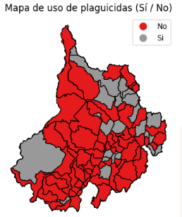

4.2 Map Coropletico

This map represents the probability of pesticide use; darker areas indicate a higher probability.

Lighter areas indicate a lower, but not null, probability, suggesting susceptibility to pesticide treatment.

Unlike the previous map, this one allows for the identification of zones with more frequent pesticide use.

Pesticide Use Probability Map

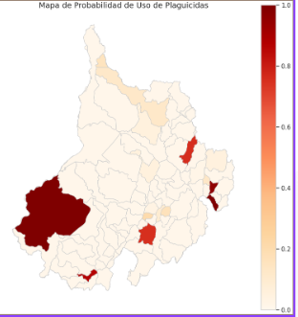

4.3 Proximity to Water Sources - Map Gaussian Variogram

Red areas represent the proximity to the most important water sources. Areas treated with pesticides within 30 meters are considered a minimum restriction, and those within 300 meters a moderate consideration.

This indicates that there is no significant difference in environmental impact between a larger buffer and a smaller one.

Protected crops within 30 m and 300 m of water bodies
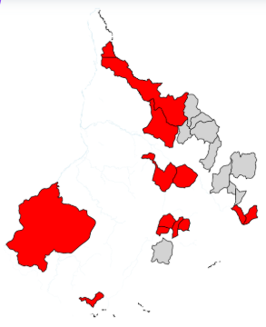

4.4 Discrete Data Visualization, Spatial Intersection (Overlay)

In this case, we observe the impact of pesticide use.

There are 148 agricultural areas within 100 meters of water sources.
On average, each area measures approximately 3,520 m².
The smallest measures 120 m², and the largest 12,300 m².
Half of them are smaller than 2,900 m².

Discrete Data Visualization
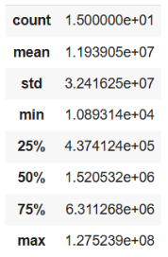

4.5 Queen-type Spatial Weights Matrix

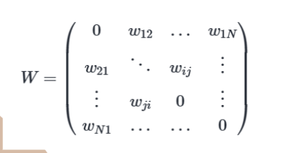
Queen Contiguity Matrix

Binary values: 1 = Neighbor, 0 = Not a Neighbor
The complete matrix shows which polygons are neighbors to each other.

This is a 27x27 matrix that describes which pesticide-affected polygons are neighbors, which is essential for spatial analysis.

An adjustment is made so that each row in the matrix sums to 1, meaning a weight is assigned to each variable.

4.6 Spatial lag

It is calculated for each pesticide-affected area:

For each analyzed variable (water areas, crops, pastures, and other land uses), the spatial lag is calculated. This represents the average value of that variable in the neighboring areas. The calculation is performed using the standardized spatial weights matrix.

Finally, comparative maps are generated where:

The first map shows the original values of the variable.

The second map shows its spatial lag.

These maps help identify spatial clustering (areas with similar values located close to each other), which is key to understanding geographic patterns in land use associated with pesticide application.

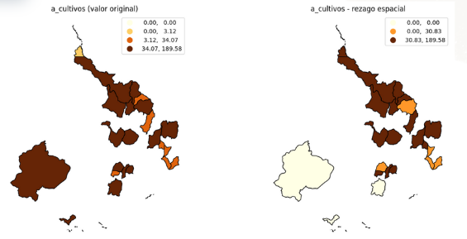



4.7 Graphic Moran Scatterplot

A scatter plot is generated for each variable where:
The X-axis shows the standardized values in each zone.
The Y-axis shows the average of those values in neighboring zones (spatial lag).
The slope of the regression line represents the Moran’s I value.
X-axis (Attribute): Value of the variable a_cultivos in a specific zone (in this case, cultivated area treated with pesticides).
Y-axis (Spatial Lag): Average value of a_cultivos in neighboring zones (i.e., the spatial lag).

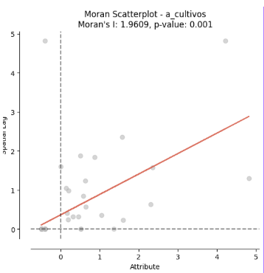

4.8 LISA Map

The LISA map confirms and complements what was observed with the high Moran’s I:

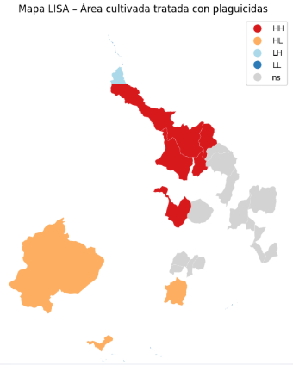

4.9 Clustering k-means

Polygonal areas with pesticide use based on the geographic location of their centroids.
K-Means is used to create four spatial clusters.
A thematic map is generated with different colors representing each group.
A table is printed showing the number of areas per group.

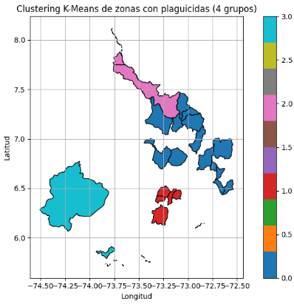

4.10 Sar - Model

The spatial lag is not significant: the coefficient of W_a_total is close to 0 with a p-value of 0.29.
This indicates that there is no direct spatial dependence in the total area treated with pesticides.

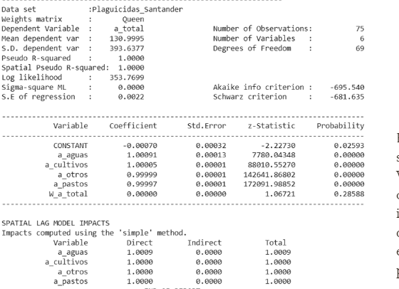

5 Conclusions:

Although the SAR model did not identify a significant spatial lag, the spatial autocorrelation analysis (Moran’s I = 1.96) and the LISA map revealed the presence of significant clusters in areas with high cultivated area and pesticide use.

The discrete data visualization and spatial intersection (overlay) identified 148 agricultural zones located within 100 meters of water sources, representing a potential environmental risk due to pesticide runoff or infiltration.

Choropleth maps showed that the probability of pesticide use varies between municipalities, highlighting areas with frequent use and others with medium or low susceptibility.

Agricultural zones within the 100-meter buffer around water bodies exhibit high variability in area (from 120 m² to 12,300 m²), suggesting differences in the intensity of use or agricultural management.

Areas with pesticide use were classified into four clusters using the K-Means algorithm. This method allowed for the spatial grouping of zones based on their location and pesticide use characteristics, supporting differentiated decision-making by area.
Polygonal areas with pesticide use based on the geographic location of their centroids.
K-Means is used to create four spatial clusters.
A thematic map is generated with different colors representing each group.
A table is printed showing the number of areas per group.

References

- Aristizábal, E. V. (2022). Libro Guía del curso de Cartografía Geotécnica. Universidad Nacional de Colombia, Departamento de Geociencias y Medio Ambiente, Facultad de Minas. Recuperado de https://edieraristizabal.github.io/Libro_cartoGeotecnia/intro.html

