For helpful reference:

<https://stackoverflow.com/questions/2636201/how-to-create-a-project-from-existing-source-in-eclipse-and-then-find-it>

# Setup guide:

1. Open Eclipse and create a new workspace “HeavenMS”
2. Click File > New > Other > Java Project > Next
3. Give it any project name
4. Uncheck “Use default location”
5. Browse to “HeavenMS” root and select it
6. Click **Next**, **NOTE under the “Source” tab:**
   1. Other than the “**src**” folder, the REST OF THE FOLDERS THAT CONSIST OF .java files NESTED INSIDE themselves under their own “src” folder will be detected by eclipse and added as a source folder.
   2. We need to REMOVE ALL THESE USELESS SOURCE FOLDER. They are a project ON ITS OWN.
   3. Select everything (shift+click) other than the “**src**” folder e.g.: “tools/MapleArrowFetcher/src”, “tools/MapleBossHpBarFetcher/src” and ““tools/MapleCashCosmeticsChecker/src”” and click on the blue link that says “Remove from Java build path”
   4. After you successfully removed it, you should only see the root folder ONLY in the “Source” tab
7. Click Finish and let the project build. You only only see **197 warnings**. **NO ERRORS.**
8. Right click on your project and see the java build path
   1. Under Source you will notice that the only src is our only src folder
   2. The “Libraries” tab will automatically import all dependencies in {projectName}/cores which will **RESOLVES ALL ERROR MESSAGE AUTOMATICALLY**
   3. Libraries tab will consist of other .jar file too which is automatically imported for us. This is awesome.
9. A few new files will be automatically created by Eclipses:
   1. .classpath
      1. Consist about details of:
         1. Our source files path
         2. Our lib files path (those in cores, tools automatically imported too. Cool)
         3. Our bin output folder
   2. .project
      1. Not sure what this is except for project name
   3. .gitignore updated automatically (if version tracking with github)

# Images:

1. 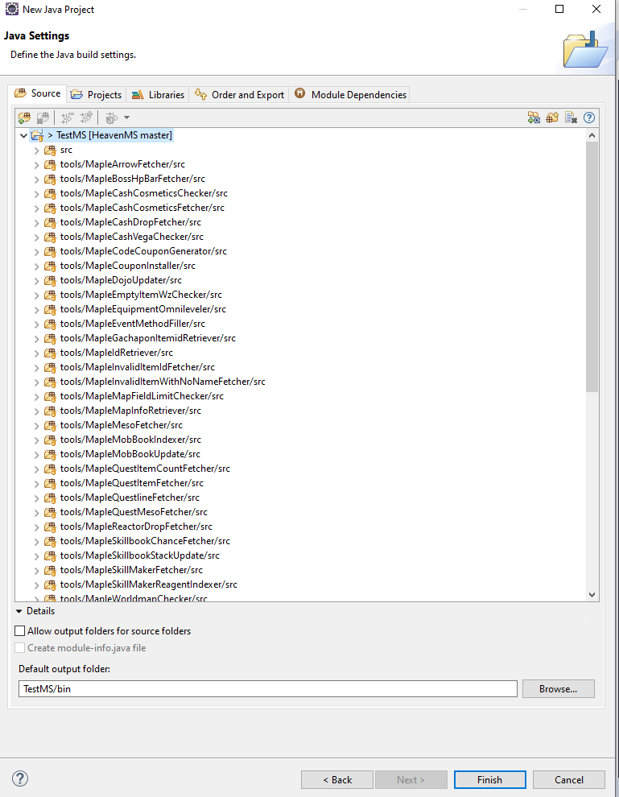
2. 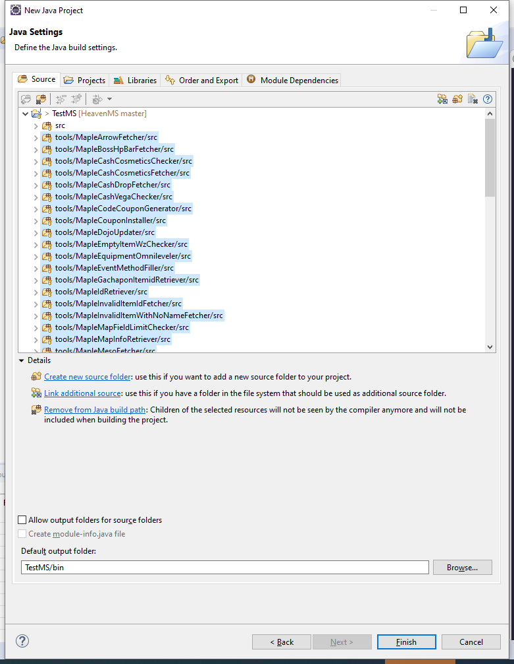
3. 