12.09.2018
File name | How it works | Some extras | How to use | Problems
add_campaigns.py | Add new campaign | campaigns.csv: contains information about campaign  campaigns_name_id.csv:  contains name and id new added campaing | Run this script | Geo location and language
Add group | Nothing is ready
add_expanded_text_ads.py | Add new adword | text.csv: contains infromation about adword  text_name_id.csv: contains name and id new added adword | 1. Run script  2. write Adwords Group name | Adding more than one text

Типы стратегий (biddingStrategyConfiguration)

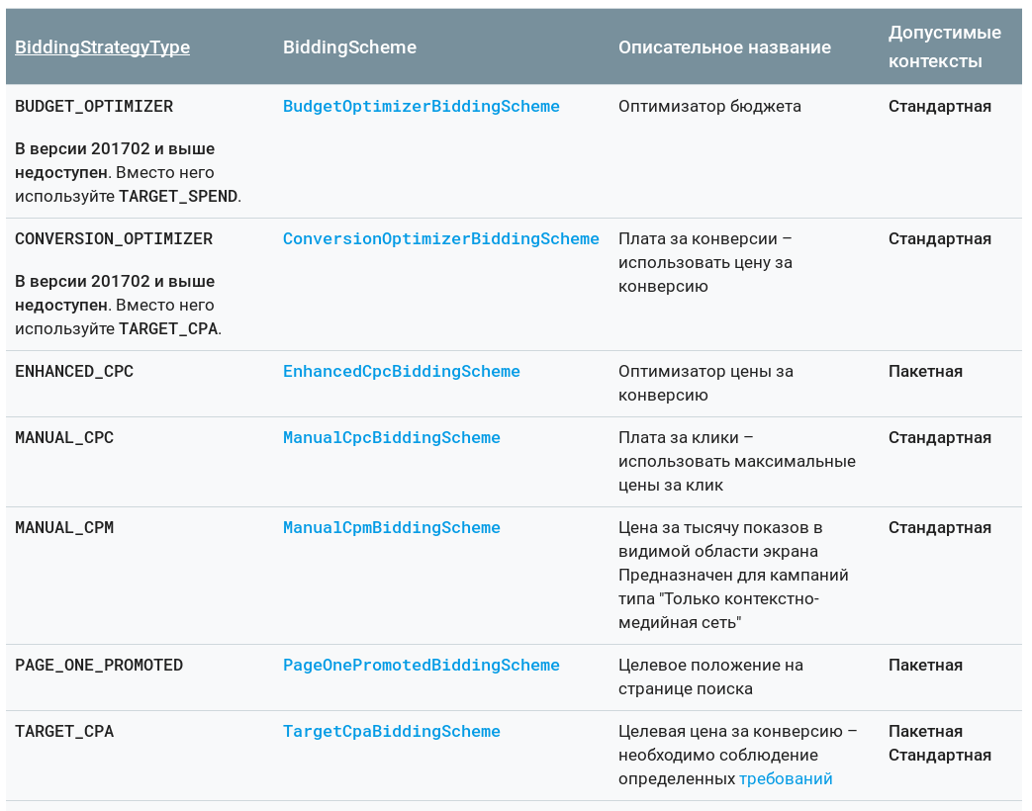

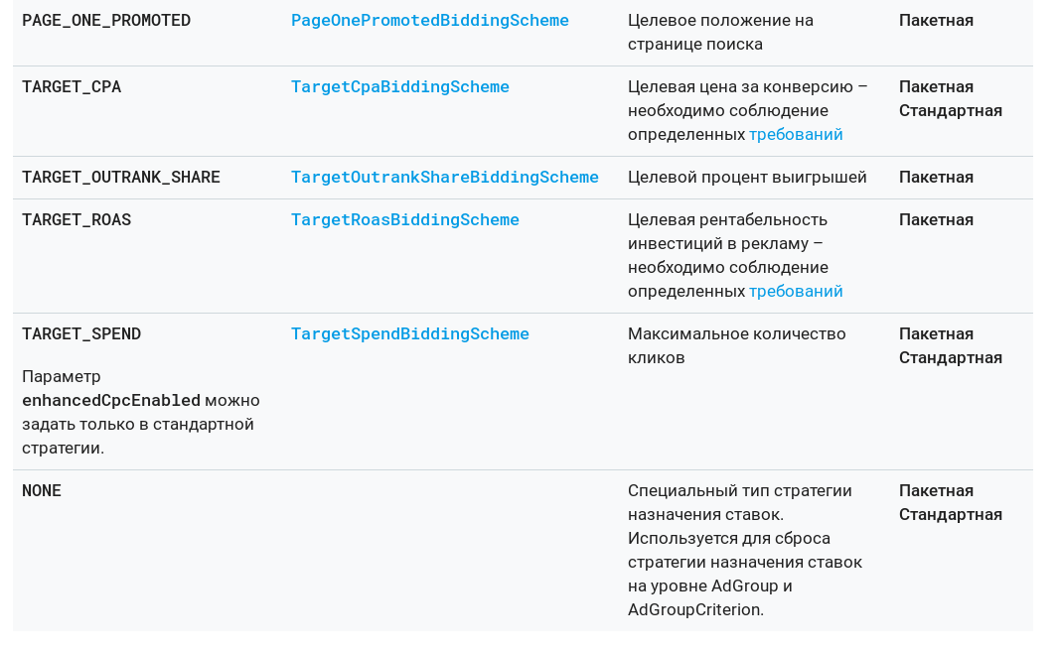
Бюджет (Amount)
Сколько бюджет

Метод показа (deliveryMethod)
1. STANDARD
2. ACCELERATED

Сети (AdvertisingChannelType)

SEARCH | Search Network. Includes display bundled, and Search+ campaigns.
DISPLAY | Google Display Network only.
SHOPPING | Shopping campaigns serve on the shopping property and on google.com search results.
MULTI_CHANNEL | Universal app campaigns that target multiple channels across search, display, youtube, etc.

Статус (Status)
UNKNOWN
ENABLED Campaign is currently serving ads depending on budget information.
PAUSED Campaign has been paused by the user.
REMOVED Campaign has been removed.

