ARverything: The World’s Leading Augmented Reality Display

|  | Dianna Yim  University of Calgary  Calgary, Canada  dianna.yim@gmail.com |  |
| --- | --- | --- |

# Introduction

Augmented reality has been a large topic of discussion over the last couple of years with real to almost impossible representations through science fiction. While there are many extremely interesting examples of this technology as demonstrated in [1], it is clear that there are still unexplored realms. Much of the augmented reality that is shown is used specifically for war and/or fighting – however, the truth is that AR can be used by everyone in a day to day fashion. *Nosedive* and *The Entire History of You* episodes in Black Mirror do a great job of showing how people can this technology with small tasks, such as viewing yourself in an apartment that you are about to buy, or projecting previous memories to yourself. ARverything takes advantage of some of these ideas and creates a world where knowledge is at your disposal.

# ARverything technology

ARverything is a technology that uses augmented reality to provide information about food, people and objects, as well as ensure that important messages or calls are not missed. In addition, specific AR messages and labels can be interacted with, giving more details as requested. Spoiled food can be notified to the user, ensuring that people stay healthy and avoid any health concerns. Allergies are also noted, with warnings alerting the user to the possible risk, as shown in figure 1. Language barriers can be replaced with live captions, along with information about the person they are currently interacting with, as demonstrated in figure 2. With these features and more, ARverything allows for people to understand the world in greater detail.

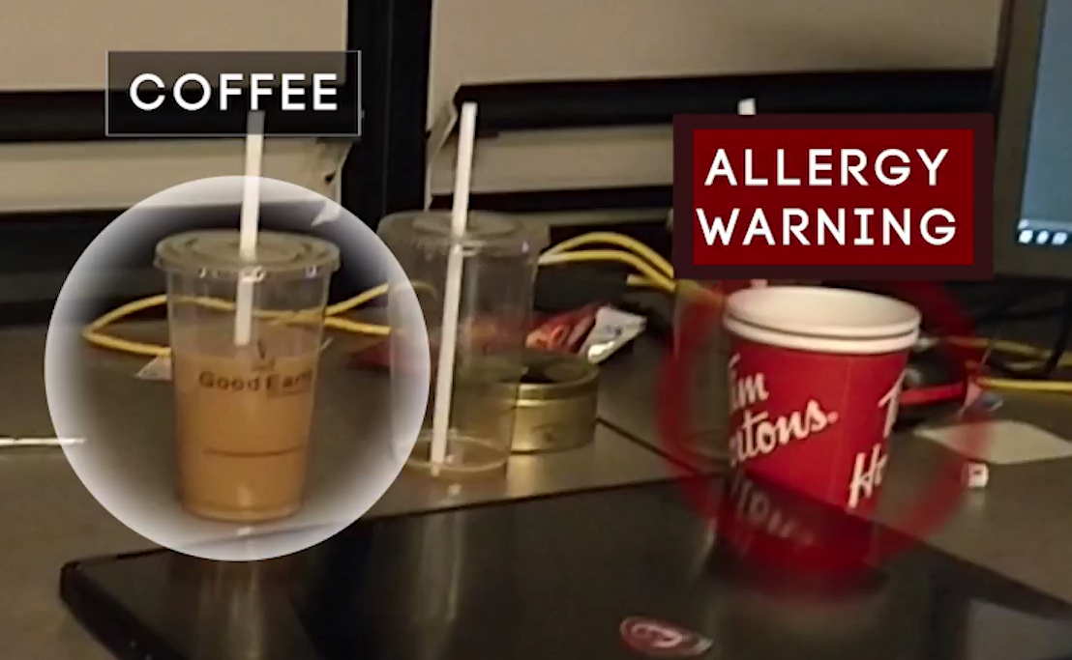

Figure 1. Display of food label and allergy warnings.

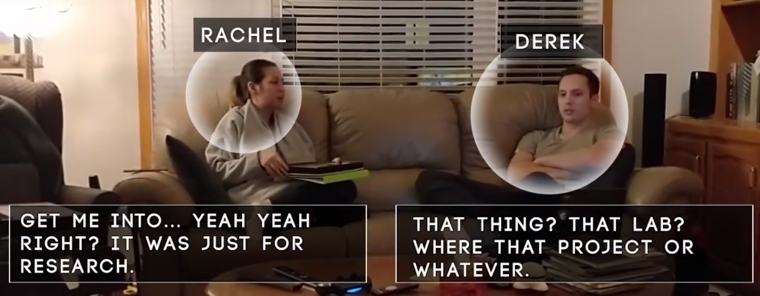

Figure 2. People labelling and conversation captions.

ARverything solves the problem of overloading a display by having a “focus sensor”, providing information only when it is relevant to the user. This allows for specific overlays to appear only when necessary. The biggest benefit while tackling the possibility of information overload is the customizability that allows users to have an AR display that is catered directly to them. Anything that appears is what they’ve deemed necessary, ensuring that additional rubbish has been stripped away.

The possible methods of interaction are based on voice, gestures, or remote controllers, depending on the user’s requirements. These interactions are typically used for augmented reality, but having a combination of the three ensures flexibility depending on the situation. People no longer have to rely on a single method of interaction, allowing for adaptability within their lives.

One of the issues with some of the current AR technology is that they are extremely reliant on gestures, which can be exhausting to use. However, ARverything provides a website which can allow users to easily navigate through menus and interfaces using a traditional mouse and keyboard. This reduces the exertion of always having one’s hand in the air, ensuring that it is not physically taxing to use this technology. Additionally, records of the user’s data can be viewed and analyzed through the website, providing a simple browsing interface that does not incorporate some of the taxing activities associated with augmented reality.

# Related Works

Tsai [2] discusses the applications of being able to focus on an object, using that to filter the information that users see on an augmented reality display. Alongside of this, Kalkofen [3] discusses the importance of other visualization techniques necessary for augmented reality. By combining these two ideas and improving the current technology available to us, it would be possible to create a display that can focus on specific objects, and display information in relation to this. This is one of the more important features in order to ensure that ARverything can become a reality.

Additionally, the technology needs to be able to quickly and easily understand objects that it is looking at, which Juang [4] does by using simple vector distance matching. With this technique and some finessing, it would be possible to build a database of objects. In addition, there is some research being done using the Structure Sensor by Aaron Hilton, president of Steampunk Digital. His goal is to create a digital dojo, where it is possible to place objects within a virtual or augmented space to create it according to a customer’s needs. In order to achieve this, he has been scanning objects into a database using the Structure Sensor, which could be extremely useful within ARverything.

# Future Work

While some parts of ARverything is within the realm of possibility, it would be difficult to analyze food through sight alone. Currently, this seems unlikely to progress – however, little steps in the right direction could lead to a revolutionary breakthrough, combining food and AR into an informative system. Much of ARverything relies heavily on our current technology to move forward, and progress in such a way that augmented reality becomes everyone’s reality.

# REFERENCES

1. Shedroff, N., & Shedroff, N. 2012. *Make it so: interaction design lessons from science fiction* (pp. 300-329). New York: Rosenfeld Media.
2. Tsai, C.-H., & Huang, J.-Y. (2018). Augmented reality display based on user behavior. Computer Standards & Interfaces, 55, 171–181. https://doi.org/10.1016/j.csi.2017.08.003
3. Kalkofen D., Sandor C., White S., Schmalstieg D. (2011) Visualization Techniques for Augmented Reality. In: Furht B. (eds) Handbook of Augmented Reality. Springer, New York, NY
4. Juang, L.-H., Wu, M.-N., & Weng, Z.-Z. (2014). Object identification using mobile devices. Measurement, 51, 100–111. https://doi.org/10.1016/j.measurement.2014.01.029