Test Suite – Login

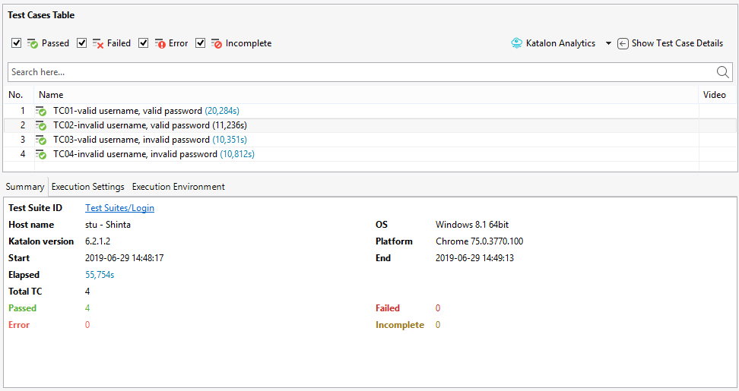

Test Suite – Product-List

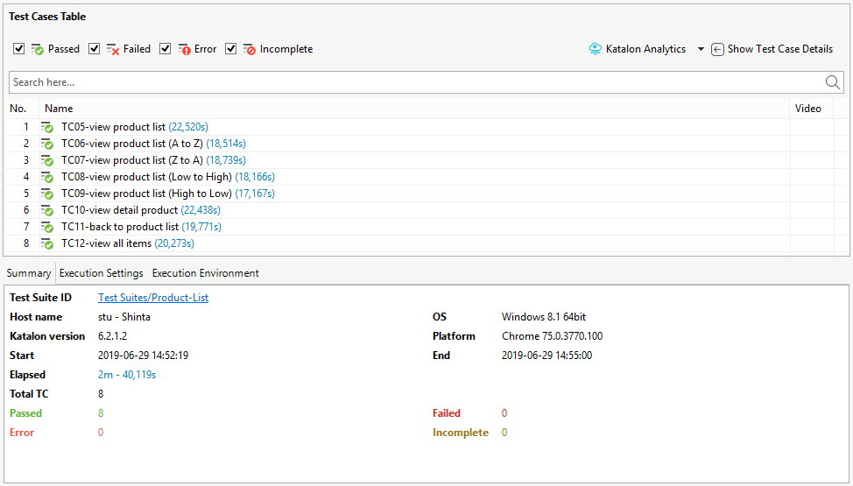

Test Suite – Cart-Checkout

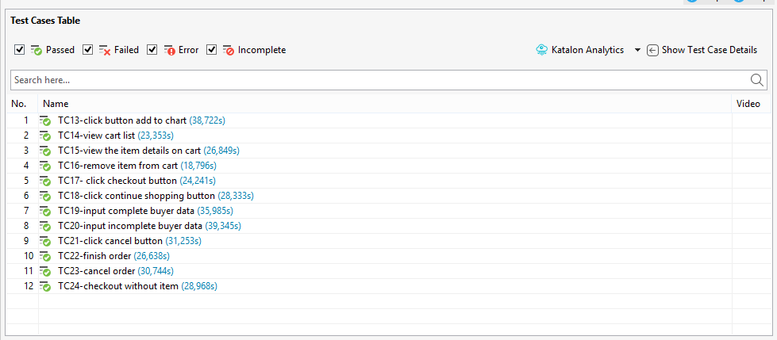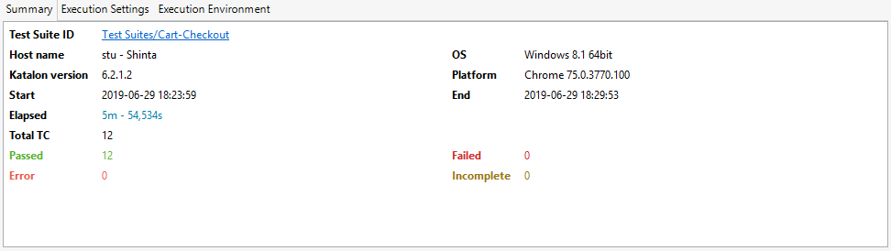

Bug found:

1. You can click the cart icon manually, you will be directed to the cart list page (cart). But when you try to do it automatically, it does not work at all. If you want to access the cart list automatically, you must have at least 1 item in your cart and the you click on the number that appears on the cart icon.
2. The item quantity cannot be set, it is only one each item.
3. There are no rules about how the data of buyer should be filled.
4. Can finish checkout without item.