1. Pointless bitwise expression.



2、Field can be local.

3、“private”（static）method declared final.



1. pointless boolean expression.



1. unnecessary continue(return) statement.

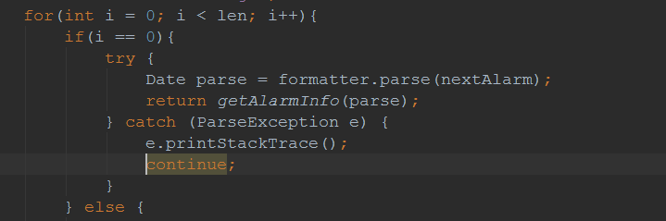

1. access static member via instance reference.



1. for array copy 修改为 System.arrayCopy(); Collection.addAll()

