Narrative and puzzle design

**If something is too complicated to build, let me know**

Beginning:

Two people wake up and hear the sound:

“Rise and shine, let’s play a game. You're probably wondering where you are. I'll tell you where you might be. You might be in the place that you die in. Now I see you as a strange mix of someone angry, terrified, confused. But mostly just pathetic. So, are you going to die here today, or do something about it?

Listen very carefully cuz I won’t repeat. You need to keep moving forward to get out. There will be some obstacles, fun obstacles along the way, just, you know, find a way to pass through. Don’t worry, there will be hints provided. I’m a reasonable person.

But the hints……. this is the fun part; the hints are in somewhere else. Since you cannot transmit yourself to get the hint, hey, how about transmit information. See the walkie talkie in your hand? Congratulations, you are not alone. Your pathetic buddy gonna give you the hints. If they dumb, you doomed.

Oh, one more thing, each obstacle has a timer, it will be activated at the moment you touch the obstacle. I would highly recommend you finish in time, or……you may not like the next part. Let’s just assume a machete will come up from nowhere or a bomb, I don’t know, honestly, I kinda forgot what I put out there.

So……that’s it. Let’s play

Puzzle design:

Note: All puzzles have a timer, it will be activated once players hit the “start block”. Every puzzle has a start block, players need to jump to hit it to see what’s the puzzle about. If they can’t solve in time, they will die and restart the puzzle with some time deduction.

1. Password to open the door

Note:

* Hidden numbers are set along the way, pass to see. Both players face the same problem and password combination.
* One block on the top near the door, hit it to see the password screen, countdown start.
* Three numbers are 2,6,9.
* 2,6 on one side, 9 on the other side.
* The password is 6-9-2.

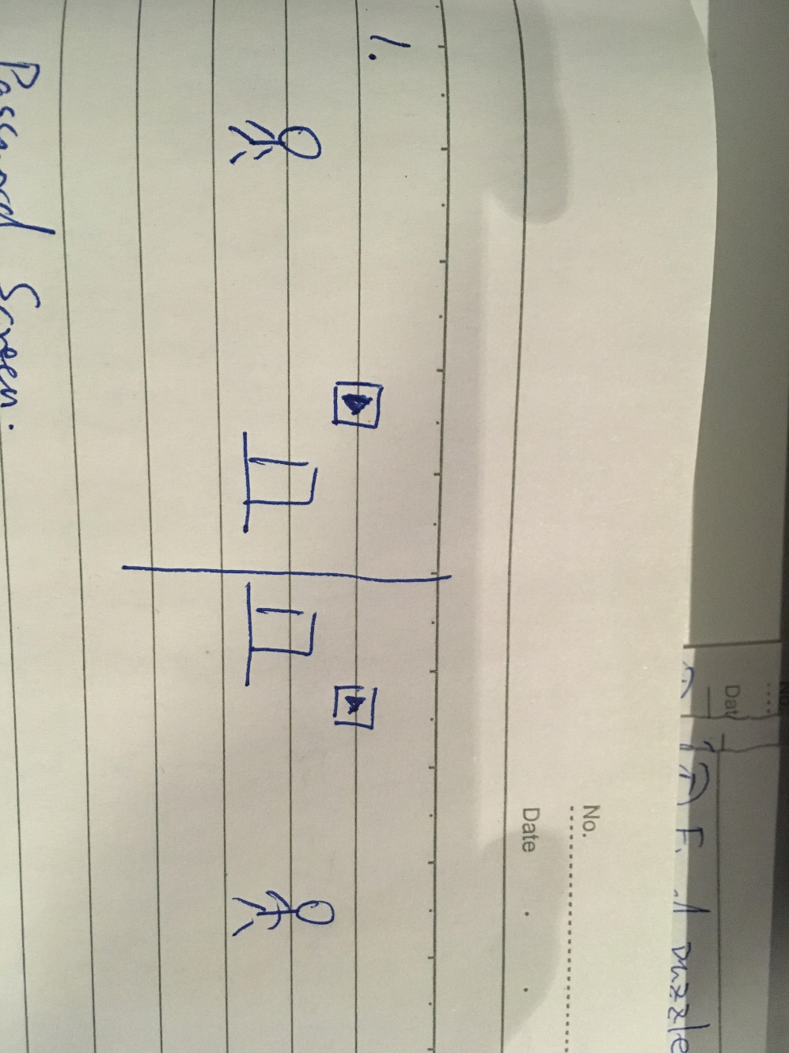

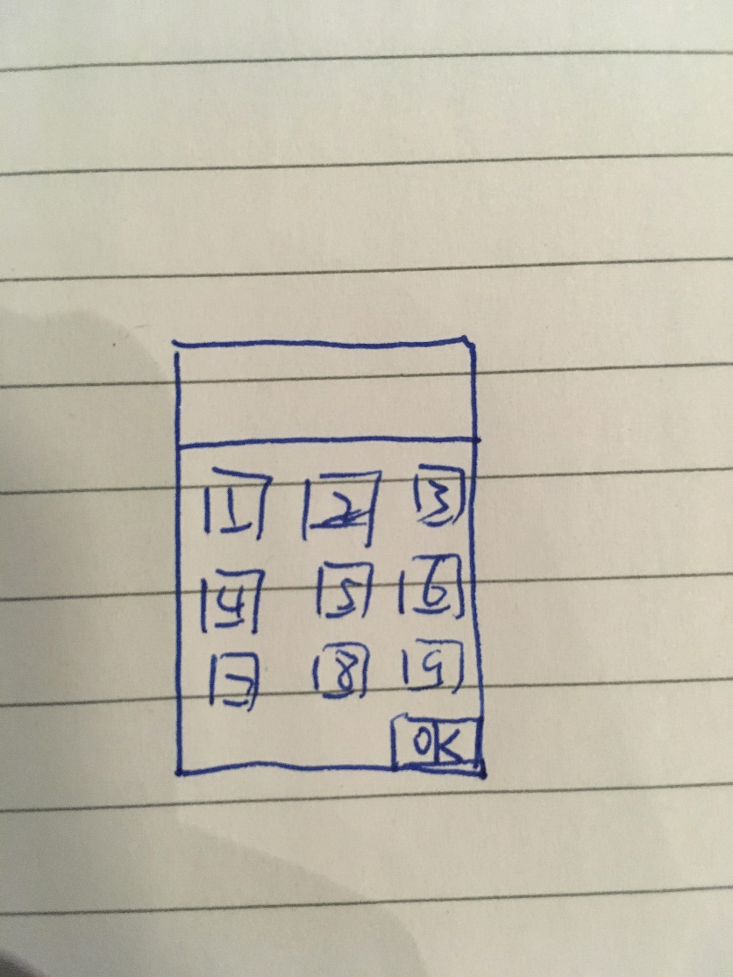

1. Choose a door

Note:

* One side has three doors—A, B, C; choose the wrong door will make the player die. On the other side, another player need to solve an equation and choose the correct answer. In the meantime, the first player need to avoid fireballs falling from the top.
* The equation: (x+4)+5-6+7-8+9=13

1. 1
2. 2
3. 3

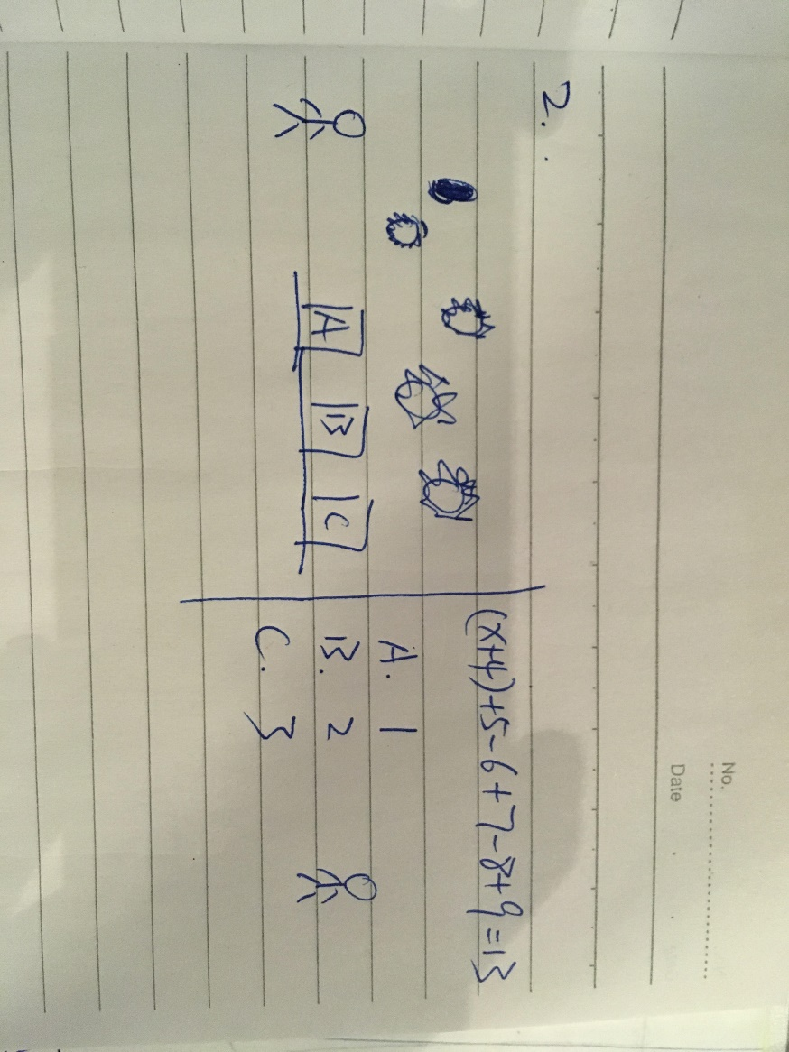

1. Jump to hit the block in right combination

Note:

* A high wall blocks their way on both sides.
* Three music blocks on the top: Do, Re, Mi
* Hit the “start block”, it will play a piece of music as the combination
* The combination is the music for the other side
* Player 1: Mi Do Re Do Mi------answer for player 2
* Player 2: Re Do Do Re Mi------answer for player 1

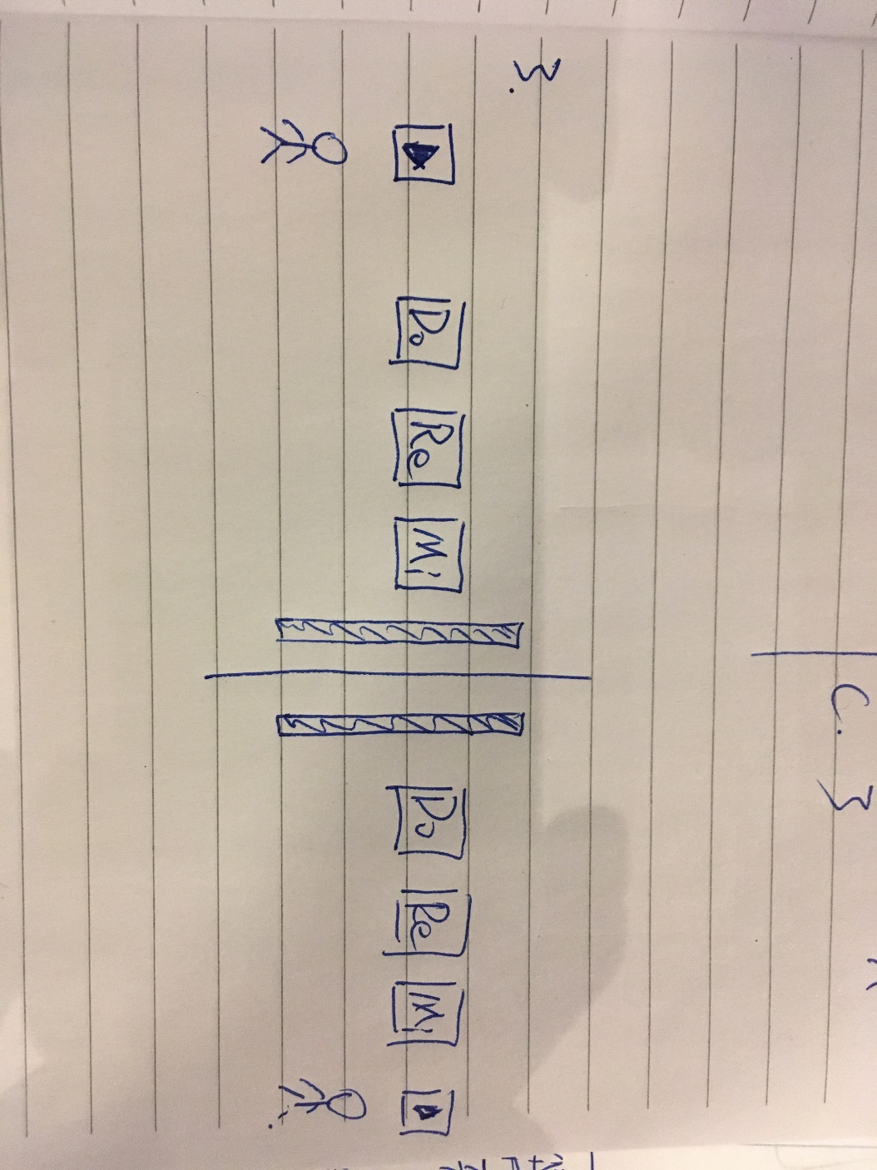

1. Password to open the door (harder one)

Note:

* Both sides have the same problem
* Blocks have different colors, match both color and number
* Colors: blue; red; tallow; green
* Each side has four numbers under four color blocks
* Player 1: B—5 R---6 Y---1 G---3
* Player 2: R---0 G---7 B---3 Y---5
* The answer of this puzzle is to add both numbers in same color and find the average of the final answer:

B: (5+3)/2=4

R: (6+0)/2=3

Y: (1+5)/2=3

G: (3+7)/2=5

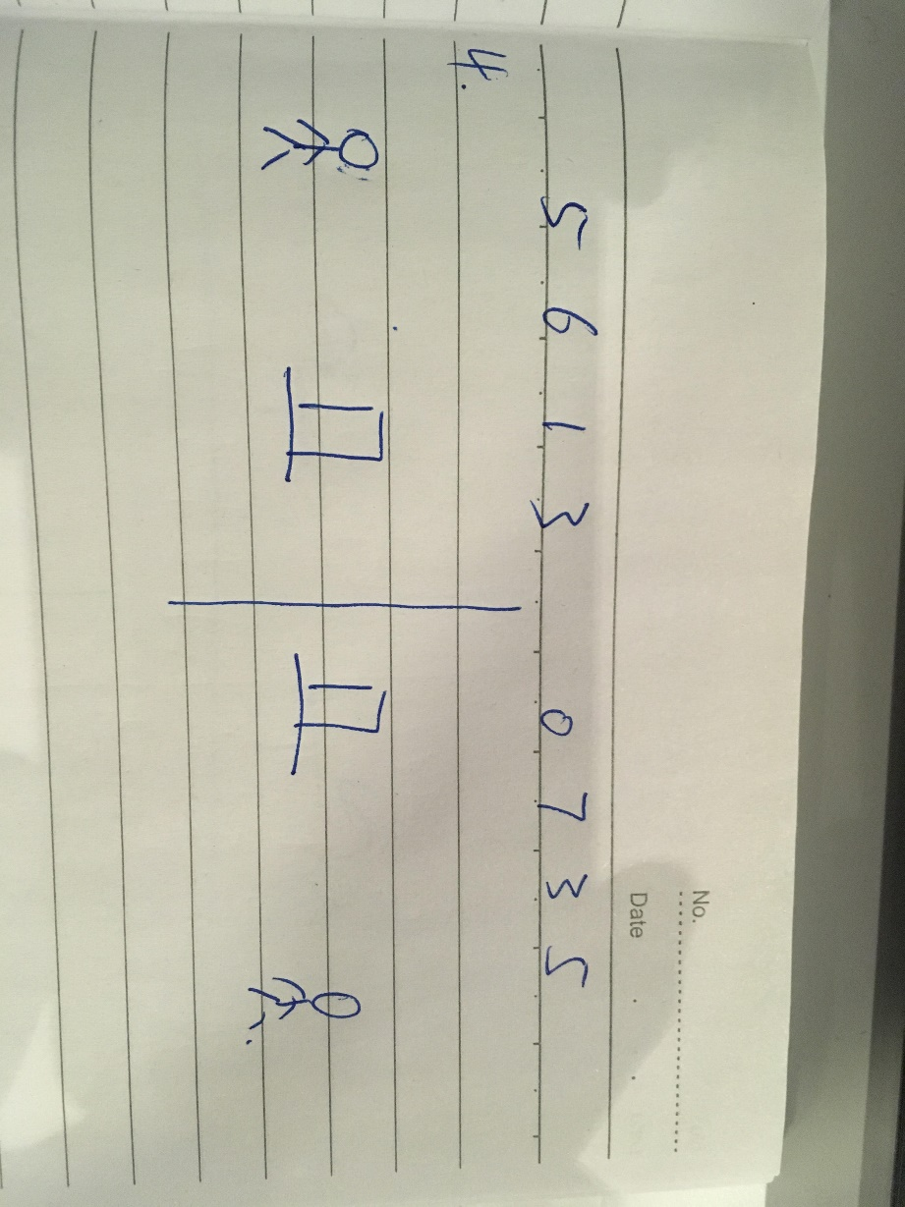

1. Word cross to open the door

Note:

* Letters needed are hidden, pass to see
* Both sides have same problem to solve
* One letter is given: T
* One side has H, A
* Other side has E, A
* The answer is HAT; TEA

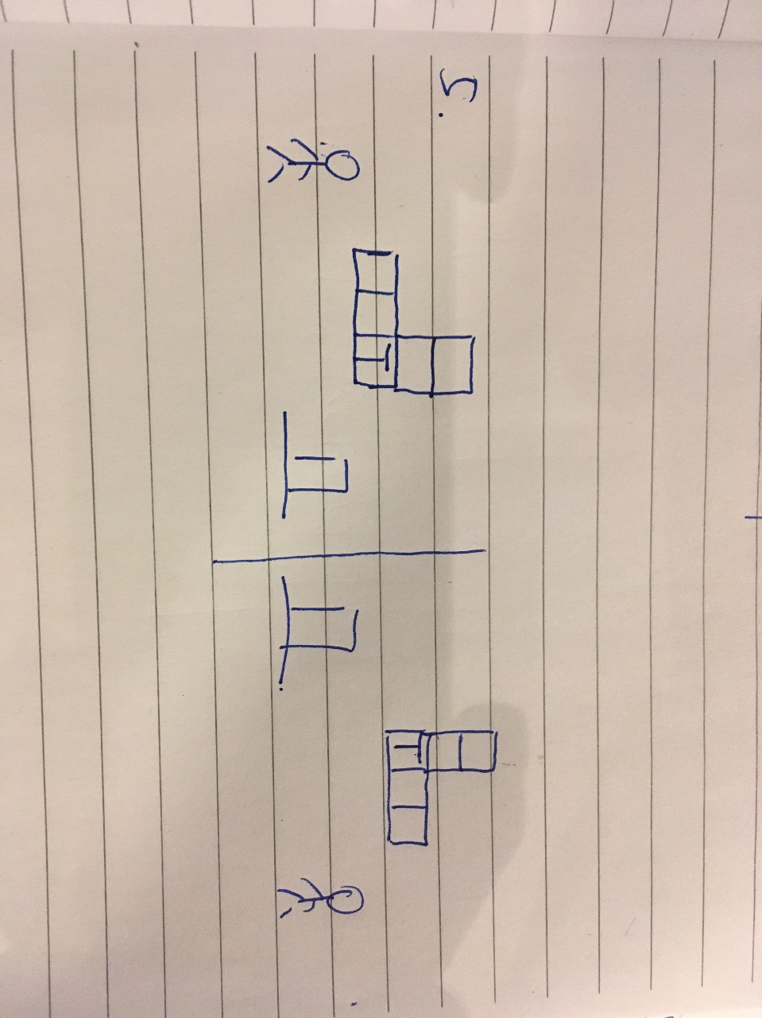

1. Final puzzle

Note:

* Completely same scenario but one side can’t see any obstacles.
* Both players need to sync their movement
* This is a vertical scene, both players going up
* They step on a platform, it will go up. In the meantime, fireballs will shoot at them, they need to jump to avoid it. (Since one side can’t see the platform or fireballs, he needs to follow the lead of the other player)
* There is a platform switch during the puzzle, both players need to jump to another platform to continue going up
* After platform switch, the invisibility also switch.
* At the end, they will meet at the top and a door opened, sun light in, they are out.

