Table of Contents

Section 1: Game Mechanics 1

• §1.1 Core Game Play 1

o Game Overview 1

o Overview Expanded 1

• §1.2 Game Flow 1

o Overall Game Flow 1

o Core Game Play Flow 1

• §1.3 Characters 1

o Player 1

o Enemy 1

• §1.4 Game Play Elements 1

o Player Primary Attack 1

o Player Secondary Attack 1

o Procession: Main Ability 1

o Enemy 1

o Extra Ability 1

• §1.5 Game Physics and Statistics 1

• §1.6 Artificial Intelligence 1

o Field of View 1

o Attack 1

o Facing 1

o Player Too Close and Group Fight 1

o Good Ally Bad Ally 1

o Path Finding 1

Section 2: User Interface 1

Game Design Document – Weakling

# Section 1: Game Mechanics

## §1.1 Core Game Play

### Game Overview

Weakling is a 2-D platformer stealth-action-process game. It’s overall design concept of game play is **HEAVY OPERATION** orientated.

### Overview Expanded

Stealth action will be explained in the section game flow. Heavy operation orientated means game experience depended heavily on player operation. Thus both the upper limit and lower limit of the game will be high, though upper limit will be higher than the lower limit.

## §1.2 Game Flow

### Overall Game Flow

Player kills enemy -> Gains experience -> upgrade to get new abilities -> combine different abilities to set up new play strategy (similar to leveling with Diablo III) -> use the different strategy to kill enemy

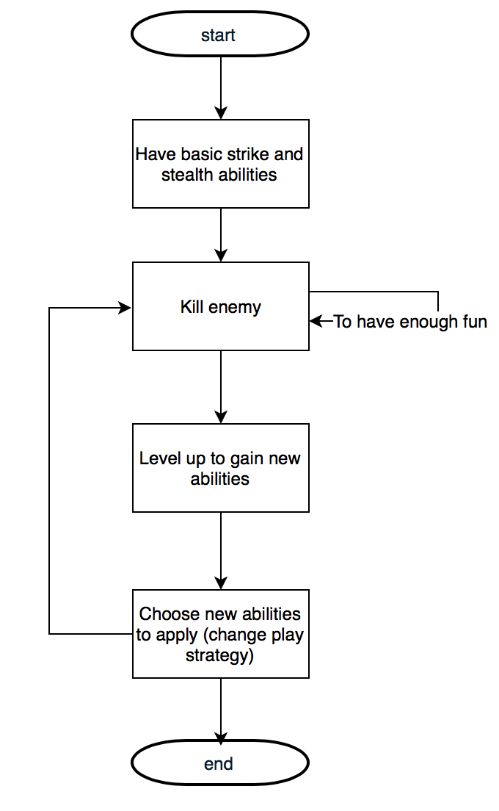

### Core Game Play Flow

hit one enemy until x% health -> process the enemy (or just kill it to loop from beginning)-> use this processed enemy to strike another enemy until x% health -> loop

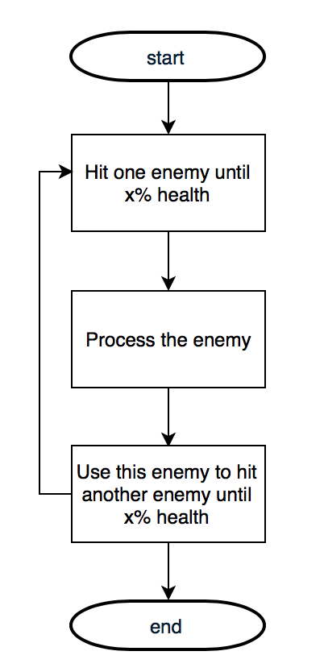

## §1.3 Characters

### Player

At first, player has the **basic attack** abilities to start off. With killing more enemies and finishing levels, player levels up and gains more abilities.

But player can **only use certain amount (let’s say, 3) of abilities at one time**. Thus with leveling up, you can only choose 3 abilities to use finishing this level, even though player might now have 10 abilities to use.

For example, player might have mid-air assassinate ability, double jump, anti-bullet, master stealth ability upon reaching level 3, but player can only choose three abilities to finish next level. Upon death / lose, player can change his/her abilities. Upon leveling up, player may or may not get extra sockets for abilities. This has to be decided later.

When player process an enemy, player’s basic attack ability is replaced by enemy’s basic attack ability and player may/may not gain an extra ability (depending on whether enemy has one).

Controllable buttons are “q”, “w”, “e”, “r” for player abilities, mouse left for primary attack, mouse right for secondary attack.

### Enemy

Enemies can have multiple abilities. Upon reaching x% health (which from now on will be called critical health), enemy becomes able to process by player. When processed, player replace his/her basic attack with enemies’ basic attack abilities.

Enemies have different basic attack style. For example, some enemies can use rifle and some can use machine gun.

Each enemy has different critical health, but the behavior when reaching below critical health is similar, slower movements, including moving, turning around and usage of abilities and attacks.

## §1.4 Game Play Elements

### Player Primary Attack

In the beginning of the game, player only has one kind of primary attack, melee.

When player process enemy, player temporarily replace his/her current primary attack ability and secondary attack ability with the enemy’s primary attack ability and secondary attack ability.

### Player Secondary Attack

In the beginning of the game, player has no secondary attack. Upon leveling up, player will learn secondary attack such as concentrate melee.

When player process enemy, player will temporarily replace his/her current secondary attack with the enemy’s secondary attack. (If applicable) If enemy does not have a secondary, then player’s secondary ability will be temporarily unusable until player comes out of the process.

### Procession: Main Ability

One of the core game play ability that player will have. This is **not removable** at any circumstances and this ability will remain active the whole time.

This ability goes as follows: After casting for x sec, player can process the enemy which reaches critical health. Player gets enemy’s primary attack and secondary attack. May/may not get the enemy’s extra abilities.

Player’s current health became enemy’s current health and player continuously deals damage to the processed enemy.

When enemy that is processed by player’s health reaches zero, player pop out of the enemy, reclaiming everything (including player health, except for cooldowns of player ability) to the state right before player process the enemy.

### Enemy

Different enemy has different abilities and status.

For status, different kind of enemy have different:

* + - Max health
    - Movement Speed
    - Turning Speed
    - Searching Speed (Speed of the increment of search bar)
    - Losing Speed (Speed of the decrement of search bar)
    - Different kind of armor (TBC)

For abilities, different kind of enemy have different:

* + - Primary Attack
    - Secondary Attack
    - Extra abilities. (TBC)

When processed by player, all of them will be inherited by player, except searching, losing speed and part (or all) of the extra abilities.

### Extra Ability

When player level up, he/she can choose extra ability. Player can equip in total x extra abilities. Overall, every extra ability should be **GAME-STRATEGY-CHANGING** boost in essence, not some talent “increase damage 5%”, but something like “gain double jump ability”.

**In** **the beginning**, player can only equip 1 extra abilities. With passing certain scene, player can equip 2, then player can equip 3.

Think of extra ability as Diablo’s ability (1, 2, 3, 4 and left right click). With different combination, player can have so **much more different strategies**. This is what our extra ability shoots for.

AND one important note, extra abilities with different strategies can and will break the main game play loop (kill -> process -> kill). BUT NOT UNTIL middle of the game play where player got used to the main game loop and started to think about different loop.

## §1.5 Game Physics and Statistics

Skip since it’s already built and strictly follow normal Physics.

## §1.6 Artificial Intelligence

### Field of View

Every enemy (AI) has its own FOV, different kind of enemy can have different FOV.

FOV of enemy works as follows:

When player enters the view range, enemy will have a bar indicating he/she has noticed something strange. If player continues to stay in the view range, the bar would begin to fill up in a certain speed, specified by the enemy’s Searching Speed (see 1.4). If player does not stay inside the view range, bar starts to decrease in a certain speed, specified by the enemy’s Losing Speed (see 1.4). If the bar fills up for the first time, then the bar turns yellow, indicating the enemy confirms noticing something strange in player’s location. Then bar begins to fill up again to turn red with twice the speed. If player stays out of FOV now, the enemy will start following the path finding algorithm to go to the position where player was standing when the bar of enemy turns yellow. Upon bar reaching red, enemy starts to attack.

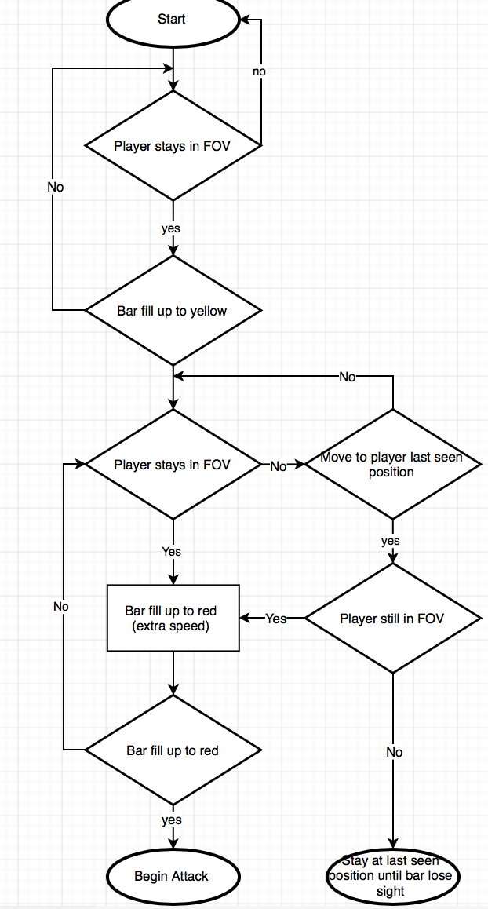

### Attack

When Enemy begins attack, enemy gains a wider field of view. If player gets out of this wider field of view, then enemy would chase player to the last seen position. After x sec of not seeing player, enemy returns to normal state. Or enemy and player fight to death. Normally player wins.

### Facing

Before enemy bar turns yellow, enemy does not change his/her facing position. Upon changing to yellow, enemy changes his/her facing position to player last seen position. Upon changing to red, enemy facing follows player.

### Player Too Close and Group Fight

If player gets too close, within x meters, enemy immediately gains red bar and start attacking player.

If enemy’s ally changes into attacking mode (aka bar turns red), then any other enemy within his/her FOV that can spot this ally immediately changes to attacking mode and start to attack player.

### Good Ally Bad Ally

If player gains control of an enemy, then player would not trigger notice when walk into other enemies’ FOV. But player will be immediately attacked if he/she start attacking first.

### Path Finding

FOV of most enemy cannot penetrate through any obstacles (except some red laser folks).

And if player last seen location is somewhere unreachable (such as midair), then find the nearest reachable position to be the last seen location.

# Section 2: User Interface