Hello,professor

I am a senior student of Harbin Normal University.I come from China.I am good at programming.I want to develop a GIS software.Now I have an intership in Beijing .I have to use a software to draw maps which is relavent to GIS.It is harder than what I have learned in school.I am so busy these days.

In my college time,I have learned a lot about GIS.This is my spciality.I have learned how to use ArcGIS.I use it mostly to do spatial analysis.My teacher demonstrated how to crate a buffer,how to crate a spatial network dataset and how to use model builder. I thorught it was hard when I frist approched it.But now I can control it well.when I was sophomore,I have learned about RS,I use ENVI to process the images of RS.It includes the correction of geomotry and radiation,image classfications.I also took courses of programming,such as C plus,C sharp,java,python,datastruct,database.When I was junior,I have learned ArcGIS engine,the second development of ArcGIS software.I remember how to use the function to import the data.The vector data is shapefile,GDB and dxf, which needs to bulid a vector class to content them and deliver to the layer class.The raster data needs to build a pyramid. The collection and management of spatial data cousrse,which is to collect the spatial data.I have learned the metrology,which is to measure the

distance and angle to compute coordnations.

I have bournden my horizens since I praticipated in ESRI YPN.I want to learn more about GIS knowledge.I wish we can communication more and more!

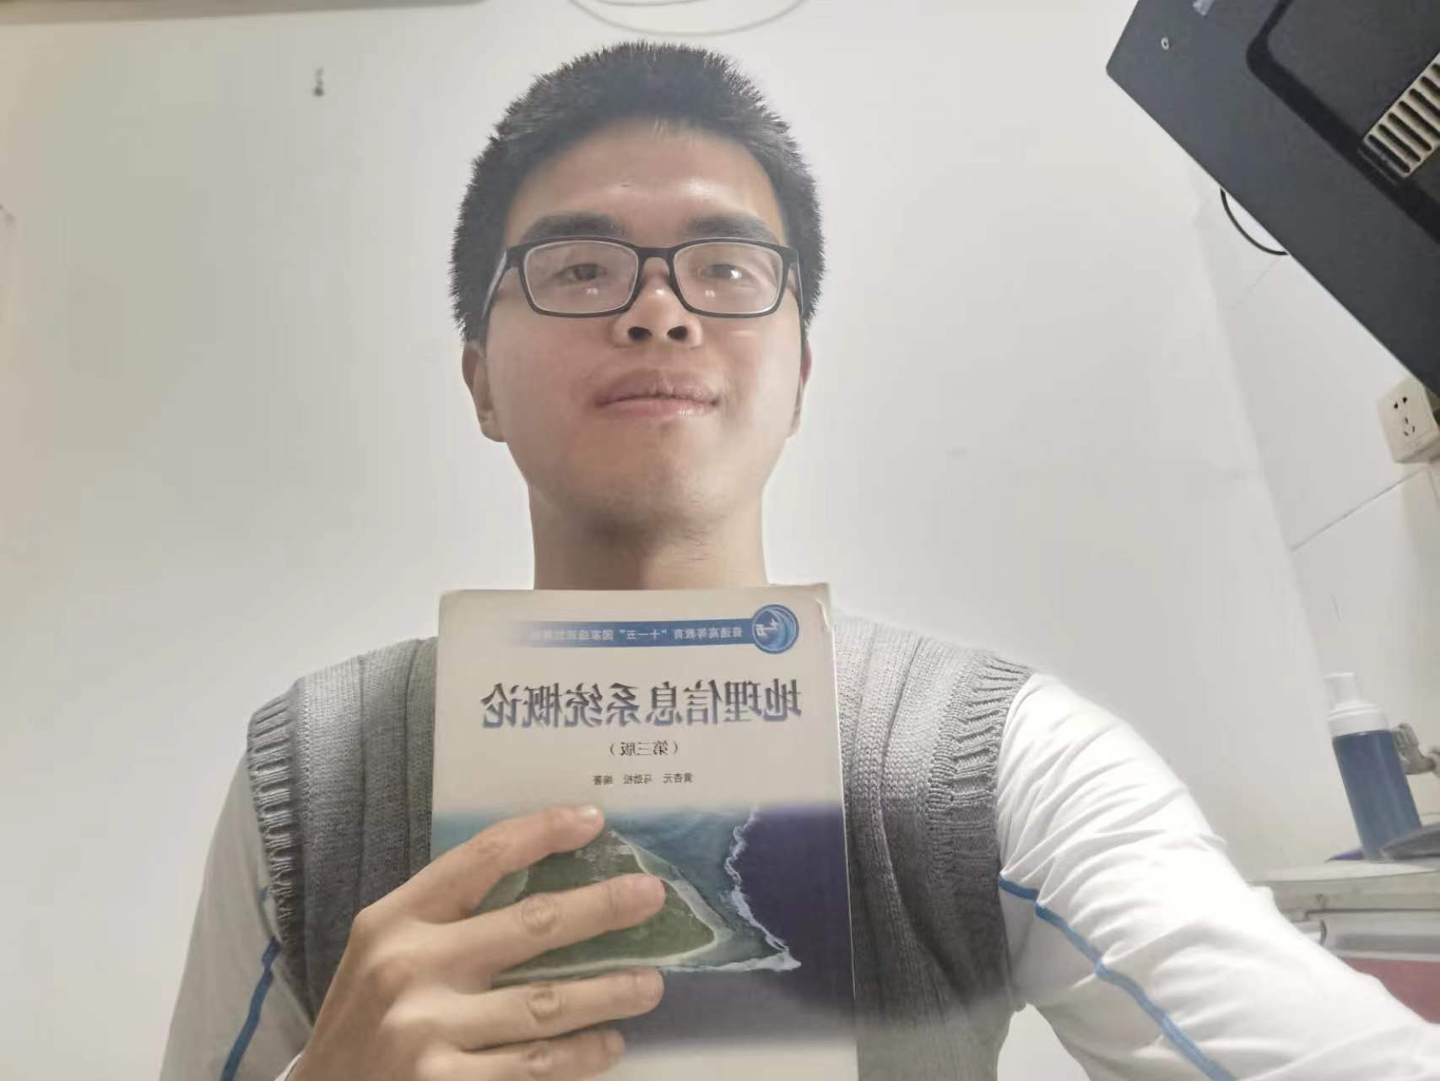

My story map

Wuhao Jiang