<http://192.168.0.1/>

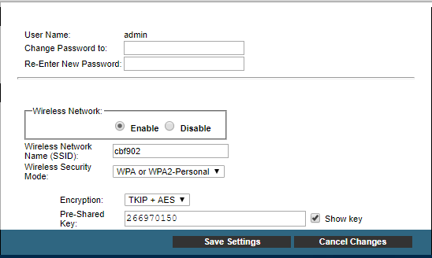

Wireless Network Name (SSID): cbf902

Pre-Shared Key: 266970150

Nueva Pre-Shared Key: **051079662**

Nueva contraseña: 123admin