

I have pasted the data.cypher file into a web based neo4j db. This is the graph it produced.

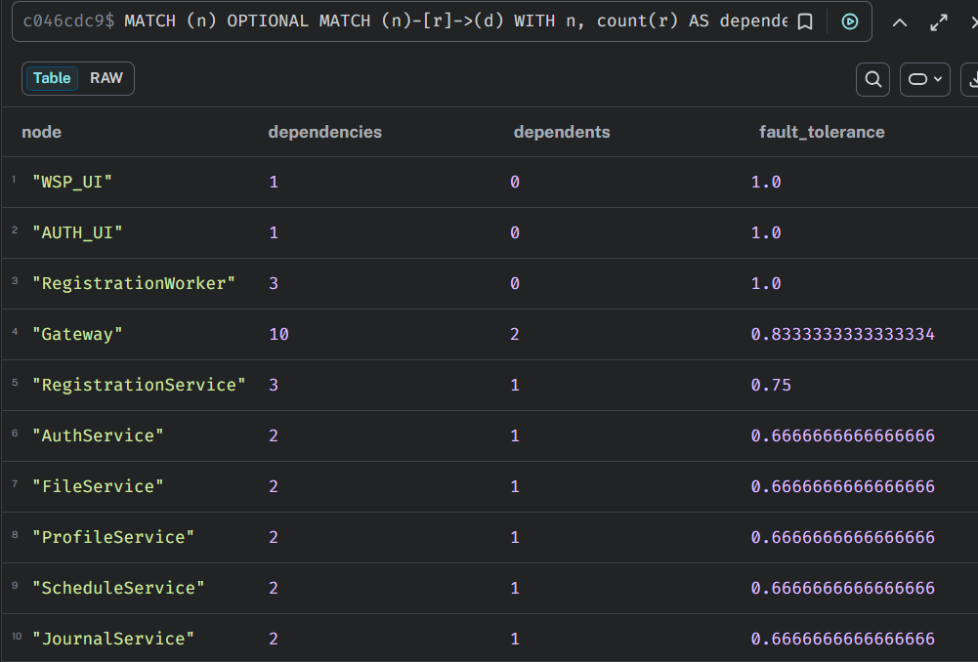

Then I calculated fault tolerance by your formula. (Outcoming dependencies / (incoming + outcoming dependencies))
The full result is in the csv file
The query is in the tolerance.cypher file
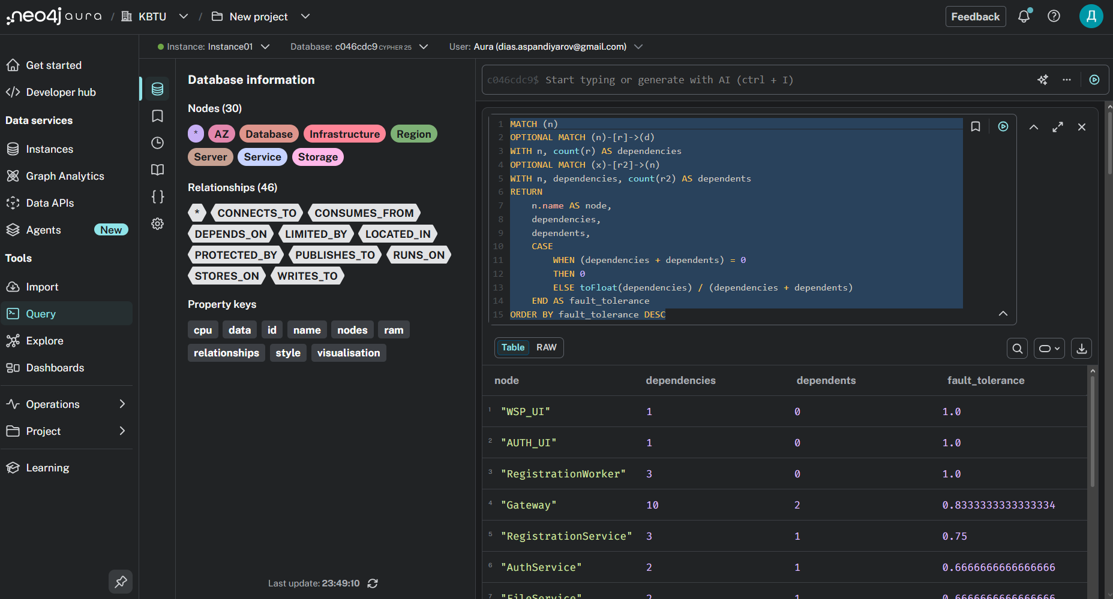
Here is the proof I actually did it

