Laboratory Work 2
Full Stack Development
Topic: BarberTime — a web service for online barbershop booking.
Team: Dias Adilov, Nurmuhammed Zaitin, Zhangir Isametov; group IT1-2315.
Instructor: Zhanibek Kanatovich.

2.1 Subject Area and Problem Analysis (Laboratory Work 1)

1. Subject Area Selection
Subject area: personal-care services, specifically small and medium-sized barbershops (2–10 chairs) in Almaty. The product of such a business is not the haircut alone but a fixed time slot with a specific barber, so appointment scheduling is the core operational process.
Justification: barbershop services are bought repeatedly (a typical client returns every 3–5 weeks), demand is concentrated in evening and weekend hours, and the capacity of each barber is strictly limited by time. Therefore the quality of the booking process directly determines utilisation of barbers and revenue, which makes the area suitable for a full-stack web system with a clear data model and real-time constraints.
Stakeholders: (1) clients — men aged approximately 16–45 who book mainly from a smartphone; (2) barbers — need a clear daily and weekly schedule; (3) administrators or owners — manage services, barbers, working hours and appointments.
Scope: the project covers the client-facing booking process, the barber schedule and the administrative management of services and appointments. Payroll, inventory, accounting and marketplace functions are explicitly excluded.

2. Problem Area
Problem statement: in most small barbershops appointments are still handled manually: clients call, write in WhatsApp or send a direct message on Instagram, and the administrator keeps the schedule on paper, in notes or in a shared chat. The schedule therefore exists only in one person's head or notebook, it is not visible to clients, and every booking requires a synchronous human conversation.
Table 1 - Stakeholders and pain points
Stakeholder | Pain point | Consequence
Client | Cannot see free time slots; must write and wait for an answer, sometimes for hours.  Cannot book outside working hours. | Friction and delay; the client books with a competitor who answers faster.
Client | No reminder before the visit; no list of own bookings. | Forgotten appointments, confusion about time.
Barber | Learns about the day's schedule from the administrator or a chat. | Idle gaps, unexpected overlaps.
Administrator / owner | Spends a large part of the day answering calls and messages; reschedules manually. | Double bookings and errors; lost working time.
Administrator / owner | No history of visits, no data on barber utilisation. | Decisions on staffing and hours are made without data.
Key question: how can a small barbershop give clients 24/7 self-service booking into genuinely free slots and keep a single consistent schedule, without the cost and complexity of a full salon CRM?

3. Analysis of Existing Solutions
Method: analogues were selected according to three criteria: (a) the solution is a widely used way to book barbershop or salon services, or is the de-facto booking channel; (b) it provides online booking or replaces it; (c) it is publicly accessible, so its booking flow can be examined from the client side. Each solution was evaluated by its type, target segment, key features, strengths, weaknesses and relevance to the proposed system. The evaluation is qualitative and based on the client-facing booking experience; prices and market statistics were not used as evidence.
Table 2 - Comparative analysis matrix of existing solutions
Solution | Type | Target segment | Key features | Strengths (+) | Weaknesses (−) | Relevance to BarberTime
1. Manual booking via Instagram / WhatsApp | Messaging channel (no system) | Any small business | Free-form chat, calls, schedule kept on paper or in notes. | Zero cost; clients already use these apps; no setup. | No visibility of free slots; depends on a human answering; double bookings; no reminders or analytics. | Baseline that BarberTime replaces; defines the core pain.
2. Dikidi | Online booking service | Beauty and personal-care businesses in the CIS | Online booking page, schedule, notifications, mobile app. | Ready-made solution; quick start. | Generic for all beauty services, not specific to barbershops; limited customisation; advanced features on paid plans. | Confirms demand for self-service booking; shows the value of a focused, branded flow.
3. YCLIENTS | Salon CRM / ERP | Medium and large salons and networks | Booking, CRM, payroll, inventory, finance, analytics. | Very broad functionality; mature reminders and reporting. | Excessive and costly for 2–5 barbers; complex interface; long onboarding. | Shows the "over-featured" end of the market that BarberTime deliberately avoids.
4. Booksy | Booking marketplace + business app | Barbers and beauty salons | Marketplace discovery, online booking, reminders, reviews. | Polished client UX; strong barber focus; reviews. | Marketplace also promotes competing shops; subscription model for businesses. | Closest UX reference for the client booking flow.
5. Google Calendar appointment schedules | General-purpose scheduling tool | Individuals and freelancers | Public booking page linked to a calendar. | Free or low cost; familiar; reliable. | Not designed for several barbers and services with different durations; no admin panel; generic design. | Demonstrates that slot visibility alone is not enough without domain logic.
Table 3 - Feature comparison (✓ - supported, ± - partially, ✗ - not supported)
Criterion | IG / WhatsApp | Dikidi | YCLIENTS | Booksy | Google Cal. | BarberTime
Real-time free slots visible to client | ✗ | ✓ | ✓ | ✓ | ✓ | ✓
Booking without calls or messages | ✗ | ✓ | ✓ | ✓ | ✓ | ✓
Client account with booking history | ✗ | ± | ± | ✓ | ✗ | ✓
Barber schedule view | ✗ | ✓ | ✓ | ✓ | ± | ✓
Administrative panel | ✗ | ✓ | ✓ | ✓ | ✗ | ✓
Visit reminders | ✗ | ✓ | ✓ | ✓ | ± | ✓ (Telegram)
Barbershop-specific UX | ✗ | ± | ± | ✓ | ✗ | ✓
Affordable for a 2–5 chair shop | ✓ | ± | ✗ | ± | ✓ | ✓
Low setup effort | ✓ | ± | ✗ | ± | ✓ | ✓
Synthesis: existing solutions fall into two groups. Manual channels are free and familiar but unreliable and opaque, while professional CRMs and marketplaces solve the booking problem but are generic, costly or excessive for a small barbershop with a few chairs. The gap is a lightweight, barbershop-specific system focused on one task — fast and correct booking — with minimal setup.

4. Proposed Solution
Concept: BarberTime is a responsive web application that lets a client book a barbershop service in three steps (service → barber → date and time) into a slot that is guaranteed to be free, and gives barbers and administrators one consistent schedule.
Value proposition: for clients — booking in under a minute at any time without calls or messages; for barbers — a clear personal schedule; for owners — fewer administrative messages, no double bookings and basic data on utilisation.
Scope of version 1: service and barber catalogue, three-step booking with free-slot calculation, client account with cancellation and rescheduling, barber schedule, administrative panel. Reminders, reviews, prepayment and loyalty are planned as optional extensions.
Success criteria:
- a booking is completed in no more than 3 steps and 60 seconds on a mobile phone;
- zero double bookings, enforced by a transactional slot check and a unique database constraint on (barber, start time);
- the interface is fully usable on screens from 360 px wide;
- the administrator no longer needs messaging to create, cancel or move an appointment.

2.2 Architecture and Technology Stack

1. Technology Stack
Table 4 - Technology stack
Layer | Technology | Justification | Alternatives considered
Frontend | React 19, Vite, TypeScript, React Router | Component model fits reusable UI (cards, slot picker, stepper); Vite gives fast builds; static typing reduces errors in booking logic; client-side routing for a single-page application. | Next.js (server rendering not required for v1), Vue, Angular
Styling | CSS Modules + design tokens (CSS variables) | Scoped styles without runtime cost; tokens provide light and dark themes and a consistent design system from Laboratory Work 3. | Tailwind CSS, styled-components
Backend | NestJS (Node.js, TypeScript) | Modular architecture (controllers, services, modules), dependency injection, built-in validation; one language across the stack. | Express, Go (Gin), Spring Boot
API | REST, JSON, OpenAPI (Swagger) | Simple resource model; automatically generated documentation for frontend integration. | GraphQL, gRPC
Database | PostgreSQL + Prisma ORM | Relational data with strict integrity; transactions and a UNIQUE (barber_id, start_at) constraint prevent double booking; type-safe queries and migrations. | MySQL, MongoDB
Authentication | JWT, phone-based sign-in, roles | Stateless authentication; role-based access for CLIENT, BARBER and ADMIN. | Session cookies, OAuth providers
Notifications | Telegram Bot API | Free reminders through a widely used messenger. | SMS gateway (paid), e-mail
DevOps | Docker, GitHub Actions | Reproducible environment; automated lint, type-check and build on each push. | GitLab CI
Hosting | Vercel (frontend), Render (backend, PostgreSQL) | Simple deployment directly from the GitHub repository. | Railway, VPS

2. System Architecture
The system follows a three-tier client–server architecture. The single-page frontend runs in the browser and communicates with the backend only through a REST API over HTTPS. The backend contains all business rules (slot calculation, booking validation, role checks), persists data in PostgreSQL and calls the Telegram Bot API asynchronously for reminders. The frontend never accesses the database directly.
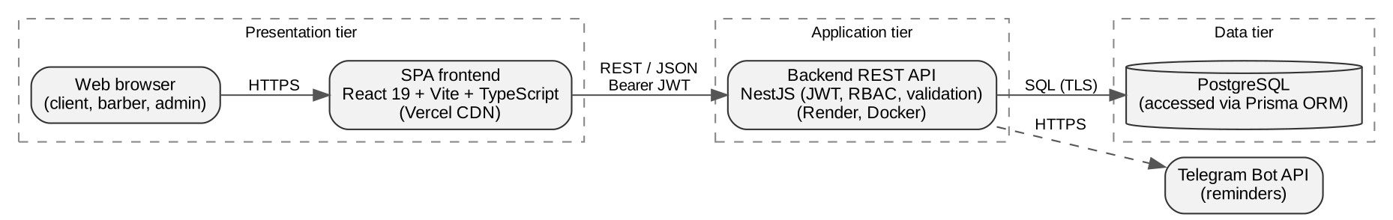
Figure 1 - System architecture of BarberTime

3. Functional Requirements
Following the instructor's structure, the functional requirements are divided into three groups: basic functionality, main functions and additional (optional) functionality.
Table 5 - Functional requirements
ID | Requirement | Actor | Group
FR-01 | Sign up and sign in by phone number. | Client, Barber, Admin | Basic
FR-02 | Browse the list of services with price and duration, filter by category. | Client | Basic
FR-03 | Browse barbers and open a barber profile (bio, rating, specialties). | Client | Basic
FR-04 | View the home page and barbershop contacts (address, hours, phone). | Client | Basic
FR-05 | Book an appointment in three steps: service, barber (or "any available"), date and time. | Client | Main
FR-06 | Calculate free slots from the barber's working schedule, service duration and existing appointments. | System | Main
FR-07 | Re-check slot availability on the server at confirmation and reject conflicting bookings. | System | Main
FR-08 | View own upcoming and past bookings; cancel or reschedule with confirmation. | Client | Main
FR-09 | View own daily and weekly schedule. | Barber | Main
FR-10 | Manage services, barbers, working hours and all appointments. | Admin | Main
FR-11 | Send a Telegram reminder two hours before the appointment. | System | Additional
FR-12 | Leave a review and rating after a completed visit. | Client | Additional
FR-13 | Online prepayment for a booking. | Client | Additional
FR-14 | Loyalty programme (e.g., discount on every sixth visit). | Client | Additional
Table 6 - Non-functional requirements
Category | Requirement
Performance | Free-slot response time under 500 ms for one barber and one day; first page load under 2 s on a 4G connection.
Reliability | Booking creation is transactional; the database guarantees uniqueness of (barber_id, start_at).
Security | HTTPS only; JWT with expiry; role-based authorisation on every protected endpoint; input validation on the server.
Usability | Responsive layout from 360 px; bottom tab bar on mobile; minimum touch target 44 px; destructive actions require confirmation.
Accessibility | Text contrast at least 4.5:1; keyboard navigation and visible focus; colour is never the only carrier of meaning.
Maintainability | TypeScript across the stack; modular structure; automated checks in CI.

4. API Design
Table 7 - Key REST endpoints
Method | Path | Description | Access
POST | /auth/login | Sign in by phone; returns JWT. | Public
GET | /services | List services (optional ?category=). | Public
GET | /barbers | List barbers. | Public
GET | /barbers/:id | Barber profile with services and reviews. | Public
GET | /barbers/:id/slots?date=&serviceId= | Free slots for a barber, date and service duration. | Public
POST | /appointments | Create a booking (transactional slot check). | Client
GET | /appointments/me | Current user's bookings. | Client
PATCH | /appointments/:id/cancel | Cancel a booking. | Client, Admin
PATCH | /appointments/:id/reschedule | Move a booking to a new free slot. | Client, Admin
GET | /barbers/me/schedule?from=&to= | Barber's own appointments for a period. | Barber
POST / PATCH / DELETE | /admin/services, /admin/barbers, /admin/working-hours | Management of catalogue and working hours. | Admin

2.3 UML Diagrams
Use case diagram. The system has three actors. The client browses services and barbers, books appointments (the use case "Book an appointment" always includes "Select a free slot"; the optional "Send reminder" use case extends booking and is performed through the external Telegram Bot API), views, cancels or reschedules bookings and leaves reviews. The barber views his own schedule, and the administrator manages the catalogue and all appointments.
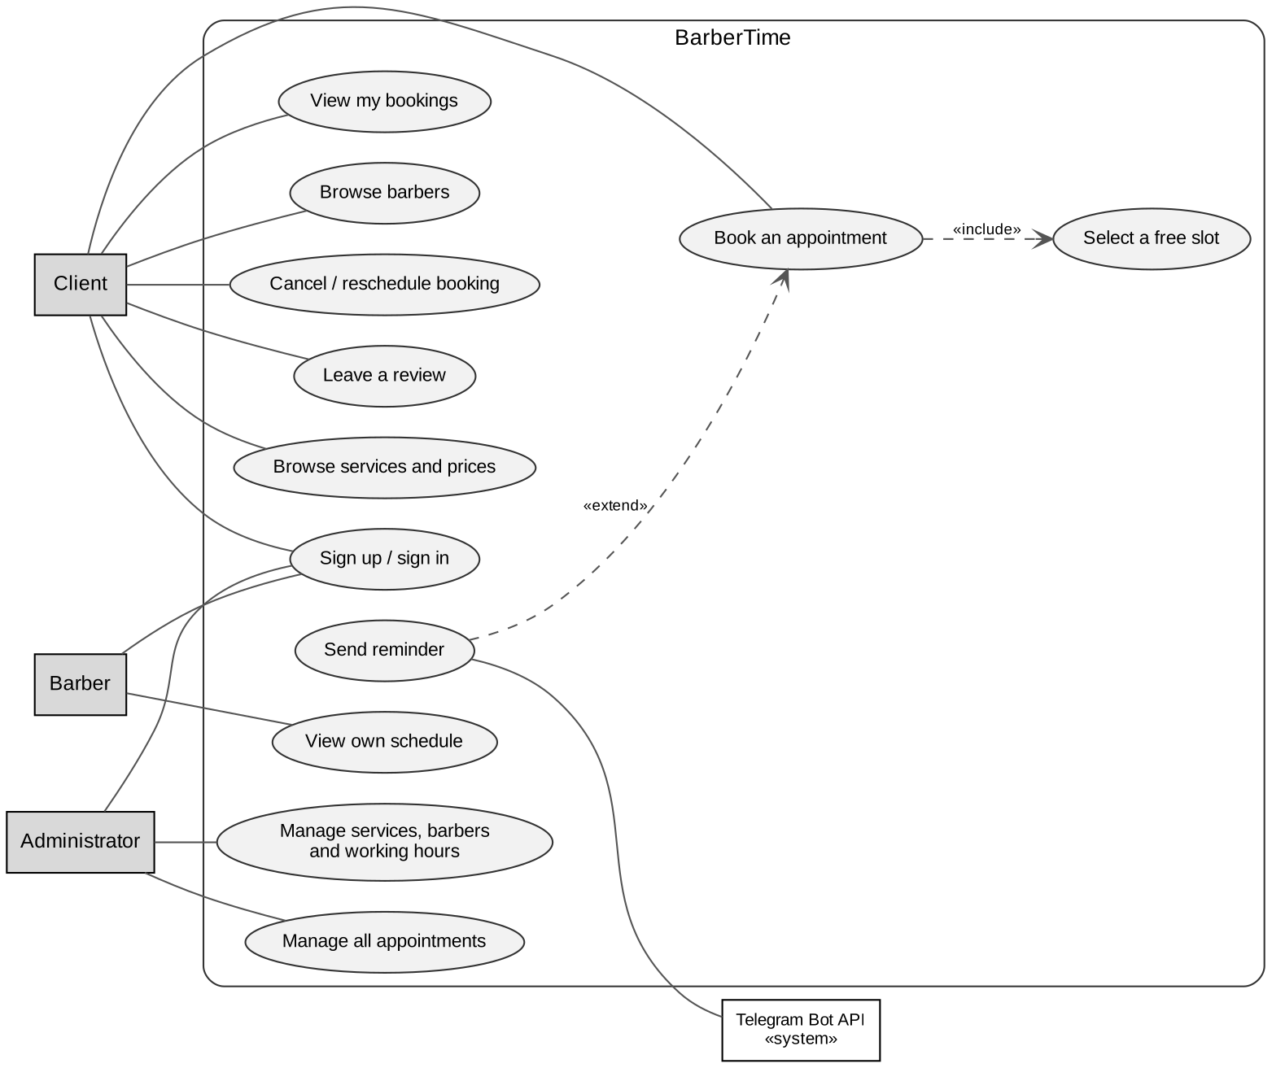
Figure 2 - Use case diagram
Class diagram. The domain model consists of six classes and two enumerations. A User has one Role; a User with the BARBER role has exactly one Barber profile. An Appointment links a client, a barber and a service for an interval [startAt, endAt) and has an AppointmentStatus (BOOKED, COMPLETED, CANCELLED, NO_SHOW). A Barber is composed of weekly WorkingHours entries that, together with existing appointments and service duration, determine free slots. A completed Appointment can have at most one Review.
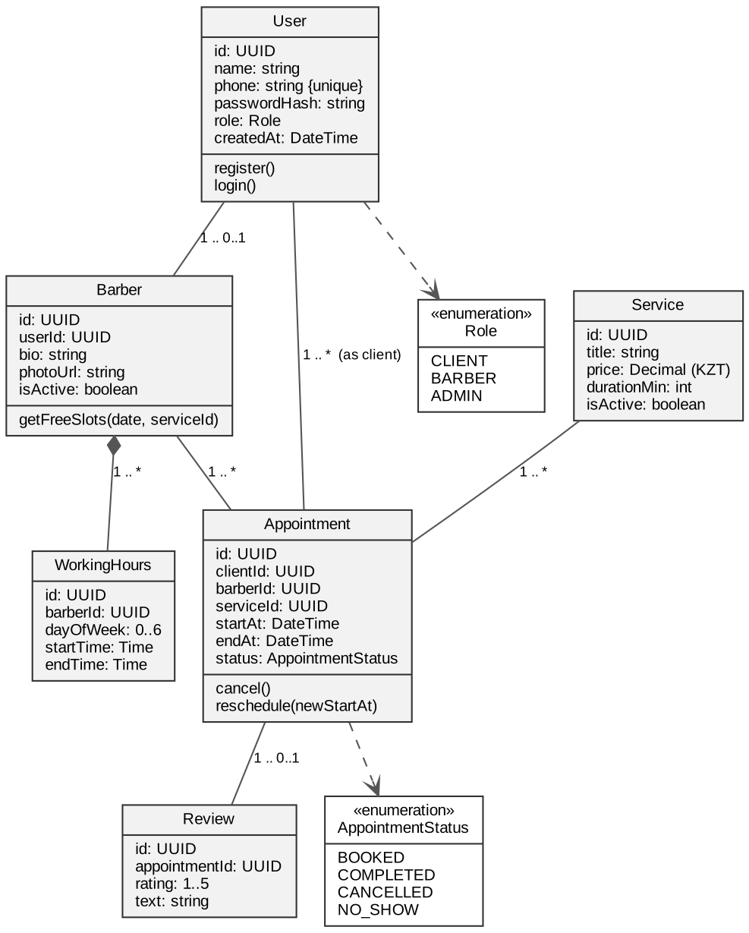
Figure 3 - Class diagram
Activity diagram. The main scenario "Book an appointment" is shown below. Authentication is requested only at confirmation, which keeps the first steps frictionless. Before the appointment is created the server re-checks that the slot is still free; if another client took it in the meantime, the user is returned to slot selection instead of receiving an error.
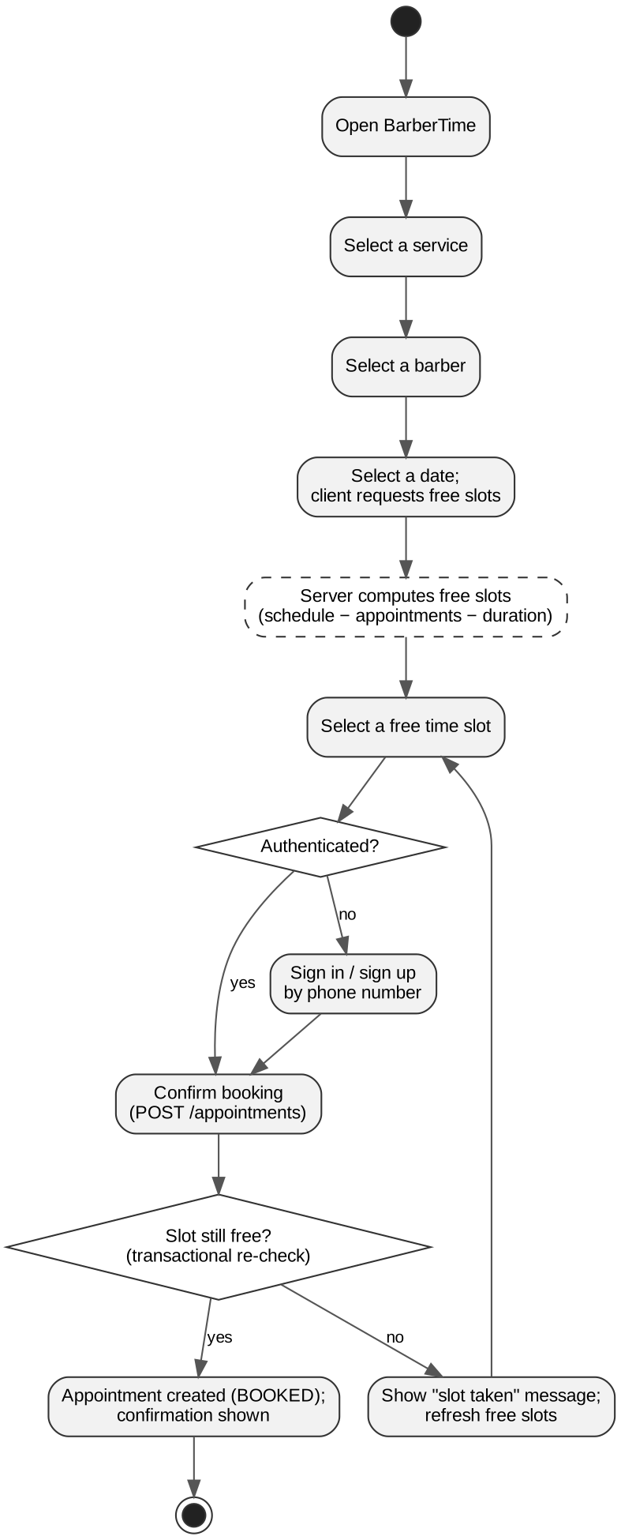
Figure 4 - Activity diagram "Book an appointment"
Database schema. The physical model maps the classes to PostgreSQL tables. The composite unique constraint on appointments (barber_id, start_at) is the final protection against double booking even under concurrent requests.
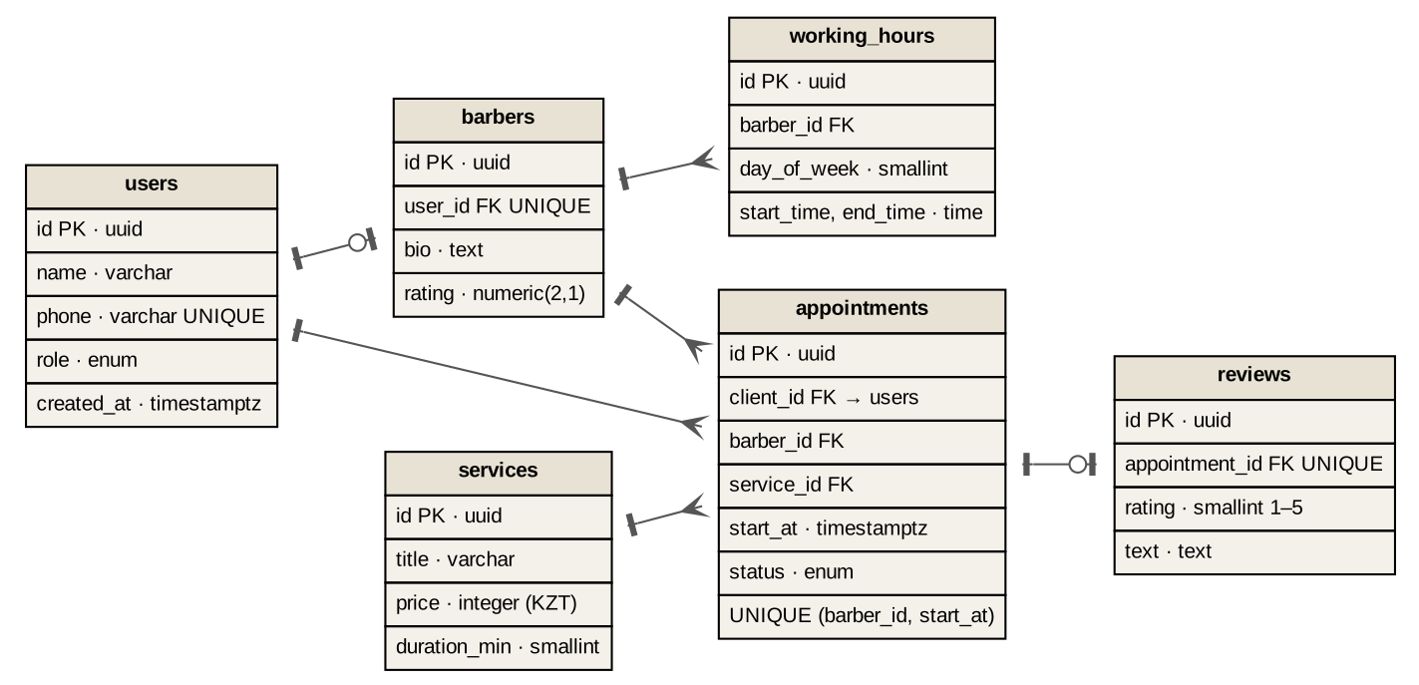
Figure 5 - Database schema (ER diagram)

2.4 GitHub Repository
Repository: https://github.com/diasqazaqbro/barbertime (public, main branch).
Contents: the repository contains the frontend single-page application developed in Laboratory Work 4 (React 19, Vite, TypeScript, React Router 7) and the laboratory reports in the docs/ folder.
Architecture of the source code: the frontend follows Feature-Sliced Design, which separates code into layers with a strict top-down dependency rule:
- src/app — application entry point, routing and global styles;
- src/pages — route-level screens (Home, Services, Barbers, Booking, My bookings, Contacts);
- src/widgets — large composite blocks such as the navigation bar, footer and booking flow;
- src/features — user actions such as selecting a time slot or cancelling a booking;
- src/entities — domain entities: service, barber, appointment;
- src/shared — reusable UI components, helpers and mock data.
Run locally: npm install, then npm run dev to start the development server, or npm run build to create a production build. The README.md file describes features, routes, the technology stack and setup instructions.

References
Apple Inc. (2026). Human Interface Guidelines. https://developer.apple.com/design/human-interface-guidelines
Meta Open Source. (2026). React documentation. https://react.dev
NestJS. (2026). NestJS documentation. https://docs.nestjs.com
Object Management Group. (2017). OMG Unified Modeling Language (UML), Version 2.5.1. https://www.omg.org/spec/UML/2.5.1
PostgreSQL Global Development Group. (2026). PostgreSQL documentation. https://www.postgresql.org/docs
Prisma. (2026). Prisma ORM documentation. https://www.prisma.io/docs
Vite. (2026). Vite documentation. https://vite.dev

