Practical Assignment Report
Working with Docker Images, Volumes and Containers
Student: Dias Zhumabekov Group: ________ Date: 10.10.2026

1. Objective
To gain practical experience with Docker images, containers, volumes and networks: running containers with a real workload, publishing ports, inter-container networking and isolation, and using tmpfs and shared volumes.

2. Environment and Workload
The work was done on macOS (Docker Engine 29.7). The infrastructure of my pet project postroika (Spring Boot) was used as the base: PostgreSQL and Redis, defined in docker-compose.yml. These are real services used by the application, so the containers are not empty.
Container | Image | Workload | Port host → container
postroika-postgres | postgres:16 | postroika_db database: project tables + lab_orders (100 orders) | 5433 → 5432
postroika-redis | redis:7.4 | Cache: 50 sessions with TTL, page_views counter, AOF | 6379 → 6379

The original docker-compose.yml was not modified. Everything related to this assignment lives in docker-compose.lab.yml (a compose override): tmpfs, the shared volume, writing logs to the shared volume, and port 5433 (port 5432 on the host is taken by a locally installed PostgreSQL).
services:
postgres:
ports: !override
- "5433:5432"
command: postgres -c logging_collector=on -c log_directory=/shared/logs/postgres
-c log_filename=postgresql.log -c log_statement=all -c log_connections=on
volumes:
- shared:/shared
redis:
command: redis-server --appendonly yes --logfile /shared/logs/redis/redis.log
tmpfs:
- /cache:size=64m,mode=1777
volumes:
- shared:/shared
volumes:
shared:
external: true
name: postroika_shared

3. Procedure

3.1. Running containers and publishing ports (tasks 1–3)
docker volume create postroika_shared
docker compose -f docker-compose.yml -f docker-compose.lab.yml up -d
bash lab/scripts/seed.sh # fill the database and cache with test data
Both containers are running and their ports are published to the host. Port reachability was checked from the host with nc.
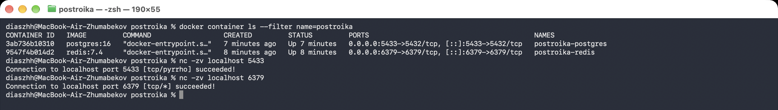
Figure 1 – running containers and published port check

3.2. Container-to-container networking (tasks 4–5)
Docker Compose creates a user-defined bridge network postroika_default with built-in DNS, so containers can reach each other by name. The images do not include ping, so it was installed with apt-get install iputils-ping while the containers still had internet access.
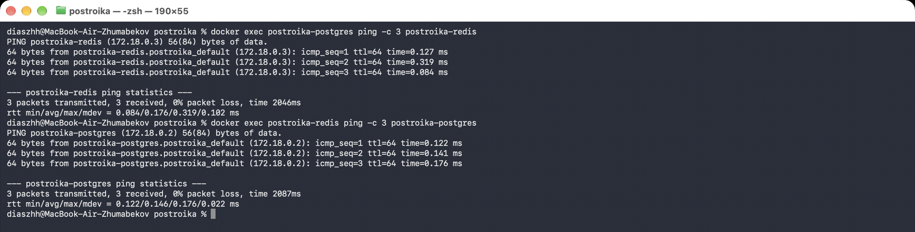
Figure 2 – containers ping each other by name on postroika_default

3.3. Isolated network (tasks 6–8)
A network was created with the --internal flag. Such a bridge network has no route to the outside (no gateway and no NAT), so containers can only see each other. The network was attached to both containers with docker network connect, and the old network was detached with docker network disconnect, without recreating the containers.
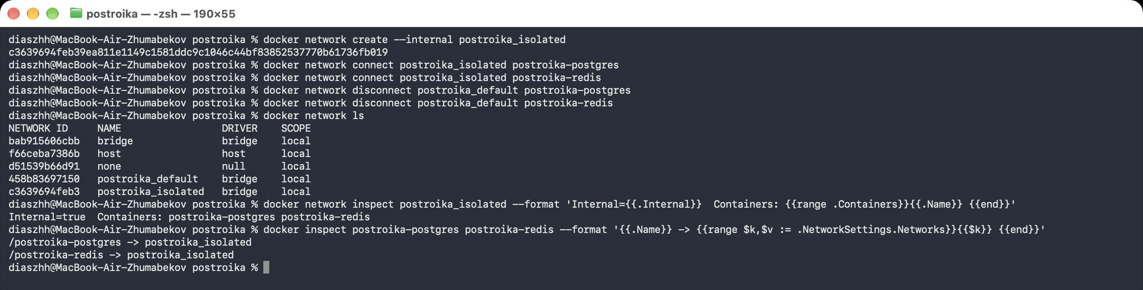
Figure 3 – creating the internal network and attaching it to the containers
Verification: apt-get update cannot resolve the repository hostnames, and ping 8.8.8.8 returns "Network is unreachable". Communication between the containers inside the isolated network still works.
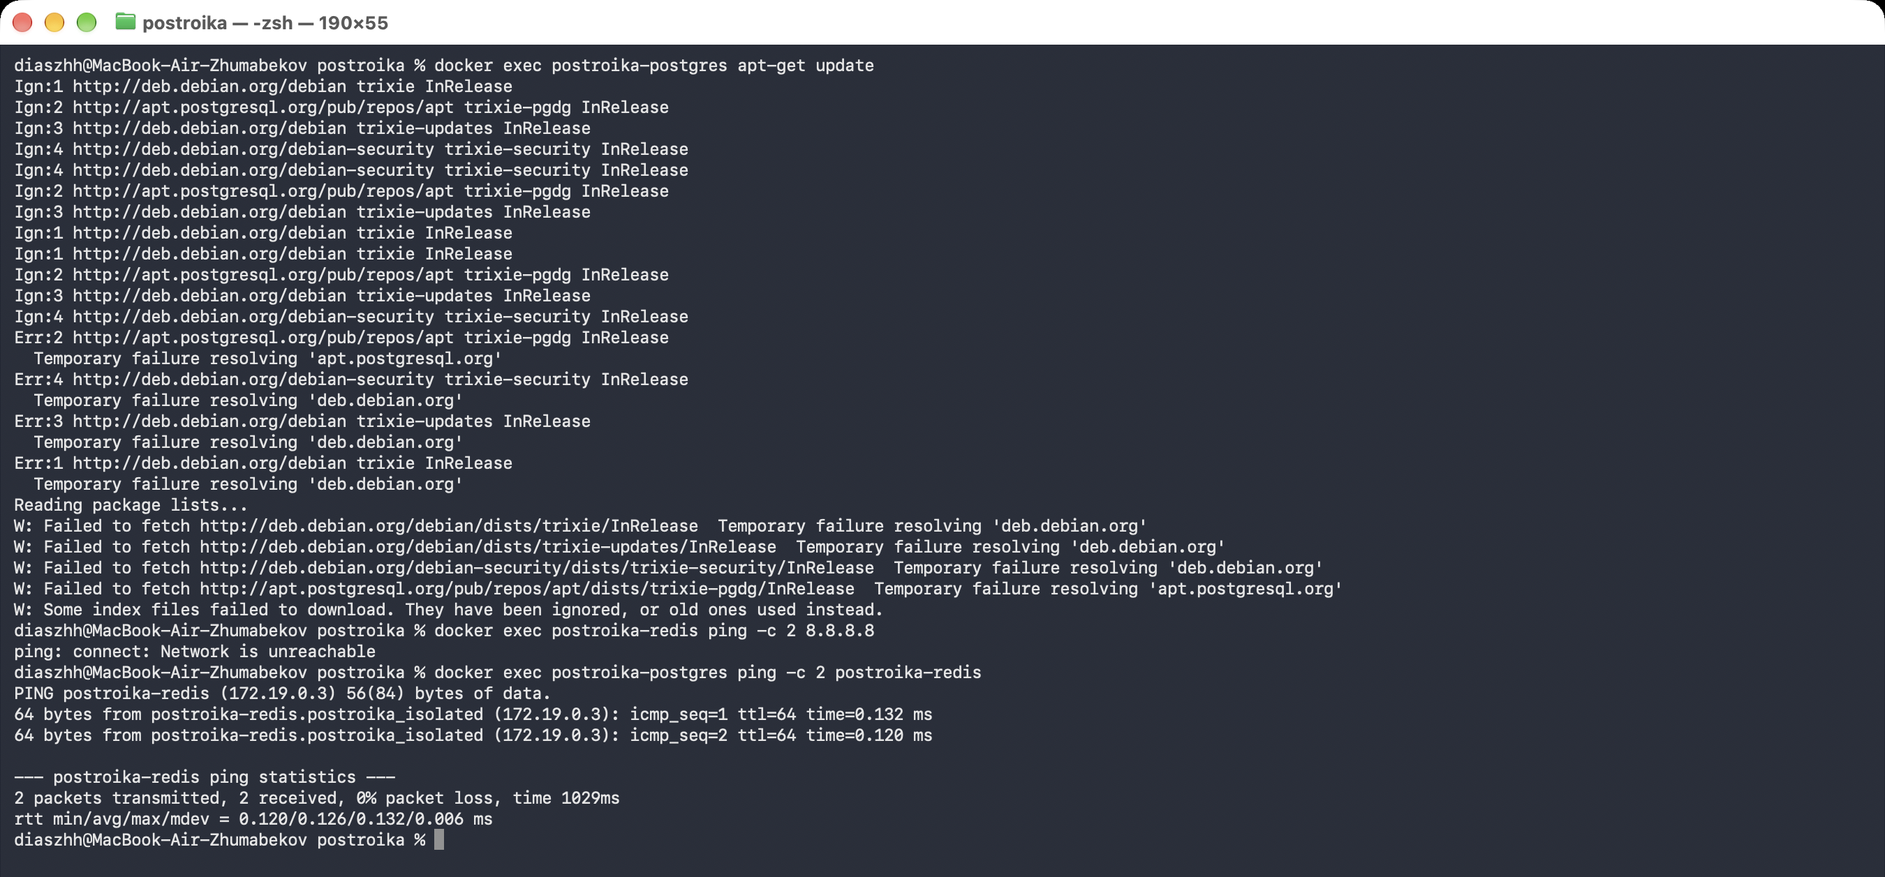
Figure 4 – no external network access from inside the containers

3.4. tmpfs volume (tasks 9–10)
A 64 MB tmpfs is mounted at /cache in postroika-redis. tmpfs data lives only in RAM and disappears when the container stops. The redis-report.sh script builds a draft report in /cache (temporary data) and appends the finished report to the shared volume.
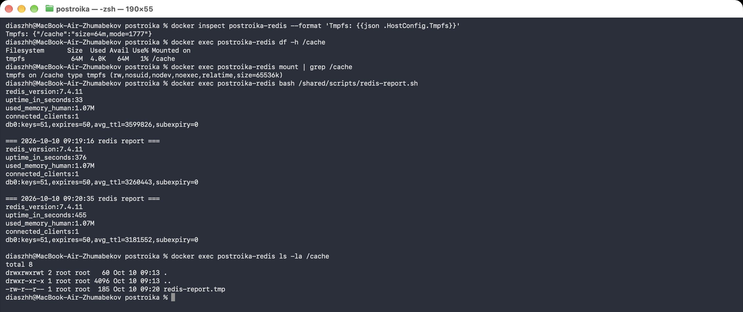
Figure 5 – tmpfs at /cache: settings, df, mount and a temporary file created in it

3.5. Shared volume for two containers (tasks 11–13)
The postroika_shared volume is mounted at /shared in both containers. It holds useful data:
- /shared/logs/postgres/postgresql.log: PostgreSQL log (connections and all SQL statements);
- /shared/logs/redis/redis.log: Redis log;
- /shared/metrics/*.log: service health reports produced by custom scripts;
- /shared/scripts/*.sh: the bash scripts themselves (seed.sh, pg-report.sh, redis-report.sh).
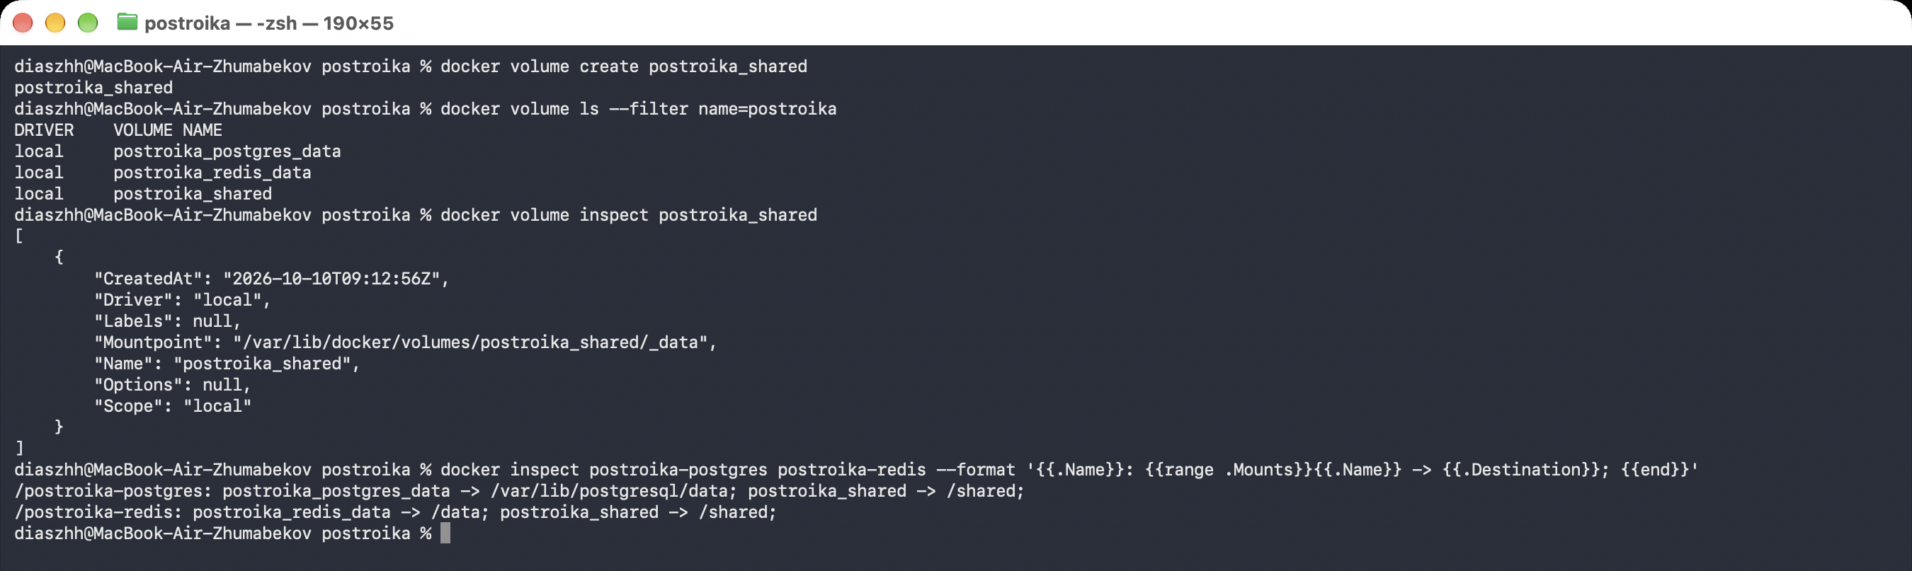
Figure 6 – the postroika_shared volume attached to both containers
Data written by one container is visible in the other: for example, the postgres log is read from the redis container, and the redis log from the postgres container.
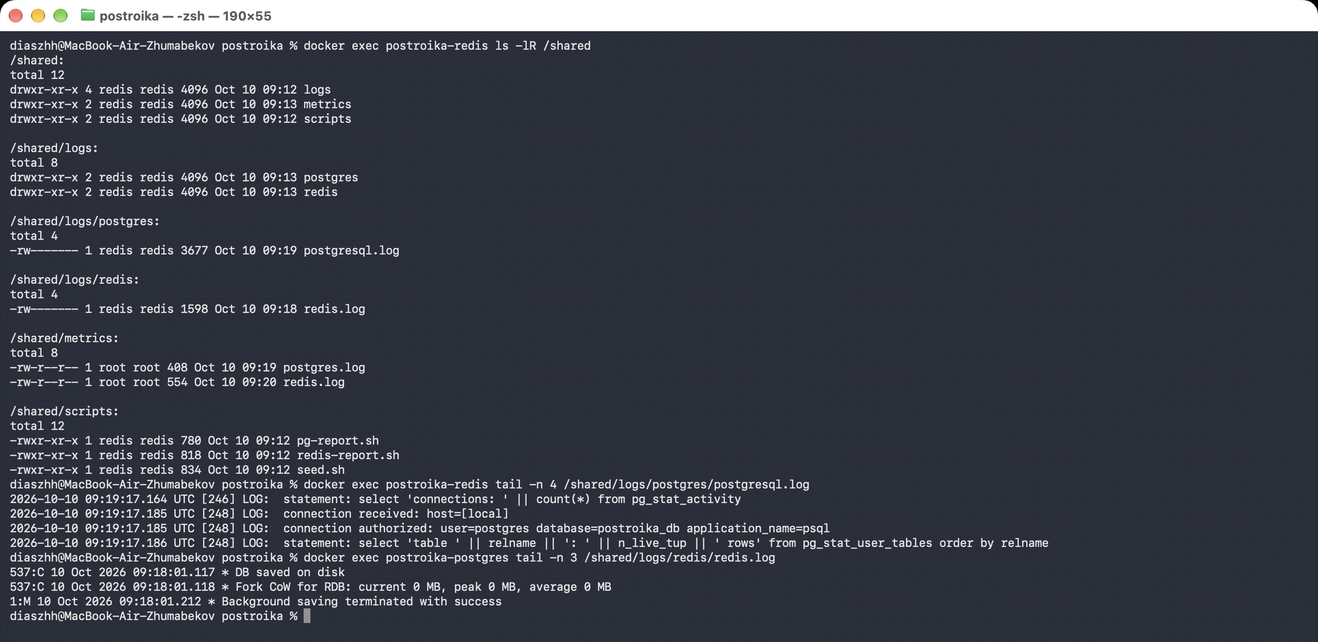
Figure 7 – contents of the shared volume and cross-container log reading
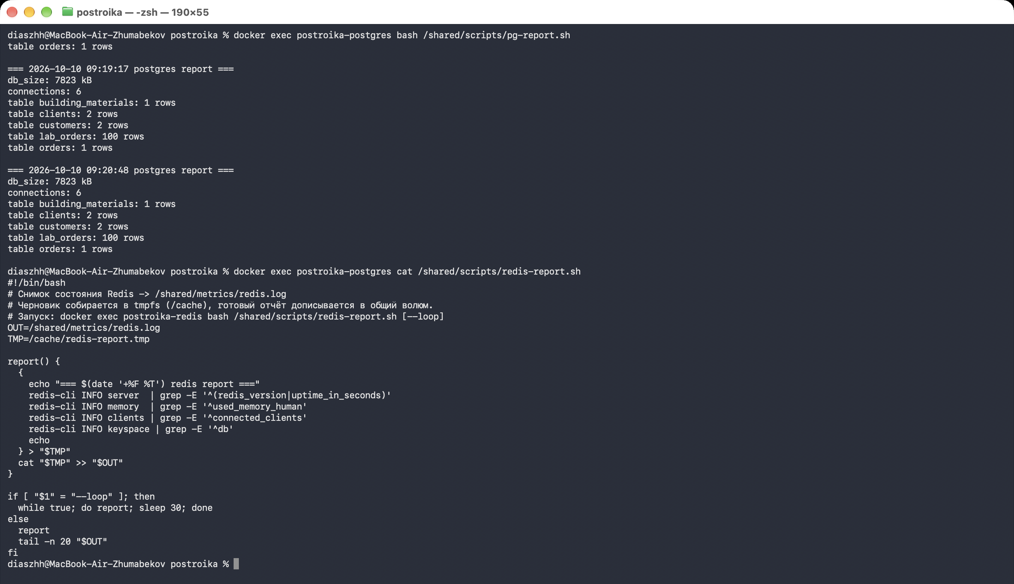
Figure 8 – the custom pg-report.sh script writing metrics to the shared volume

4. Custom Scripts
Script | Runs in | What it does
seed.sh | host | Creates the lab_orders table (100 rows), puts 50 sessions with TTL and a counter into Redis
pg-report.sh | postroika-postgres | DB size, connection count, rows per table → /shared/metrics/postgres.log
redis-report.sh | postroika-redis | Version, uptime, memory, clients, keys; draft in tmpfs → /shared/metrics/redis.log

Both report scripts support a --loop mode (a snapshot every 30 seconds) for continuous monitoring.

5. Possible Questions
What is the difference between a volume, a bind mount and tmpfs?
A volume is managed by Docker, stored in /var/lib/docker/volumes, and survives container removal. A bind mount is a host directory mounted into the container. tmpfs lives only in RAM, is never written to disk, and disappears when the container stops.
Why --internal instead of --network none?
none is a built-in network with no interfaces: the container is completely alone and cannot see even its neighbours. An internal network cuts off outside access but keeps container-to-container communication, so the services can still work with each other.
Why did the containers have to be recreated for tmpfs and the shared volume?
Mounts are defined only when a container is created; unlike networks, they cannot be attached to a running container. No database data was lost, because it lives in named volumes.
Why can containers ping each other by name?
User-defined bridge networks have Docker's embedded DNS server (127.0.0.11), which resolves container names. The default bridge network does not have it.
Why is postgres on port 5433?
Port 5432 on the host is taken by a local PostgreSQL. The 5433:5432 mapping publishes the container on a free host port.

6. Conclusion
Two containers with a real workload (PostgreSQL and Redis) were started, their ports were published to the host, and container-to-container networking was verified. An internal network was created; after attaching it, the containers lost external network access while still being able to reach each other. A tmpfs volume was attached to Redis, and a shared volume was created for both containers, where service logs and the output of custom bash scripts are stored. All objectives of the assignment were achieved.

