# TUGAS TEORI

**KONSEP JARINGAN**



Disusun oleh:

# Muhammad zaid

# 2110191013

**PROGRAM STUDI D-IV TEKNIK INFORMATIKA POLITEKNIK ELEKTRONIKA NEGERI SURABAYA**

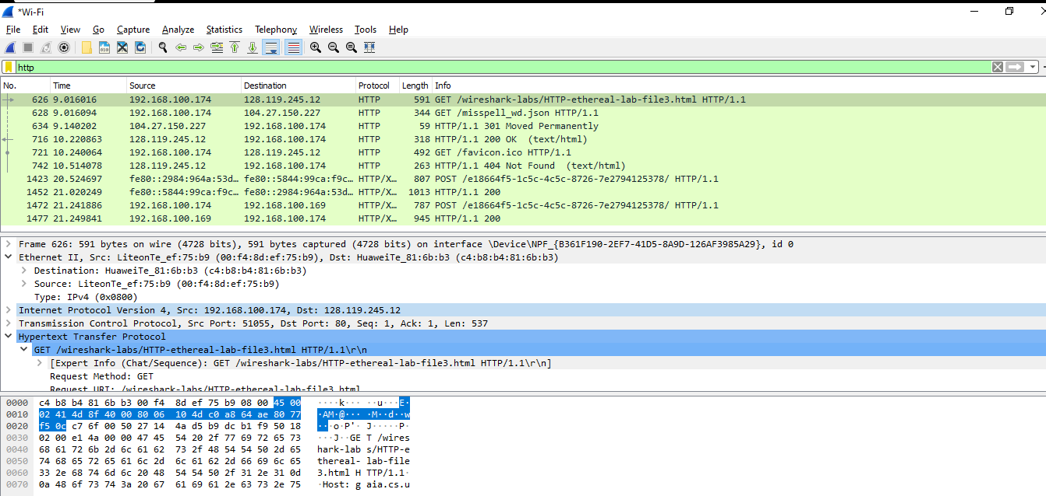

Answer the following questions, based on the contents of the Ethernet frame containing the HTTP GET message. Whenever possible, when answering a question you should hand in a printout of the packet(s) within the trace that you used to answer the question asked. Annotate the printout3 to explain your answer. To print a packet, use File->Print, choose Selected packet only, choose Packet summary line, and select the minimum amount of packet detail that you need to answer the question.

1. What is the 48-bit Ethernet address of your computer ? Answer :

Ethernet Address laptop saya adalah "00;f4:8d:ef:75:b9".

1. = What is the 48-bit destination address in the Ethernet frame? Is this the Ethernet address of gaia.cs.umass.edu? (Hint: the answer is no). What device has this as its Ethernet address? [Note: this is an important question, and one that students sometimes get wrong. Re-read pages 468-469 in the text and make sure you understand the answer here.]

Answer :

Destination address pada Ethernet frame adalah "00;f4:8d:ef:75:b9". Ini bukan Ethernet address dari gaia.cs.umass.edu, tetapi merupakan Ethernet address router yang terkoneksi dengan laptop saya.

1. Give the hexadecimal value for the two-byte Frame type field. What upper layer protocol does this correspond to?

Answer :

Frame type nya adalah "0x0800". Hal ini mengarah ke IP protocol.

1. How many bytes from the very start of the Ethernet frame does the ASCII "G" in "GET" appear in the Ethernet frame?

Answer :

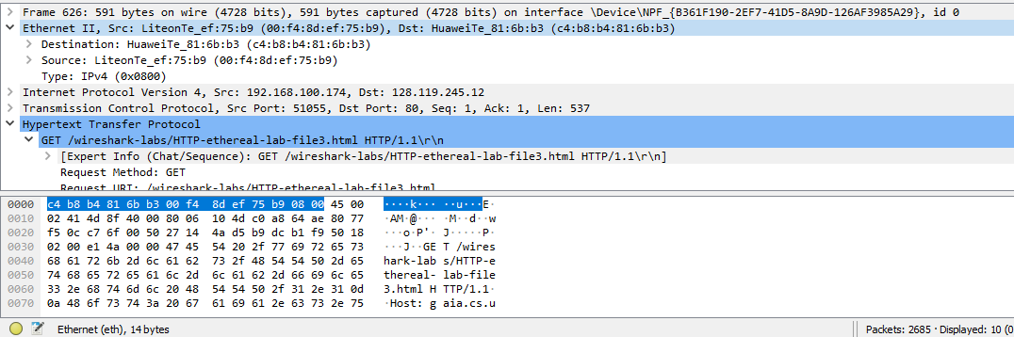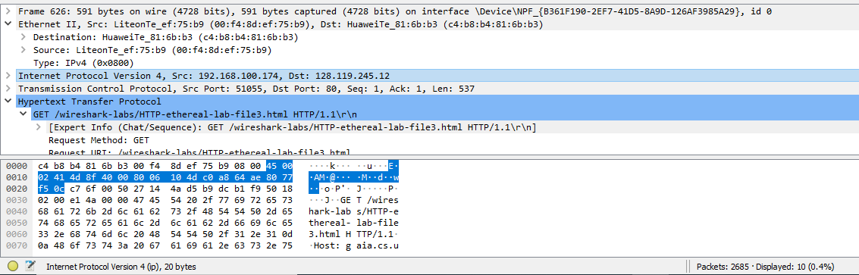

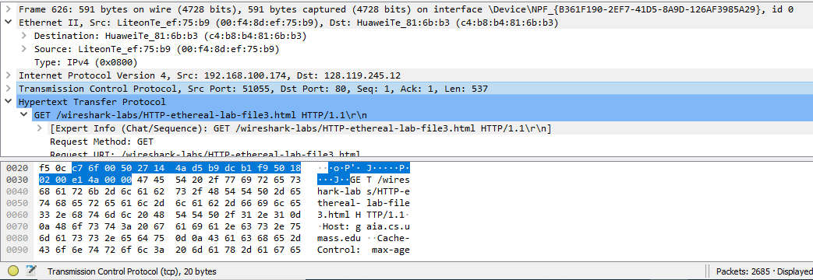

Ethernet (eth), 14 bytes + Internet Protocol Version 4 (ip), 20 bytes + Transmission Control Protocol (tcp), 20 bytes. Total semuanya terdapat 54 bytes sebelum ASCII "G".

Next, answer the following questions, based on the contents of the Ethernet frame containing the first byte of the HTTP response message

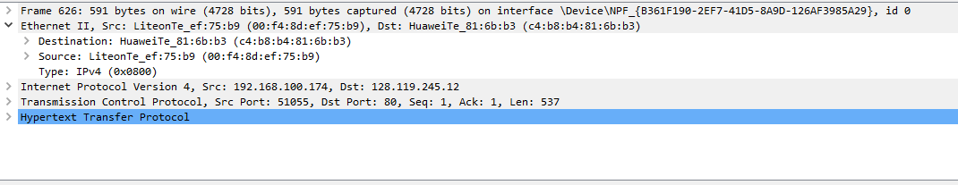

1. What is the value of the Ethernet source address? Is this the address of your computer, or of gaia.cs.umass.edu (Hint: the answer is no). What device has this as its Ethernet address?

Answer :

Nilai dari Ethernet source addressnya adalah " c4:b8:b4:81:6b:b3". Address tersebut bukan milik komputer saya dan bukan milik gaia.cs.umass.edu, melainkan milik router yang terkoneksi dengan laptop saya.

1. What is the destination address in the Ethernet frame? Is this the Ethernet address of your computer? Answer :

Nilai dari Ethernet destination address adalah "c4:b8:b4:81:6b:b3". Itu adalah MAC address dari laptop saya.

1. 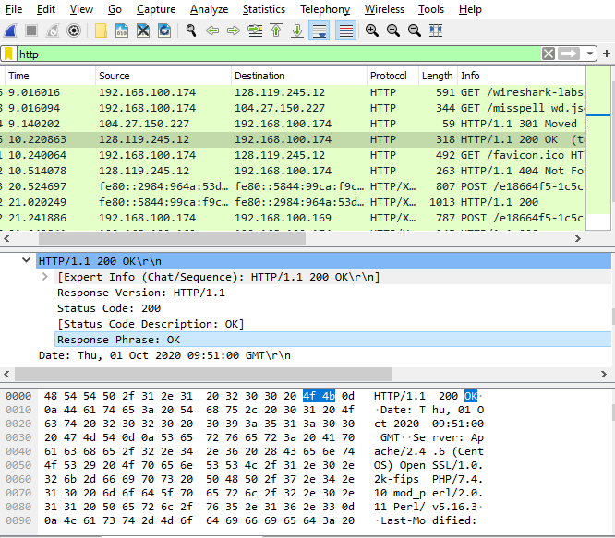Give the hexadecimal value for the two-byte Frame type field. What upper layer protocol does this correspond to?

Answer :

Frame type nya adalah "0x0800". Hal ini mengarah ke IP protocol.

1. How many bytes from the very start of the Ethernet frame does the ASCII “O” in “OK” (i.e., the HTTP response code) appear in the Ethernet frame?

HTTP-Version, 8bytes + Text item, 1 bytes + HTTP Response Status Code, 3 bytes + Text item, 1 bytes. Totalnya ada 81 bytes.

9. Write down the contents of your computer’s ARP cache. What is the meaning of each column value?

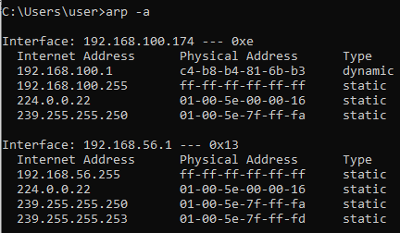

Jawab :

Kolom pertama menunjukkan IP address, kolom kedua menunjukkan physical address.

1. What are the hexadecimal values for the source and destination addresses in the Ethernet frame containing the ARP request message?

Jawab :

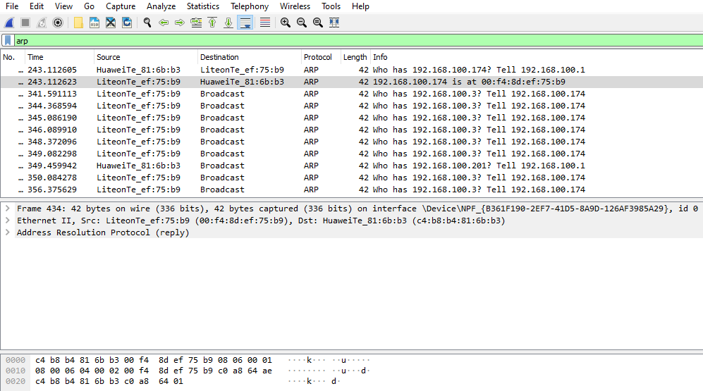

Source addressnya "00:f4:8d:ef:75:b9​" itu merupakan physical address laptop saya dan destination addressnya "​ff:ff:ff:ff:ff:ff​" itu merupakan broadcast.

1. Give the hexadecimal value for the two-byte Ethernet Frame type field. What upper layer protocol does this correspond to?

Jawab :

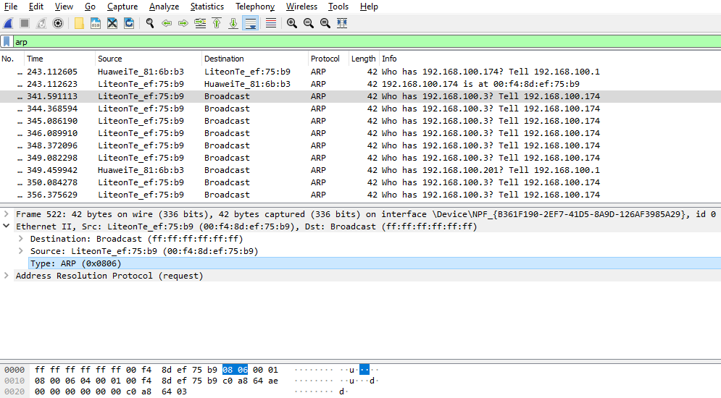

Nilai untuk 2 byte tipenya adalah "​0x0806​" dengan nama ARP.

1. Download the ARP specification from [​ftp://ftp.rfc-editor.org/in-notes/std/std37.txt](ftp://ftp.rfc-editor.org/in-notes/std/std37.txt)​.A readable, detailed discussion of ARP is also at <http://www.erg.abdn.ac.uk/users/gorry/course/inet-pages/arp.html>​.

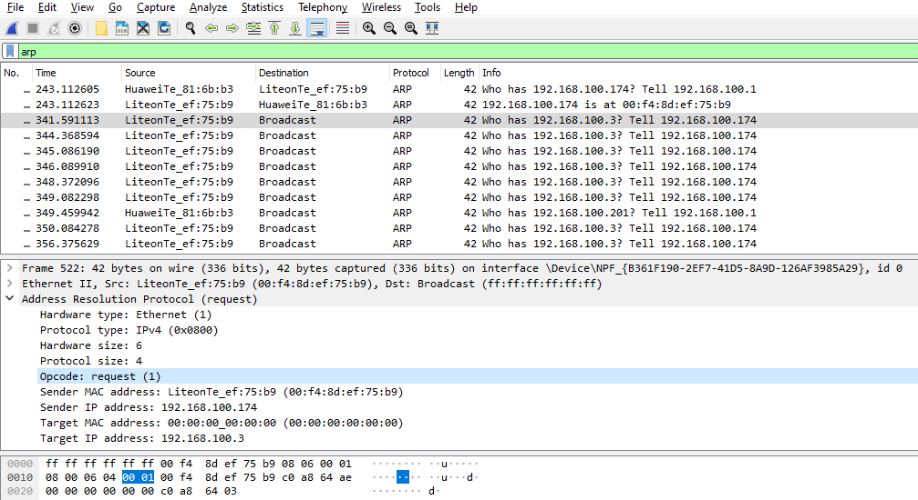

1. How many bytes from the very beginning of the Ethernet frame does the ARP ​*opcode​*field begin?

Jawab :

Ethernet (eth) 14 bytes + Hardware type (arp.hw.type) 2 bytes + Protocol type (arp.proto.type) 2 bytes + Hardware size (arp.hw.size) 1 byte + Protocol size (arp.proto.size) 1 byte. Total semuanya 20 bytes.

1. What is the value of the ​*opcode​*field within the ARP-payload prt of the Ethernet frame in which an ARP request is made?

Jawab :

Nilai opcode dalam ARP-payload adalah "00 01".

Does the ARP message contain the IP address of the sender? Jawab :

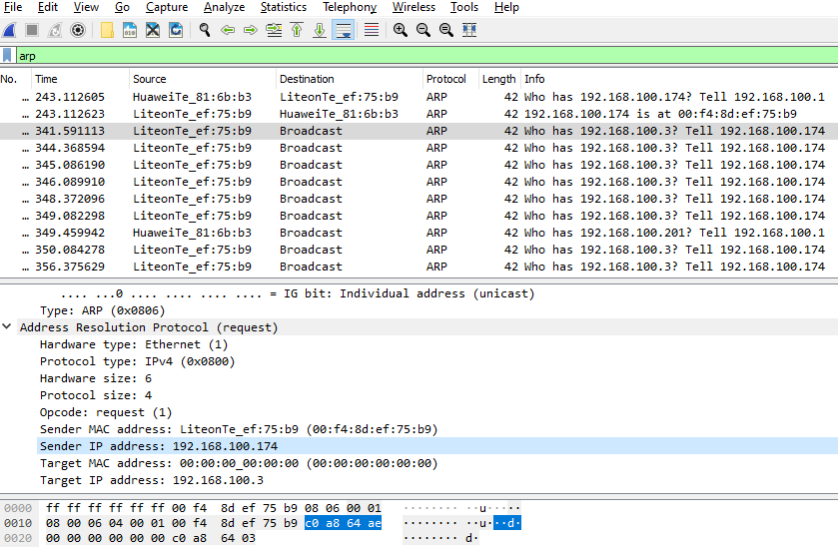

Iya, ARP message mengandung IP address pengirim yaitu "192.168.1.174".

1. Where in the ARP request does the "question" appear – the Ethernet address of the machine whose corresponding IP address is being queried?

Jawab :

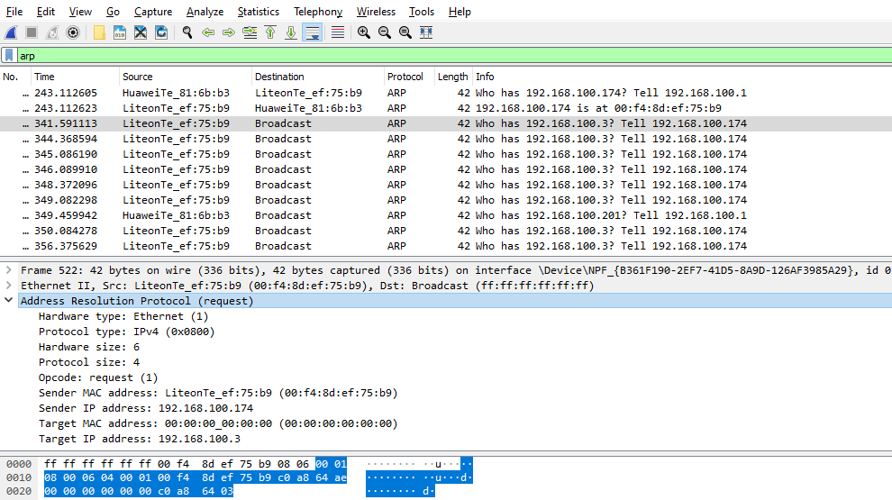

Terletak pada ​*Target IP address​*.

13. Now find the ARP reply that was sent in response to the ARP request.

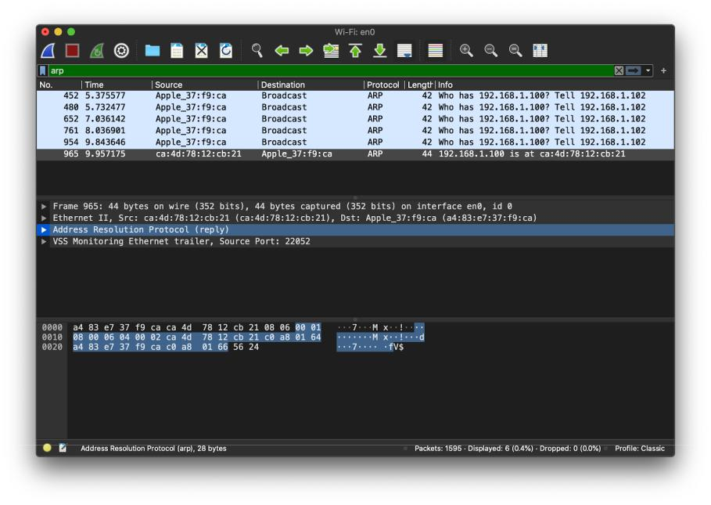

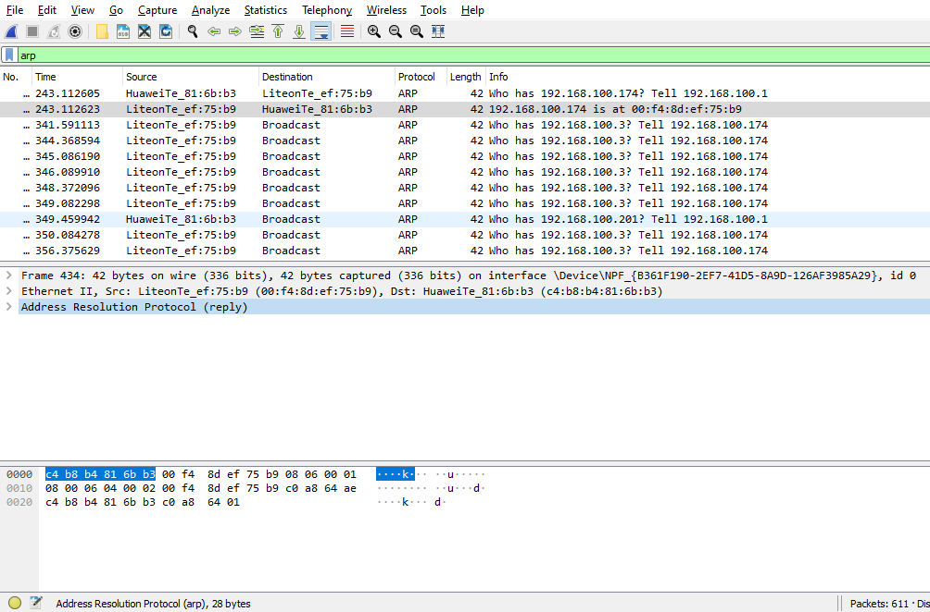

* 1. How many bytes from the very beginning of the Ethernet frame does the ARP ​*opcode​*field begin?

Jawab :

Terdapat 28 bytes dari awal Ethernet frame sebelum opcode ARP dimulai.

* 1. What is the value of the ​*opcode​*field within the ARP-payload part of the Ethernet frame in which an ARP response is made?

Jawab :

Nilai opcode dari ARP yang menandakan bahwa itu adalah ARP reply adalah "00 02".

* 1. Where in the ARP message does the "answer" to the earlier ARP request appear – the IP address of the machine having the Ethernet address whose corresponding IP address is being queried?

Jawab :

Terletak pada ​*Sender MAC address​*.

1. What are the hexadecimal values for the source and destination addresses in the Ethernet frame containing the ARP reply message?

Jawab :

Alamat source "00:f4:8d:ef:75:b9" dan alamat destination " c4:b8:b4:81:6b:b3​"

1. Open the ​*ethernet-ethereal-trace-1​*trace file in <http://gaia.cs.umass.edu/wireshark-labs/wireshark-traces.zip>​.The first and second ARP packets in this trace correspond to an ARP request sent by the computer running Wireshark, and the ARP reply sent to the computer running Wireshark by the computer with the ARP-requested Ethernet address. But there is yet another computer on this network, as indicated by packet 6 – another ARP request. Why is there no ARP reply (sent in response to the ARP request in packet 6) in the packet trace? Jawab :

Karena pada perangkat lainnya yang mendapat broadcast merasa itu bukan address mereka sehingga tidak ada reply sama sekali, kecuali perangkat yang bersangkutan akan me-reply ARP requestnya.