CODEBOOK v1 [o] v2 [o] v3 [o] v4 [o] v5 [o]
/VARINFO POSITION LABEL TYPE FORMAT MEASURE ROLE VALUELABELS MISSING ATTRIBUTES RESERVEDATTRIBUTES
/FILEINFO NAME LOCATION CASECOUNT LABEL DOCUMENTS WEIGHT ATTRIBUTES RESERVEDATTRIBUTES
/OPTIONS VARORDER=VARLIST SORT=ASCENDING
/STATISTICS COUNT PERCENT MEAN STDDEV QUARTILES.

Codebook

Notes
Output Created |  | 04-OCT-2013 19:27:49
Comments
Input | Data | C:\Documents and Settings\Administrador\Escritorio\data-files\created-with-spss\pspp-examples\HOTEL_SAV_7.sav
Input | Active Dataset | DataSet1
Input | Filter | <none>
Input | Weight | <none>
Input | Split File | <none>
Input | N of Rows in Working Data File | 17
Syntax |  | CODEBOOK v1 [o] v2 [o] v3 [o] v4 [o] v5 [o]  /VARINFO POSITION LABEL TYPE FORMAT MEASURE ROLE VALUELABELS MISSING ATTRIBUTES RESERVEDATTRIBUTES  /FILEINFO NAME LOCATION CASECOUNT LABEL DOCUMENTS WEIGHT ATTRIBUTES RESERVEDATTRIBUTES  /OPTIONS VARORDER=VARLIST SORT=ASCENDING  /STATISTICS COUNT PERCENT MEAN STDDEV QUARTILES.
Resources | Processor Time | 00:00:00,05
Resources | Elapsed Time | 00:00:00,11

[DataSet1] C:\Documents and Settings\Administrador\Escritorio\data-files\created-with-spss\pspp-examples\HOTEL_SAV_7.sav

File Information
File Name |  | HOTEL_SAV_7.sav
Location |  | C:\Documents and Settings\Administrador\Escritorio\data-files\created-with-spss\pspp-examples
Label
Weight Variable |  | <none>
Number of Cases | Unweighted | 17
Number of Cases | Weighted | 17

v1
 |  | Value | Count | Percent
Standard Attributes | Position | 1
Standard Attributes | Label | I am satisfied with the level of service
Standard Attributes | Type | Numeric
Standard Attributes | Format | F8
Standard Attributes | Measurement | Ordinal
Standard Attributes | Role | Input
Valid Values | 1 | Strongly Disagree | 5 | 29,4%
Valid Values | 2 | Disagree | 4 | 23,5%
Valid Values | 3 | No Opinion | 3 | 17,6%
Valid Values | 4 | Agree | 3 | 17,6%
Valid Values | 5 | Strongly Agree | 2 | 11,8%

v2
 |  | Value | Count | Percent
Standard Attributes | Position | 2
Standard Attributes | Label | The value for money was good
Standard Attributes | Type | Numeric
Standard Attributes | Format | F8
Standard Attributes | Measurement | Ordinal
Standard Attributes | Role | Input
Valid Values | 1 | Strongly Disagree | 5 | 29,4%
Valid Values | 2 | Disagree | 7 | 41,2%
Valid Values | 3 | No Opinion | 2 | 11,8%
Valid Values | 4 | Agree | 1 | 5,9%
Valid Values | 5 | Strongly Agree | 2 | 11,8%

v3
 |  | Value | Count | Percent
Standard Attributes | Position | 3
Standard Attributes | Label | The staff were slow in responding
Standard Attributes | Type | Numeric
Standard Attributes | Format | F8
Standard Attributes | Measurement | Ordinal
Standard Attributes | Role | Input
Valid Values | 1 | Strongly Disagree | 2 | 11,8%
Valid Values | 2 | Disagree | 2 | 11,8%
Valid Values | 3 | No Opinion | 5 | 29,4%
Valid Values | 4 | Agree | 3 | 17,6%
Valid Values | 5 | Strongly Agree | 5 | 29,4%

v4
 |  | Value | Count | Percent
Standard Attributes | Position | 4
Standard Attributes | Label | My concerns were dealt with in an efficient manner
Standard Attributes | Type | Numeric
Standard Attributes | Format | F8
Standard Attributes | Measurement | Ordinal
Standard Attributes | Role | Input
Valid Values | 1 | Strongly Disagree | 6 | 35,3%
Valid Values | 2 | Disagree | 3 | 17,6%
Valid Values | 3 | No Opinion | 4 | 23,5%
Valid Values | 4 | Agree | 2 | 11,8%
Valid Values | 5 | Strongly Agree | 2 | 11,8%

v5
 |  | Value | Count | Percent
Standard Attributes | Position | 5
Standard Attributes | Label | There was too much noise in the rooms
Standard Attributes | Type | Numeric
Standard Attributes | Format | F8
Standard Attributes | Measurement | Ordinal
Standard Attributes | Role | Input
Valid Values | 1 | Strongly Disagree | 7 | 41,2%
Valid Values | 2 | Disagree | 6 | 35,3%
Valid Values | 3 | No Opinion | 2 | 11,8%
Valid Values | 4 | Agree | 1 | 5,9%
Valid Values | 5 | Strongly Agree | 1 | 5,9%

SUMMARIZE
/TABLES=v1 v2 v3 v4 v5
/FORMAT=NOLIST TOTAL
/TITLE='Case Summaries'
/MISSING=VARIABLE
/CELLS=COUNT.

Summarize

Notes
Output Created |  | 04-OCT-2013 19:28:21
Comments
Input | Data | C:\Documents and Settings\Administrador\Escritorio\data-files\created-with-spss\pspp-examples\HOTEL_SAV_7.sav
Input | Active Dataset | DataSet1
Input | Filter | <none>
Input | Weight | <none>
Input | Split File | <none>
Input | N of Rows in Working Data File | 17
Missing Value Handling | Definition of Missing | For each dependent variable in a table, user-defined missing values for the dependent and all grouping variables are treated as missing.
Missing Value Handling | Cases Used | Cases used for each table have no missing values in any independent variable, and not all dependent variables have missing values.
Syntax |  | SUMMARIZE  /TABLES=v1 v2 v3 v4 v5  /FORMAT=NOLIST TOTAL  /TITLE='Case Summaries'  /MISSING=VARIABLE  /CELLS=COUNT.
Resources | Processor Time | 00:00:00,03
Resources | Elapsed Time | 00:00:00,08

Case Processing Summary
 | Cases
 | Included |  | Excluded |  | Total
 | N | Percent | N | Percent | N | Percent
I am satisfied with the level of service | 17 | 100,0% | 0 | 0,0% | 17 | 100,0%
The value for money was good | 17 | 100,0% | 0 | 0,0% | 17 | 100,0%
The staff were slow in responding | 17 | 100,0% | 0 | 0,0% | 17 | 100,0%
My concerns were dealt with in an efficient manner | 17 | 100,0% | 0 | 0,0% | 17 | 100,0%
There was too much noise in the rooms | 17 | 100,0% | 0 | 0,0% | 17 | 100,0%

Case Summaries
N
I am satisfied with the level of service | The value for money was good | The staff were slow in responding | My concerns were dealt with in an efficient manner | There was too much noise in the rooms
17 | 17 | 17 | 17 | 17

FREQUENCIES VARIABLES=v1 v2 v3 v4 v5
/BARCHART FREQ
/ORDER=ANALYSIS.

Frequencies

Notes
Output Created |  | 04-OCT-2013 19:28:35
Comments
Input | Data | C:\Documents and Settings\Administrador\Escritorio\data-files\created-with-spss\pspp-examples\HOTEL_SAV_7.sav
Input | Active Dataset | DataSet1
Input | Filter | <none>
Input | Weight | <none>
Input | Split File | <none>
Input | N of Rows in Working Data File | 17
Missing Value Handling | Definition of Missing | User-defined missing values are treated as missing.
Missing Value Handling | Cases Used | Statistics are based on all cases with valid data.
Syntax |  | FREQUENCIES VARIABLES=v1 v2 v3 v4 v5  /BARCHART FREQ  /ORDER=ANALYSIS.
Resources | Processor Time | 00:00:06,28
Resources | Elapsed Time | 00:00:06,52

Statistics
 |  | I am satisfied with the level of service | The value for money was good | The staff were slow in responding | My concerns were dealt with in an efficient manner | There was too much noise in the rooms
N | Valid | 17 | 17 | 17 | 17 | 17
N | Missing | 0 | 0 | 0 | 0 | 0

Frequency Table

I am satisfied with the level of service
 |  | Frequency | Percent | Valid Percent | Cumulative Percent
Valid | Strongly Disagree | 5 | 29,4 | 29,4 | 29,4
Valid | Disagree | 4 | 23,5 | 23,5 | 52,9
Valid | No Opinion | 3 | 17,6 | 17,6 | 70,6
Valid | Agree | 3 | 17,6 | 17,6 | 88,2
Valid | Strongly Agree | 2 | 11,8 | 11,8 | 100,0
Valid | Total | 17 | 100,0 | 100,0

The value for money was good
 |  | Frequency | Percent | Valid Percent | Cumulative Percent
Valid | Strongly Disagree | 5 | 29,4 | 29,4 | 29,4
Valid | Disagree | 7 | 41,2 | 41,2 | 70,6
Valid | No Opinion | 2 | 11,8 | 11,8 | 82,4
Valid | Agree | 1 | 5,9 | 5,9 | 88,2
Valid | Strongly Agree | 2 | 11,8 | 11,8 | 100,0
Valid | Total | 17 | 100,0 | 100,0

The staff were slow in responding
 |  | Frequency | Percent | Valid Percent | Cumulative Percent
Valid | Strongly Disagree | 2 | 11,8 | 11,8 | 11,8
Valid | Disagree | 2 | 11,8 | 11,8 | 23,5
Valid | No Opinion | 5 | 29,4 | 29,4 | 52,9
Valid | Agree | 3 | 17,6 | 17,6 | 70,6
Valid | Strongly Agree | 5 | 29,4 | 29,4 | 100,0
Valid | Total | 17 | 100,0 | 100,0

My concerns were dealt with in an efficient manner
 |  | Frequency | Percent | Valid Percent | Cumulative Percent
Valid | Strongly Disagree | 6 | 35,3 | 35,3 | 35,3
Valid | Disagree | 3 | 17,6 | 17,6 | 52,9
Valid | No Opinion | 4 | 23,5 | 23,5 | 76,5
Valid | Agree | 2 | 11,8 | 11,8 | 88,2
Valid | Strongly Agree | 2 | 11,8 | 11,8 | 100,0
Valid | Total | 17 | 100,0 | 100,0

There was too much noise in the rooms
 |  | Frequency | Percent | Valid Percent | Cumulative Percent
Valid | Strongly Disagree | 7 | 41,2 | 41,2 | 41,2
Valid | Disagree | 6 | 35,3 | 35,3 | 76,5
Valid | No Opinion | 2 | 11,8 | 11,8 | 88,2
Valid | Agree | 1 | 5,9 | 5,9 | 94,1
Valid | Strongly Agree | 1 | 5,9 | 5,9 | 100,0
Valid | Total | 17 | 100,0 | 100,0

Bar Chart

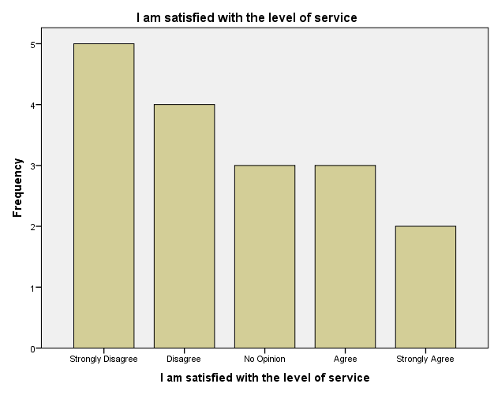

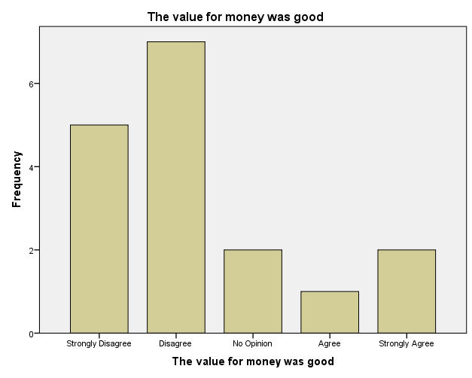

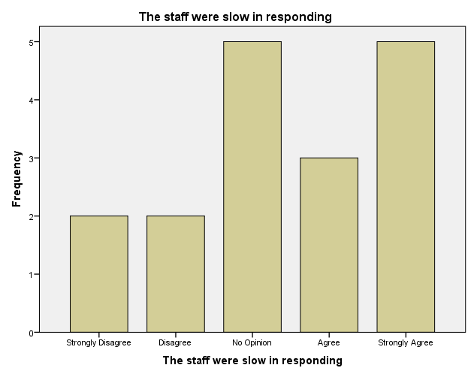

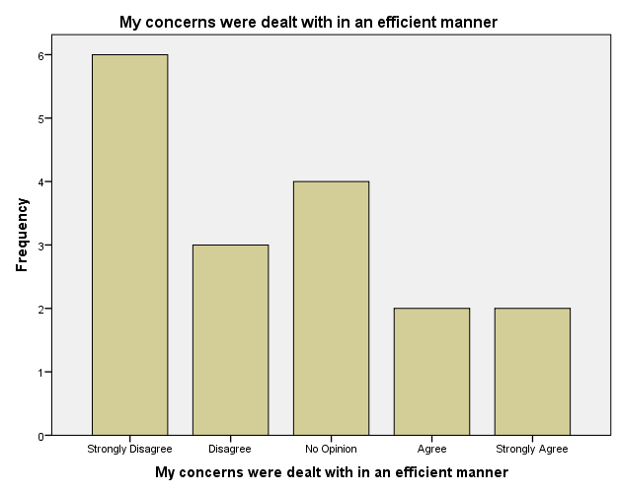

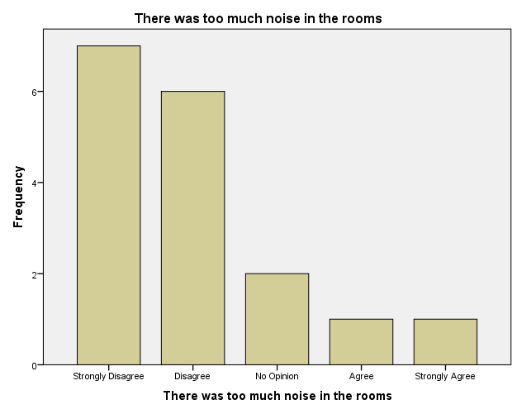

EXAMINE VARIABLES=v1 v2 v3 v4 v5
/PLOT BOXPLOT STEMLEAF HISTOGRAM NPPLOT
/COMPARE GROUPS
/MESTIMATORS HUBER(1.339) ANDREW(1.34) HAMPEL(1.7,3.4,8.5) TUKEY(4.685)
/PERCENTILES(5,10,25,50,75,90,95) HAVERAGE
/STATISTICS DESCRIPTIVES EXTREME
/CINTERVAL 95
/MISSING LISTWISE
/NOTOTAL.

Explore

Notes
Output Created |  | 04-OCT-2013 19:29:05
Comments
Input | Data | C:\Documents and Settings\Administrador\Escritorio\data-files\created-with-spss\pspp-examples\HOTEL_SAV_7.sav
Input | Active Dataset | DataSet1
Input | Filter | <none>
Input | Weight | <none>
Input | Split File | <none>
Input | N of Rows in Working Data File | 17
Missing Value Handling | Definition of Missing | User-defined missing values for dependent variables are treated as missing.
Missing Value Handling | Cases Used | Statistics are based on cases with no missing values for any dependent variable or factor used.
Syntax |  | EXAMINE VARIABLES=v1 v2 v3 v4 v5  /PLOT BOXPLOT STEMLEAF HISTOGRAM NPPLOT  /COMPARE GROUPS  /MESTIMATORS HUBER(1.339) ANDREW(1.34) HAMPEL(1.7,3.4,8.5) TUKEY(4.685)  /PERCENTILES(5,10,25,50,75,90,95) HAVERAGE  /STATISTICS DESCRIPTIVES EXTREME  /CINTERVAL 95  /MISSING LISTWISE  /NOTOTAL.
Resources | Processor Time | 00:00:16,22
Resources | Elapsed Time | 00:00:18,91

Case Processing Summary
 | Cases
 | Valid |  | Missing |  | Total
 | N | Percent | N | Percent | N | Percent
I am satisfied with the level of service | 17 | 100,0% | 0 | 0,0% | 17 | 100,0%
The value for money was good | 17 | 100,0% | 0 | 0,0% | 17 | 100,0%
The staff were slow in responding | 17 | 100,0% | 0 | 0,0% | 17 | 100,0%
My concerns were dealt with in an efficient manner | 17 | 100,0% | 0 | 0,0% | 17 | 100,0%
There was too much noise in the rooms | 17 | 100,0% | 0 | 0,0% | 17 | 100,0%

Descriptives
 |  |  | Statistic | Std. Error
I am satisfied with the level of service | Mean |  | 2,59 | ,344
I am satisfied with the level of service | 95% Confidence Interval for Mean | Lower Bound | 1,86
I am satisfied with the level of service | 95% Confidence Interval for Mean | Upper Bound | 3,32
I am satisfied with the level of service | 5% Trimmed Mean |  | 2,54
I am satisfied with the level of service | Median |  | 2,00
I am satisfied with the level of service | Variance |  | 2,007
I am satisfied with the level of service | Std. Deviation |  | 1,417
I am satisfied with the level of service | Minimum |  | 1
I am satisfied with the level of service | Maximum |  | 5
I am satisfied with the level of service | Range |  | 4
I am satisfied with the level of service | Interquartile Range |  | 3
I am satisfied with the level of service | Skewness |  | ,395 | ,550
I am satisfied with the level of service | Kurtosis |  | -1,127 | 1,063
The value for money was good | Mean |  | 2,29 | ,318
The value for money was good | 95% Confidence Interval for Mean | Lower Bound | 1,62
The value for money was good | 95% Confidence Interval for Mean | Upper Bound | 2,97
The value for money was good | 5% Trimmed Mean |  | 2,22
The value for money was good | Median |  | 2,00
The value for money was good | Variance |  | 1,721
The value for money was good | Std. Deviation |  | 1,312
The value for money was good | Minimum |  | 1
The value for money was good | Maximum |  | 5
The value for money was good | Range |  | 4
The value for money was good | Interquartile Range |  | 2
The value for money was good | Skewness |  | 1,076 | ,550
The value for money was good | Kurtosis |  | ,350 | 1,063
The staff were slow in responding | Mean |  | 3,41 | ,333
The staff were slow in responding | 95% Confidence Interval for Mean | Lower Bound | 2,71
The staff were slow in responding | 95% Confidence Interval for Mean | Upper Bound | 4,12
The staff were slow in responding | 5% Trimmed Mean |  | 3,46
The staff were slow in responding | Median |  | 3,00
The staff were slow in responding | Variance |  | 1,882
The staff were slow in responding | Std. Deviation |  | 1,372
The staff were slow in responding | Minimum |  | 1
The staff were slow in responding | Maximum |  | 5
The staff were slow in responding | Range |  | 4
The staff were slow in responding | Interquartile Range |  | 3
The staff were slow in responding | Skewness |  | -,367 | ,550
The staff were slow in responding | Kurtosis |  | -,883 | 1,063
My concerns were dealt with in an efficient manner | Mean |  | 2,47 | ,344
My concerns were dealt with in an efficient manner | 95% Confidence Interval for Mean | Lower Bound | 1,74
My concerns were dealt with in an efficient manner | 95% Confidence Interval for Mean | Upper Bound | 3,20
My concerns were dealt with in an efficient manner | 5% Trimmed Mean |  | 2,41
My concerns were dealt with in an efficient manner | Median |  | 2,00
My concerns were dealt with in an efficient manner | Variance |  | 2,015
My concerns were dealt with in an efficient manner | Std. Deviation |  | 1,419
My concerns were dealt with in an efficient manner | Minimum |  | 1
My concerns were dealt with in an efficient manner | Maximum |  | 5
My concerns were dealt with in an efficient manner | Range |  | 4
My concerns were dealt with in an efficient manner | Interquartile Range |  | 3
My concerns were dealt with in an efficient manner | Skewness |  | ,513 | ,550
My concerns were dealt with in an efficient manner | Kurtosis |  | -,935 | 1,063
There was too much noise in the rooms | Mean |  | 2,00 | ,284
There was too much noise in the rooms | 95% Confidence Interval for Mean | Lower Bound | 1,40
There was too much noise in the rooms | 95% Confidence Interval for Mean | Upper Bound | 2,60
There was too much noise in the rooms | 5% Trimmed Mean |  | 1,89
There was too much noise in the rooms | Median |  | 2,00
There was too much noise in the rooms | Variance |  | 1,375
There was too much noise in the rooms | Std. Deviation |  | 1,173
There was too much noise in the rooms | Minimum |  | 1
There was too much noise in the rooms | Maximum |  | 5
There was too much noise in the rooms | Range |  | 4
There was too much noise in the rooms | Interquartile Range |  | 2
There was too much noise in the rooms | Skewness |  | 1,318 | ,550
There was too much noise in the rooms | Kurtosis |  | 1,449 | 1,063

M-Estimators
 | Huber's M-Estimatorª | Tukey's Biweight^{b} | Hampel's M-Estimator^{c} | Andrews' Wave^{d}
I am satisfied with the level of service | 2,42 | 2,46 | 2,49 | 2,46
The value for money was good | 2,07 | 2,06 | 2,15 | 2,06
The staff were slow in responding | 3,53 | 3,50 | 3,51 | 3,50
My concerns were dealt with in an efficient manner | 2,26 | 2,31 | 2,36 | 2,31
There was too much noise in the rooms | 1,85 | 1,82 | 1,89 | 1,82

a. The weighting constant is 1,339.
b. The weighting constant is 4,685.
c. The weighting constants are 1,700, 3,400, and 8,500
d. The weighting constant is 1,340*pi.

Percentiles
 |  | Percentiles
 |  | 5 | 10 | 25 | 50
Weighted Average(Definition 1) | I am satisfied with the level of service | 1,00 | 1,00 | 1,00 | 2,00
Weighted Average(Definition 1) | The value for money was good | 1,00 | 1,00 | 1,00 | 2,00
Weighted Average(Definition 1) | The staff were slow in responding | 1,00 | 1,00 | 2,50 | 3,00
Weighted Average(Definition 1) | My concerns were dealt with in an efficient manner | 1,00 | 1,00 | 1,00 | 2,00
Weighted Average(Definition 1) | There was too much noise in the rooms | 1,00 | 1,00 | 1,00 | 2,00
Tukey's Hinges | I am satisfied with the level of service |  |  | 1,00 | 2,00
Tukey's Hinges | The value for money was good |  |  | 1,00 | 2,00
Tukey's Hinges | The staff were slow in responding |  |  | 3,00 | 3,00
Tukey's Hinges | My concerns were dealt with in an efficient manner |  |  | 1,00 | 2,00
Tukey's Hinges | There was too much noise in the rooms |  |  | 1,00 | 2,00

Percentiles
 |  | Percentiles
 |  | 75 | 90 | 95
Weighted Average(Definition 1) | I am satisfied with the level of service | 4,00 | 5,00 | .
Weighted Average(Definition 1) | The value for money was good | 3,00 | 5,00 | .
Weighted Average(Definition 1) | The staff were slow in responding | 5,00 | 5,00 | .
Weighted Average(Definition 1) | My concerns were dealt with in an efficient manner | 3,50 | 5,00 | .
Weighted Average(Definition 1) | There was too much noise in the rooms | 2,50 | 4,20 | .
Tukey's Hinges | I am satisfied with the level of service | 4,00
Tukey's Hinges | The value for money was good | 3,00
Tukey's Hinges | The staff were slow in responding | 5,00
Tukey's Hinges | My concerns were dealt with in an efficient manner | 3,00
Tukey's Hinges | There was too much noise in the rooms | 2,00

Extreme Values
 |  |  | Case Number | Value
I am satisfied with the level of service | Highest | 1 | 3 | 5
I am satisfied with the level of service | Highest | 2 | 5 | 5
I am satisfied with the level of service | Highest | 3 | 1 | 4
I am satisfied with the level of service | Highest | 4 | 11 | 4
I am satisfied with the level of service | Highest | 5 | 15 | 4
I am satisfied with the level of service | Lowest | 1 | 16 | 1
I am satisfied with the level of service | Lowest | 2 | 13 | 1
I am satisfied with the level of service | Lowest | 3 | 8 | 1
I am satisfied with the level of service | Lowest | 4 | 6 | 1
I am satisfied with the level of service | Lowest | 5 | 2 | 1
The value for money was good | Highest | 1 | 10 | 5
The value for money was good | Highest | 2 | 17 | 5
The value for money was good | Highest | 3 | 8 | 4
The value for money was good | Highest | 4 | 5 | 3
The value for money was good | Highest | 5 | 14 | 3
The value for money was good | Lowest | 1 | 16 | 1
The value for money was good | Lowest | 2 | 15 | 1
The value for money was good | Lowest | 3 | 12 | 1
The value for money was good | Lowest | 4 | 4 | 1
The value for money was good | Lowest | 5 | 2 | 1
The staff were slow in responding | Highest | 1 | 6 | 5
The staff were slow in responding | Highest | 2 | 8 | 5
The staff were slow in responding | Highest | 3 | 13 | 5
The staff were slow in responding | Highest | 4 | 16 | 5
The staff were slow in responding | Highest | 5 | 17 | 5
The staff were slow in responding | Lowest | 1 | 15 | 1
The staff were slow in responding | Lowest | 2 | 5 | 1
The staff were slow in responding | Lowest | 3 | 11 | 2
The staff were slow in responding | Lowest | 4 | 3 | 2
The staff were slow in responding | Lowest | 5 | 14 | 3ª
My concerns were dealt with in an efficient manner | Highest | 1 | 5 | 5
My concerns were dealt with in an efficient manner | Highest | 2 | 13 | 5
My concerns were dealt with in an efficient manner | Highest | 3 | 1 | 4
My concerns were dealt with in an efficient manner | Highest | 4 | 6 | 4
My concerns were dealt with in an efficient manner | Highest | 5 | 3 | 3^{b}
My concerns were dealt with in an efficient manner | Lowest | 1 | 16 | 1
My concerns were dealt with in an efficient manner | Lowest | 2 | 15 | 1
My concerns were dealt with in an efficient manner | Lowest | 3 | 12 | 1
My concerns were dealt with in an efficient manner | Lowest | 4 | 9 | 1
My concerns were dealt with in an efficient manner | Lowest | 5 | 4 | 1^{c}
There was too much noise in the rooms | Highest | 1 | 11 | 5
There was too much noise in the rooms | Highest | 2 | 3 | 4
There was too much noise in the rooms | Highest | 3 | 5 | 3
There was too much noise in the rooms | Highest | 4 | 15 | 3
There was too much noise in the rooms | Highest | 5 | 4 | 2^{d}
There was too much noise in the rooms | Lowest | 1 | 14 | 1
There was too much noise in the rooms | Lowest | 2 | 12 | 1
There was too much noise in the rooms | Lowest | 3 | 10 | 1
There was too much noise in the rooms | Lowest | 4 | 8 | 1
There was too much noise in the rooms | Lowest | 5 | 7 | 1^{c}

a. Only a partial list of cases with the value 3 are shown in the table of lower extremes.
b. Only a partial list of cases with the value 3 are shown in the table of upper extremes.
c. Only a partial list of cases with the value 1 are shown in the table of lower extremes.
d. Only a partial list of cases with the value 2 are shown in the table of upper extremes.

Tests of Normality
 | Kolmogorov-Smirnovª |  |  | Shapiro-Wilk
 | Statistic | df | Sig. | Statistic | df | Sig.
I am satisfied with the level of service | ,190 | 17 | ,102 | ,885 | 17 | ,038
The value for money was good | ,295 | 17 | ,000 | ,823 | 17 | ,004
The staff were slow in responding | ,171 | 17 | ,200* | ,890 | 17 | ,047
My concerns were dealt with in an efficient manner | ,203 | 17 | ,061 | ,868 | 17 | ,020
There was too much noise in the rooms | ,265 | 17 | ,003 | ,806 | 17 | ,002

*. This is a lower bound of the true significance.
a. Lilliefors Significance Correction

I am satisfied with the level of service

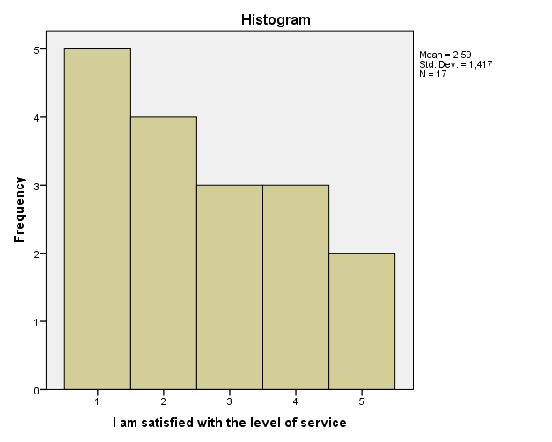

I am satisfied with the level of service Stem-and-Leaf Plot

Frequency Stem & Leaf

5,00 1 . 00000
4,00 2 . 0000
3,00 3 . 000
3,00 4 . 000
2,00 5 . 00

Stem width: 1
Each leaf: 1 case(s)

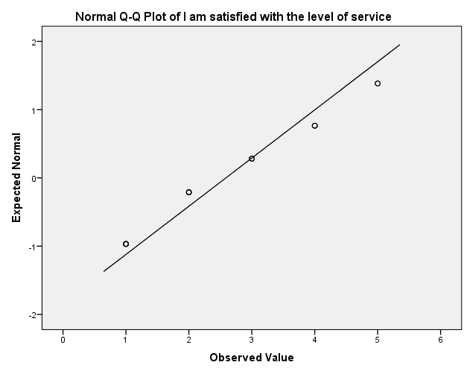

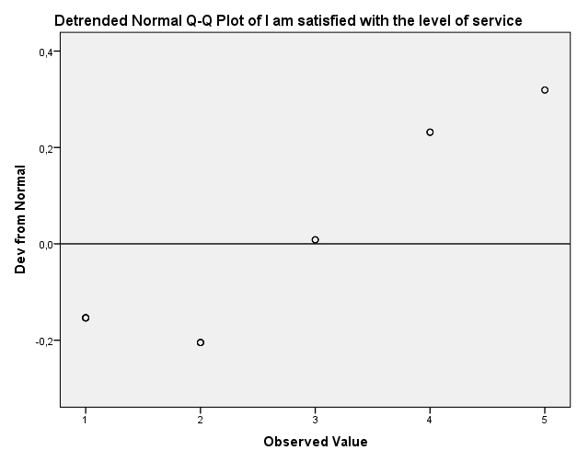

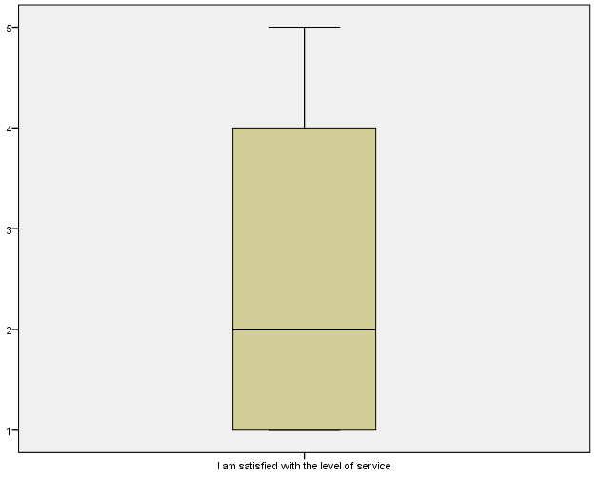

The value for money was good

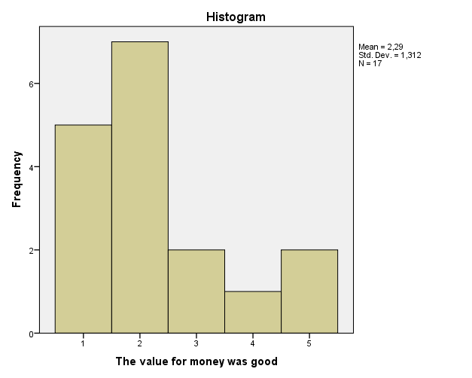

The value for money was good Stem-and-Leaf Plot

Frequency Stem & Leaf

5,00 1 . 00000
7,00 2 . 0000000
2,00 3 . 00
1,00 4 . 0
2,00 5 . 00

Stem width: 1
Each leaf: 1 case(s)

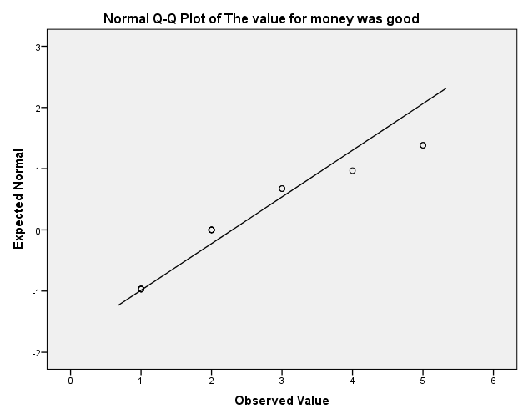

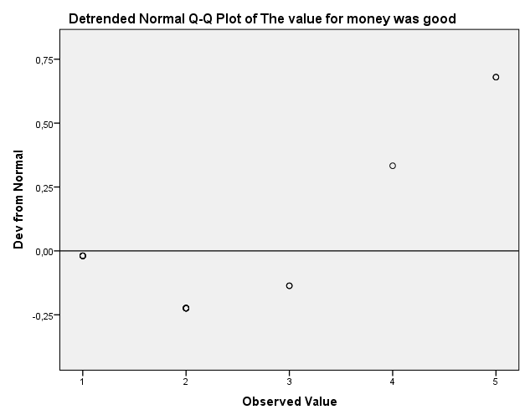

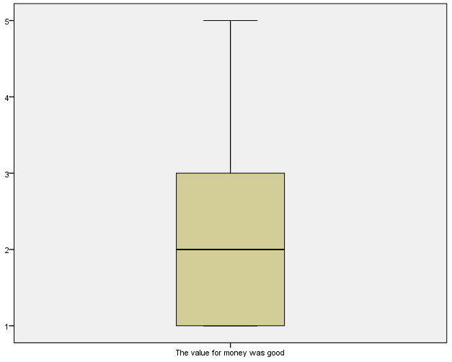

The staff were slow in responding

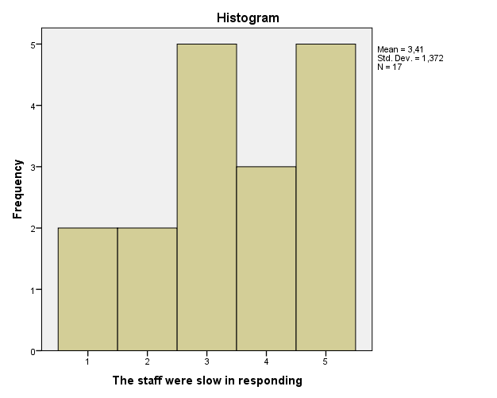

The staff were slow in responding Stem-and-Leaf Plot

Frequency Stem & Leaf

2,00 1 . 00
2,00 2 . 00
5,00 3 . 00000
3,00 4 . 000
5,00 5 . 00000

Stem width: 1
Each leaf: 1 case(s)

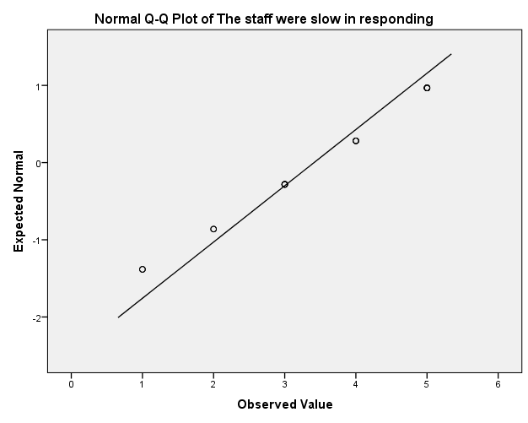

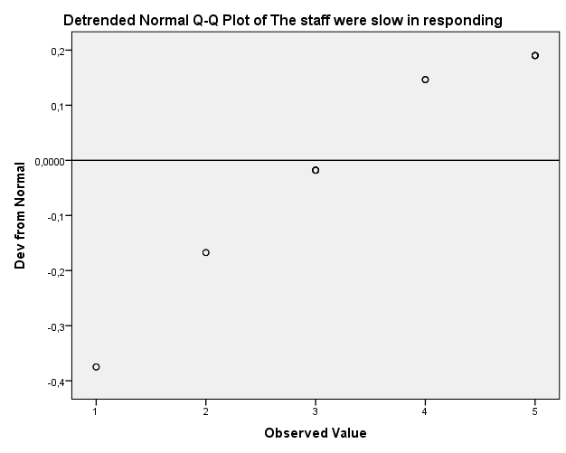

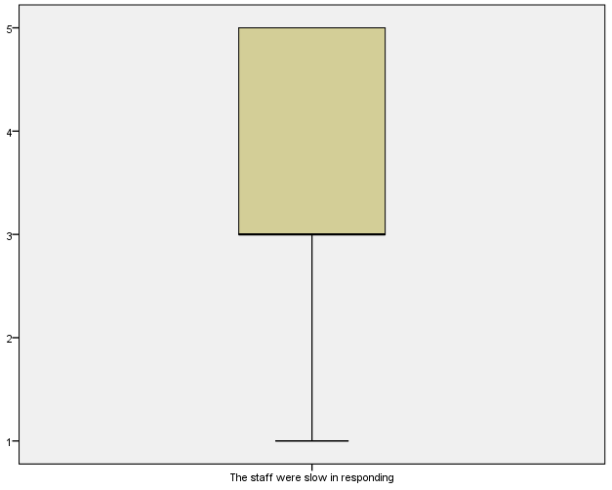

My concerns were dealt with in an efficient manner

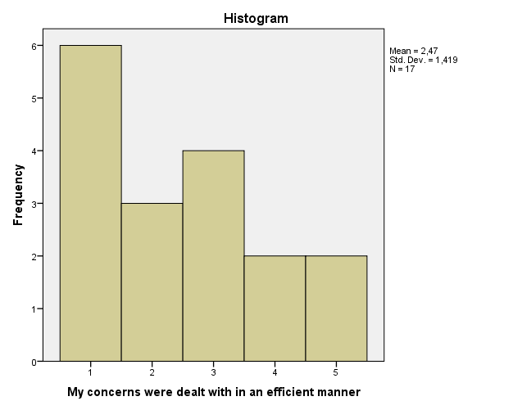

My concerns were dealt with in an efficient manner Stem-and-Leaf Plot

Frequency Stem & Leaf

6,00 1 . 000000
3,00 2 . 000
4,00 3 . 0000
2,00 4 . 00
2,00 5 . 00

Stem width: 1
Each leaf: 1 case(s)

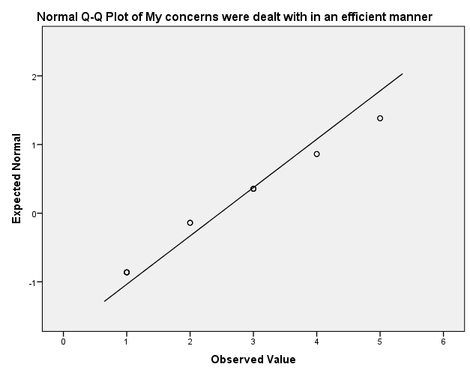

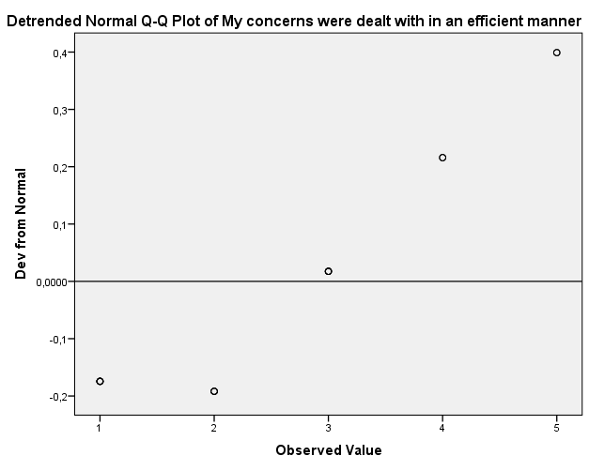

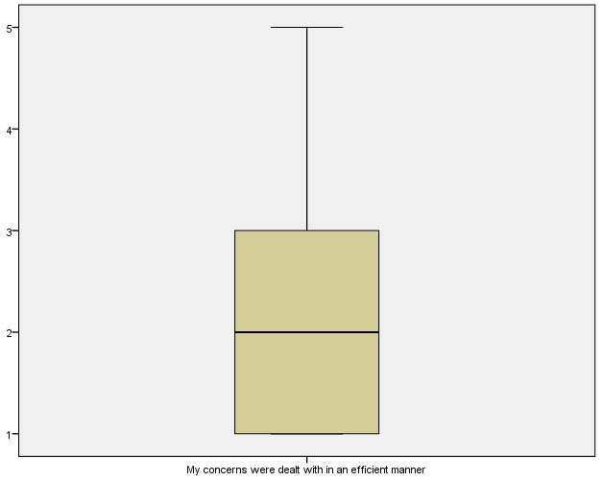

There was too much noise in the rooms

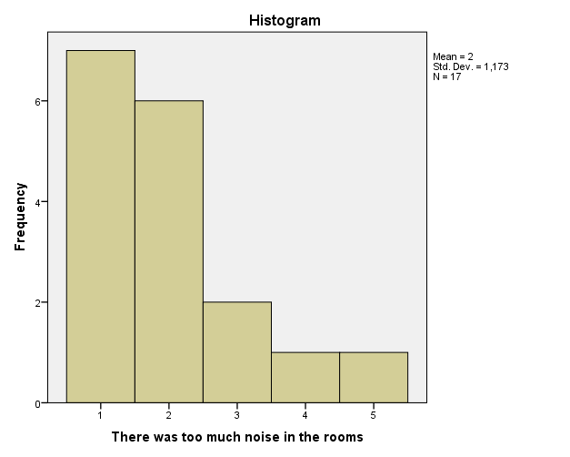

There was too much noise in the rooms Stem-and-Leaf Plot

Frequency Stem & Leaf

7,00 1 . 0000000
,00 1 .
6,00 2 . 000000
,00 2 .
2,00 3 . 00
2,00 Extremes (>=4,0)

Stem width: 1
Each leaf: 1 case(s)

