Animes :

* ID (Primary Key)
* Title
* Description

Episodes :

* ID (Primary Key)
* Number
* Title
* Anime_id (Foreign Key)

Genres :

* ID (Primary Key)
* Title

Animes_Genres:

* Anime_ID (Foreign Key)
* Genre_ID (Foreign Key)

ACCESING MYSQL (Terminal)

1. Command prompt. Change directory

Cd xampp

Cd mysql

Cd bin

Mysql.exe -u root

SHOW databases

ACCESING MYSQL (PHPMyAdmin)

1. Admin xampp

CREATING DATABASES ON MYSQL (TERMINAL)

1. CREATE database …(isi nama database)…. 🡪 Creating databases
2. SHOW database
3. DROP database …(isi nama database)…. 🡪 deleting databases
4. USE …(isi nama table)…. 🡪choose databases

CREATING TABLE ON MYSQL (TERMINAL)

1. SHOW tables 🡪 menampilkan data yang ada didalam databases
2. CREATE TABLE …(isi nama table)…. ( nama nama kolomnya   
   satuanId INT NOT NULL AUTO_INCREMENT,  
   satuanNama VARCHAR (30) NOT NULL,

PRIMARY KEY (satuanId);

1. DESCRIBE nama table ; 🡪 menampilkan data yang terdapat didalam table

ADD FOREIGN KEY

1. INDEX (sebut kolomnya)  
   INDEX (supplier_id),  
   INDEX (satuan_id),
2. FOREIGN KEY (supplier_id) REFERENCES supplier (reference to primary key) (supplierId)  
   ON DELETE RESTRICT ON UPDATE CASCADE
3. FOREIGN KEY (satuan_id) REFERECES satuan (satuanId)  
   ON DELETE RESTRICT ON UPDATE CASCADE

First table : animes

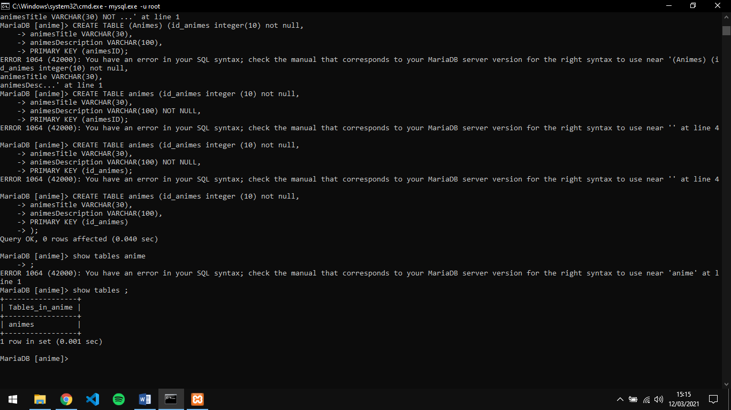

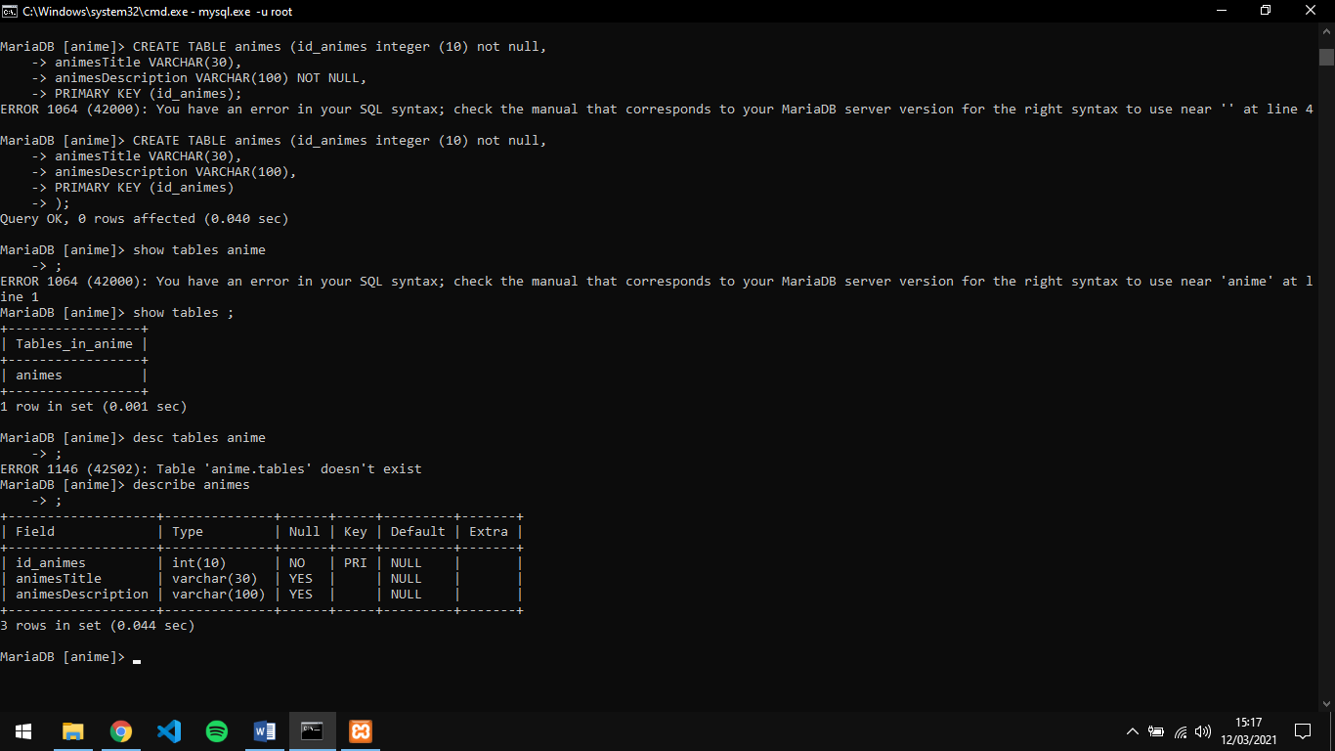

Second tables : episodes

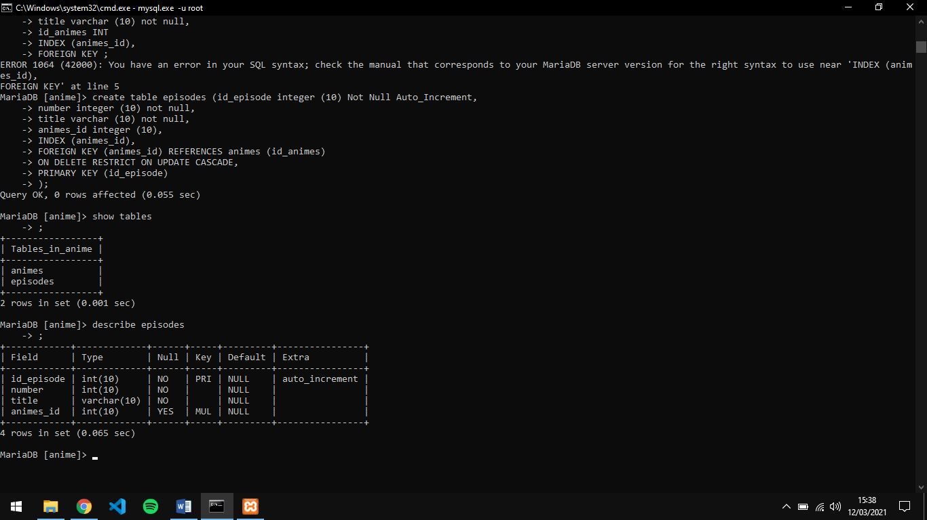

Third table genres

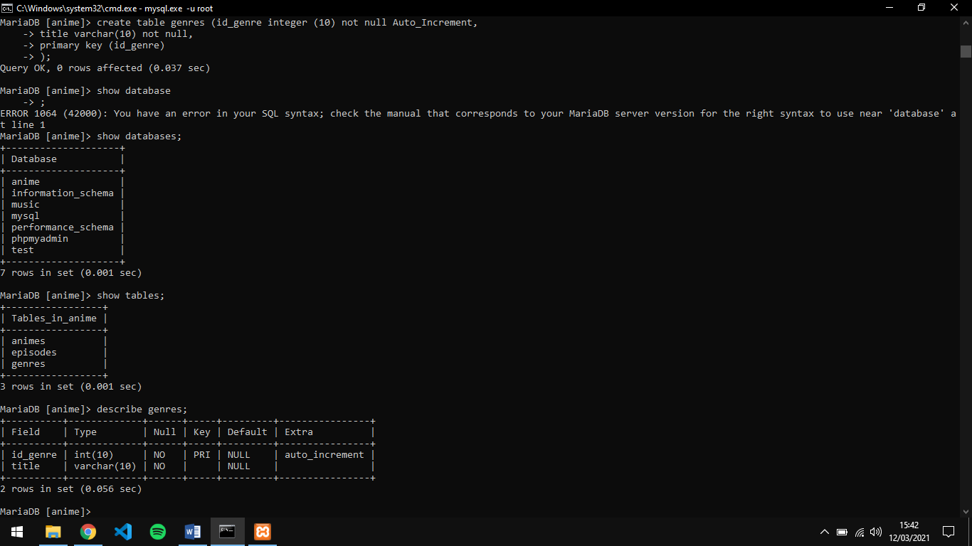

Fourth table animes_genres

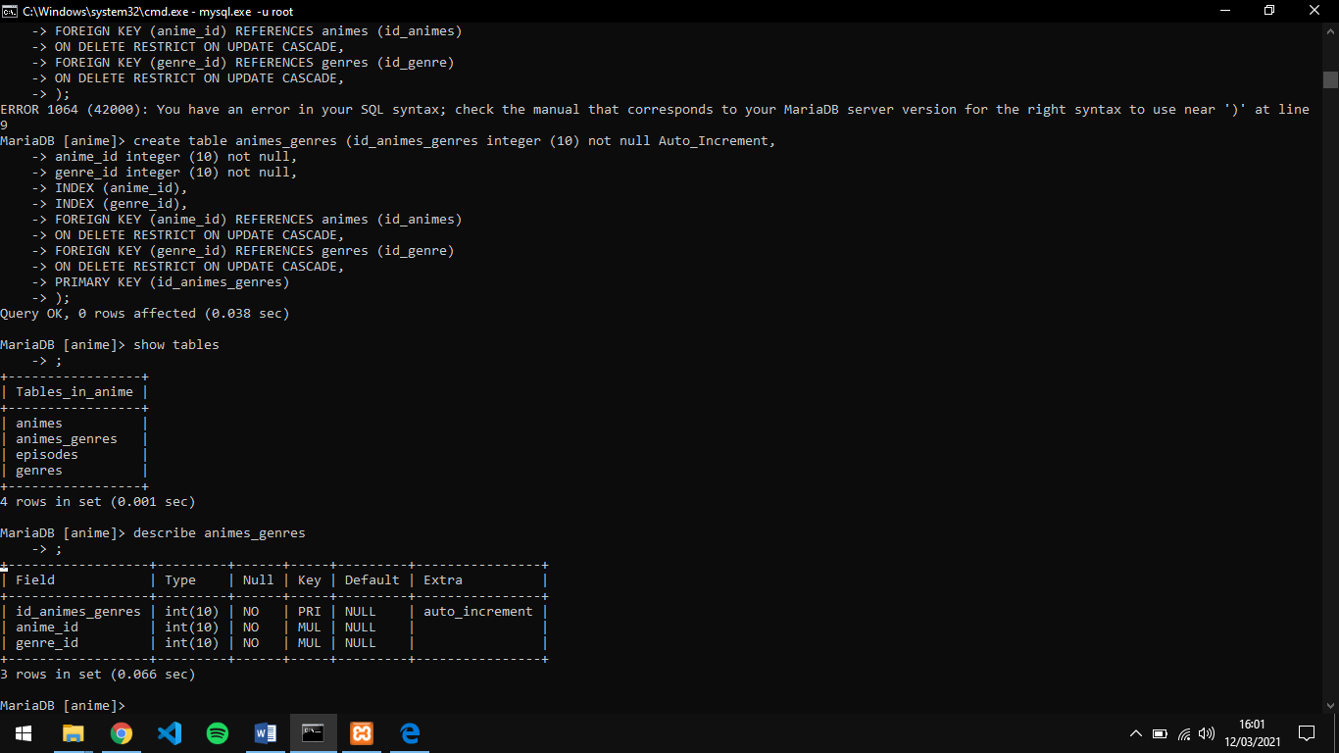

DML (INSERT, UPDATE, DELETE)

INSERT

1. INSERT INTO ….tujuanYangMauDiInsert….. VALUES ….isiDariValuesNya…. 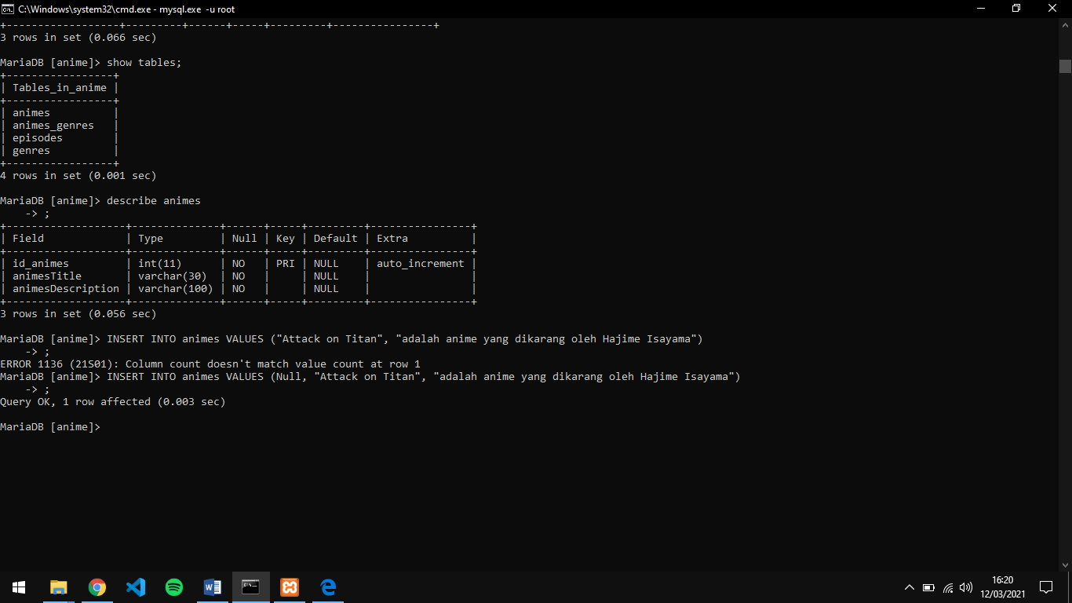
2. GET DATA : SELECT * FROM …..isiyangmauditampilkan….

Insert Animes Datas :

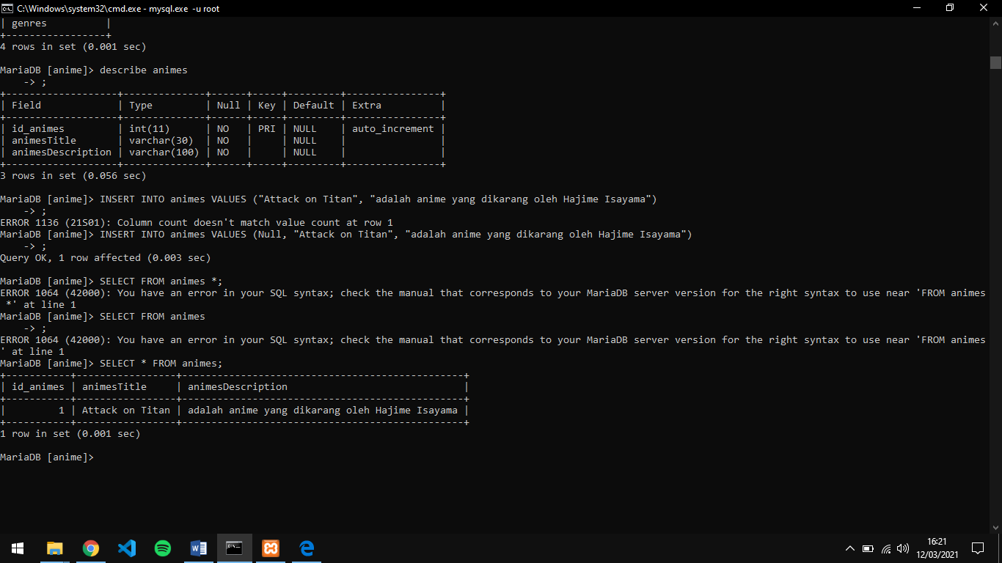

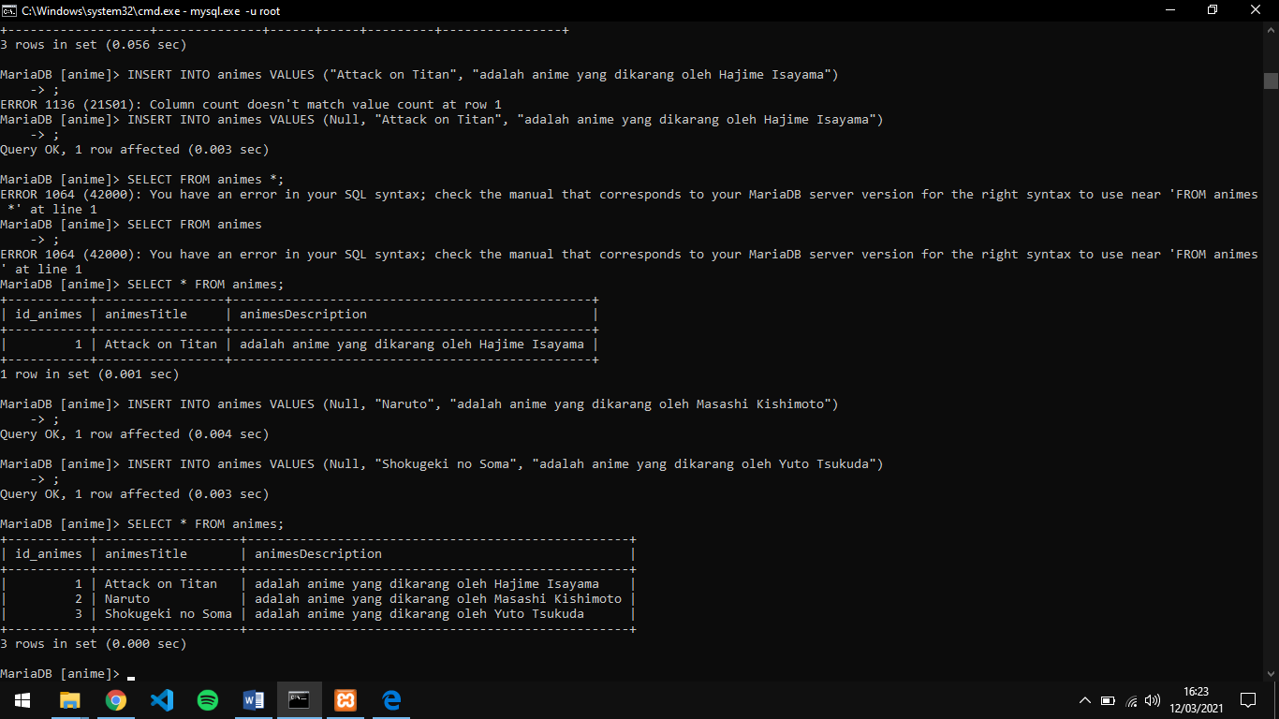 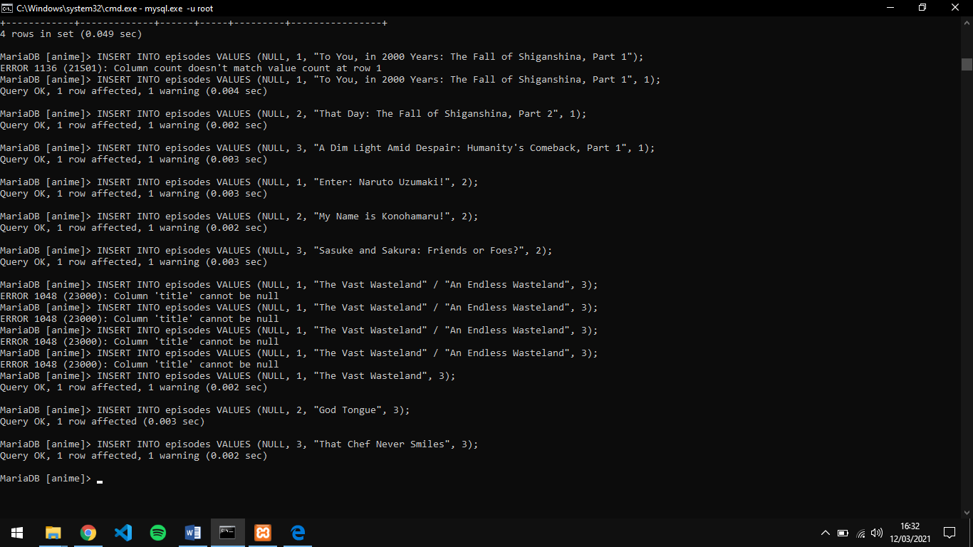

Insert episodes datas: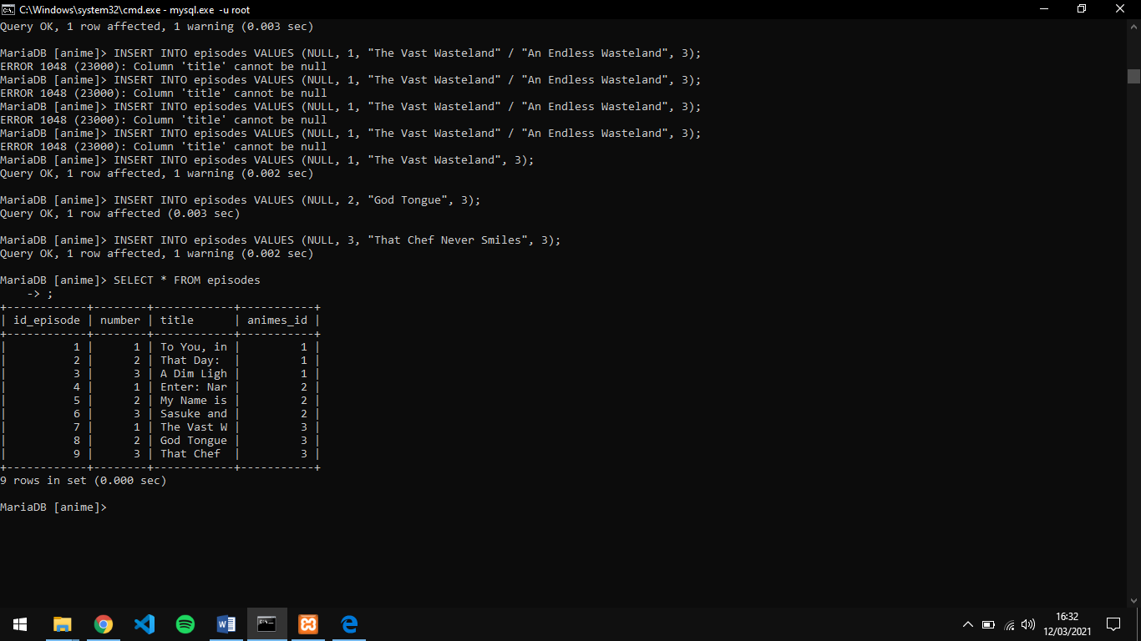

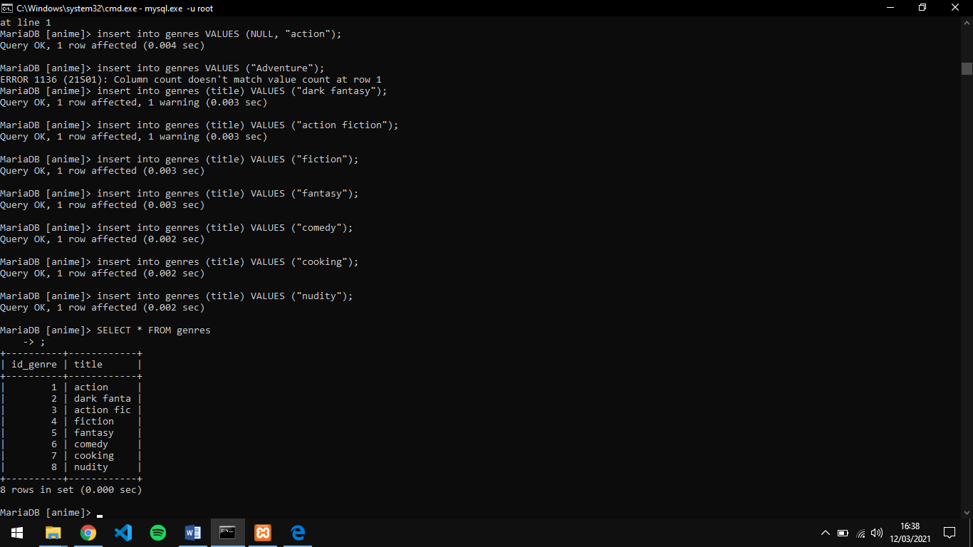

Animes_genres insert data

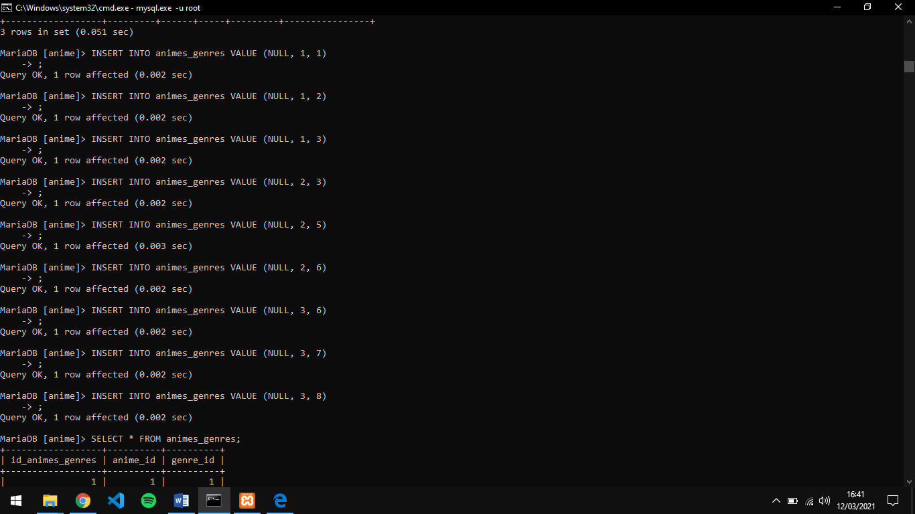

Animes_genres get data

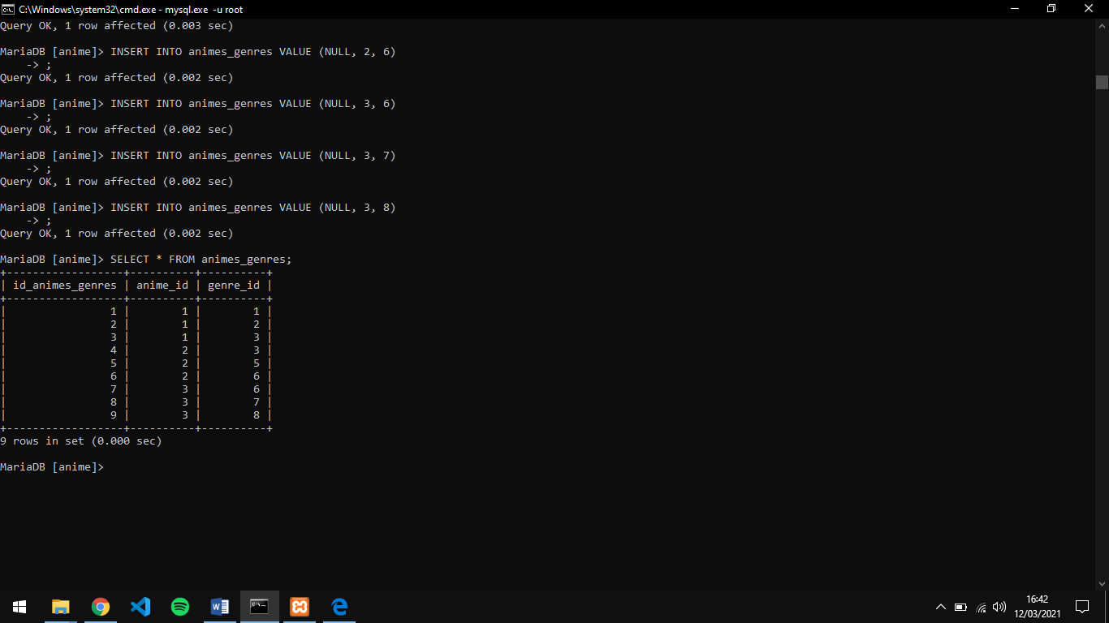

ERD

