Table of Contents

# Figure 1.

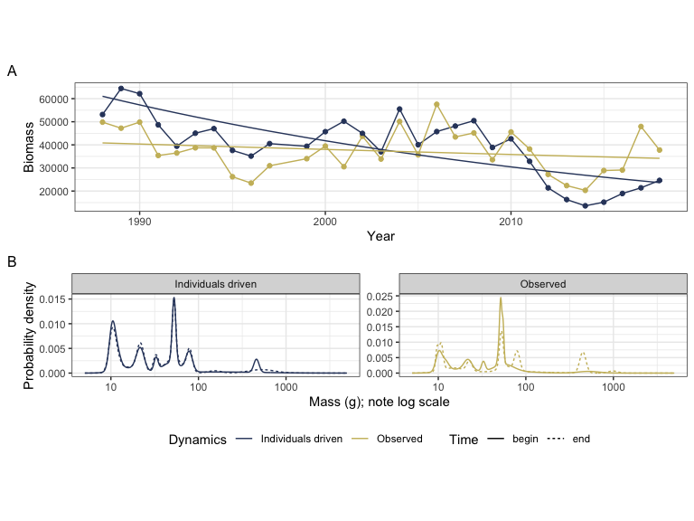

#### Figure 1.

# Figure 2.

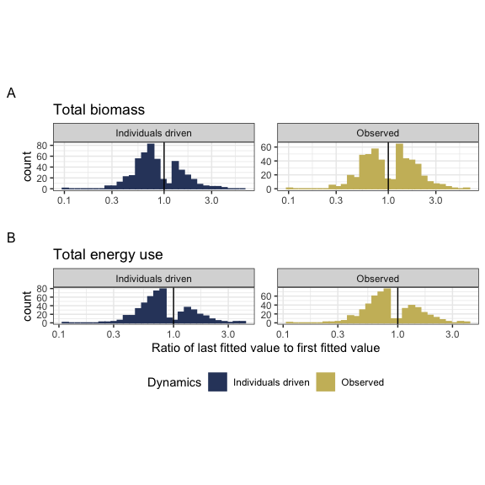

#### Figure 2

# Figure 3. Visualizing decoupling

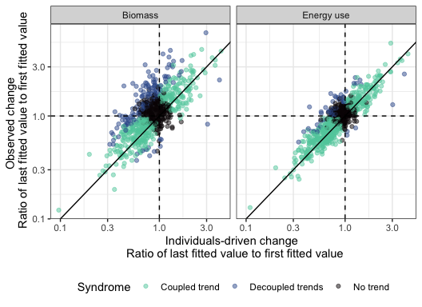

#### Figure 3

# Figure 4

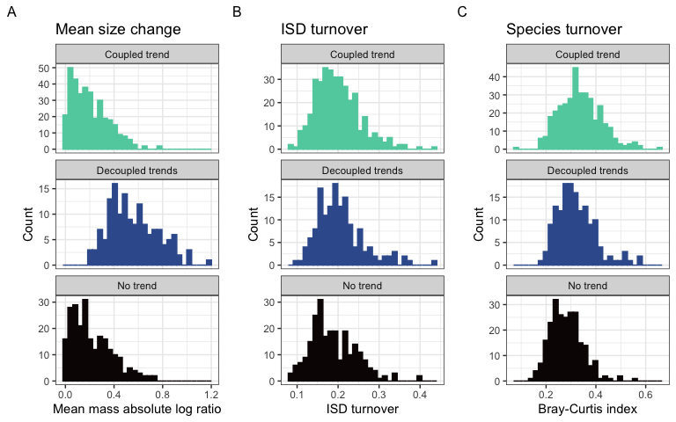

#### Figure 4

# Tables

### Table 1.

| Currency | Selected model | Number of routes | Proportion of routes |
| --- | --- | --- | --- |
| Total biomass | Intercept-only | 238 | 0.32 |
| Total biomass | Trend, not decoupled | 352 | 0.48 |
| Total biomass | Decoupled trend | 149 | 0.20 |
| Total energy use | Intercept-only | 230 | 0.31 |
| Total energy use | Trend, not decoupled | 456 | 0.62 |
| Total energy use | Decoupled trend | 53 | 0.07 |

#### Table 1

Table of the number and proportion of routes whose dynamics for total biomass and total energy use are best described by the following syndromes: no directional change (intercept-only model, biomass ~ 1 or energy use ~ 1); a coupled trend (biomass ~ year or energy use ~ year); or a model with decoupled temporal trends for observed and individuals-driven dynamics (biomass ~ year * dynamics or energy use ~ year * dynamics, where dynamics refers to observed or null model, individuals-driven dynamics).

31-32% of routes are best described as syndromes of “No directional change” (intercept-only models). For the remaining routes, in most instances, the dynamics of biomass and energy use exhibit a temporal trend, but with no detectable difference in the temporal trends for individuals-driven and observed dynamics (“Coupled trends”). However, for a substantial minority of routes (20% overall for biomass, or 30% of routes with a temporal trend; 7% overall for energy use, or 10% of routes with a temporal trend), there is a detectable deviation between the trends expected due only to changes in abundance and the observed dynamics (“Decoupled trends”).

### Table 2.

| Currency | Proportion of increasing individuals-driven trends | Proportion of increasing observed trends | Number of routes with temporal trends |
| --- | --- | --- | --- |
| Total biomass | 0.33 | 0.49 | 501 |
| Total energy use | 0.30 | 0.35 | 509 |

#### Table 2

The proportion of trends that are increasing (specifically, for which the ratio of the last fitted value to the first fitted value > 1) for individuals-driven and observed dynamics, for routes exhibiting temporal trends (“coupled trends” or “decoupled trends”) in total biomass and total energy use (for biomass, n = 501; for energy use, n = 509). Trends that are not increasing are decreasing.

Trends in individuals-driven dynamics are dominated by declines (67% of routes for total biomass, and 70% of routes for total energy). Observed dynamics for biomass differ qualitatively from the individuals-driven dynamics. Specifically, observed trends in biomass are evenly divided between increases and decreases (49% increasing). Observed trends in energy use more closely mirror individuals-driven trends (65% declines).