**Introduction**

The species abundance distribution (SAD) is one of the few ecological patterns whose shape is so consistent that it is often considered an ecological law (Lawton 1999, McGill et al 2007). Across varied ecosystems and taxa, the species abundance distribution is nearly always dominated by a few very abundant species and a larger number of increasingly rare species, generating a distinctive hollow- or J-shaped curve (Fisher 1943). Community ecologists have used the species abundance distribution to test numerous theories intended to determine which biological processes are most important for structuring assemblages of species (McGill et al 2007). However, using the species abundance distribution to distinguish amongst theories has proven frustrating because many theories predict similar shapes (McGill et al 2007), and even experimental manipulations generate little variation in the shape of the SAD (Supp and Ernest 2014). After decades of use as a theoretical benchmark, the utility of the SAD for assessing the processes structuring ecological communities is currently unclear.

Increasing evidence for statistical constraints operating on the shape of the SAD (Locey and White, Harte, White et al 2012, older refs – Sugihara?) has complicated our understanding of the SAD as a *biological* pattern. Accumulating evidence suggests that statistical constraints may actually generate the most striking feature of the species abundance distribution – the hollow curve. At its core, the SAD is a representation of how the total number of individuals in a community (N) are partitioned among the number of species (S) in that community. If our implicit null expectation for such a distribution is that individuals are uniformly distributed across species (i.e. equal numbers of individuals per species), the hollow curve we see in nature is indeed surprising. However, a uniform distribution is not necessarily the appropriate baseline. Just as a Gaussian distribution emerges in the limit of many samples around a population mean, power-law or log-series distributions (i.e. ‘hollow-shaped’ curves) emerge as statistical attractors for abundance distributions (Frank 2009, 2019). Whether using statistical mechanics (i.e. the Maximum Entropy Theory of Ecology (METE); Harte et al 2008, Harte 2011) or combinatorics (i.e. ‘the feasible set’; Locey and White 2013), the random division of individuals into species can, on its own, generate realistic hollow curves. Because these statistically generated SADs are excellent empirical fits to those seen in nature (Harte et al 2011, White et al 2012, Locey and White 2013), it is reasonable to expect that statistical constraints alone may account for the widespread phenomenon of the hollow-curve SAD.

If SADs are statistically inclined to be hollow curves without requiring biological influences, it is no surprise that we have struggled to interpret the hollow curve in biological terms. However, just because the main feature of the SAD may be statistically determined, it does not necessarily follow that the SAD cannot be biologically informative. Biological processes may cause relatively subtle, but meaningful, deviations between observed SADs and their statistical expectations (Locey and White 2013, Harte and Newman 2014). We may be able to use those *deviations* to evaluate theories (Harte and Newman 2014, Xiao et al 2016) by interpreting SADs not in terms of their absolute shape, but in terms of their shape relative to what we would expect simply due to statistical processes operating within the constraints of S and N(Frank 2009, Locey and White 2013). Using SADs in this fashion depends on our capacity to detect and quantify deviations between empirical observations and randomness, which requires metrics and computational approaches that allow us to quantify and interpret whatever deviations may exist, across many different types of ecological communities.

Based on logic developed in statistical mechanics and related fields, one challenge for detecting deviations may emerge from the relatively small size of sampled communities in ecology (in terms ofthe observed values of S and N). In general, when a system involves very large numbers of subcomponents (i.e. individuals and species in the case of the SAD), and therefore has numerous possible arrangements, nearly all of the arrangements tend to cluster around one set of large-scale characteristics (Jaynes 1979, Haegeman and Loreau 2008). When most possible outcomes cluster tightly around one particular outcome, an observation whose large-scale characteristics deviate even slightly from those shared by the majority of possible arrangements can be confidently concluded to be unlikely to be generated at random. This deviation, even if small, would therefore be an indication that the information and assumptions that generated it are incorrect or at least missing an important process at play in the system (Jaynes 1979). In our case, even small deviations in our observed SAD from the expected random outcome would suggest there arenon-statistical processes at work causing our observed SAD to be more or less even or skewed than expected (depending on how it compared to the statistically generated distribution). Crucially, expectations obtained in this way are most informative when most of the possible small-scale arrangements appear similar at large scale – i.e., when the distribution of expected outcomes is very narrowly peaked or clustered around a particular shape of the distribution (Jaynes 1979, Haegeman and Loreau 2008). If the array of possible arrangements encompasses broader and more even variation in large-scale characteristics, the expectation is less well-resolved and less informative (Jaynes 1979). When this occurs, we have less confidence that an observation that differs from the *most* likely characteristics is inconsistent with the expectation, because the expectation itself is nonspecific (Jaynes 1979, Haegeman and Loreau 2008). Small systems may be more likely to generate relatively broad expectations, because they have fewer subcomponents and fewer possible arrangements (Haegeman and Loreau 2008). This may be particularly relevant to ecology, because ecological systems can have considerably fewer subcomponents than is usual for the systems usually studied via statistical mechanics (Haegeman and Loreau 2008). However, it is not clear whether ecological communities are affected by these small-size phenomena, and if so, which community sizes (in terms of S and N) are affected the most.

Here we build upon the combinatoric approach developed by Locey and White (2013) to establish if, and in what ways, empirical SADs deviate from a statistical expectation based on S and N. We also examine whether smaller communities indeed have less narrowly-defined statistical baselines than large ones, and whether this appears to modulate our capacity to identify deviations. For [# communities] communities spanning X Y and Z taxa, we use combinatorics to generate the distribution of possible states for the SAD i.e., the statistical baseline) for each community based on its number of species and number of individuals. We then compare *observed* SADs to their corresponding statistical baselines and evaluate 1) if the shapes of observed SADs are consistently unusual given their statistical expectations, 2) how the narrowness of the statistical expectation varies over gradients of *S* and *N*, and 3) whether this variation is associated with variation in whether observations can be distinguished from the expectation.

**Methods**

*Datasets*

We use a compilation of community abundance data for trees, birds, mammals, and miscellaneous other taxa that has been used in recent macroecological explorations of the SAD (White et al 2012, Baldridge et al 2014). This compilation consists of cleaned and summarized community abundance data for trees obtained from the Forest Inventory and Analysis (ref) and Gentry plots (ref), birds from the North American Breeding Bird Survey (ref), mammals from the Mammal Community Abundance Database (ref), and a variety of less commonly sampled taxa from the Miscellaneous Abundance Database (ref). We filtered these data to remove exceptionally large or small communities, because characterizing the random expectation for the SAD becomes computationally intractable for very large communities, and becomes trivially uninformative for very small ones. We therefore filtered our datasets to remove communities with more than X species or X individuals, or fewer than 2 species or X individuals. We also removed communities for which N = S, because these communities have only one possible SAD. We further filtered the FIA database, which contains roughly 100,000 communities of which approximately 90,000 have fewer than 10 species. Rather than analyze all of these small communities, we randomly selected 10,000 small communities to include in the analysis. All FIA communities with more than 10 species were included in the analysis. Finally, for sites that had repeated sampling over time, we followed White et al (2012) and Baldridge et al (2014) and analyzed only a single, randomly selected, year of data. It should be noted that our analyses include data from the Mammal Community Database and Miscellaneous Abundance Database that were collected over longer timescales and cannot be disaggregated, with an average temporal scale of X. After filtering exceptionally large or small communities and multiple years of data collection, our final dataset consisted of X communities encompassing X taxa, with S and N ranging from 2 X and X to X, respectively (Figure). Code detailing the filtering process can be found at X

*Generating the statistical baseline*

We use the concept of the *feasible set* to characterize a statistical baseline for the SAD (Locey and White, 2013). For a given number of individuals *N*,there is a finite array of unique ways to partition those individuals into *S* species. The feasible set is the complete set of these unique partitions, or elements. In Locey and White (2013), partitions are unique if and only if they differ in the number of species present with each abundance; neither species nor individuals are distinguishable from each other. Operationally, this means that for *S = 3* and *N = 9*, the vectors *(1, 3, 5)* and *(2, 2, 5)* count as distinct partitions, but *(1, 3, 5)* and *(3, 1, 5)* count as only one element of the feasible set because they have identical numbers, with only their order differing. Alternative assumptions regarding the distinguishability of species and/or individuals would effectively change the probabilities associated with various elements of the feasible set, because some partitions can be achieved via more permutations than others. However, in the absence of strongjustification for one set of assumptions over another, we adopted a simple set of assumptions that have previously been shown to generate realistic statistical baselines (Locey and White 2013).

Characterizing the feasible set can be computationally intensive, particularly for large combinations of S and N. While it is possible to list all possible partitions of a small number of individuals into a small number of species, the number of elements in the feasible set increases rapidly with S and N and renders it necessary to draw samples from the feasible set, rather than enumerating all of its elements. Unbiased sampling of large feasible sets is itself a nontrivial computational problem, and the computational resources required has constrained previous efforts in this vein (Locey and White 2013). We developed an algorithm to efficiently and uniformly sample feasible sets even for large values of S and N. We implemented this algorithm in an R package, available on GitHub at [www.github.com/diazrenata/feasiblesads](http://www.github.com/diazrenata/feasiblesads); details of the sampling methodology are available at <https://github.com/ha0ye/feasiblesads/blob/algo-vignette/vignettes/sampling_algorithm.Rmd>.

For every community in our database, we uniformly drew 4000 samples from the feasible set to characterize the distribution of statistically probable shapes for the SAD. We filtered the 4000 samples to unique elements. For small values of S and N, it can be impossible or highly improbable to randomly draw 4000 unique samples from the feasible set, but for large communities, all 4000 are usually unique. We refer to this as the sampled feasible set.

*Comparing observed SADs to their baselines*

In the absence of any other process, an SAD with a particular S and N is likely to have a shape (i.e. the expected distribution of abundances across species) that reflects whatever shapes are common among the elements of its feasible set. Metrics related to the shape of the distribution of abundances across species are frequently used in the study of community structure and have been used specifically in the context of distinguishing observed SADs from the feasible set (Locey and White 2013). We focus on two metrics to describe the shape of the SAD, skewness and Simpson’s evenness. Skewness measures the asymmetry of a distribution around its mean, with a negative skew indicating a longer tail of values to the left of the mean and a positive skew indicating the converse. Simpson’s evenness is a commonly used metric in ecology for assessing how equitably abundance is distributed across species. By calculating these metrics for each of the unique samples in the community’s sampled feasible set (see *Generating the statistical baseline* above), we generated a distribution describing the general shape (i.e. evenness or skewness) that we expect from randomly generated SADs. Note that it is not possible to calculate skewness when S < 3 or all abundances are equal, and we exclude those cases from analyses of skewness.

To assess whether the shape of an observed SAD was statistically unlikely, we calculated Simpson’s evenness and skewness for the observed SADs and compared this to the distribution of Simpson’s evenness or skewness obtained from the community’s sampled feasible set. An observed SAD’s deviation from its feasible set was determined by assessing what percent of values in its sampled distribution were below the observed value. This percentile rank is comparable across different community sizes, allowing broad-scale assessment across wide ranges of S and N. When we compare across communities, if communities tend to reflect random draws from their feasible set, we would expect their percentile rank values to be uniformly distributed from 0 to 100. However, if observed SADs are consistently more skewed or even than their feasible sets, the percentile values will be disproportionately concentrated towards the extremes. This logic breaks down if there are very few unique values in the distribution of possible values, which can occur for small feasible sets. We excluded instances for which the distribution of possible values had fewer than 20 unique values, because in these cases, it is impossible for an observation to fall above or below the 95th or 5th percentile.

*The narrowness of the expectation*

We also used these distributions of skewness and evenness from the sampled feasible set to describe the relative narrowness or breadth of the statistical expectation over gradients of S and N in order to address whether there could be issues with determining whether small communities differ from their randomly-generated samples. We quantified the narrowness of a distribution as the ratio of the range of values encompassed within a 95% interval to the full range of values in the distribution (Figure). This allowed us to isolate and compare the *narrowness* of distributions that are not necessarily normally distributed and vary considerably in their actual values, means, ranges, and standard deviations. This metric corresponds qualitatively to more computationally-intensive approaches to measuring the self-similarity of the elements of feasible sets (Supplement).

**Results and Discussion**

We found widespread evidence that the shapes of the SADs for a range of real ecological communities are statistically unlikely when compared to their feasible sets. Many communities from the BBS, Gentry, Mammal Communities, and Misc. Abund datasets exhibited empirical SADs that were highly skewed and highly uneven relative to their feasible sets, more than would be expected by chance (Figure, Table). Combined across these four datasets, nearly 16% of observed SADs are more skewed than 95% of shapes exhibited in their feasible sets, and 31% are less even than 95% of their feasible sets. By chance we would expect only 5% of observed distributions to fall in these extremes. If our detected deviations are indeed the signal of ecological processes operating on top of statistical constraints, then our results suggest that the way prevailing processes that structure communities tend to be ones that cause abundance distributions to be more uneven, rather than those that cause individuals to be spread evenly across species. These processes might be those that promote the persistence of rare species at extremely low abundances (e.g. refs) – thereby lengthening the rare tail of the SAD – or processes that encourage or allow dominant species to be hyper-dominant without driving other species entirely to extinction (e.g. refs). Identifying the processes at play in particular systems will require further exploration, but the approach we have demonstrated here helps isolate the signal we can try to explain.

While we detected many communities that deviated statistically from the expected forms in their feasible set, there were many communities that were not. This would appear to suggest that for some communities SADs are simply statistical artefacts and support suggestions, such as Harte (20XX), that ecological processes tend to have conflicting impacts on abundance distributions, resulting in no net effect beyond some fundamental constraints. However, results from the FIA data set suggests another factor could be impeding our ability to discern structure from randomness. Across communities in the FIA, percentile scores were near uniformly-distributed for skewness (5% of observations are more skewed than 95% of their feasible set), and much noisier than any of the other datasets for evenness (9% of observations are less even) (Figure, Table). FIA communities are also, by far, the smallest across our databases: [most of them] have fewer than [X species/N individuals]; only [x%] of communities from the other four datasets are within this size range. Given arguments from statistical mechanics and related fields (refs), these communities may be experiencing additional statistical issues related to community size. If the lack of discernable deviations from the feasible set is indeed a result of FIA’s generally small community size, then we would expect similarly small communities in other datasets to also show a similar pattern. We identified approximately 370 communities that compared with FIA in S and N and we found no difference in the distribution of percentile scores between FIA and other datasets (Figure, Table). Although this is a highly restricted subset of sites – approximately 370 points of comparison, relative to the 20,000 FIA sites we analyzed – the lack of a difference between FIA and other comparable sites points to community size, and not biological features specific to FIA, as a likely explanation for the relatively weak evidence for deviations across the full FIA dataset.

Community size may affect our ability to detect deviations because small communities may not have enough possible arrangements of their subcomponents, or elements in their feasible sets, to generate highly resolved distributions for the most probable shapes (ref). If this is indeed the case, then we would expect small communities to have broader shape distributions than larger communities, increasing the difficulty of detecting whether small differences in shape are different from random expectations. When we compared the distributions of shape metrics for small communities to those for large ones, we found that samples from the feasible sets for small communities do indeed generate broader distributions of evenness, and especially skewness, than those for large communities (Figure). These broad distributions may not be specific enough to constitute a strong statistical expectation, and the deviations – or lack thereof – that we detect are correspondingly less informative. If this is indeed the case, it means that small-community considerations may affect our capacity to meaningfully distinguish signal from randomness for communities with ranges of S and N that are quite common in ecological data. FIA communities, with their broad distributions of shape metrics and overall lack of detectable signal (Figure), have on the order of 10 species and 50-100 individuals. While these values do not constitute hard thresholds, they may indicate a general range of values below which we have relatively diminished power to distinguish deviation from randomness. Unless we can develop more sensitive methods for identifying deviations even for these small communities, we may stand to learn the most by focusing on SADs from relatively large communities. In the meantime, sampling the range of forms represented in the feasible set helps us identify when the distribution of shapes present is relatively broad and therefore less informative.

The approach we used, following Locey and White (XXXX), reflects the random partitioning of individuals into species and the resulting distribution is considered unique if the vector of numbers is unique – regardless of the order those numbers occur in the vector (e.g., [1,3,5] = [5,3,1]). Biologically, these differences in the order reflect differences in which species contains the most or least individuals. Traditionally in the study of abundance distributions, we have assumed that which species contains the most or least individuals is unimportant by comparing shapes, without reference to which species is in which abundance category (ref), a philosophy that is reflected in the statistical baseline approach employed here. However, there has never been a thorough examination of either the validity or outcome of alternative methods for generating an SAD statistical baseline. This means that there is currently no unambiguous logical argument for one baseline over another. O(e.g., ref) C

Our study demonstrates both the utility, and the potential challenges, with applying tools from the study of complex systems and statistical mechanics to study ecological communities (Harte….)**.** While concepts such as maximum entropy and the feasible set are promising new horizons for macroecology, the small size of some ecological communities may present challenges that do not occur as often in the large systems for which these tools were originally developed (Haegeman and Loreau). If a substantial contingent of ecological systems have broad, nonspecific distributions of probable outcomes, these approaches may be less informative than we might hope. However, when the data we have for a community are large enough to overcome this challenge, these approaches demonstrate that while statistical constraints have strong effects on the SAD, these constraints alone do not fully account for the extremely uneven SADs we often observe in nature – leaving an important role for ecological process. This ability to diagnose the specific deviations from randomness that exist in SADs can refresh our perspective on the distribution and open up new avenues for better understanding how and when biological drivers affect its shape. Focusing on these deviations could offer new leverage for evaluating theoretical predictions for the SAD by forcing theories to predict not the general shape produced by statistical constraints, but the deviations that may be the actual signal of ecology. Testing whether existing theories (e.g. neutral theory, METE; refs) and common functional approximations (logseries, exponential, and log normal; refs) can accurately predict deviations from the feasible set may provide extremely insightful, in this context. While promising, there is still much work to do to assess our ability to disentangle biological signal from randomness, including assessing alternate statistical baselines and calibrating our expected power to detect deviations, especially for small communities. Continuing to explore and account for the interplay between statistical constraint and biological process constitutes a promising and profound new approach to our understanding of this familiar, yet surprisingly mysterious, ecological pattern.

**Figures**

##### Figure 1: Communities by dataset, S, N

##### 

##### Figure 2: 95% ratio illustration

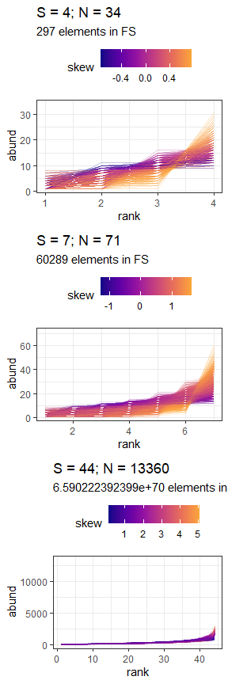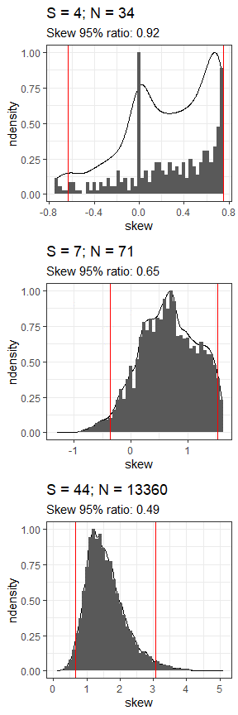

Samples of unique SADs are drawn from a community’s feasible set. Feasible sets can range substantially in size, depending on the community size (e.g., a feasible set of 297 unique distributions for S=4 and N=34 vs 6.5e+70 unique distributions for S=44, N=13360). For every sample of distributions drawn from the feasible set (left column), we calculate the skewness (color scale) or evenness (not shown). These values generate the distribution of expected statistic values from the feasible set (right column). The ratio of the range encompassed in the 95% interval (space between red lines, right), compared to the full range of values for the statistic, describes how narrowly peaked or broad the distribution is. This ratio tends to decrease as the size of the feasible set increases and the distribution becomes more narrowly defined (top to bottom).

##### Figure 3: Overall percentile results

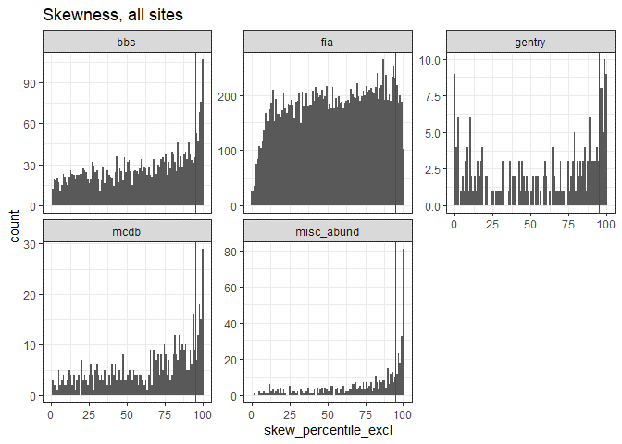

Dotted line is 95.

Excludes communities for which S < 3

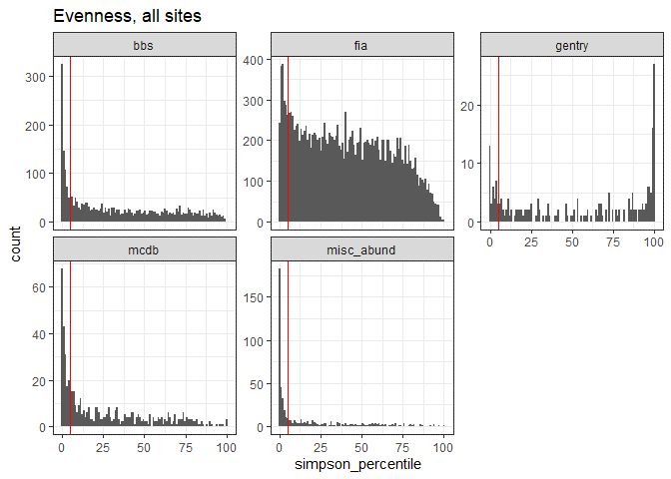

Dotted line is 95.

##### Table 1: Percentile results

| **dat** | **proportion_skew_high** | **nsites_skew** | **proportion_even_low** | **nsites_even** |
| --- | --- | --- | --- | --- |
| bbs | 0.1301839 | 2773 | 0.2596466 | 2773 |
| fia | 0.0542077 | 18300 | 0.0939657 | 18113 |
| gentry | 0.1883408 | 223 | 0.1517857 | 224 |
| mcdb | 0.1582868 | 537 | 0.3542435 | 542 |
| misc_abund | 0.3455285 | 492 | 0.5959184 | 490 |

| **fia_yn** | **proportion_skew_high** | **nsites_skew** | **proportion_even_low** | **nsites_even** |
| --- | --- | --- | --- | --- |
| fia | 0.0542077 | 18300 | 0.0939657 | 18113 |
| not fia | 0.1634783 | 4025 | 0.3072723 | 4029 |

##### Figure 5: 95% intervals vs. size of feasible set

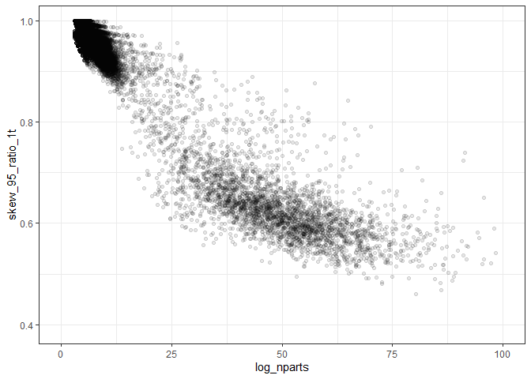

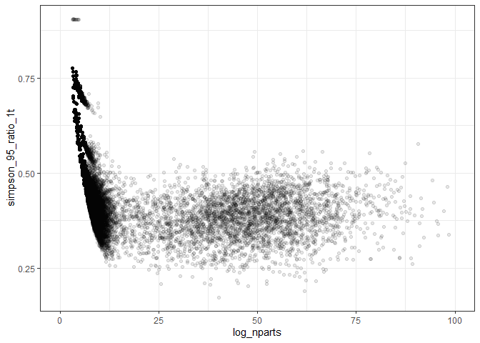

##### Figure 7: Distribution of 95% intervals by dataset

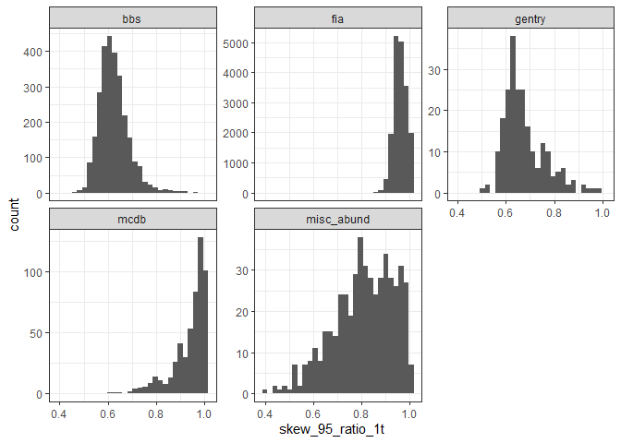

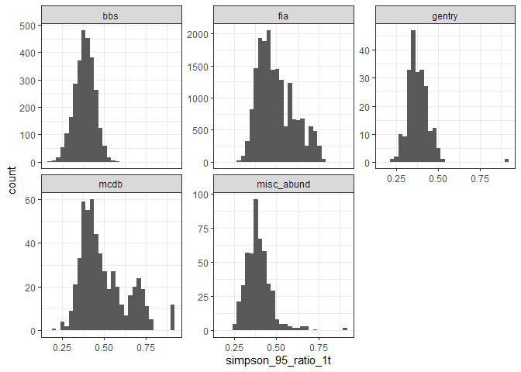

##### Figure 8: Direct comparison of FIA and similarly sized sites

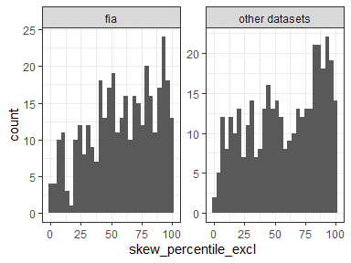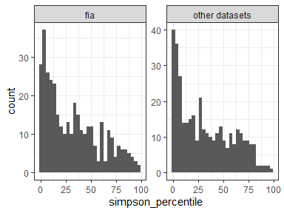

##### Table 2: Percentile results comparing FIA to direct counterparts

| **fia_yn** | **prop_skew_high** | **prop_even_low** | **nsites_skew** | **nsites_even** |
| --- | --- | --- | --- | --- |
| fia | 0.0808625 | 0.1780822 | 371 | 365 |
| other datasets | 0.0862534 | 0.2109589 | 371 | 365 |