**Title:** Empirical abundance distributions are more uneven than expected given their statistical baseline

**Running title:** SADs deviate from statistical baselines

**Author names and affiliations:**

Renata M. Diaz*1, Hao Ye2, S. K. Morgan Ernest3

1 School of Natural Resources and Environment, University of Florida, Gainesville, Florida, USA. [renata.diaz@weecology.org](mailto:renata.diaz@weecology.org); *corresponding author

2 Health Science Center Libraries, University of Florida, Gainesville, Florida, USA. [Hao’s email]

3 Department of Wildlife Ecology and Conservation, University of Florida, Gainesville, Florida, USA. [skmorgane@ufl.edu](mailto:skmorgane@ufl.edu)

**Address for correspondence:**

Renata M. Diaz  
[renata.diaz@weecology.org](mailto:renata.diaz@weecology.org)  
Full address, phone, and fax

**Statement of authorship:** RMD and SKME conceived the analysis; HY devised the algorithm to sample the feasible set, reviewed the coded implementation, and wrote the explanatory vignette; RMD conducted the analyses and wrote the first draft of the manuscript; all authors contributed substantively to revisions.

**Data accessibility statement**: All data used are available publicly via GitHub and figshare.

**Keywords:** Species abundance distributions; feasible set; combinatorics; macroecology; constraints

**Conflict of interests:** The authors declare no conflicts of interest.

**Type of article**: Letter

**Word counts:**

Abstract:  
Main text:

**Number of references:**

**Number of figures, tables, and text boxes:**

**Abstract**

The prevalence of the species abundance distribution’s hollow-curve shape across many communities is frequently assumed to reflect ecological processes structuring communities. However, this hollow curve can also emerge from the statistical process of dividing a particular number of individuals into a given number of species. While the hollow curve may be a statistical artefact, ecological processes may introduce subtle deviations between empirical species abundance distributions and their statistically most probable forms. By comparing 24,500 communities to their statistical baselines, we found that empirical communities are consistently highly skewed and uneven relative to their statistical baselines. However, small communities – with few species or individuals – exhibit poorly-resolved statistical baselines, evidently reducing our capacity to detect deviations. The extraordinarily skewed and uneven nature of empirical abundance distributions provides new avenues for testing ecological theory, while the issues posed by small communities illustrate the limitations of statistical baselines for studying ecological pattern.

**Introduction**

The distribution of how the total number of individuals in a community are partitioned among the species in that community, or the species abundance distribution (SAD), is one of the few ecological patterns whose shape is so consistent that it is often considered an ecological law (Lawton 1999, McGill et al 2007). Across varied ecosystems and taxa, the species abundance distribution is dominated by a few very abundant species and a larger number of increasingly rare species, generating a distinctive hollow- or J-shaped curve (Fisher 1943). Community ecologists have attempted to test numerous theories intended to determine which biological processes are most important for structuring assemblages of species by comparing theoretical predictions for the SAD to observed SADs (McGill et al 2007). However, using the species abundance distribution to distinguish amongst theories has proven frustrating because many theories predict similar shapes (McGill et al 2007), and even experimental manipulations generate little variation in the shape of the SAD (Supp and Ernest 2014). After decades of attention for both its consistent pattern and potential as a theoretical benchmark, the utility of the SAD for assessing the processes structuring ecological communities is currently unclear.

Accumulating evidence suggests that statistical constraints may actually generate the most striking feature of the species abundance distribution – the hollow curve (White et al 2012, Locey and White 2013, Frank 2019). Power-law or log-series distributions (i.e. ‘hollow-shaped’ curves) emerge as statistical attractors for abundance distributions generally (Frank 2009, 2019). In the specific case of the SAD, approaches using both statistical mechanics (i.e. the Maximum Entropy Theory of Ecology (METE); Harte et al 2008, Harte 2011) and combinatorics (i.e. ‘the feasible set’; Locey and White 2013) generate realistic hollow curves via the random division of the total number of individuals in a community, *N*,into the total number of species present, *S*. Because these statistically generated SADs are excellent empirical fits to those seen in nature (Harte et al 2011, White et al 2012, Locey and White 2013), statistical constraints alone may account for the widespread phenomenon of the hollow-curve SAD. Failing to account for these statistical considerations may have led us to focus on an obvious but relatively uninformative aspect of the SAD.

If SADs are statistically inclined to be hollow curves without requiring biological influences, it is no surprise that we have struggled to use the hollow curve to definitively identify the ecological processes that shape SADs. However, this does not necessarily mean that the SAD cannot be biologically informative. Biological factors may introduce relatively subtle, but meaningful, deviations between the shapes of observed SADs and the shapes of the SADs we would expect to observe simply due to the mathematical constraints imposed by *S* and *N,* which we refer to as the statistical baseline (Locey and White 2013, Harte and Newman 2014). It may be possible to use these *deviations* to detect strong ecological processes or evaluate theories (Harte and Newman 2014, Xiao et al 2016). If, as is often the case for large values of *S* and *N,* the vast majority of mathematically achievable SADs for a community share a similar shape (Locey and White 2013), an empirically observed SAD that deviates even slightly from this statistical baseline is unlikely to have emerged at random (Locey and White 2013). Such a deviation might be the signature of a non-statistical – i.e., biological – process operating on the relative abundances of species (Harte and Newman 2014). We can then evaluate proposed processes or theories based on how well they predict these *deviations* between observed SADs and their statistical baselines, and not just the general, mathematically-forced shape for the distribution.

Successfully interpreting SADs in this fashion depends on our capacity to detect and quantify deviations between empirical observations and their statistical baselines, which requires metrics and computational approaches that allow us to quantify and interpret whatever deviations may exist. Here, we build upon the combinatoric approach developed by Locey and White (2013) to define and explore the statistical baselines for SADs given S and N. For a given S and N, there exists a finite (but potentially very large) set of possible distributions of individuals into species. Collectively, this set of possible SADs is referred to as the feasible set, with each possible SAD constituting a single element of the set. If an observed SAD is simply drawn at random from the set of mathematically possible SADs, it is likely to have a shape similar to the shapes most common in the feasible set. The feasible set can therefore be used as a statistical baseline for assessing whether observed SADs deviate from what is likely to occur simply due to mathematical constraints, and to explore how the statistical baseline varies over gradients of S and N (Locey and White 2013).

The shape of the statistical baseline is critically important for disentangling the aspects of the SAD that are likely generated by statistical constraints from those generated by other processes. If the vast majority of mathematically possible SADs are similar in shape – generating a very specific, narrowly defined statistical baseline – then even small deviations between an observed SAD and this baseline can signal the operation of ecological processes. However, if many different shapes occur with more equal frequency in the feasible set, the statistical baseline is less specific and less well defined, and our sensitivity for distinguishing biological signal from statistical constraints will be vastly reduced. A poorly defined statistical baseline is more likely to occur when the size of the community, in terms of *S* and *N,* is small, because in such cases there may be too fewpossible SADs in the feasible set for a particular shape to emerge as the most common, and therefore most likely, shape. When this occurs, we have reduced confidence that even an observation that deviates from the statistical baseline could not reasonably have emerged at random from the relatively restricted pool of possible outcomes (Jaynes 1957). This general concern has been widely acknowledged as relevant to efforts to compare ecological observations to statistical baselines (Harte 2011, White et al 2012, Locey and White 2013), but there has not yet been a specific effort to quantify these effects for the SAD or to identify the range of community sizes most strongly affected. Because ecologists study the SAD for communities varying in size from the very small – *S* and *N* < 5 – to the enormous – *S* and *N* in the thousands and tens of thousands – it is important to identify the community sizes for which we can and cannot confidently detect deviations from the statistical baseline and contextualize our interpretations accordingly.

Here we use the feasible set to define statistical baselines for empirical SADs for 22,000 communities of birds, mammals, trees, and miscellaneous other taxa based on their number of species and number of individuals. We then compare *observed* SADs to their corresponding statistical baselines and evaluate 1) if the shapes of observed SADs are consistently unusual given their statistical baseline, 2) how the specificity of the statistical baseline varies over gradients of *S* and *N*, and 3) whether this variation appears to be associated with variation in our capacity to detect deviations between observations and the corresponding baselines.

**Methods**

*Datasets*

We used a compilation of community abundance data for trees, birds, mammals, and miscellaneous other taxa (White et al 2012, Baldridge 2016, Baldridge 2015). This compilation consists of cleaned and summarized community abundance data for trees obtained from the Forest Inventory and Analysis (Woudenberg et a al 2020) and Gentry transects (Phillipes and Miller 2002), birds from the North American Breeding Bird Survey (Sauer et al 2013), mammals from the Mammal Community Abundance Database (Thibault et al 2011), and a variety of less commonly sampled taxa from the Miscellaneous Abundance Database (Baldridge 2015). Because characterizing the random expectation for the SAD becomes computationally intractable for very large communities, we filtered our datasets to remove communities with more than 40720 individuals. This resulted in the removal of 4 communities from the Miscellaneous Abundance Database. We further filtered the FIA database, which contains 103,343 communities of which 92,988 have fewer than 10 species. Rather than analyze all these small communities, we randomly selected 10,000 small communities to include in the analysis. We also included all FIA communities with more than 10 species, which added an additional 10,355 FIA communities to the analysis and resulted in a total of 20,355 FIA communities. Finally, for sites that had repeated sampling over time, we followed White et al (2012) and Baldridge (2016) and analyzed only a single, randomly selected, year of data, because samples taken from a single community at different time points are likely to covary. It should be noted that our analyses include data from the Mammal Community Database and Miscellaneous Abundance Database that were collected over longer timescales and cannot be disaggregated into finer units of time. We also removed from our analyses any communities with only one species, or for which N = S or N = S + 1, because these communities have only one mathematically possible SAD. Our final dataset consisted of approximately 22,000 communities with S and N ranging from 2 to 250 and 3 to 40714, respectively. Details and code for the filtering process can be found in the appendix (see Appendix S1 in Supporting Information).

*Generating the statistical baseline*

We use the concept of the *feasible set* to characterize a statistical baseline for the SAD (Locey and White, 2013). For a given number of individuals *N*,there is a finite number of unique ways to partition those individuals into *S* species. The complete set of these unique partitions is the feasible set. Because, in this approach, neither species nor individuals are distinguishable from each other, partitions are unique if and only if they differ in the number of species that have a particular abundance (Locey and White, 2013). Operationally, this means that for *S = 3* and *N = 9*, the vectors *(1, 3, 5)* and *(2, 2, 5)* count as distinct partitions, but *(1, 3, 5)* and *(3, 1, 5)* count as only one element of the feasible set because they each contain one species with an abundance 1, 3, and 5, respectively, and they differ only in the *order* of the numbers. Alternative formulations of the SAD with different assumptions regarding the distinguishability of species and/or individuals would change the probabilities associated with various elements of the feasible set, because some partitions can be achieved via more permutations than others. However, in the absence of strongjustification for one set of assumptions over another, we adopted this simple set of assumptions that has previously been shown to generate realistic statistical baselines (Locey and White 2013).

Therefore, characterizing the statistical properties of the feasible set for large combinations of S and N can be computationally intensive. This renders it necessary to draw samples from the feasible set, rather than enumerating all of its elements. Unbiased sampling of large feasible sets is a nontrivial computational problem that has constrained previous efforts in this vein (Locey and White 2013). We developed an algorithm to efficiently and uniformly sample feasible sets even for large values of S and N. We implemented this algorithm in an R package, available on GitHub at [www.github.com/diazrenata/feasiblesads](http://www.github.com/diazrenata/feasiblesads); details of the sampling methodology are available at <https://github.com/ha0ye/feasiblesads/blob/algo-vignette/vignettes/sampling_algorithm.Rmd>.

For every community in our database, we drew 4000 samples from the feasible set to characterize the distribution of statistically probable shapes for the SAD. We filtered the 4000 samples to unique elements. For small values of S and N, it can be impossible or highly improbable for the 4000 samples from the feasible set to all be unique, but for large communities, all 4000 are usually unique. We refer to this as the sampled feasible set.

*Comparing observed SADs to their baselines*

In the absence of any other process, an SAD with a particular S and N is likely to have a shape similar to the shape that is most common among the SADs in the feasible set for the same S and N, while strong processes may cause observed SADs to have shapes that deviate from this statistical baseline (Locey and White 2013). We focus on two metrics to describe the shape of the SAD, skewness and Simpson’s evenness. Skewness measures the asymmetry of a distribution around its mean, and Simpson’s evenness is a commonly used metric in ecology for assessing how equitably abundance is distributed across species (Locey and White 2013). By calculating these metrics for each of the samples in the community’s sampled feasible set (see *Generating the statistical baseline* above), we generated a distribution describing the general shape (i.e. evenness or skewness) that we expect from the statistically-generated SADs. Note that skewness, as implemented in the R package “e1071” (Meyer et al 2019), always evaluates to 0 for distributions with only two species, and we excluded those cases from analyses of skewness (but included those communities for analyses using Simpson’s evenness).

To assess whether the shape of an observed SAD was statistically unlikely, we calculated Simpson’s evenness and skewness for the observed SAD and compared these observed values to the distributions of evenness and skewness obtained from that community’s sampled feasible set. An observed SAD’s deviation from its feasible set was determined by computing the percentile rank of its skewness and evenness relative to the sampled distributions for skewness and evenness, respectively. These percentile ranks are comparable across different community sizes, allowing broad-scale assessment across wide ranges of S and N. After aggregating across communities, if community abundance distributions reflect random draws from their feasible sets, their percentile rank values should be uniformly distributed from 0 to 100. However, if observed SADs are consistently more skewed or even than their feasible sets, the percentile values will be disproportionately concentrated towards the extremes. Because an earlier survey in this space (Locey and White 2013) found that the tendency is for empirical SAD to be more skewed and less even than their feasible sets, we used one-tailed 95% confidence intervals and tested for unusually *high* values for skewness and *low* values for evenness. This comparison is not meaningful if there are very few unique values in the distributions of skewness and evenness, which can occur for small feasible sets. We therefore excluded communities for which the distribution of skewness or evenness values from the sampled feasible set had fewer than 20 unique values (in these cases, it is impossible for an observation to fall above or below the 95th or 5th percentile, respectively). Our final aggregated analyses included 22,142 communities for evenness and 22,325 communities for skewness.

*The narrowness of the expectation*

We also used the distributions of skewness and evenness from the sampled feasible set to describe the relative specificity of the statistical baseline, in order to assess whether there could be challenges in determining whether observed communities differ from their statistical baselines. We quantified the narrowness of a distribution as the ratio of the range of values encompassed within a 95% density interval relative to the full range of values in the distribution (Figure). This breadth index for the statistical baseline ranges from 0 (a very narrow distribution and well-resolved baseline) to 1 (a very broad distribution), and allows us to compare the *narrowness* of distributions that are not necessarily normally distributed and vary considerably in their actual values, means, ranges, and standard deviations. This metric corresponds qualitatively to more computationally-intensive approaches to measuring the self-similarity of the elements of feasible sets (see Appendix S2).

**Results**

*Observed SADs compared to their feasible sets*

For four of the five datasets we analyzed – BBS, Gentry, Mammal Communities, and Misc. Abund – empirical SADs are highly skewed and highly uneven relative to their feasible sets, much more frequently than would be expected by chance (Figure; Table 1 in Appendix S3). Combined across these four datasets, 16% of observed SADs are more skewed than 95% of their feasible sets, and 31% are less even than 95% of their feasible sets. By chance we would expect only 5% of observed distributions to fall in these extremes. These outcomes contrast with the results from the FIA dataset, for which percentile scores were near-uniformly distributed for skewness (5% of observations are more skewed than 95% of the feasible set), and less concentrated at the extreme than any of the other datasets for evenness (9% of observations are less even than 95% of their feasible set).

*The narrowness of the expectation*

Across the communities we analyzed, the statistical baseline for both skewness and evenness narrows considerably as the size of the feasible set increases (Figure, Figure). The size (or number of elements) of the feasible set increases with species richness (S), total abundance (N), and average abundance (N/S). At the extreme, for communities with relatively small feasible sets – fewer than approximately 1000 elements for skewness, and approximately 200 elements for evenness – the breadth index approaches 1, meaning that a 95% density interval of the values in the distribution approaches the entire range of values. Among the datasets we analyzed, the FIA database is the most dominated by communities for which the breadth index is very high, reflecting relatively broad and nonspecific statistical expectations for the shape of the feasible set (Figure).

**Discussion**

We found widespread evidence that the shapes of the SADs for a range of real ecological communities are more skewed and less even than we would expect given the distribution of shapes within their feasible sets. These deviations most likely signal that ecological processes operate on top of statistical constraints and drive the SAD away from the shape it would assume in the absence of a dominating non-statistical process. Our results suggest that the prevailing processes structuring these communities cause abundance distributions to be more uneven – rather than those that cause individuals to be spread evenly across species. Ecological processes may lengthen the rare tail of the SAD, for example by promoting the persistence of rare species at very low abundances (e.g. Yenni et al 2012). Or, they could drive abundant species to have larger populations that would be statistically expected, without driving other species entirely to extinction (Chesson 2000). Although a disproportionate number of communities deviated statistically their feasible sets, there were also many comparable communities for which we did not detect deviations. In such cases, numerous ecological processes may operate simultaneously and with countervailing impacts on abundance distributions, resulting in no dominating net effect on the shape of the distribution beyond that imposed by fundamental constraints (Harte 2008; Harte and Newman 2014). Going forward, testing whether ecological theories or common functional approximations (e.g. the log-normal distribution) accurately predict this range of variation in deviations between observed SADs and their expectations may be much more fruitful than focusing only on the general form of the SAD, which may emerge from statistical constraints (McGill et al 2007; Locey and White 2013).

Unlike the other four datasets, communities in the FIA dataset showed weak or no evidence of deviations from their feasible sets. These results may reflect statistical issues related to community size. The FIA communities are by far the smallest across our datasets. Communities with small values of S and N have smaller feasible sets, which affects our ability to detect deviations from the most probable shapes for the SAD. When there are relatively few possible SADs, the distributions of evenness and skewness values derived from the feasible set are less narrowly peaked, meaning there is a relatively weak statistical distinction between “common” and “extreme” shapes for the SAD. In fact, across the datasets, the feasible sets for small communities generally generated broader distributions of evenness, and especially skewness, than those for large communities (Figure 5 in Appendix S2). For such communities, the deviations – or lack thereof – that we perceive are less informative than for larger communities with more strongly defined statistical baselines (Jaynes 1957).

If the lack of discernable deviations from the feasible set for the FIA communities is indeed a byproduct of their generally small size, then we would expect similarly-sized communities from other datasets to have similar results. We identified 371 communities from other datasets with S and N matching communities in the FIA, and found no difference in the distribution of percentile scores between communities from FIA and communities from other datasets (Figure; Table 2 in Appendix S3). Although 371 communities constitutes a small sample relative to the 20,355 FIA communities we analyzed, these results point to community size, and not attributes specific to FIA, as a likely explanation for the weak evidence for deviations across the full FIA dataset.

If this is indeed the case, it means that small-community considerations may affect our capacity to meaningfully distinguish signal from randomness using this approach. FIA communities, with their broad distributions of shape metrics and overall lack of detectable signal, have on the order of 10 species and 50-100 individuals. While these values do not constitute hard thresholds, they may indicate a general range of values below which we have relatively diminished power to detect deviations from the statistical baseline represented by the feasible set. To meaningfully draw inferences from deviations in these small communities, we will likely need more sensitive metrics (than skewness and evenness), and/or theories with very specific predictions for the SAD to test. In the absence of such, we may stand to learn the most by focusing on SADs from relatively large communities.

It is also important to recognize that there are multiple plausible approaches to defining a statistical baseline for the SAD, of which we have taken only one (Locey and White 2013; Haegeman and Loreau 2008). Our approach follows Locey and White (2013) and reflects the random partitioning of individuals into species, with the resulting distributions considered unique if the species’ abundance values are unique, regardless of the order in which the values occur. The philosophy behind the feasible set reflects a longstanding approach in the study of abundance distributions: to focus on the shape of the distribution without regard to species’ identities (McGill 2007). To include differences in *order* in the statistical baseline would imply that identifying *which* species contain the most or least individuals is important for testing our theories. There has yet to be a direct examination of either the validity or outcomes of alternative methods for generating statistical baselines for the SAD. Other formulations for the statistical baseline may be equally valid and generate different statistical expectations, including forms that approximate exponential, Poisson, or log-series distributions (Favretti 2018, Harte et al 2008). Comparing the results that emerge from different baselines will be an important next step towards reinvigorating the use of the SAD as a diagnostic tool.

Our study demonstrates both the utility, and the potential challenges, of applying tools from the study of complex systems and statistical mechanics to the study of ecological communities (Harte 2008, Harte and Newman 2014, Haegeman and Loreau 2008, White et al 2012)**.** While concepts such as maximum entropy and the feasible set are promising new horizons for macroecology, the small size of some ecological communities may present difficulties that do not occur as often in the domains for which these tools were originally developed (Haegeman and Loreau 2008, Jaynes 1957). If the observed numbers of species and individuals from a substantial number of ecological communities are too small to generate highly resolved statistical baselines, these approaches may be less informative than we might hope – as appears to be the case for the smallest communities in our analysis. However, our application of these approaches in larger communities demonstrates that while mathematical constraints appear to have strong effects on the general form of the SAD, these constraints alone do not fully account for the extremely uneven SADs we often observe in nature – leaving an important role for ecological processes. This ability to detect and diagnose the specific ways in which empirical SADs deviate from randomness can generate new avenues for understanding how and when biological drivers affect the SAD. There are, of course, still many facets to be improved in our ability to distinguish biological signal from randomness, including assessing alternative statistical baselines and calibrating our expected power to detect deviations, especially for small communities. Indeed, more sensitive metrics could also enable identification of processes that operate through time (note that, in this analysis, we sampled each community at a single point in time). Continuing to explore and account for the interplay between statistical constraint and biological process constitutes a promising and profound new approach to our understanding of this familiar, yet surprisingly mysterious, ecological pattern.

**Acknowledgements**

RMD was supported by the National Science Foundation Graduate Research Fellowship under Grant No. DGE-1315138 and DGE-1842473. We thank Erica Newman, Justin Kitzes, and Ethan White for helpful and illuminating discussions.

**Figures**

##### Figure 1: Illustration of breadth index

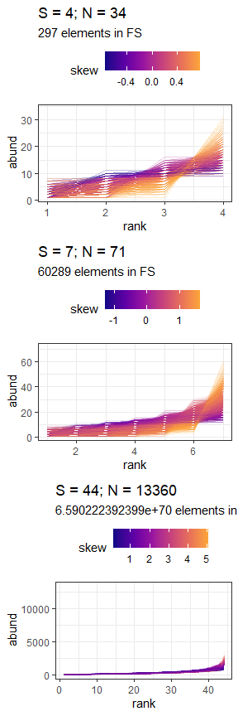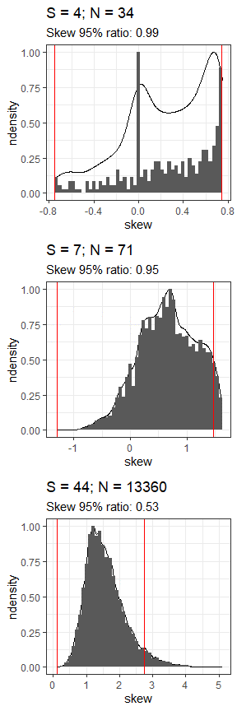

Large feasible sets may allow better detection of deviations from the statistical baseline by generating more specific, narrowly-defined baselines. We illustrate this phenomenon using 3 hypothetical communities: a small community (S = 4, N = 34; top row), an intermediate community (S = 7, N = 71; middle row), and a large community (S= 44, N = 13360; bottom row). Larger communities have more possible SADs, and thus larger feasible sets. The large communiity has approximately 6.59e+70 possible SADs in its feasible set, while the intermediate community has 60,289 and the small community has only 297. For every SAD sampled from the feasible set (left column), we calculate the skewness (color scale) or evenness (not shown). The distributions of these value constitute the statistical baseline for comparison to observed data. We defined a “breadth index” as the ratio of the range encompassed in the one-tailed 95% density interval (space between red lines, right), compared to the full range of values for the statistic (the maximum and minimum values from the sampled feasible set). As the size of the feasible set increases and the distribution of summary statistics narrows, the breadth index decreases, indicating an increase in the specificity of the statistical baseline.

##### Figure 3: Overall percentile results

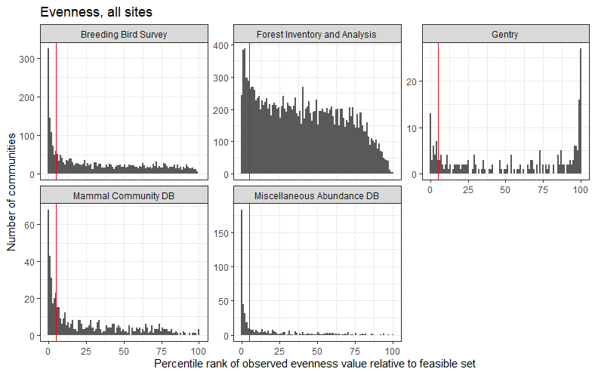

Histograms of percentile ranks for observed values of skewness (top) and evenness (bottom) relative to the distributions of values from the sampled feasible set for all communities. These plots exclude communities with fewer than 20 unique values for skewness or evenness in the sampled feasible set, and plots for skewness exclude communities with fewer than 3 species. The vertical red line marks the 95th percentile for skewness and the 5th percentile for evenness. At random, percentile ranks should be uniformly distributed from 0 to 100, and no more than 5% of values should be above or below the 95th and 5th percentiles, respectively.

##### Figure 4: Distribution of 95% intervals by dataset

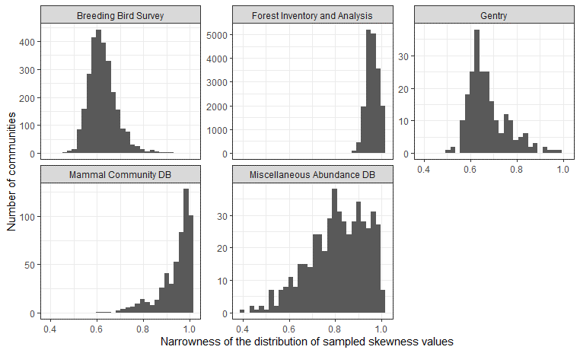

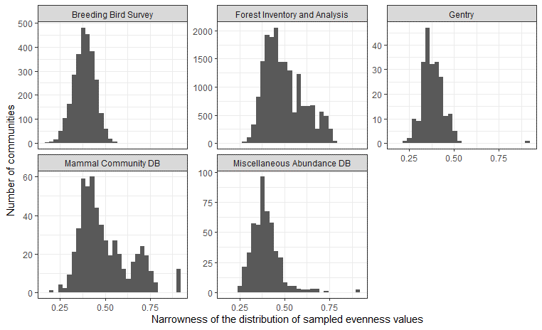

Histograms of the narrowness of the distribution of skewness (top) and evenness (bottom) values for the sampled feasible sets for communities from each dataset, excluding communities with fewer than 20 unique values for skewness or evenness and, for skewness, fewer than 3 species. The narrowness of the distribution is described as the ratio of the range of the one-tailed 95% interval to the full range of values. This value ranges from 0-1, with higher values indicating broader distributions.

##### Figure 5: Direct comparison of FIA and similarly sized sites

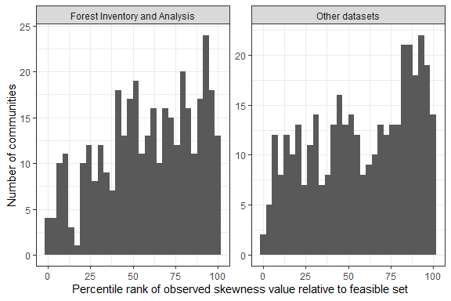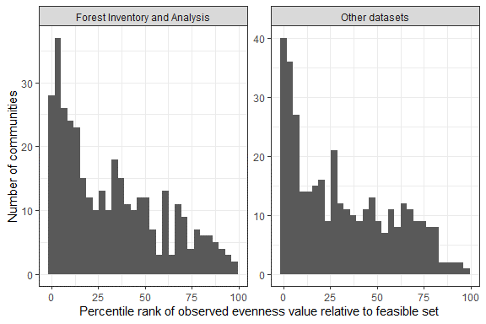

Histograms of percentile ranks for observed values of skewness (left) and evenness (right) relative to the distributions of values from the sampled feasible set for 371 pairs comprising a FIA community and a community from another dataset with the same S and N as the FIA community. These plots exclude communities with fewer than 20 unique values for skewness or evenness in the sampled feasible set. At random, percentile ranks should be uniformly distributed from 0 to 100.

**References**

Baldridge, E. (2015). *MiscAbundanceDB_main*. <https://doi.org/10.6084/m9.figshare.95843.v4>

Baldridge, E., Harris, D. J., Xiao, X., & White, E. P. (2016). An extensive comparison of species-abundance distribution models. *PeerJ*, *4*, e2823. <https://doi.org/10.7717/peerj.2823>

Chesson, P. (2000). Mechanisms of Maintenance of Species Diversity. *Annual Review of Ecology and Systematics*, *31*(1), 343–366. <https://doi.org/10.1146/annurev.ecolsys.31.1.343>

Favretti, M. (2018). Remarks on the Maximum Entropy Principle with Application to the Maximum Entropy Theory of Ecology. *Entropy*, *20*(1), 11. <https://doi.org/10.3390/e20010011>

Fisher, R. A., Corbet, A. S., & Williams, C. B. (1943). The Relation Between the Number of Species and the Number of Individuals in a Random Sample of an Animal Population. *Journal of Animal Ecology*, *12*(1), 42–58. JSTOR. <https://doi.org/10.2307/1411>

Frank, S. A. (2009). The common patterns of nature. *Journal of Evolutionary Biology*, *22*(8), 1563–1585. <https://doi.org/10.1111/j.1420-9101.2009.01775.x>

Frank, Steven A. (2019). The common patterns of abundance: The log series and Zipf’s law. *F1000Research*, *8*, 334. <https://doi.org/10.12688/f1000research.18681.1>

Haegeman, B., & Loreau, M. (2008). Limitations of entropy maximization in ecology. *Oikos*, *117*(11), 1700–1710. <https://doi.org/10.1111/j.1600-0706.2008.16539.x>

Harte, J., Zillio, T., Conlisk, E., & Smith, A. B. (2008). Maximum Entropy and the State-Variable Approach to Macroecology. *Ecology*, *89*(10), 2700–2711. <https://doi.org/10.1890/07-1369.1>

Harte, John. (2011). *Maximum Entropy and Ecology: A Theory of Abundance, Distribution, and Energetics*. Oxford University Press. <https://doi.org/10.1093/acprof:oso/9780199593415.001.0001>

Harte, John, & Newman, E. A. (2014). Maximum information entropy: A foundation for ecological theory. *Trends in Ecology & Evolution*, *29*(7), 384–389. <https://doi.org/10.1016/j.tree.2014.04.009>

Jaynes, E. T. (1957). Information Theory and Statistical Mechanics. *Physical Review*, *106*(4), 620–630. <https://doi.org/10.1103/PhysRev.106.620>

Lawton, J. H. (1999). Are There General Laws in Ecology? *Oikos*, *84*(2), 177. <https://doi.org/10.2307/3546712>

Locey, K. J., & White, E. P. (2013). How species richness and total abundance constrain the distribution of abundance. *Ecology Letters*, *16*(9), 1177–1185. <https://doi.org/10.1111/ele.12154>

McGill, B. J., Etienne, R. S., Gray, J. S., Alonso, D., Anderson, M. J., Benecha, H. K., Dornelas, M., Enquist, B. J., Green, J. L., He, F., Hurlbert, A. H., Magurran, A. E., Marquet, P. A., Maurer, B. A., Ostling, A., Soykan, C. U., Ugland, K. I., & White, E. P. (2007). Species abundance distributions: Moving beyond single prediction theories to integration within an ecological framework. *Ecology Letters*, *10*(10), 995–1015. <https://doi.org/10.1111/j.1461-0248.2007.01094.x>

Meyer, D., Dimitriadou, E., Hornik, K., Weingessel, A., & Leisch, F. (2019). *E1071: Misc Functions of the Department of Statistics, Probability Theory Group (Formerly: E1071), TU Wien*. <https://CRAN.R-project.org/package=e1071>

Phillips, O., & Miller, J. S. (2002). *Global patterns of plant diversity: Alwyn H. Gentry’s forest transect data set* (Vol. 89). Missouri Botanical Press.

Sauer, J. R., Link, W. A., Fallon, J. E., Pardieck, K. L., & Ziolkowski, D. J. (2013). The North American Breeding Bird Survey 1966–2011: Summary Analysis and Species Accounts. *North American Fauna*, *79 (79)*, 1–32. <https://doi.org/10.3996/nafa.79.0001>

Supp, S. R., & Ernest, S. K. M. (2014). Species-level and community-level responses to disturbance: A cross-community analysis. *Ecology*, *95*(7), 1717–1723. <https://doi.org/10.1890/13-2250.1>

Thibault, K. M., Supp, S. R., Giffin, M., White, E. P., & Ernest, S. K. M. (2011). Species composition and abundance of mammalian communities. *Ecology*, *92*(12), 2316–2316. <https://doi.org/10.1890/11-0262.1>

White, E. P., Thibault, K. M., & Xiao, X. (2012). Characterizing species abundance distributions across taxa and ecosystems using a simple maximum entropy model. *Ecology*, *93*(8), 1772–1778. <https://doi.org/10.1890/11-2177.1>

Woudenberg, S. W., Conkling, B. L., O’Connell, B. M., LaPoint, E. B., Turner, J. A., & Waddell, K. L. (2010). The Forest Inventory and Analysis Database: Database description and users manual version 4.0 for Phase 2. *Gen. Tech. Rep. RMRS-GTR-245. Fort Collins, CO: U.S. Department of Agriculture, Forest Service, Rocky Mountain Research Station. 336 p.*, *245*. <https://doi.org/10.2737/RMRS-GTR-245>

Xiao, X., O’Dwyer, J. P., & White, E. P. (2016). Comparing process-based and constraint-based approaches for modeling macroecological patterns. *Ecology*, *97*(5), 1228–1238. <https://doi.org/10.1890/15-0962.1>

Yenni, G., Adler, P. B., & Ernest, S. K. M. (2012). Strong self-limitation promotes the persistence of rare species. *Ecology*, *93*(3), 456–461. <https://doi.org/10.1890/11-1087.1>