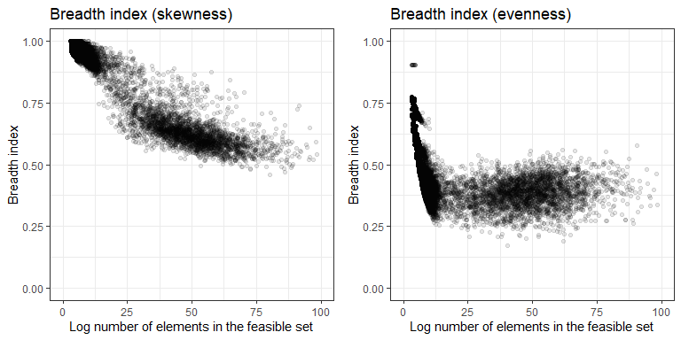

**Figure S5** The breadth index (defined as the ratio of the width of a one-tailed 95% density interval relative to the full range of a distribution) for the distributions of skewness and evenness obtained from the sampled feasible set declines as the number of elements in the feasible set increases. This indicates more narrow and well-resolved statistical baselines for large feasible sets.