##### Table 1: Percentile results (**move to supplement)**

|  |  |  |  |  |
| --- | --- | --- | --- | --- |
| **Dataset** | **Proportion of communities with skewness above 95th percentile** | **Number of communities analyzed for skewness** | **Proportion of communities with evenness below 5th percentile** | **Number of communities analyzed for evenness** |
| Breeding Bird Survey | 0.130184 | 2773 | 0.259647 | 2773 |
| Forest Inventory and Analysis | 0.054208 | 18300 | 0.093966 | 18113 |
| Gentry | 0.188341 | 223 | 0.151786 | 224 |
| Mammal Community DB | 0.158287 | 537 | 0.354244 | 542 |
| Miscellaneous Abundance DB | 0.345529 | 492 | 0.595918 | 490 |

|  |  |  |  |  |
| --- | --- | --- | --- | --- |
| **Dataset** | **Proportion of communities with skewness above 95th percentile** | **Number of communities analyzed for skewness** | **Proportion of communities with evenness below 5th percentile** | **Number of communities analyzed for evenness** |
| Forest Inventory and Analysis | 0.054208 | 18300 | 0.093966 | 18113 |
| Other datasets | 0.163478 | 4025 | 0.307272 | 4029 |

##### Figure 5: 95% intervals vs. size of feasible set **(move to supplement)**

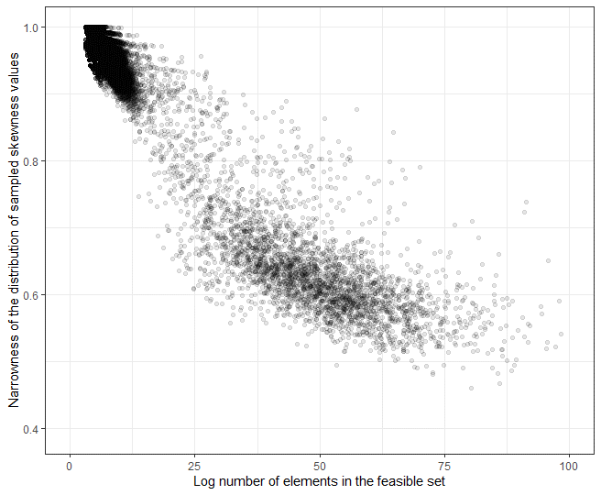

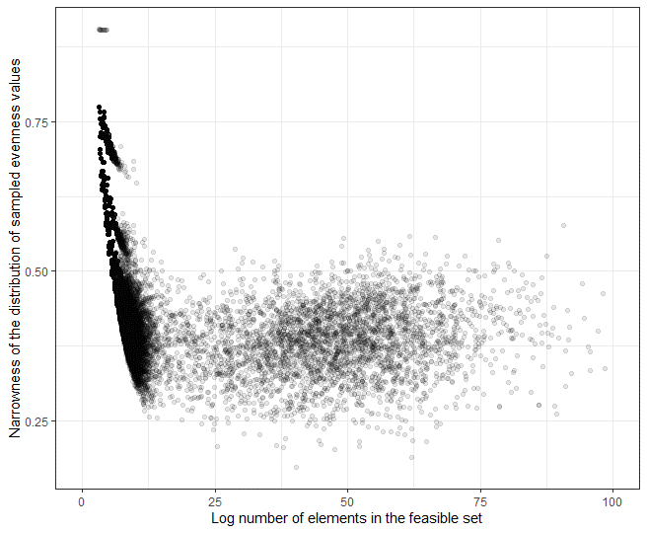

The narrowness of the distribution of skewness (top) and evenness (bottom) values from the sampled feasible set compared to the number of elements in the feasible set. The narrowness of the distribution is described as the ratio of the range of the 0-95th quantile values (for skewness), or the 5th-100th quantile values (for evenness), compared to the range of values from the entire sample. This ratio ranges from 0-1, with larger values indicating broader distributions and less-specific statistical expectations. The number of elements in the feasible set increases with increasing S, N, and average abundance (N/S). Both plots exclude feasible sets with fewer than 20 unique values for skewness or evenness, and skewness also excludes communities with S < 3.

##### Table 2: Percentile results comparing FIA to direct counterparts **(move to supplement)**

|  |  |  |  |  |
| --- | --- | --- | --- | --- |
| **Dataset** | **Proportion of communities with skewness above 95th percentile** | **Number of communities analyzed for skewness** | **Proportion of communities with evenness below 5th percentile** | **Number of communities analyzed for evenness** |
| Forest Inventory and Analysis | 0.0808625 | 371 | 0.1780822 | 365 |
| Other datasets | 0.0862534 | 371 | 0.2109589 | 365 |