# Figure S5.

## Warning: Removed 30 rows containing missing values (geom_point).  
  
## Warning: Removed 30 rows containing missing values (geom_point).

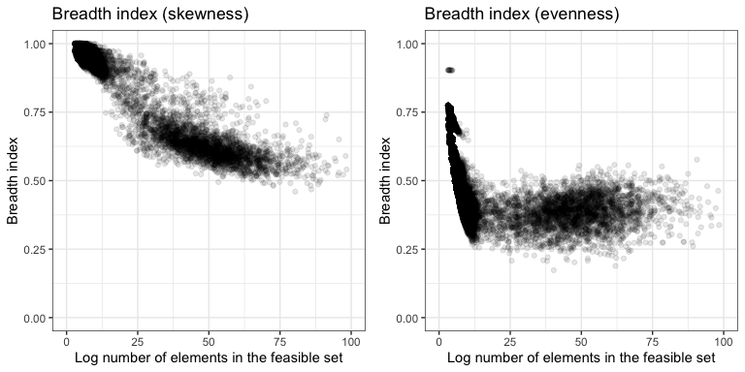

## quartz_off_screen   
## 2

**Legend.** The breadth index (defined as the ratio of the width of a one-tailed 95% density interval relative to the full range of a distribution) for the distributions of skewness and evenness obtained from the sampled feasible set declines as the number of elements in the feasible set increases. This indicates more narrow and well-resolved statistical baselines for large feasible sets.