# Figure S4

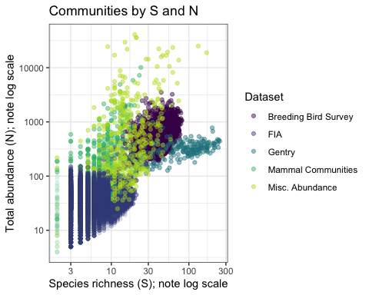

## quartz_off_screen   
## 2

**Legend.** Distribution of communities from each dataset in termof total abundance (N) and species richness (S). Communities range from few species and individuals (lower left corner) to speciose communities with many individuals (upper right). However, datasets are not evenly distributed across this state space due to differences in their sampling intensity, design, and underlying biology (e.g. productivity, regional richness, taxonomic group, or other factors that influence the capacity of a community to support large numbers of species and individuals).