Unusual Gentry communities

Renata Diaz

2021-03-22

The Gentry communities are extreme relative to hte other datasets (in grey), in that they have high species richness and low abundance. Of these, the most extreme communities have extremely low average abundance (e.g. N/S < 3).

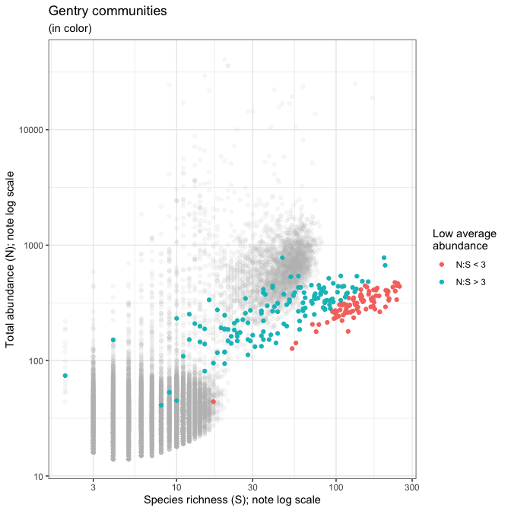

These low-average-abundance communities account for most of the signal of extreme values in the unusual direction for various metrics - that is, a **low** number of rare species and **low** skewness, and **high** Shannon and Simpson evenness. Gentry communities with average abundance > 3 tend to show the signal in the same direction as most other communities.

