Erodium and SPEI

library(dplyr)

##   
## Attaching package: 'dplyr'

## The following objects are masked from 'package:stats':  
##   
## filter, lag

## The following objects are masked from 'package:base':  
##   
## intersect, setdiff, setequal, union

library(soar)  
library(ggplot2)  
knitr::opts_chunk$set(echo = FALSE, fig.dim = c(6, 3))  
  
theme_set(theme_bw())  
  
era_grid <- facet_grid(cols = vars(oera), space = "free", scales = "free_x")  
both_scale <- scale_color_viridis_d(begin = .1, end = .7)  
both_fscale <- scale_fill_viridis_d(begin = .1, end = .7)  
  
era_df <- make_era_df() %>%  
 mutate(year = format.Date(event_date, "%Y")) %>%  
 mutate(year = as.integer(year))

## Loading in data version 2.95.0

## Joining, by = "plot"

## Loading in data version 2.95.0  
## Loading in data version 2.95.0

## Joining, by = "plot"

## Joining, by = c("year", "season", "plot")

## Joining, by = "year"

# Treatment levels

Gaps are for censuses in 1996, 2000, 2006, and 2011 where plots were censused but no individuals were found (of any species).

The interaction between plottype and era is not significant, so dropping it:

## Analysis of Deviance Table  
##   
## Model 1: erod_treatment_prop_abundance ~ oplottype * oera  
## Model 2: erod_treatment_prop_abundance ~ oplottype + oera  
## Resid. Df Resid. Dev Df Deviance Pr(>Chi)  
## 1 49 8.8253   
## 2 51 9.1253 -2 -0.30006 0.3984

## Joining, by = c("period", "oplottype")

## Joining, by = c("period", "oplottype", "oera")

## Scale for 'y' is already present. Adding another scale for 'y', which will  
## replace the existing scale.

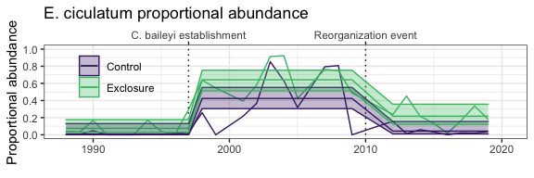

## oera oplottype prob SE df asymp.LCL asymp.UCL  
## 1 a_pre_pb CC 0.02145939 0.01079527 Inf 0.0003010452 0.04261774  
## 2 b_pre_reorg CC 0.39322644 0.05788210 Inf 0.2797795987 0.50667328  
## 3 c_post_reorg CC 0.06913796 0.02439780 Inf 0.0213191511 0.11695676  
## 4 a_pre_pb EE 0.06522945 0.02805998 Inf 0.0102328927 0.12022601  
## 5 b_pre_reorg EE 0.67343001 0.05516094 Inf 0.5653165486 0.78154346  
## 6 c_post_reorg EE 0.19115891 0.04953200 Inf 0.0940779846 0.28823984

## contrast oplottype estimate SE df z.ratio  
## 1 a_pre_pb - b_pre_reorg CC -0.37176705 0.05568789 Inf -6.675904  
## 2 a_pre_pb - c_post_reorg CC -0.04767856 0.02380256 Inf -2.003086  
## 3 b_pre_reorg - c_post_reorg CC 0.32408848 0.05393334 Inf 6.009057  
## 4 a_pre_pb - b_pre_reorg EE -0.60820056 0.05916867 Inf -10.279099  
## 5 a_pre_pb - c_post_reorg EE -0.12592946 0.05576805 Inf -2.258093  
## 6 b_pre_reorg - c_post_reorg EE 0.48227110 0.06677846 Inf 7.221956  
## p.value  
## 1 7.373158e-11  
## 2 1.114336e-01  
## 3 5.596030e-09  
## 4 3.241851e-14  
## 5 6.185877e-02  
## 6 1.558975e-12

## spei

## Loading required package: lmomco

## Loading required package: parallel

## # Package SPEI (1.7) loaded [try SPEINews()].

## Joining, by = c("year", "month")

## Registered S3 method overwritten by 'quantmod':  
## method from  
## as.zoo.data.frame zoo

## Joining, by = "year"

## Warning: Removed 22 rows containing missing values (position_stack).

## Warning: Removed 1 rows containing missing values (geom_col).

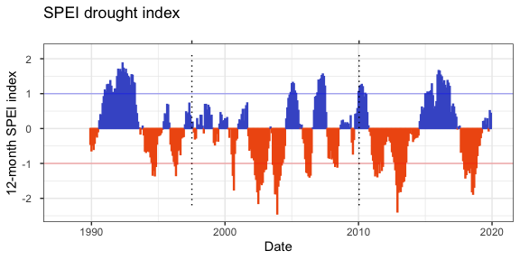

## Warning: Removed 22 rows containing missing values (position_stack).

## Warning: Removed 1 rows containing missing values (geom_col).

