MS figs

# Figures

## 1. Compensation and total energy use

Lines are 6-month moving averages. Horizontal lines + ribbons are means and SE or CL from GLM or GLS.

**Compensation** refers to compensatory gains in energy use by small granivores on exclosure plots relative to controls. Calculated as $\frac{SmgranExclosure−SmgranControl}{DipoControl}$. **Total energy** refers to the overall loss in energy use caused by kangaroo rat removal.

## Joining, by = "era"

## Joining, by = "era"

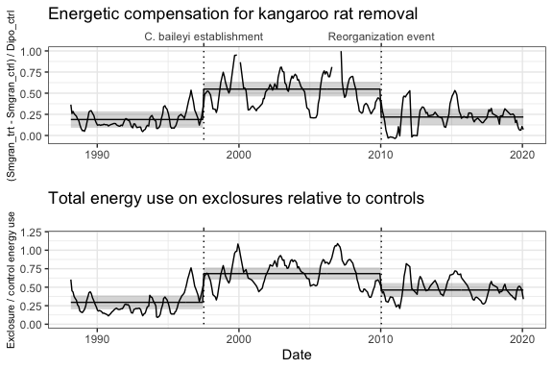

## TableGrob (2 x 1) "arrange": 2 grobs  
## z cells name grob  
## 1 1 (1-1,1-1) arrange gtable[layout]  
## 2 2 (2-2,1-1) arrange gtable[layout]

## 2. Rodent community composition

## Joining, by = c("period", "oplottype")

## Joining, by = c("period", "oplottype", "censusdate")

## Joining, by = c("period", "oplottype")  
## Joining, by = c("period", "oplottype")

## Warning: Removed 114 row(s) containing missing values (geom_path).  
  
## Warning: Removed 114 row(s) containing missing values (geom_path).

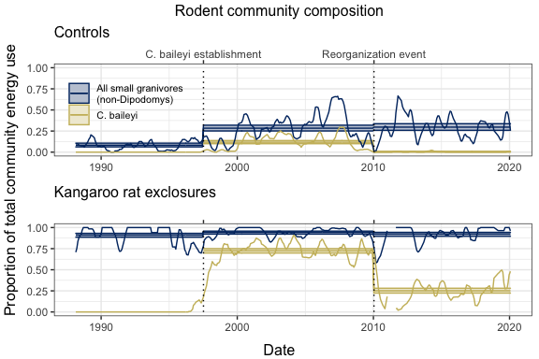

## TableGrob (4 x 2) "arrange": 5 grobs  
## z cells name grob  
## 1 1 (2-2,2-2) arrange gtable[layout]  
## 2 2 (3-3,2-2) arrange gtable[layout]  
## 3 3 (1-1,2-2) arrange text[GRID.text.240]  
## 4 4 (4-4,2-2) arrange text[GRID.text.241]  
## 5 5 (1-4,1-1) arrange text[GRID.text.242]

# Model results

## 1. Compensation & total energy use

### Compensation

## Generalized least squares fit by REML  
## Model: smgran_comp ~ era   
## Data: compensation   
## AIC BIC logLik  
## 62.62169 81.75169 -26.31084  
##   
## Correlation Structure: Continuous AR(1)  
## Formula: ~period   
## Parameter estimate(s):  
## Phi   
## 0.5141927   
##   
## Coefficients:  
## Value Std.Error t-value p-value  
## (Intercept) 0.1887873 0.04849229 3.893142 0.0001  
## erab_pre_reorg 0.3596238 0.06442326 5.582204 0.0000  
## erac_post_reorg 0.0296368 0.06914950 0.428590 0.6685  
##   
## Correlation:   
## (Intr) erb_p_  
## erab_pre_reorg -0.742   
## erac_post_reorg -0.701 0.528  
##   
## Standardized residuals:  
## Min Q1 Med Q3 Max   
## -2.2604463 -0.4462201 -0.1654825 0.4070499 7.5010175   
##   
## Residual standard error: 0.2973631   
## Degrees of freedom: 342 total; 339 residual

Estimates:

## era emmean SE df lower.CL upper.CL  
## 1 a_pre_pb 0.1887873 0.04849229 56.08128 0.09164873 0.2859260  
## 2 b_pre_reorg 0.5484112 0.04322376 60.40971 0.46196281 0.6348595  
## 3 c_post_reorg 0.2184241 0.04931009 59.73403 0.11978024 0.3170680

Contrasts:

## contrast estimate SE df t.ratio  
## 1 a_pre_pb - b_pre_reorg -0.35962380 0.06442326 60.44042 -5.5822045  
## 2 a_pre_pb - c_post_reorg -0.02963679 0.06914950 57.97849 -0.4285901  
## 3 b_pre_reorg - c_post_reorg 0.32998701 0.06502290 62.66119 5.0749352  
## p.value  
## 1 1.767478e-06  
## 2 9.038819e-01  
## 3 1.099306e-05

### Total energy use

## Generalized least squares fit by REML  
## Model: total_e_rat ~ era   
## Data: energy_ratio   
## AIC BIC logLik  
## -148.4102 -129.2802 79.2051  
##   
## Correlation Structure: Continuous AR(1)  
## Formula: ~period   
## Parameter estimate(s):  
## Phi   
## 0.6318768   
##   
## Coefficients:  
## Value Std.Error t-value p-value  
## (Intercept) 0.2955610 0.04616723 6.401964 0.0000  
## erab_pre_reorg 0.3881293 0.06052106 6.413128 0.0000  
## erac_post_reorg 0.1666183 0.06555100 2.541812 0.0115  
##   
## Correlation:   
## (Intr) erb_p_  
## erab_pre_reorg -0.740   
## erac_post_reorg -0.703 0.537  
##   
## Standardized residuals:  
## Min Q1 Med Q3 Max   
## -1.9222140 -0.6293278 -0.1030659 0.5885477 5.4080459   
##   
## Residual standard error: 0.2404411   
## Degrees of freedom: 342 total; 339 residual

Estimates:

## era emmean SE df lower.CL upper.CL  
## 1 a_pre_pb 0.2955610 0.04616723 36.54729 0.2019781 0.3891438  
## 2 b_pre_reorg 0.6836903 0.04074287 38.89409 0.6012729 0.7661077  
## 3 c_post_reorg 0.4621793 0.04658963 38.01610 0.3678648 0.5564937

Contrasts:

## contrast estimate SE df t.ratio  
## 1 a_pre_pb - b_pre_reorg -0.3881293 0.06052106 40.83178 -6.413128  
## 2 a_pre_pb - c_post_reorg -0.1666183 0.06555100 37.48394 -2.541812  
## 3 b_pre_reorg - c_post_reorg 0.2215110 0.06082448 41.78673 3.641807  
## p.value  
## 1 3.379158e-07  
## 2 3.965179e-02  
## 3 2.096605e-03

## 2. Community composition

### All small granivores

##   
## Call:  
## glm(formula = smgran_prop ~ oera * oplottype, family = quasibinomial(),   
## data = smgran_dat)  
##   
## Deviance Residuals:   
## Min 1Q Median 3Q Max   
## -1.43532 -0.24132 0.08354 0.39955 1.04138   
##   
## Coefficients:  
## Estimate Std. Error t value Pr(>|t|)   
## (Intercept) 0.56734 0.05530 10.260 < 2e-16 ***  
## oera.L 0.60675 0.09777 6.206 9.47e-10 ***  
## oera.Q -0.45238 0.09375 -4.826 1.73e-06 ***  
## oplottype.L 2.78683 0.07820 35.636 < 2e-16 ***  
## oera.L:oplottype.L -0.69768 0.13827 -5.046 5.80e-07 ***  
## oera.Q:oplottype.L 0.18833 0.13258 1.421 0.156   
## ---  
## Signif. codes: 0 '***' 0.001 '**' 0.01 '*' 0.05 '.' 0.1 ' ' 1  
##   
## (Dispersion parameter for quasibinomial family taken to be 0.1838797)  
##   
## Null deviance: 537.12 on 682 degrees of freedom  
## Residual deviance: 121.81 on 677 degrees of freedom  
## (1 observation deleted due to missingness)  
## AIC: NA  
##   
## Number of Fisher Scoring iterations: 5

Estimates:

Estimates from emmeans differ numerically (very slightly) from estimates obtained via predict() and back transformation. Below are estimates from emmeans, because those are what are used for contrasts.

## oera oplottype prob SE df asymp.LCL asymp.UCL  
## 1 a_pre_pb CC 0.08164722 0.010997378 Inf 0.06009275 0.1032017  
## 2 b_pre_reorg CC 0.28390991 0.017089764 Inf 0.25041459 0.3174052  
## 3 c_post_reorg CC 0.29641647 0.019582852 Inf 0.25803478 0.3347982  
## 4 a_pre_pb EE 0.91112174 0.011428789 Inf 0.88872172 0.9335218  
## 5 b_pre_reorg EE 0.94259757 0.008816024 Inf 0.92531848 0.9598767  
## 6 c_post_reorg EE 0.92328231 0.011469992 Inf 0.90080154 0.9457631

Estimates from predict:

## oplottype oera est lower upper  
## 1 CC a_pre_pb 0.08164722 0.06218075 0.1065157  
## 2 EE a_pre_pb 0.91112174 0.88545594 0.9314816  
## 3 CC b_pre_reorg 0.28390991 0.25100331 0.3192915  
## 4 EE b_pre_reorg 0.94259757 0.92220436 0.9578890  
## 5 CC c_post_reorg 0.29641647 0.25879944 0.3370151  
## 6 EE c_post_reorg 0.92328231 0.89696410 0.9433030

Contrasts:

## contrast oplottype estimate SE df z.ratio  
## 1 a_pre_pb - b_pre_reorg CC -0.20226269 0.02032246 Inf -9.9526681  
## 2 a_pre_pb - c_post_reorg CC -0.21476925 0.02245953 Inf -9.5625006  
## 3 b_pre_reorg - c_post_reorg CC -0.01250656 0.02599131 Inf -0.4811824  
## 4 a_pre_pb - b_pre_reorg EE -0.03147583 0.01443397 Inf -2.1806774  
## 5 a_pre_pb - c_post_reorg EE -0.01216057 0.01619191 Inf -0.7510277  
## 6 b_pre_reorg - c_post_reorg EE 0.01931526 0.01446662 Inf 1.3351609  
## p.value  
## 1 2.520206e-14  
## 2 2.353673e-14  
## 3 8.802138e-01  
## 4 7.449544e-02  
## 5 7.330034e-01  
## 6 3.756080e-01

### C. baileyi

##   
## Call:  
## glm(formula = pb_prop ~ oera * oplottype, family = quasibinomial(),   
## data = pb_nozero)  
##   
## Deviance Residuals:   
## Min 1Q Median 3Q Max   
## -0.77785 -0.23751 -0.07486 0.18362 1.66203   
##   
## Coefficients:  
## Estimate Std. Error t value Pr(>|t|)   
## (Intercept) -2.0044 0.1601 -12.523 < 2e-16 ***  
## oera.L -2.0922 0.2263 -9.243 < 2e-16 ***  
## oplottype.L 2.7474 0.2263 12.138 < 2e-16 ***  
## oera.L:oplottype.L 0.8987 0.3201 2.807 0.00521 **   
## ---  
## Signif. codes: 0 '***' 0.001 '**' 0.01 '*' 0.05 '.' 0.1 ' ' 1  
##   
## (Dispersion parameter for quasibinomial family taken to be 0.1092629)  
##   
## Null deviance: 242.507 on 454 degrees of freedom  
## Residual deviance: 51.407 on 451 degrees of freedom  
## (1 observation deleted due to missingness)  
## AIC: NA  
##   
## Number of Fisher Scoring iterations: 8

Estimates:

## oera oplottype prob SE df asymp.LCL asymp.UCL  
## 1 b_pre_reorg CC 0.117288823 0.009400892 Inf 0.0988634136 0.135714232  
## 2 c_post_reorg CC 0.002798409 0.001746027 Inf -0.0006237412 0.006220559  
## 3 b_pre_reorg EE 0.724806906 0.013048523 Inf 0.6992322718 0.750381541  
## 4 c_post_reorg EE 0.251282850 0.014409839 Inf 0.2230400854 0.279525616

Estimates from predict:

## oplottype oera est lower upper  
## 1 CC b_pre_reorg 0.117288823 0.0997539092 0.137435493  
## 2 EE b_pre_reorg 0.724806906 0.6979584533 0.750123216  
## 3 CC c_post_reorg 0.002798409 0.0008022601 0.009713007  
## 4 EE c_post_reorg 0.251282850 0.2235730526 0.281183261  
## 5 CC <NA> NA NA NA  
## 6 EE <NA> NA NA NA

Contrasts:

## contrast oplottype estimate SE df z.ratio  
## 1 b_pre_reorg - c_post_reorg CC 0.1144904 0.009561662 Inf 11.97390  
## 2 b_pre_reorg - c_post_reorg EE 0.4735241 0.019439841 Inf 24.35843  
## p.value  
## 1 4.868315e-33  
## 2 4.719332e-131

