NDVI and other climate variables

# NDVI

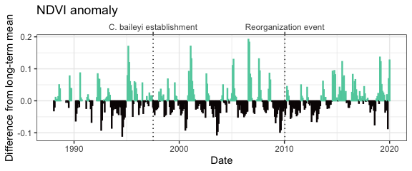

Monthly NDVI (mean NDVI from Landsat 5, 7, and 8) difference from long-term mean for each month from January 1988-January 2020.

# Precipitation

## Total precipitation

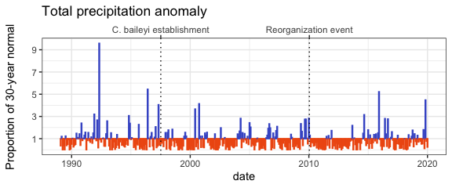

Monthly precipitation anomaly as a proportion of the 30-year PRISM normal.

## Summer precipitation

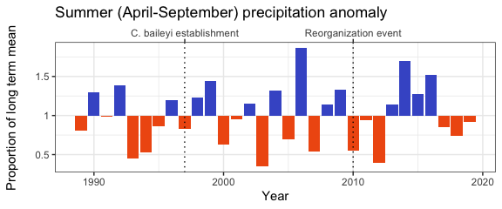

Summer precipitation (total precipitation from April-September per year) as a proportion of the long-term mean.

## Winter precipitation

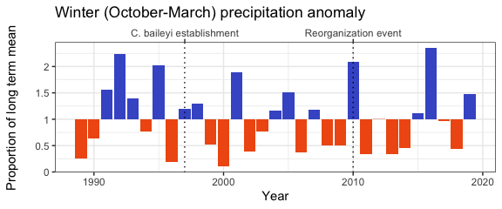

Winter precipitation (total precipitation from October-March the following year) as a proportion of the long-term mean.

# Temperature

## Mean temperature

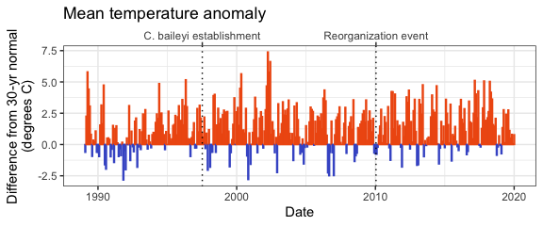

Mean temperature anomaly as difference from the 30-year PRISM normal.

## Days above 35 C

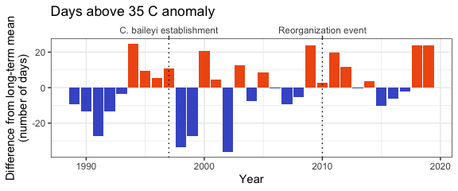

Number of days per calendar year when maximum temperature > 35C; anomaly calculated as difference from long term mean.

## Min temperature

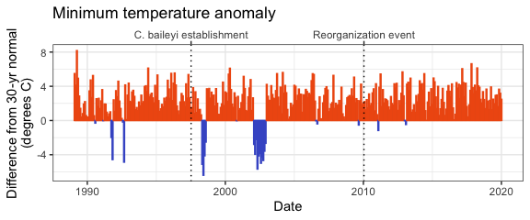

Min temperature anomaly as difference from the 30-year PRISM normal.

## Max temperature

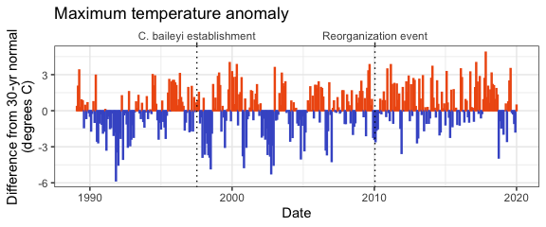

Max temperature anomaly as difference from the 30-year PRISM normal.