NDVI and other climate variables

# NDVI

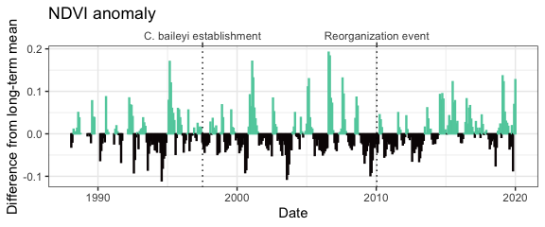

Monthly NDVI (mean NDVI from Landsat 5, 7, and 8; Maesk et al. 2006; Vermote et al. 2016) difference from long-term mean for each month from January 1988-January 2020. Obtained via *portalr* (Christensen et al. 2019)

# Precipitation

## Total precipitation

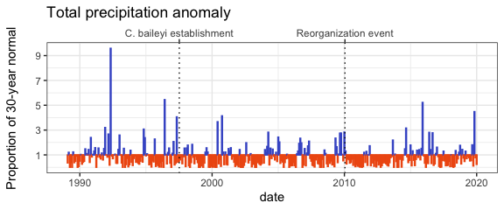

Monthly precipitation anomaly as a proportion of the 30-year PRISM normal.

## Summer precipitation

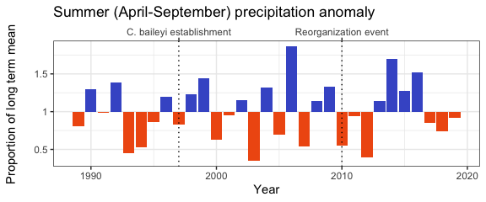

Summer precipitation (total precipitation from April-September per year) as a proportion of the long-term mean.

## Winter precipitation

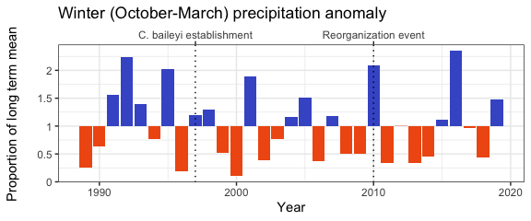

Winter precipitation (total precipitation from October-March the following year) as a proportion of the long-term mean.

# Temperature

## Mean temperature

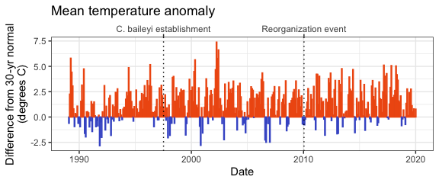

Mean temperature anomaly as difference from the 30-year PRISM normal.

## Days above 35 C

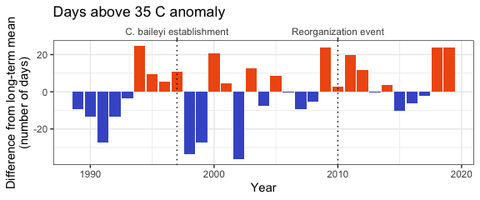

Number of days per calendar year when maximum temperature > 35C; anomaly calculated as difference from long term mean.

## Min temperature

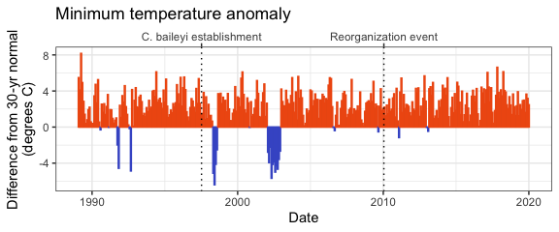

Min temperature anomaly as difference from the 30-year PRISM normal.

## Max temperature

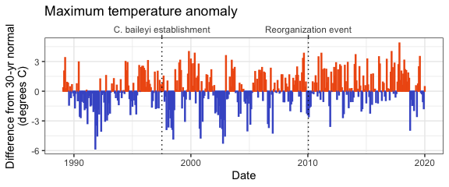

Max temperature anomaly as difference from the 30-year PRISM normal.

# References

Christensen, E. M., G. M. Yenni, H. Ye, J. L. Simonis, E. K. Bledsoe, R. M. Diaz, S. D. Taylor, E. P. White, and S. K. M. Ernest. 2019. portalr: an R package for summarizing and using the Portal Project Data. Journal of Open Source Software 4:1098.

Masek, J.G., Vermote, E.F., Saleous, N., Wolfe, R., Hall, F.G., Huemmrich, F., Gao, F., Kutler, J., and Lim, T.K. (2006). A Landsat surface reflectance data set for North America, 1990-100, IEEE Geoscience and Remote Sensing Letters. 3:68-72.

PRISM Climate Group, Oregon State University, <http://prism.oregonstate.edu>, Norm81m (Monthly and annual 1981-2010 Normals), active as of October 2019, latest release date July 2012.

Vermote, E., Justice, C., Claverie, M., & Franch, B. (2016). Preliminary analysis of the performance of the Landsat 8/OLI land surface reflectance product. Remote Sensing of Environment, 185, 46-56.