Big question: Do different neighborhoods affect the housing prices?

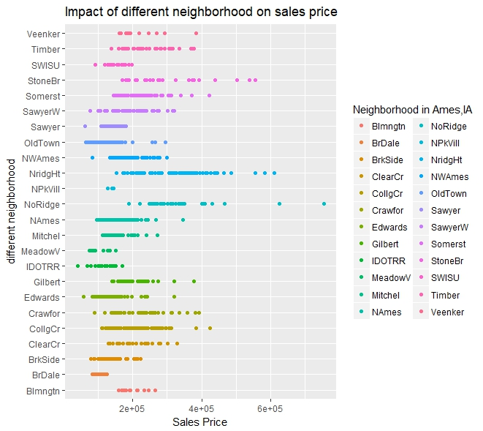

1. Neighborhoods North VS South

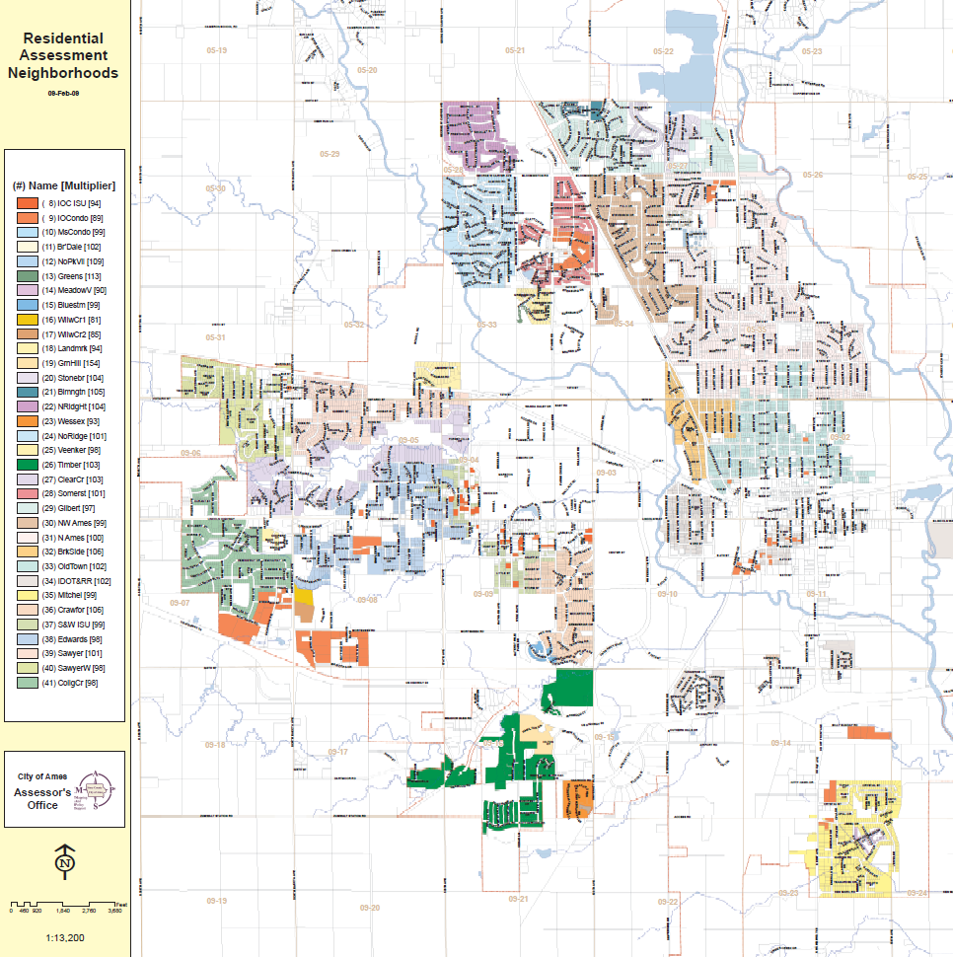

1. Bloomington Heights

2. Brookside

3. Gilbert

4. North Ames

5. Northridge

6. Northpark Villa

7. Northridge Heights

8. Northwest Ames

9. Old Town

10. Somerset

11. Stone Brook

12. Briardale

13. Bluestem

14. Clear Creek

15. College Creek

16. Crawford

17. Edwards

18. Meadow Village

19. Mitchell

20. South & West of Iowa State University

21. Sawyer

22. Sawyer West

23. Timberland

24. Veenker

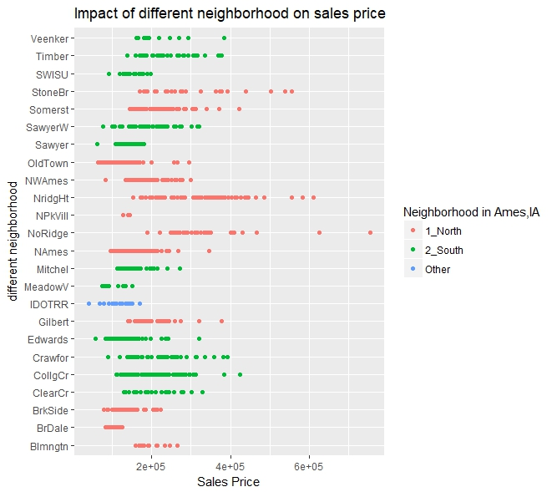

Yes, neighborhoods matters. Now what variables are more important in different neighborhoods?

1. Pick the variables that are available to the buyers

1. MSSubClass: Identifies the type of dwelling involved in the sale.
2. MSZoning: Identifies the general zoning classification of the sale.
3. LotArea: Lot size in square feet
4. Neighborhood: Physical locations within Ames city limits
5. HouseStyle: Style of dwelling
6. YearBuilt: Original construction date
7. YearRemodAdd: Remodel date (same as construction date if no remodeling or additions)
8. RoofMatl: Roof material
9. Exterior1st: Exterior covering on house
10. Exterior2nd: Exterior covering on house (if more than one material)
11. BsmtFinType1: Rating of basement finished area
12. TotalBsmtSF: Total square feet of basement area (Redistribute the categories)
13. Heating: Type of heating
14. GrLivArea: Above grade (ground) living area square feet
15. FullBath: Full bathrooms above grade
16. HalfBath: Half baths above grade
17. BedroomAbvGr: Bedrooms above grade (does NOT include basement bedrooms)
18. Fireplaces: Number of fireplaces
19. GarageType: Garage location
20. GarageCars: Size of garage in car capacity
21. GarageArea: Size of garage in square feet
22. MoSold: Month Sold (MM)
23. YrSold: Year Sold (YYYY)
24. SaleCondition: Condition of sale

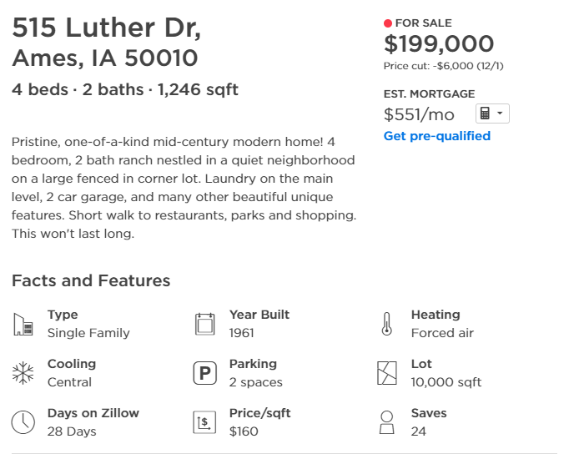

2. Decision tree model

Based on the available info, using all 24 predictors, the first decision tree model was built. The result below shows the split in the neighborhood, as we expected. However, the split was not 100% matching as the location

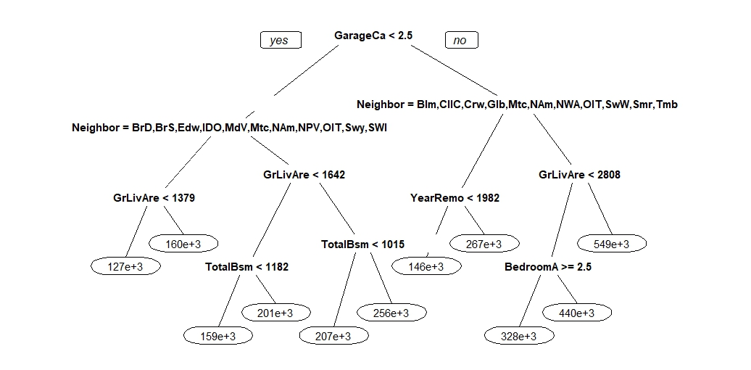

**12. Briardale**

**2. Brookside**

**17. Edwards**

**Iowa DOT and Rail Road**

**18. Meadow Village**

**19. Mitchell**

**4. North Ames**

**6. Northpark Villa**

**9. Old Town**

**21. Sawyer**

**22. Sawyer West**

**1. Bloomington Heights**

**15. College Creek**

**16. Crawford**

**3. Gilbert**

**19. Mitchell**

**4. North Ames**

**8. Northwest Ames**

**9. Old Town**

**20. South & West of Iowa State University**

**10. Somerset**

**23. Timberland**