

**JMJ MARIST BROTHERS** **MIT 261 - Project**

Notre Dame of Marbel University 1st Semester SY 2025-2026

City of Koronadal Mrs. Brenda M. Balala, MIT

**MIT 261– Parallel and Distributed Systems**

**Project Title**

**Parallel and Distributed Student Performance Analytics Platform with MongoDB**

**Group members: Assigned Tasked**

1. **ALDEN QUIÑONES REGISTRAR**
2. **JUSTINE JOHN JAY DE ALA FACULTY**
3. **APRIL ANN BUDIONGAN STUDENT**

Contents

Registrar’s Office Dashboard Reports 4

1. St/////udent Academic Standing Report 4

2. Subject Pass/Fail Distribution 5

3. Enrollment Trend Analysis 5

4. Incomplete Grades Report 5

5. Retention and Dropout Rates 5

6. Top Performers per Program 6

7. Curriculum Progress and Advising 6

Faculty Dashboard Reports 9

1. Class Grade Distribution 9

2. Student Progress Tracker 10

3. Subject Difficulty Heatmap 11

4. Intervention Candidates List 11

5. Grade Submission Status 12

6. Custom Query Builder 12

7. Students Grade Analytics (Per Teacher) 13

Students Dashboard Reports 14

1. Academic Transcript Viewer 18

2. Performance Trend Over Time 18

3. Subject Difficulty Ratings 19

4. Comparison with Class Average 19

5. Passed vs Failed Summary 19

6.Curriculum and Subject Viewer 20

Source code for each dashboard and reports 22

Registrar’s Office Dashboard Reports 22

1. Student Academic Standing Report 22

2. Subject Pass/Fail Distribution 22

3. Enrollment Trend Analysis 22

4. Incomplete Grades Report 22

5. Retention and Dropout Rates 22

6. Top Performers per Program 22

7. Curriculum Progress and Advising 22

Faculty Dashboard Reports 22

1. Class Grade Distribution 22

2. Student Progress Tracker 22

3. Subject Difficulty Heatmap 22

4. Intervention Candidates List 22

5. Grade Submission Status 22

6. Custom Query Builder 22

7. Students Grade Analytics (Per Teacher) 22

Students Dashboard Reports 22

1. Academic Transcript Viewer 22

2. Performance Trend Over Time 22

3. Subject Difficulty Ratings 22

4. Comparison with Class Average 22

5. Passed vs Failed Summary 22

6. Curriculum and Subject Viewer 22

Recommendations for Dashboard Enhancements 22

MongoDB Database Model for Dashboard Enhancements 23

# Registrar’s Office Dashboard Reports

## 1. Student Academic Standing Report

|  |  |  |  |  |  |  |
| --- | --- | --- | --- | --- | --- | --- |
|  |  |  |  |  |  |  |
|  |  |  |  |  |  |  |
|  |  |  |  |  |  |  |

**Insight**: Enables quick identification of high achievers, students needing support, and overall academic distribution.

## 2. Subject Pass/Fail Distribution

| **Subject Code** | **Subject Name** | **Semester** | **Pass Count** | **Fail Count** | **Pass %** | **Fail %** |
| --- | --- | --- | --- | --- | --- | --- |
| MATH101 | Calculus I | Spring 2025 | 120 | 30 | 80% | 20% |
| BIO201 | Cell Biology | Spring 2025 | 90 | 10 | 90% | 10% |
| … | … | … | … | … | … | … |

**Insight**: Clear visibility into subject-level performance by term—supports targeted interventions.

## 3. Enrollment Trend Analysis

| **Semester** | **Total Enrollment** | **New Enrollees** | **Dropouts** | **Retention Rate (%)** |
| --- | --- | --- | --- | --- |
| Fall 2023 | 2000 | 500 | 100 | 95% |
| Spring 2024 | 1950 | 300 | 150 | 92% |
| Fall 2024 | 2100 | 600 | 50 | 97% |

**Insight**: Plotting these values as line or area charts reveals enrollment dynamics—semester over semester or year over year.

## 4. Incomplete Grades Report

| **Student ID** | **Name** | **Course Code** | **Course Title** | **Term** | **Grade Status** |
| --- | --- | --- | --- | --- | --- |
| S005 | Alice Reyes | ENG301 | Advanced English | Spring 2025 | INC |
| S010 | Mark Lee | HIST210 | Modern History | Spring 2025 | Dropped |
| … | … | … | … | … | … |

**Insight**: Helps Registrar’s Office identify and follow up with students and instructors regarding incomplete or missing grade submissions.

## 5. Retention and Dropout Rates

|  | **Semester to Semester** | **Retained** | **Dropped Out** | **Retention Rate (%)** |
| --- | --- | --- | --- | --- |
|  | Fall 2023 → Spring 2024 | 450 | 50 | 90% |
|  | Fall 2022 → Spring 2023 | 430 | 70 | 86% |
|  | … | … | … | … |

**Insight**: Measures student persistence and identifies retention issues early—critical for institutional planning.

## 6. Top Performers per Program

| **Program** | **Semester** | **Student ID** | **Student Name** | **GPA** | **Rank** |
| --- | --- | --- | --- | --- | --- |
| Computer Science | Spring 2025 | S025 | Maria Cruz | 99 | 1 |
| Biology | Spring 2025 | S038 | Ahmed Khan | 99 | 1 |
| … | … | … | … | … | … |

**Insight**: Highlights top academic performers by discipline—great for awards, recognitions, and program-level analysis.

## 7. Curriculum Progress and Advising

Filter by course and student name:

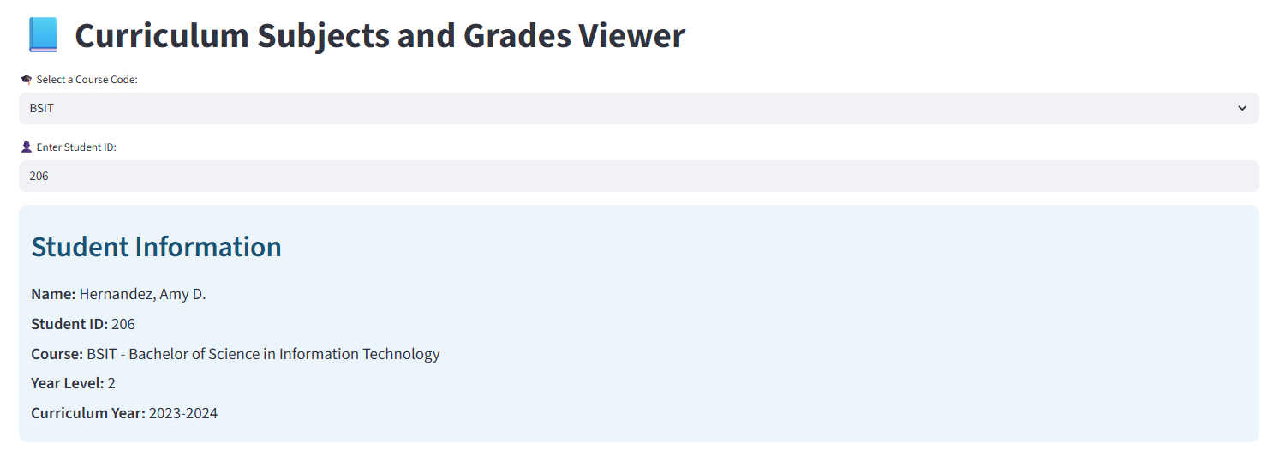

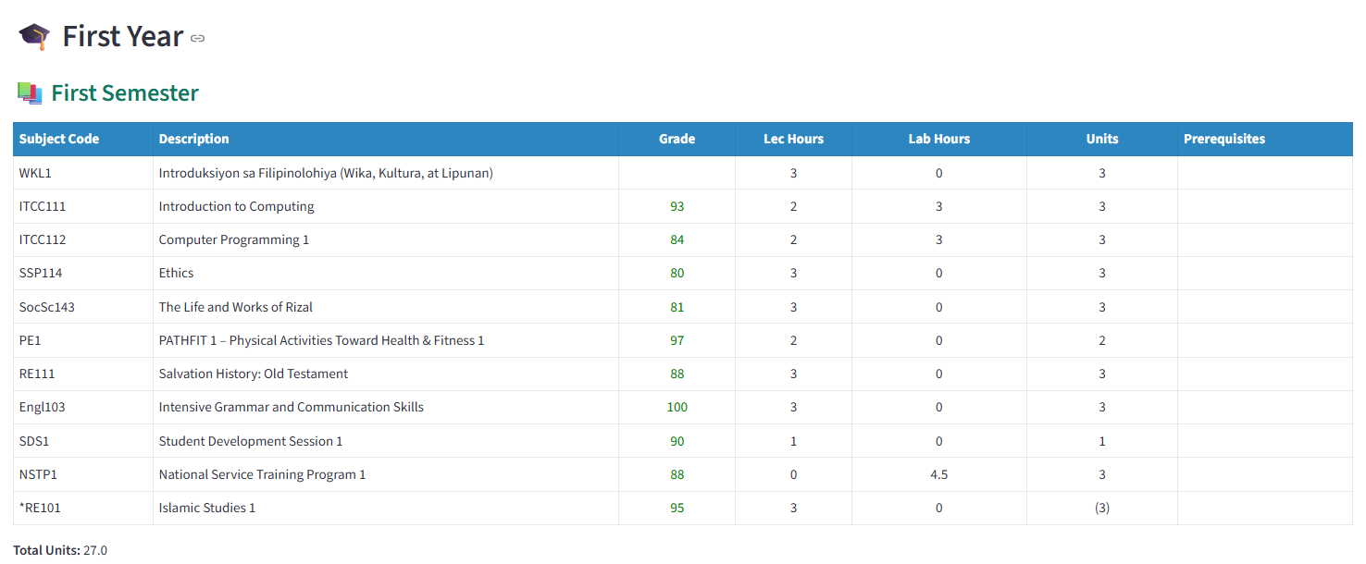

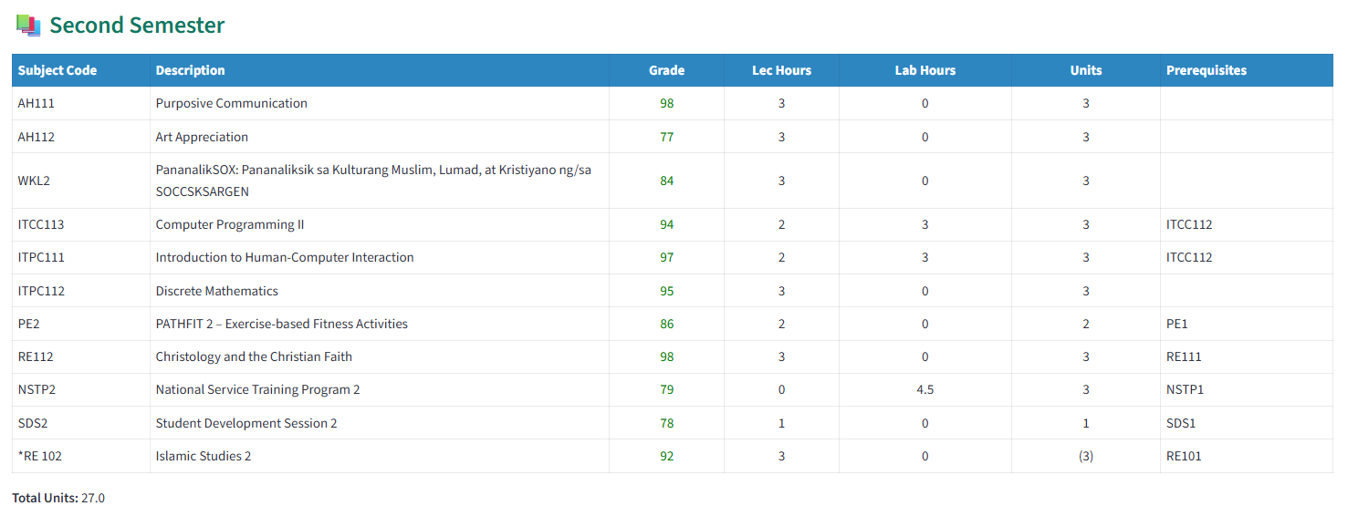

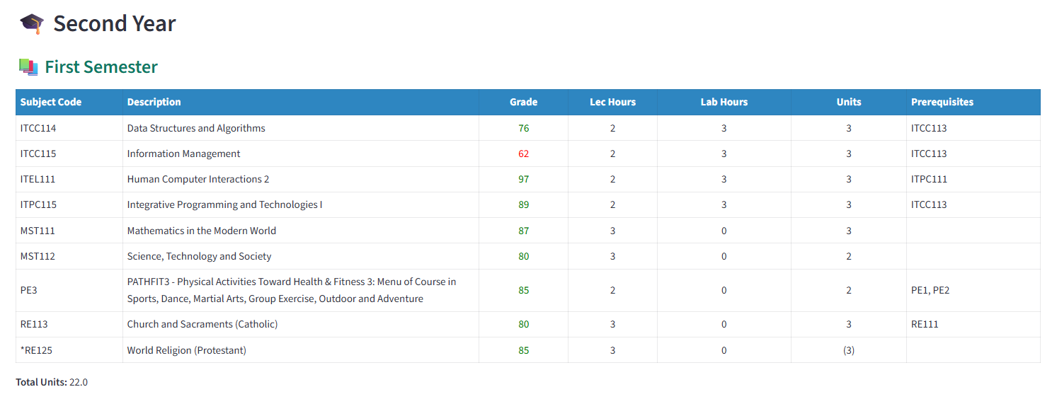

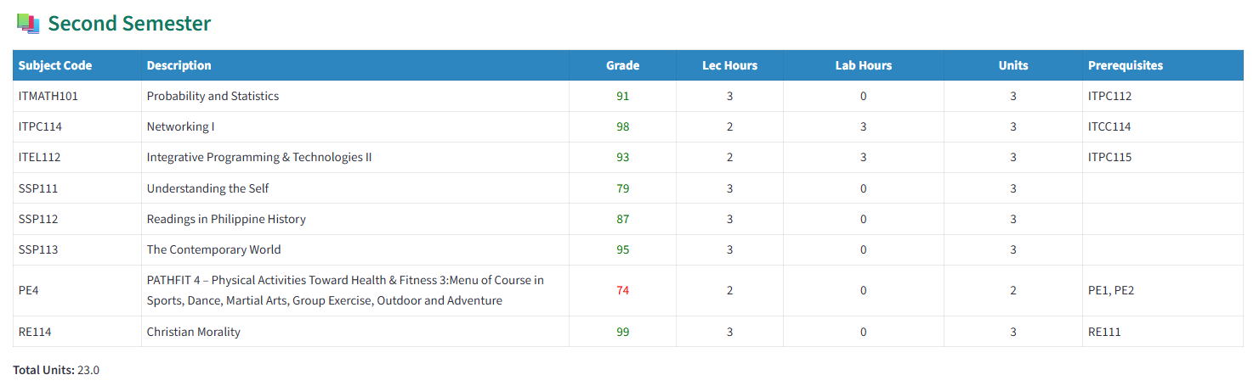

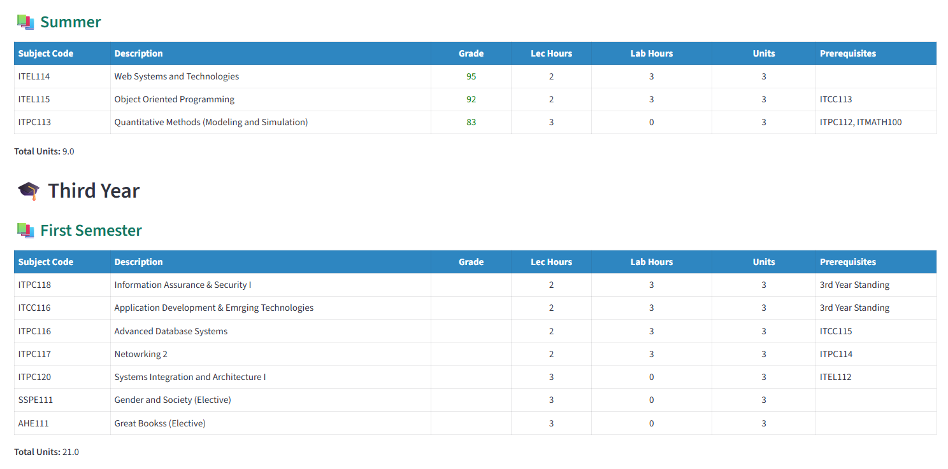

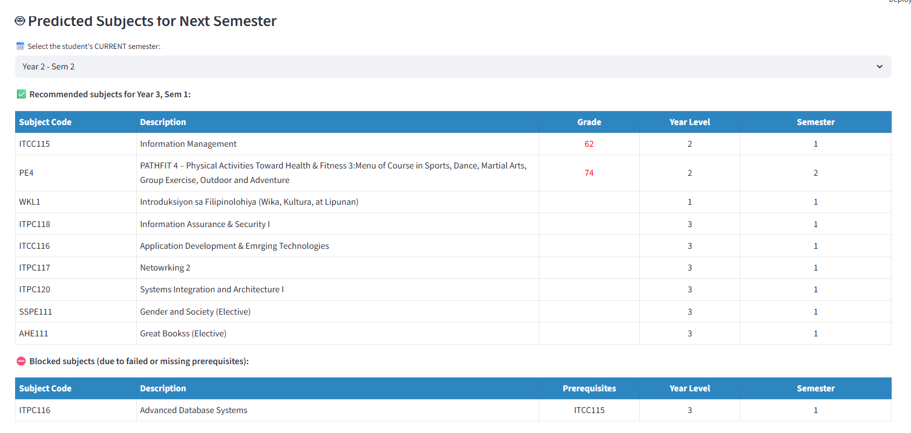

# Faculty Reports

## Class Grade Distribution

* Displays a histogram of student grade distribution per subject.

Faculty Name: Antonio Luna

Semester and School Year: FirstSem - 2024

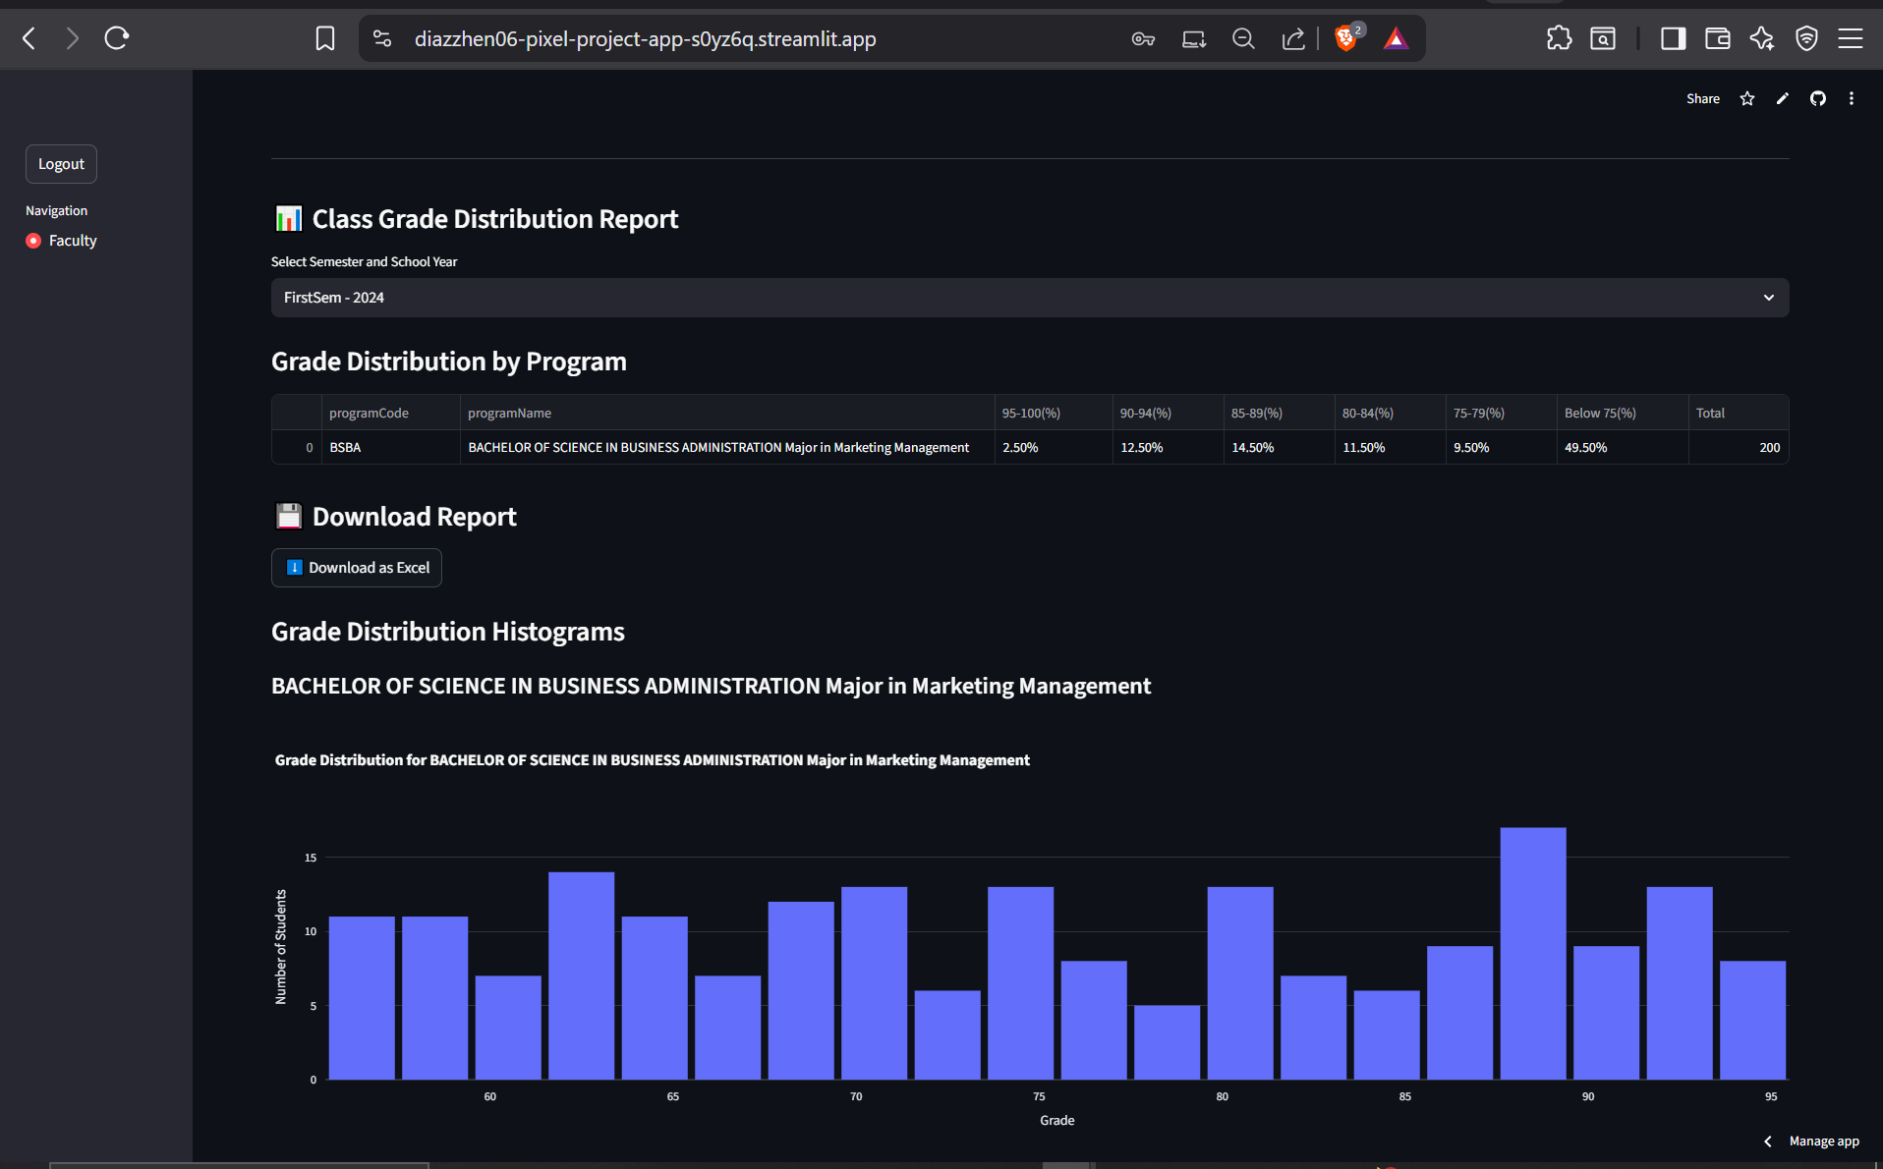

**Insight:** Quick view of overall performance—identifies courses with skewed grade distributions or those with high failure rates.

## Student Progress Tracker

Shows longitudinal performance for individual students.

Filtered by Subject or course or YearLevel

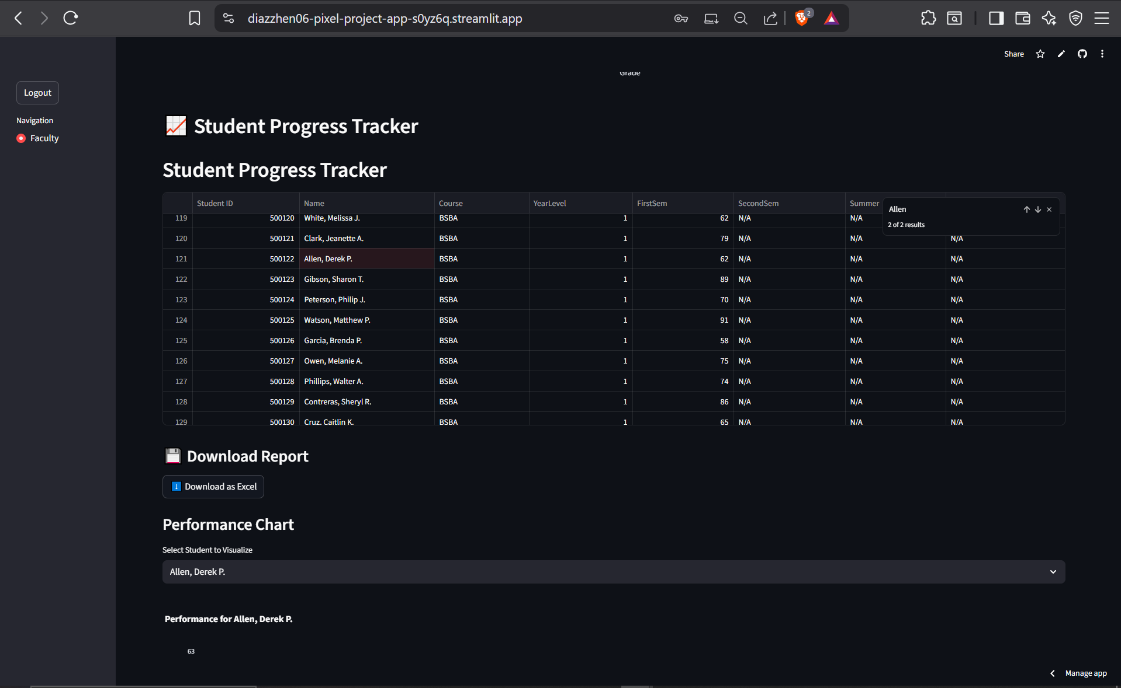

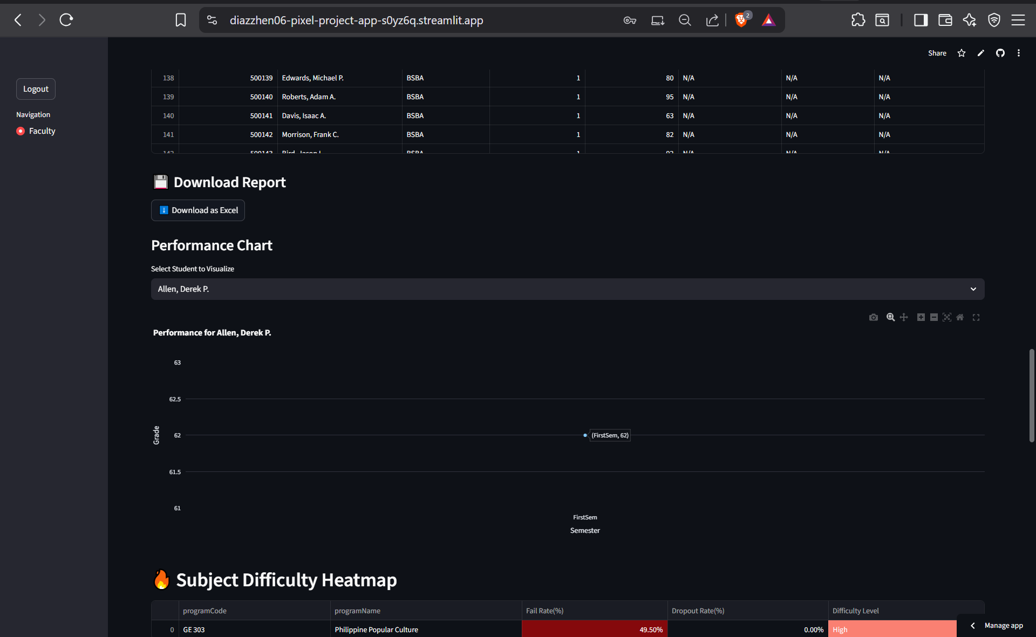

## Subject Difficulty Heatmap

* Visualizes subjects with high failure or dropouts
* 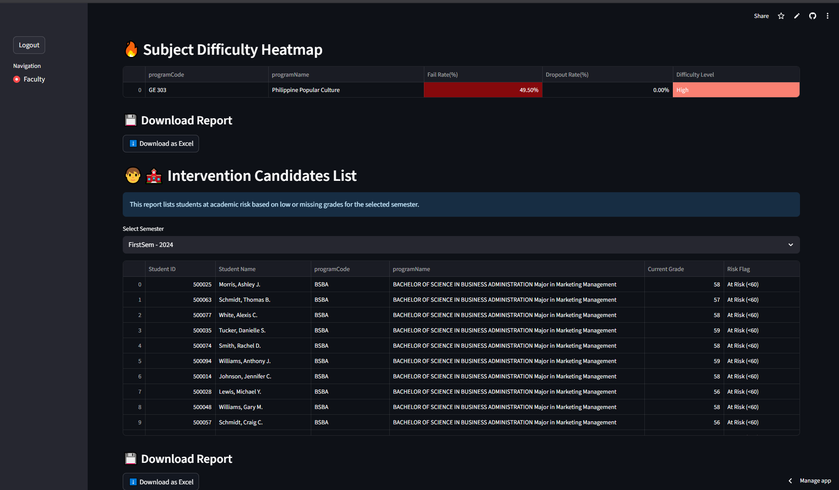Subjects handled by the faculty

## Intervention Candidates List

* Lists students at academic risk based on current semester data (e.g. low grades, missing grades)

Faculty Name: Antonio Luna

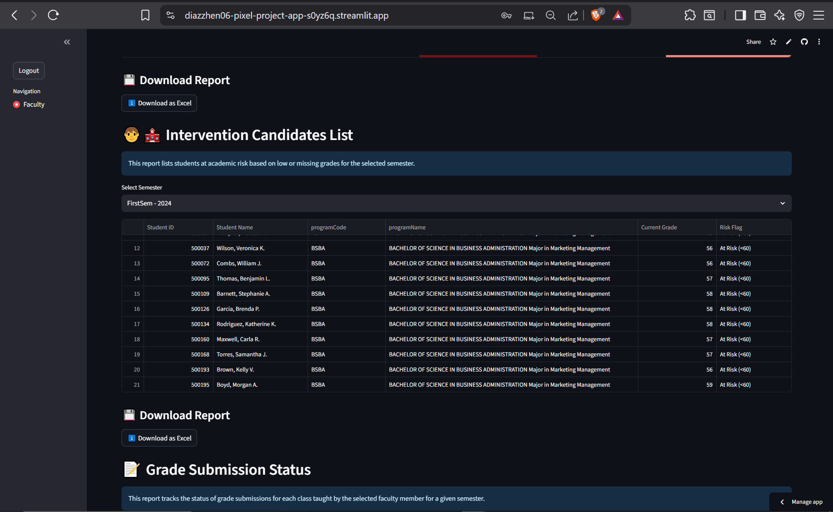

## Grade Submission Status

* Tracks the status of grade submissions by faculty for each class. (e.g. complete grades, with blank grades)

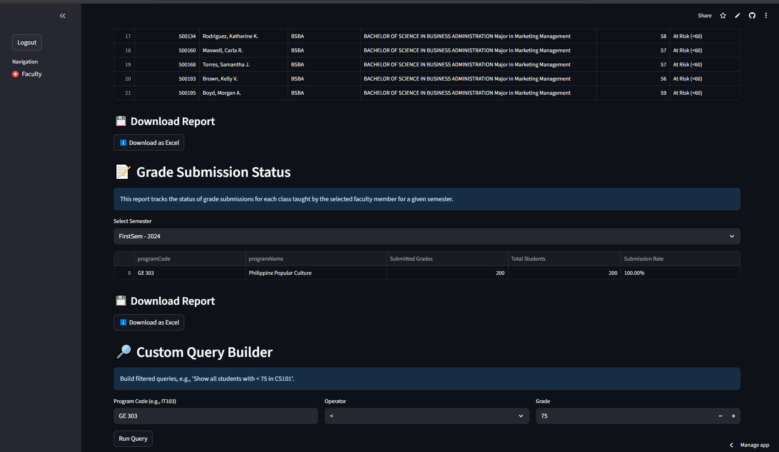

## Custom Query Builder

* Allows users to build filtered queries (e.g., “Show all students with <75 in CS101”).

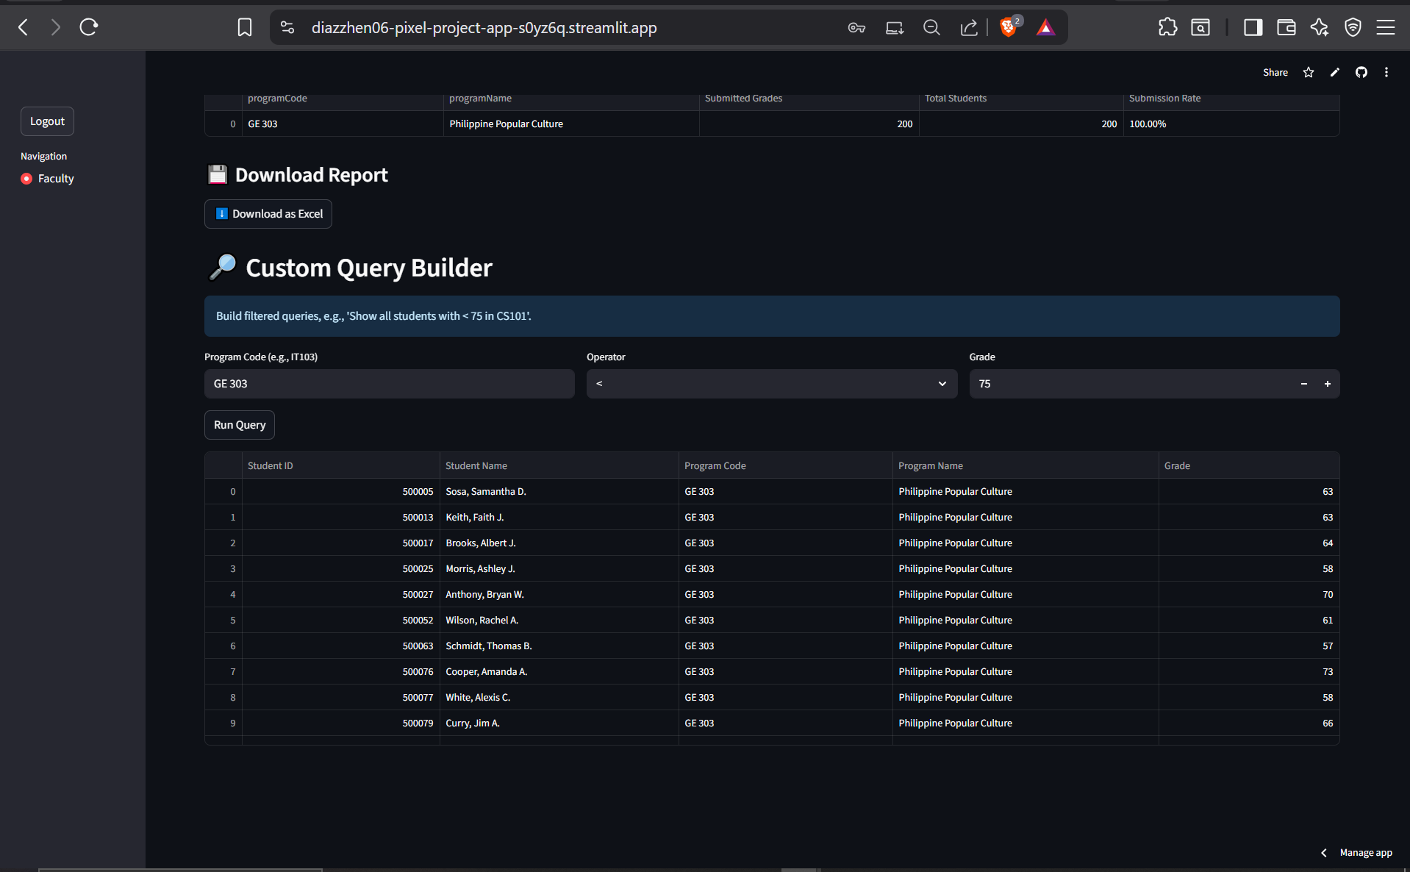

## Students Grade Analytics (Per Teacher)

📊 Grades Summary of Faculty: Antonio Luna

Student Grades

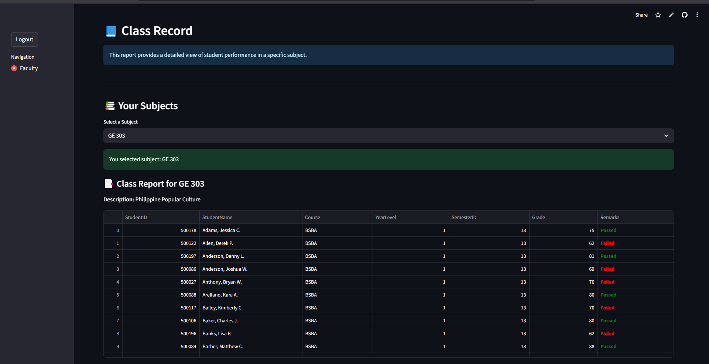

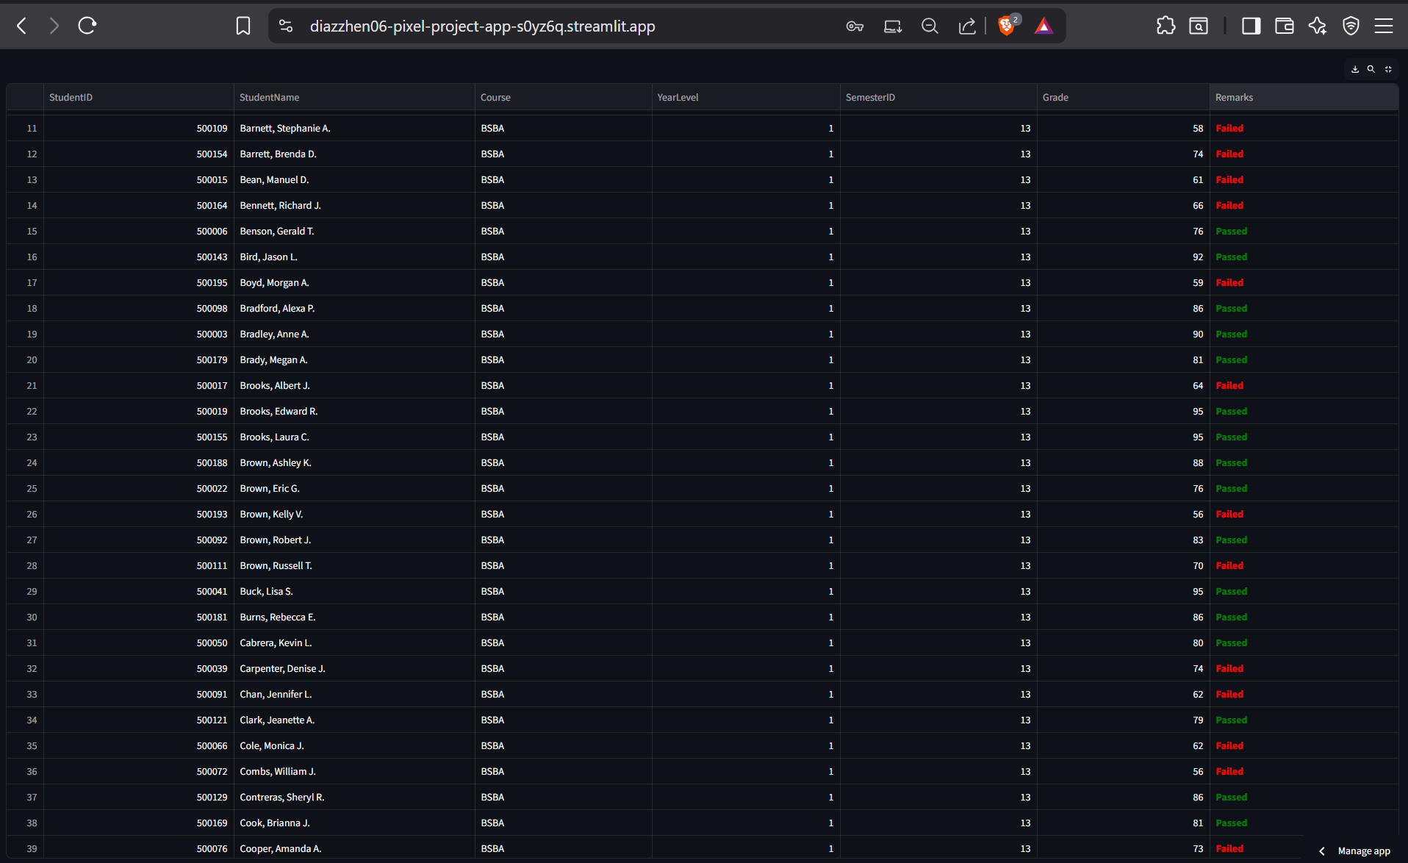

# 

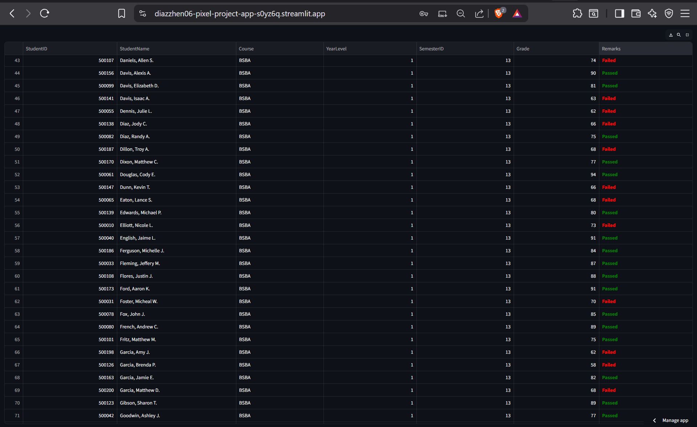

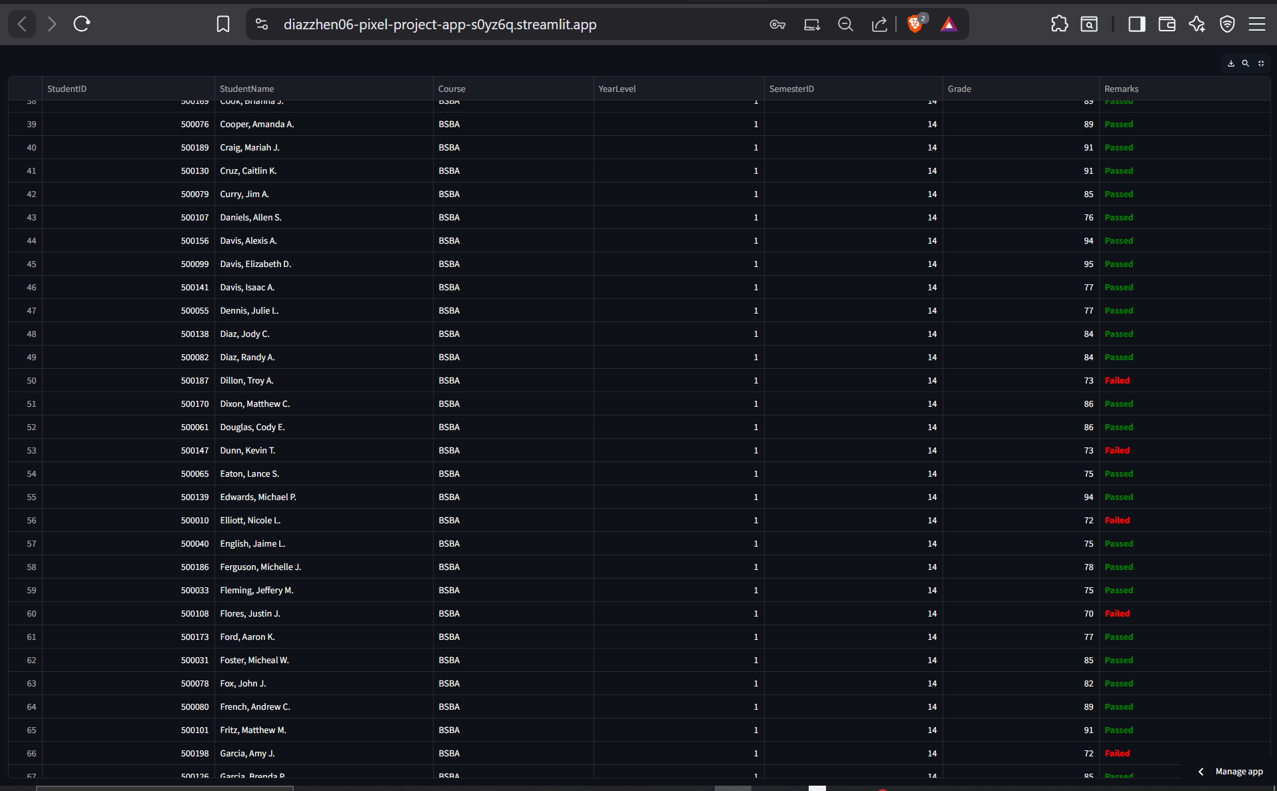

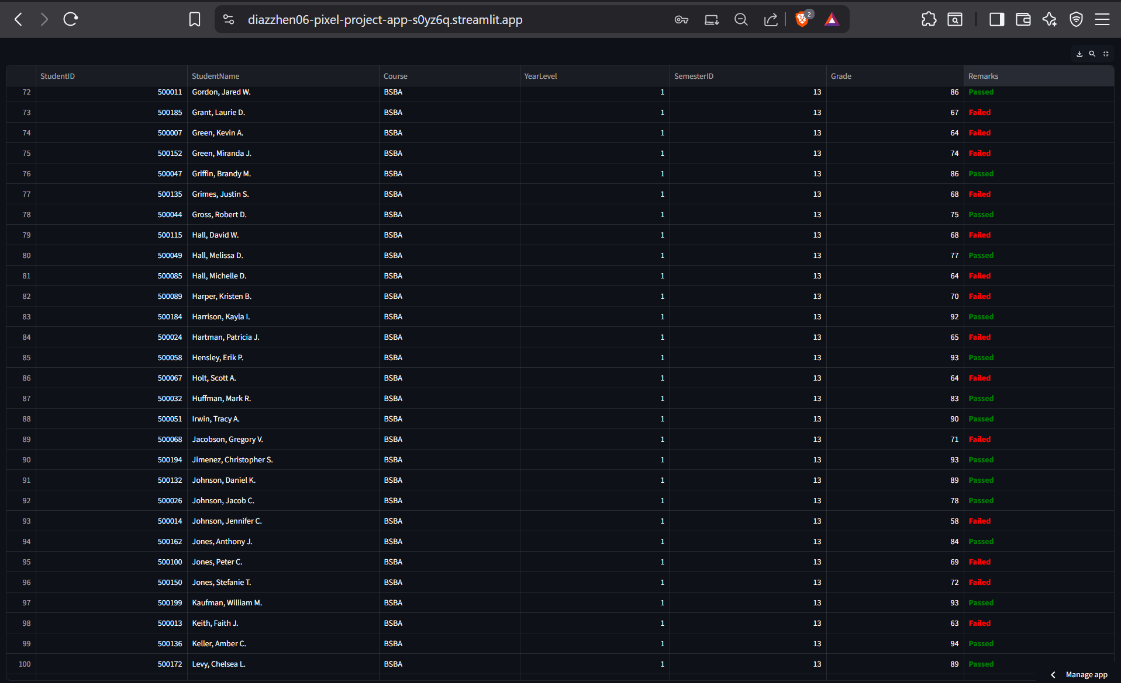

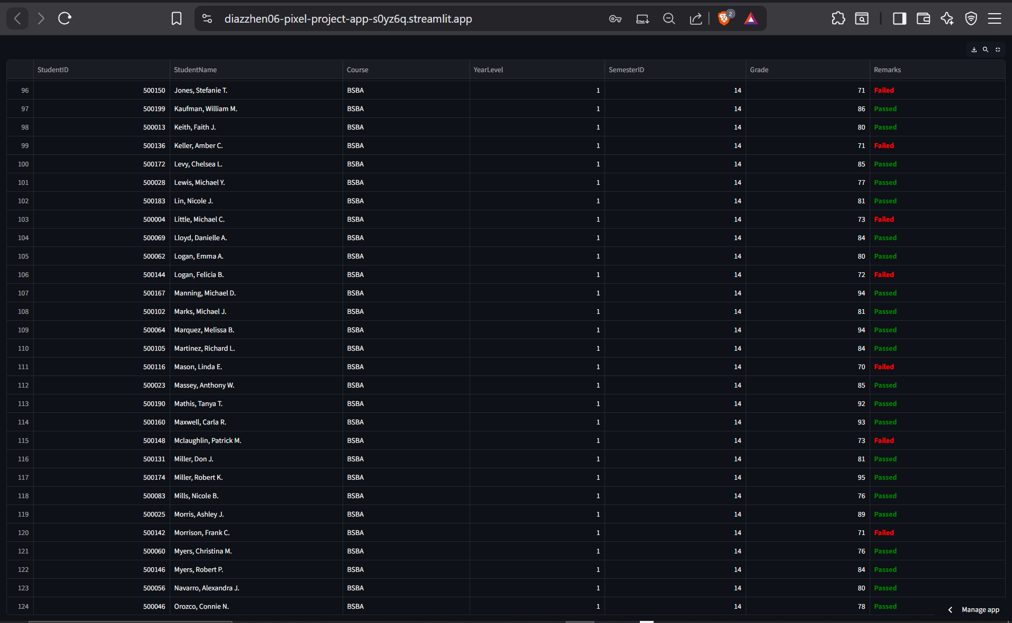

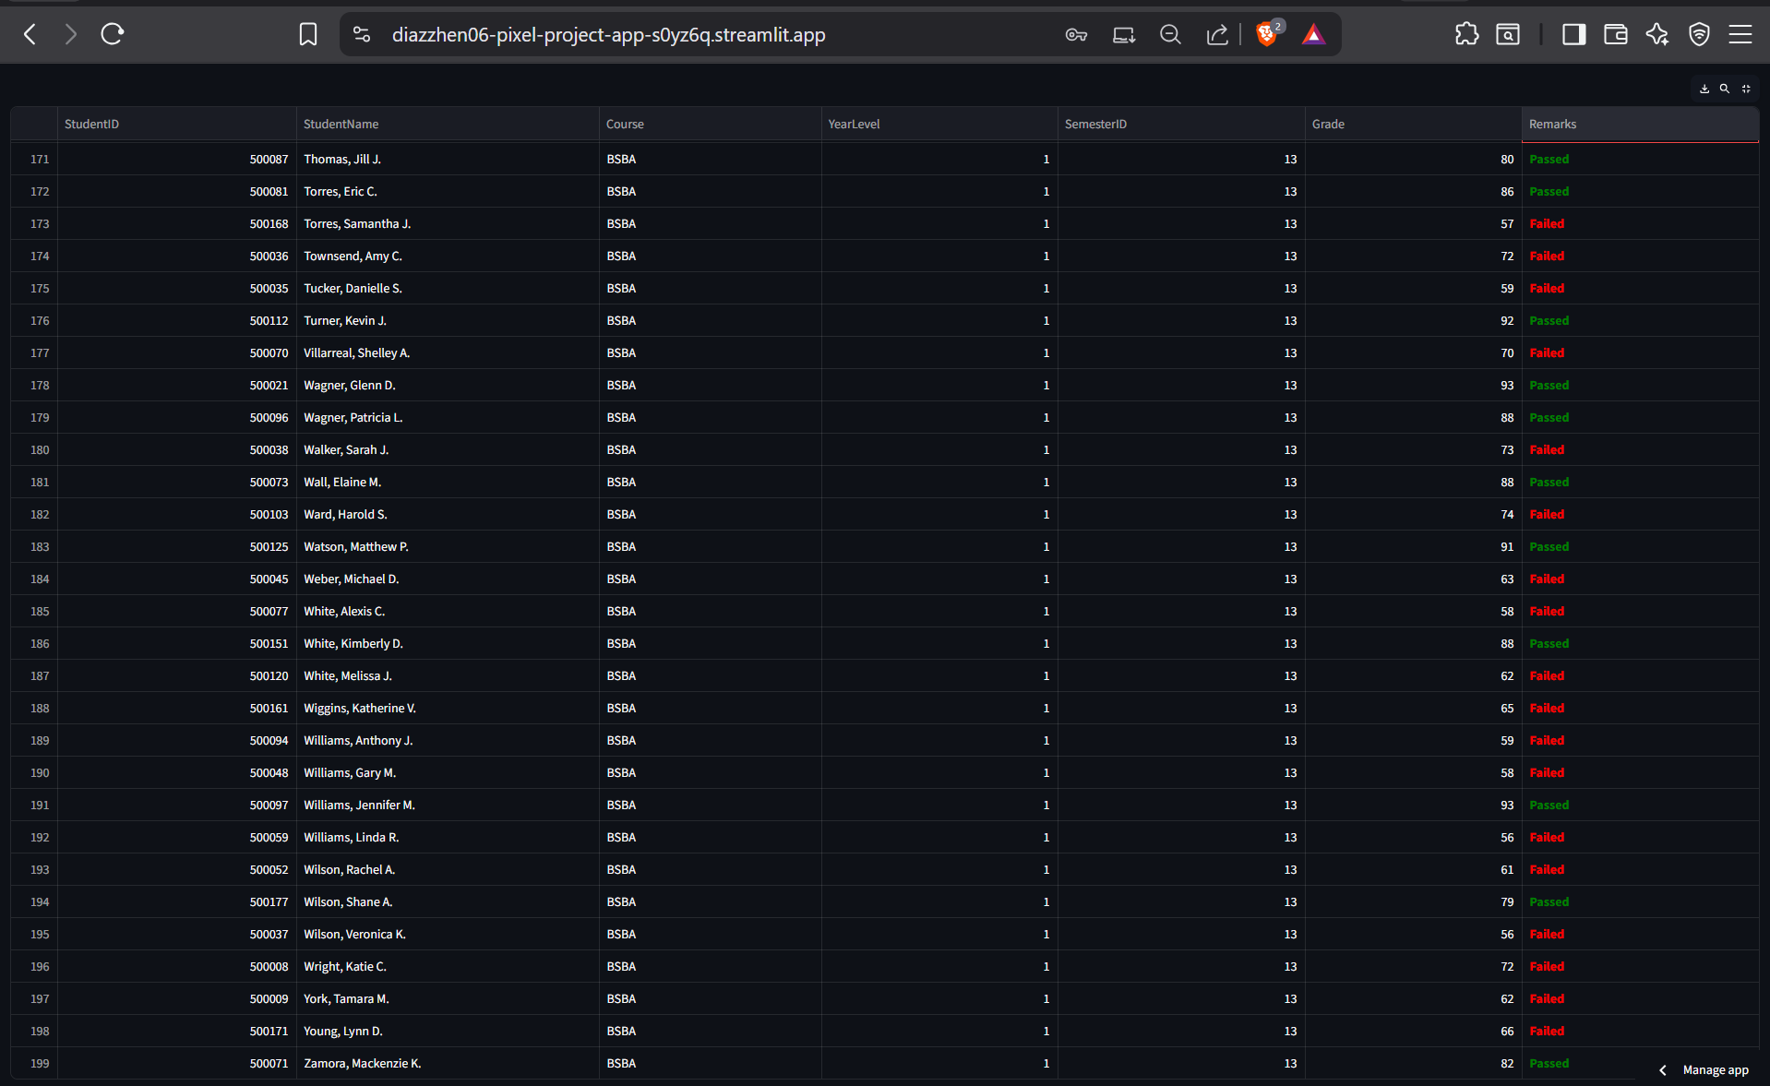

# 

# 

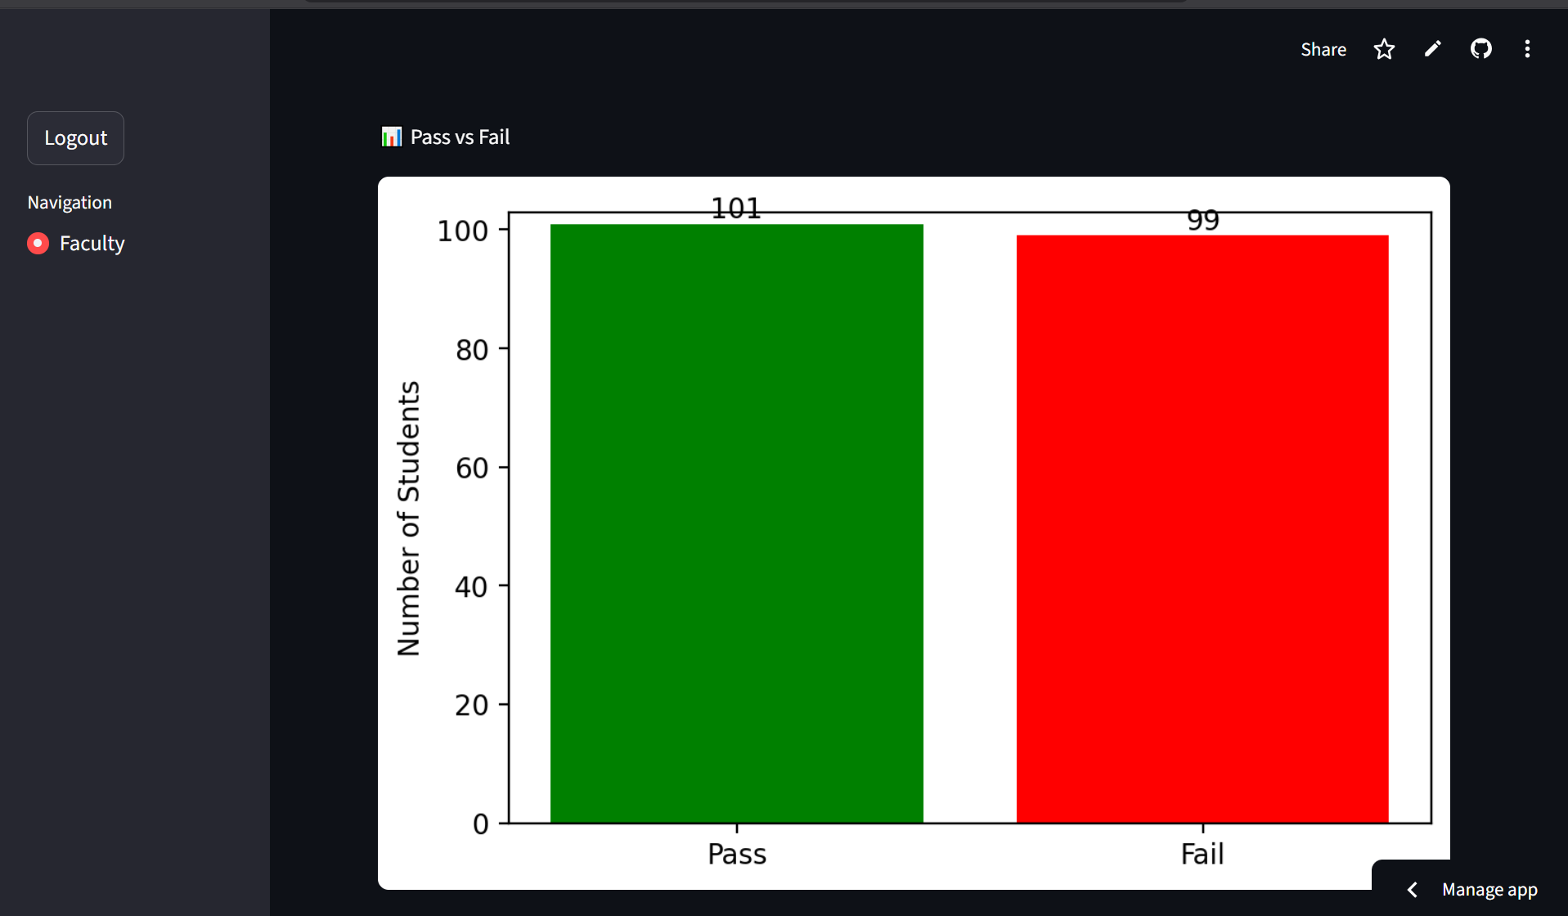

# 

# 

# Students Dashboard Reports

## 1. Academic Transcript Viewer

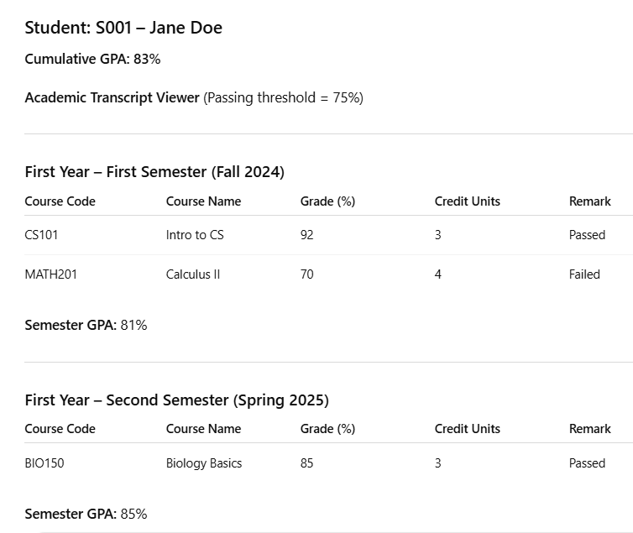

## 2. Performance Trend Over Time

| Semester | Semester GPA |
| --- | --- |
| Fall 2023 | 89.17 |
| Spring 2024 | 90.15 |
| Fall 2024 | 85.57 |
| Spring 2025 | 89.79 |

**Description:** Represents GPA progression across semesters, ideal for a line chart visual.

## 3. Subject Difficulty Ratings

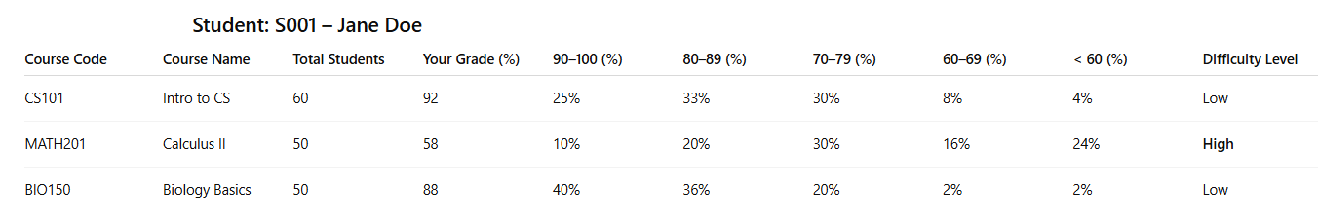

## 4. Comparison with Class Average

|  |  |  |  |
| --- | --- | --- | --- |

**Description:** Highlights how the student’s performance stacks up against peers.

## 5. Passed vs Failed Summary

|  |  |  |
| --- | --- | --- |
|  |  |  |
|  |  |  |

**Description:** A simple summary of academic outcomes—ideal for pie or bar chart depiction.

Followed by pie chart.

## 6.Curriculum and Subject Viewer

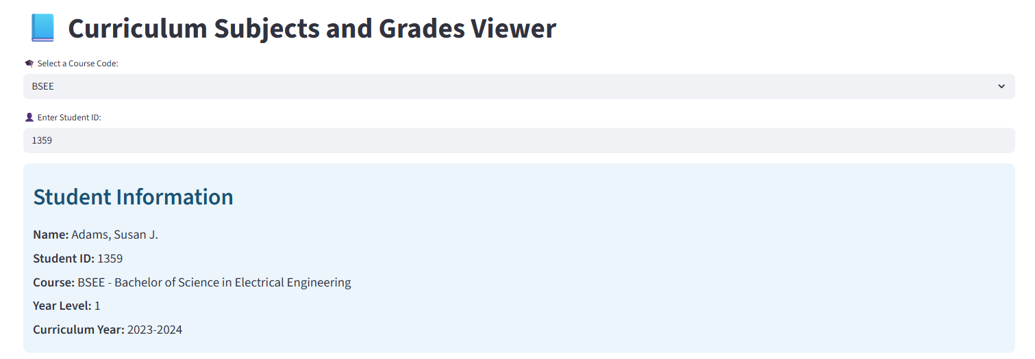

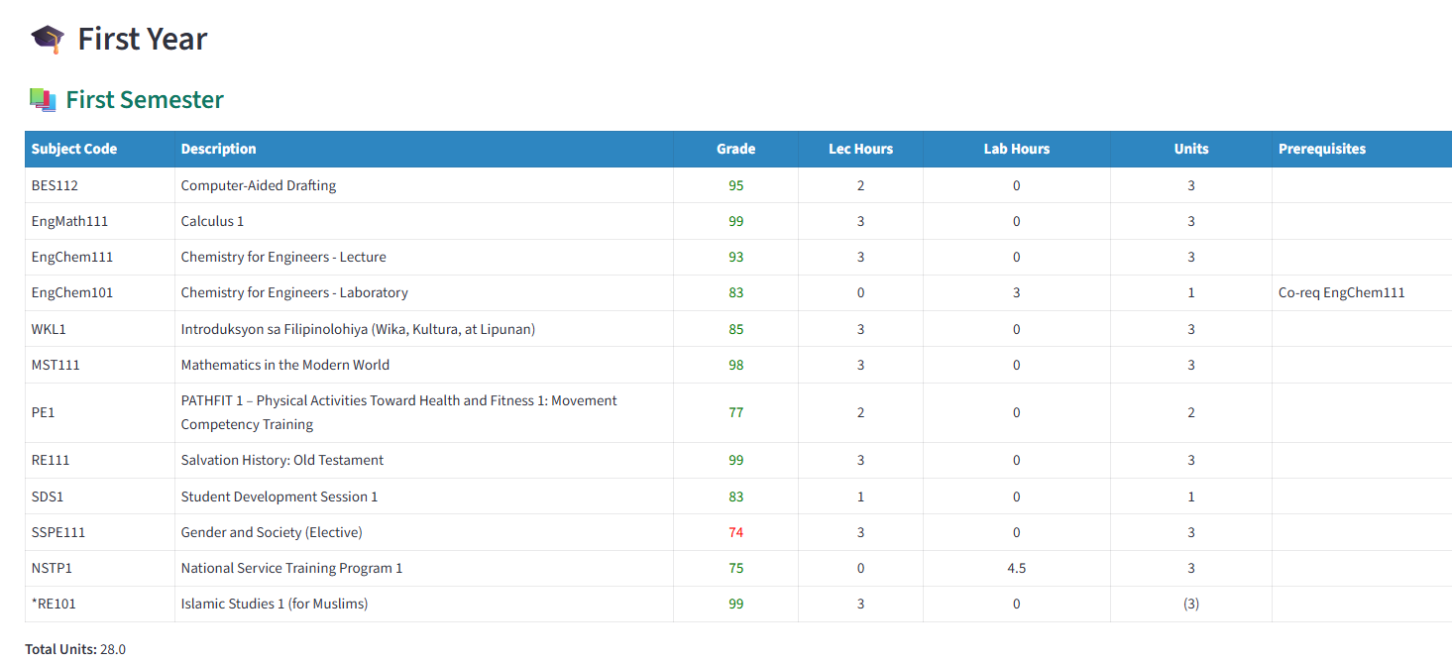

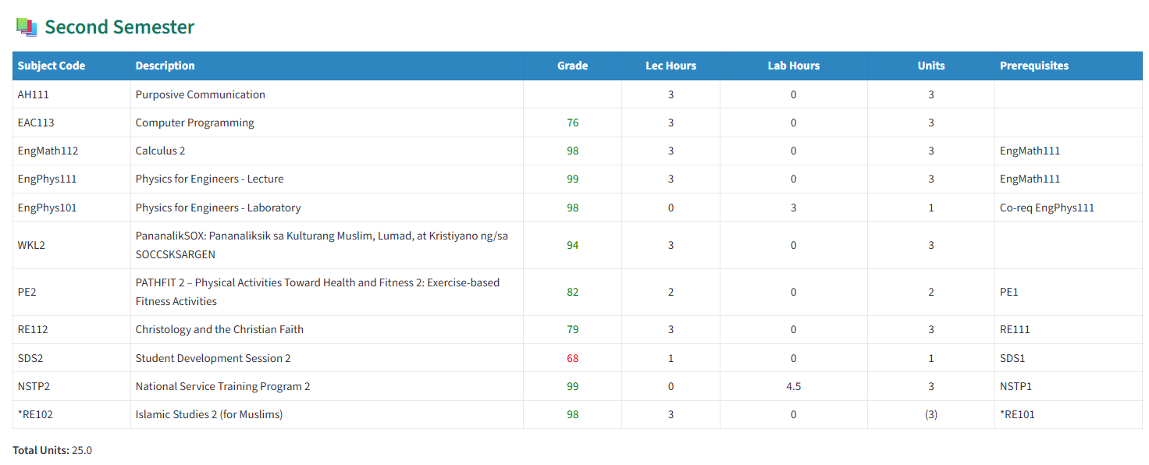

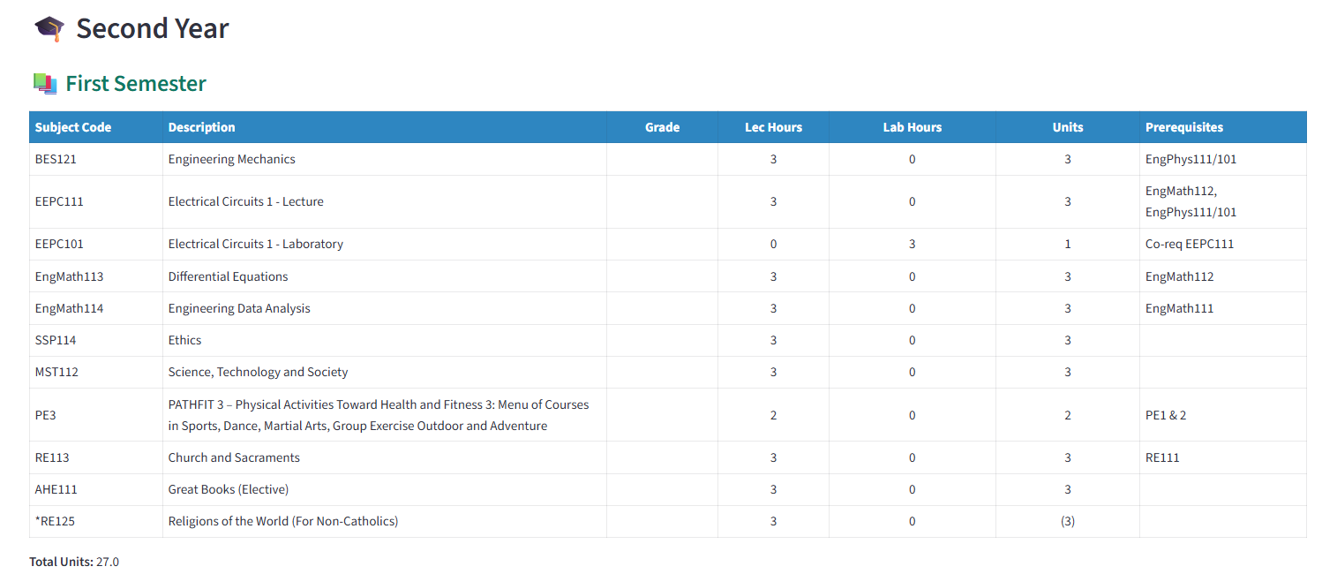

**Print this portion after checking, for documentation…**

# Source code for each dashboard and reports

# Registrar’s Office Dashboard Reports

## 1. Student Academic Standing Report

## 2. Subject Pass/Fail Distribution

## 3. Enrollment Trend Analysis

## 4. Incomplete Grades Report

## 5. Retention and Dropout Rates

## 6. Top Performers per Program

## 7. Curriculum Progress and Advising

# Faculty Dashboard Reports

## 1. Class Grade Distribution

## 2. Student Progress Tracker

## 3. Subject Difficulty Heatmap

## 4. Intervention Candidates List

## 5. Grade Submission Status

## 6. Custom Query Builder

## 7. Students Grade Analytics (Per Teacher)

# Students Dashboard Reports

## 1. Academic Transcript Viewer

## 2. Performance Trend Over Time

## 3. Subject Difficulty Ratings

## 4. Comparison with Class Average

## 5. Passed vs Failed Summary

## 6. Curriculum and Subject Viewer

# Recommendations for Dashboard Enhancements

To strengthen the **Distributed Academic Performance Analytics System** and expand its capability beyond descriptive analytics toward **predictive** and **prescriptive analytics**, provide your recommendations for each type of dashboard.

Your recommendations should:

1. Be **specific to the role** (Registrar, Faculty, Student).
2. Include both **predictive features** (e.g., forecasting grades, enrollment trends, student risk) and **prescriptive features** (e.g., recommended actions, course adjustments, support strategies).
3. Suggest **analytics-driven improvements** that will support better decision-making, early interventions, and long-term academic planning.
4. Please organize your recommendations under the following categories:
   1. **Registrar Dashboard**
   2. **Faculty Dashboard**
   3. **Student Dashboard**

# MongoDB Database Model for Dashboard Enhancements

Design a new MongoDB database model that defines collections and relationships capable of supporting descriptive, predictive, and prescriptive analytics. The model must ensure that the system can generate accurate reports and insights for the Registrar, Faculty, and Student dashboards.