## Team 4

Daniel Barnes - Code

Arie Jian - Documentation

## Change Request

The generated PDF is not displaying the amount of a prescription that was dispensed.

### Concept Location

|  |  |  |
| --- | --- | --- |
| Step | Description | Rationale |
| 1 | Search source code for pdf/encounter | Trying to find logic which creates PDF |
| 2 | Search source code for “Generate PDF” | Trying to find logic which creates PDF |
| 3 | Examine PDFController in indexEncounter.scala.html | Referenced in indexEncounter.scala.html |
| 4 | Examine BuildPDF method of PDFController.java | Looking for where the prescription section of the PDF is created. |
| 5 | Examine the implementation of PrescriptionItem referenced in PDFController | We need to know if we can get the amount from the PrescriptionItem  ※ Found getAmount() is available |
| 6 | Examine the implementation of retrieveDispensedPrescriptionItems() in SearchService | Called by buildPDF() to get the prescriptions |
| 7 | Examine the implementation of createPrescriptionItem() in ItemModelMapper | Understand how PrescriptionItem is created  ※ getAmount() is called |
| 8 | Find usages of PrescriptionItem() method | We found there are 4 usages referenced in PDFController |
| 9 | Examine getAssessments() method of PDFController.java | Understand how the dispensed PDF table is created (line 426) |
| 10 | Bookmark line 455 of PDFController.java | The PDF table is created here |
| 11 | Look at history/encounter in route file | Learn how prescription is displayed in html page so we can make PDF table look similar |
| 12 | Examine HistoryController | Patient's history is displayed by HistoryController |
| 13 | Examine indexEncounter.scala.html | Displays the prescriptions in HTML table |

### Impact Analysis

|  |  |  |
| --- | --- | --- |
| Step | Description | Rationale |
| 1 | Add getPrescriptionText() | The new function does not have any impact |
| 2 | Modify getAssessments() | The change is local to the block of code where it is implemented and has no impact.. |

### Pre-factoring

|  |  |  |
| --- | --- | --- |
| Step | Description | Rationale |
| 1 | Extract call to prescription.getName() into a separate getPrescriptionText() method. | One place to modify how a prescription is displayed. |

### Actualization

|  |  |  |
| --- | --- | --- |
| Step | Description | Rationale |
| 1 | Add a getPrescriptionText() method to PDFController | The prescription text will be needed in two places |
| 2 | Replace usage of prescription.getName() with getPrescriptionText(prescription) in getAssessments() method | We want to replace the prescription name with more descriptive text. |

### Validation

|  |  |  |
| --- | --- | --- |
| Step | Description | Rationale |
| 1 | Follow “steps to reproduce.” | Ensure prescription is rendered properly. |
| 2 | Follow “steps to reproduce” except choose to replace prescription at Pharmacy step. The “Replace” functionality is currently broken. | Ensure “Replaced” column is rendered properly. We cannot because it is not implemented properly yet. |

## 

## 

## Timing

|  |  |
| --- | --- |
| Phase | Time (minutes) |
| Concept Location | 60 |
| Impact Analysis | 5 |
| Actualization | 110 |
| Validation | 30 |
| Total | 205 |

## Reverse Engineering

fEMR_CR2_Sequence Diagram

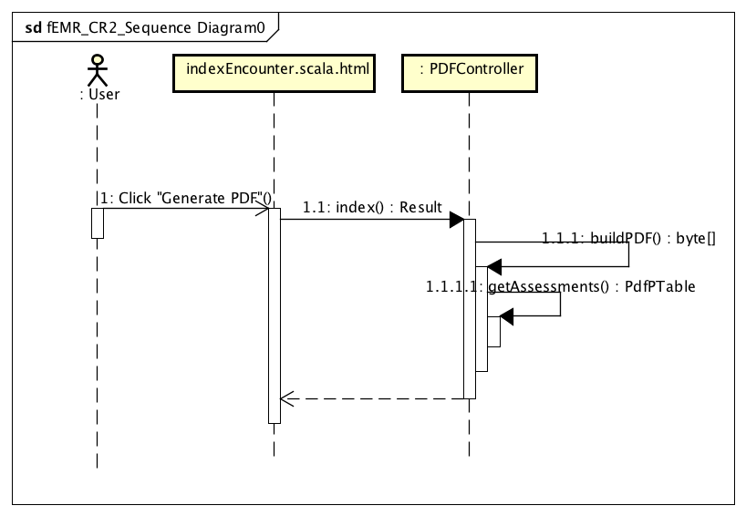

fEMR_CR2_Class Diagram

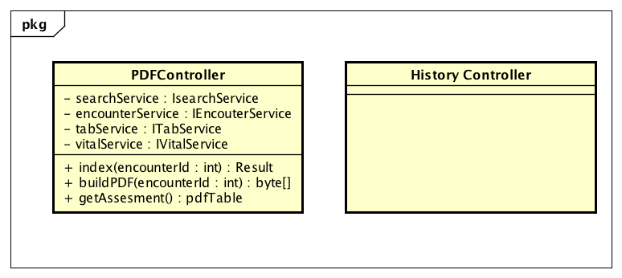

## Conclusions

Again, the concept location was simple to start using text string search. Once we realized that the routes file contained a mapping of html pages to class methods, we were able to use it for location as well. We decided to do more than simply add the amount to the PDF table and endeavored to make the PDF prescription display contain the same information as the HTML display. This included adding the medication form, such as “tabs” or “caps”, and the drug name with value and units (“acetaminophen 325 mg”). We separated out the composition of the text to be displayed in the table into a separate method so that future modifications would be easier.

#### Classes and methods changed

* app/femr/ui/controllers/PDFController.java
  + getAssessments()
  + getPrescriptionText()