Swift Academy – Homework #1

Send html files with all additional resources (if necessary) to address: [dimitrov.webmaster@gmail.com](mailto:dimitrov.webmaster@gmail.com) before 21.10.2016y.

For subject type: [SWIFT][HW1] – Html homework

Ex.1 Write an HTML page like the following (use ordered list with unordered list inside <li> element:

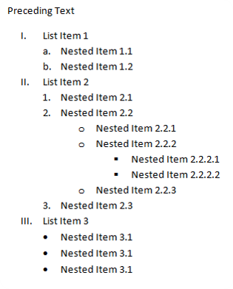Example:

<ol>

<li>Item 1</li>

<li>

<ul>

<li>Item 2</li>

<li>Item 3</li>

</ul>

</li>

</ol>

\*As you can see html elements can be nested each other.

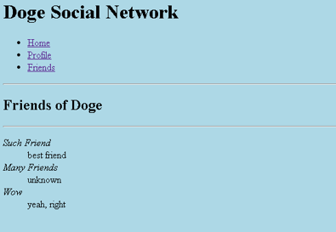Ex.2 Write an HTML page like the following:

Ex3: Create your own CV using HTML tables (you can use dummy data).

Ex4. Create User login form with submit button (for action attribute leave empty).

Ex5. Create User Register form with fields: username, password, retype password, birthday, sex, home address, work address, school name, years of education, phone number, email, additional notes, accept terms and conditions (do not show them). Each field should have appropriate label with text that describes it. Form action should be empty.

\*Hint: You can use as many resources from the internet as you wish.