Portable Education with Augmented Reality (PEAR)
Kenia Castro, Richard DiBacco, Matthew Frazier, Katelyn Jones

Department of Computer Science, University of Central Florida, Orlando, Florida, 32816-2450

Abstract — Augmented reality is a relatively new and emerging technology with many exciting applications. Utilizing it for educational purposes has the potential to make learning more engaging, interactive, and fun We intend on expanding and exploring this use case with our application, Portable Education with Augmented Reality, or PEAR. The goals of this project are to create an educational mobile game in an augmented reality environment and to determine if it is beneficial as an educational supplement. This application will then be use in a research study to determine if using augmented reality does increase learning and retention of subject material.

Index Terms — Augmented reality, mobile application, video games, educational games

I. Introduction
With the modern advances made in the augmented reality field, especially since Google and Apple have recently released their ARCore and ARKit augmented reality frameworks, this is a perfect time to delve into how schools and educational institutions can use this technology for educational purposes. By incorporating augmented reality into their curriculum, learning can become more engaging, and by extension more effective. We plan to use this project to explore how an augmented reality game can achieve the goals of making learning more interactive and fun.
Our primary objective is to develop a game that focuses on one subject initially in an augmented reality setting. Ideally this would be used as a framework that can be further expanded upon later by easily adding new content. Our subject of choice is astronomy. We decided a STEM field would be a good choice due to the highly technical nature of this project, and a physical science would be easiest to represent in an augmented reality environment. Astronomy seemed to fit these criteria.
Beyond development of the game play, data acquisition is a crucial part of the project. We want educators to be able to review any data available on the students’ progress through the game. Datum like correct answer percentage, what answers were available when they student chose an incorrect answer, how long they spent on that question, how long they spent in a sub-section of the game, and others will be collected. These can be useful data points that educators can use to correct any misunderstandings or misconceptions students have about the topic.
As this is a multi-faceted project, we will be using several different technologies to achieve our goals. The primary focus is on the game play, and this will likely take most of our development time. We will be using Vuforia and the Unity game engine to develop this portion of it. We chose Vuforia primarily because of its cross-platform capabilities. It will enable us to build once and deploy to both iOS and Android devices. It also has both ARCore and ARKit libraries available for use, making it an ideal choice.
For the data collection, it needs to be stored in an easy to use and access format. We will be using Firebase for data storage. It will be fed data from the mobile game and accessed through a web portal for teachers. The front-end website will be developed with Angular using HTML, CSS, and Typescript. AngularFire2, a library for communication between Google Firebase and the Angular website, will also be required for website development. We will also use the Bootstrap framework due to its readily available documentation, ease of use, and clean interface. The website needs to be intuitive and easy to use for both data analysis and possibly adding new content to the game later.

II. Concept and Design
Augmented Reality, or AR, is a means in which one can augment or overlay computer generated images or data into the real world.
The idea of augmented reality was first introduced way back in 1901 by an author named L. Frank Baum. His idea was a set of electronic glasses that overlays data over people that you are looking at. Since then, there have been many advances to the augmented reality field, which include but are not limited to the Google Glass, the Microsoft HoloLens, and Pokémon Go.
We were asked by our sponsor, Dr. Emily Johnson, to create a mobile device application that was interactive, fun, and educational. Its purpose is to track participant’s progress and answers to learn whether the interactive process that is involved with augmented reality aids in the retention of information.
Our answer to this is to create a learning game application framework that can be used for any topic that an instructor chooses.
The main purpose of the augmented reality/mixed reality application is the implementation of a fun learning game that collects and analyzes data about the learning process. Tracking the percentage of right or wrong answers allows us to learn whether the application has made any sort of impact on the user in the retention of new data. Ideally, the use of augmented reality or mixed reality will make the concepts that are presented easier to retain.
The application should be lightweight since it needs to run on a wide range of mobile devices. Its user interface and other interactive aspects need to be intuitive; if most of the time the user is attempting to learn how to use the application, it takes away from the actual information that is trying to be taught.
A. Broader Impacts.
One of the main applications for this project is in the field of education. Augmented reality is one of the newest areas that is enhancing learning both inside and outside the classroom. From traditional classroom environments in local middle schools to science museums across the nation, augmented reality can give students a new way to interact with and visualize information using mobile devices. It can also give educators a new way to present their ideas by supplementing their existing lesson plans and providing new outlets for communication and problem-solving.
There are student communities (both locally in our city and in the rest of the United States) that come from low-income areas or underrepresented areas who may not have the funds or availability to visit a science museum or conduct more equipment-intensive experiments in class. Our application can offer a lower cost alternative to help students experience a new way to visualize space, the solar system, and planet physics and help bring parts of the digital world into the real world, allowing for a more immersive learning experience right in their classroom. It can allow students to directly interact with and create objects to better deepen learning using a portable device.
Our mobile application can also help students gain more interest in STEM fields by exposing them to different topics in science and showing them that there are multiple ways to still experience and learn besides a traditional textbook. One of the important things about exposing students to STEM is showing them that all these diverse areas of study exist and that things they are already familiar with (mobile devices, playing games, AR filters for photos) can be combined with what they are learning in school to create new innovations.

III. Features and Requirements
After much deliberation and brainstorming, we arrived at our final gameplay idea, which is outlined as follows. We decided the best way to create an educational augmented reality application was the make it more of a framework that could then be applied to numerous different subjects. We determined that focusing on physical sciences would be the best place to start. We’ve narrowed down the subject to Astronomy, and more specifically the Solar System, for our initial proof of concept development focus.
The idea is that the user will participate in a two-mode game. The initial portion will be the collection portion of the game. Here the user will collect materials or object that will later be used for building a larger model or scene. This will be like previous games such as Pokémon Go, but will not be location-base, rather the items will be populated into an augmented reality environment at random locations surrounding the user. The items being collected depend on the current objective and subject. Once an item has been collected the user can switch to build mode.
In build mode, the user will combine previously collected items to create either a larger structure. For our astronomy example, users will collect items such as the Sun and Earth. After that, the user will be required to place the Sun and all the planets into an overall model that represents the Solar System. This will force the user to place the planets in the correct relative location and result in learning even more about our Solar System.
The following sections provide a detailed listing of the project requirements.
A. Must Have Features
- The students must be able to create an account.
  - The account will be associated with a classroom utilizing a code provided by a teacher.
- Teachers must be able to create an account and associate that account with one or many classrooms.
- Students must be able to collect items in collect mode.
  - For students to collect items they must answer questions about them.
  - Students should be able to review short videos about each item.
- Students must be able to combine items into an overall structure like the solar system.
  - The elements must be placed in the correct location, testing the students’ knowledge about the overall structure.
- Data must be gathered at each step of the process on student progress.
  - How long the student spent on each material/element.
  - How long the student spent on combining the larger elements into the overall structure.
  - Which questions the student got correct and which they got incorrect.
  - What the student selected for their answer.
  - The overall percentage of correct and incorrect answers.
  - The overall progress through each level/module.
- Teachers must be able to view their class’ overall progress through a level.
- Teachers must be able to view an individual student’s progress through a level.
- Teachers must be able to review all the data collected for each level.
- Teachers should have a way to export the data to a .csv or .xls format.
B. Nice to Have Features
- A free-roam mode in which the students can view the overall structure they have created at their leisure.
- Mini-games for certain materials collected that must be played to collect the material.
- Teachers can upload their own questions and models for each subject, level, or module.
C. Dream Features.
- Incorporating virtual reality elements into the game.
- Creating high-quality 3D models for each of the elements, materials, and overall structure.

IV. General Outline of Project
There are three main components of our project: the mobile application, website application, and backend database. Figure 1 is a diagram that shows the relationship between these components as well as their individual properties.
A. Mobile Application
FIGURE I
HIGH LEVEL DIAGRAM OF PROJECT
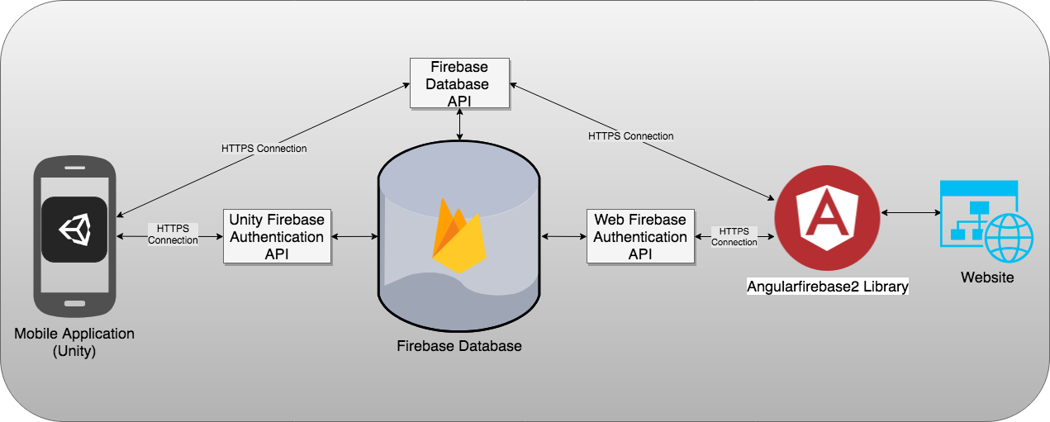
Because we wish to maximize the accessibility of PEAR, we must develop for both Android and iOS devices. Fortunately, there are libraries for augmented reality available for each platform, as well as some for cross-platform development. Namely, ARKit for iOS and ARCore for Android. We chose Unity, utilizing the Vuforia framework, to be our platform as it can use both libraries effectively, and create a native build for each platform. Working with Vuforia and Unity has proved very straight-forward and easy to develop prototypes. There was an initial learning curve of course, but after getting over that the development process has been smooth.
B. Website
To ensure that the website design is slick and polished, we will be using Bootstrap, a powerful tool for designing responsive and professional websites. We will also be using Figma, a UI/UX design tool that is used to prototype and design the look and feel of a software product on multiple devices. The website will be comprised of a progress dashboard, and a CSV export system.
The progress dashboard will allow teachers to monitor the progress of their students. It should display all of the previously mentioned data to be gathered about students in an easy to view and understand format.
The CSV export allows teachers to gather the student’s profile information into a spreadsheet. We may also have this spreadsheet contain statistics of each data field comparing students within the class and other students taking the same course. Not only will this help teachers analyze their student’s progress in the app, it will also help them understand what to focus on in future class lessons.
B. Backend
Because the backend is an integral part to both the mobile and web application, our team wanted to focus on selecting a technology that could robustly handle the amounts of traffic generated and be easily incorporated to both components. The backend is comprised of the database and an API. The API transfers data from the database to the website and mobile application. We decided to go with Google Firebase for both this API and database.
The database must store user data, user profiles and question. The user profiles contain data for each player, including their names, the elapsed time in each mission, number of times a mission is played, submitted answers, and class they’re in.
The database is broken into three major portions: answers, classroom, and user.
In the answers portion is where all the information based on the answers for the questions from the users will be stored. The answers are stored underneath a user id and then categorized by class, module, and object.
The classroom portion is where all the information about the classroom is stored, such as the list of users within the class, the list of modules within a class, all the items that are in the class, and the questions and answers that will be available in the application.
The user portion of the database will keep track of all user-specific information. This includes things like the users’ name, email address, and what classrooms they belong to.

V. Technology Stack
A. Game Engine

We initially researched both Unity and Unreal as a game development engine. At first glance, Unity’s interface is strikingly like that of Unreal; both contain a window to place objects in an environment (Unreal’s Level Editor and Unity’s Scene View) along with windows that displays the environment’s objects in a list and their respective properties. Unity’s Inspector View does allow for more custom configuration compared to Unreal’s Details panel.
Unreal seems to be a huge component for many large games that have been very successful. Because they are aware of their user base, it is very easy to get started in making a game. However, because Unreal mainly geared towards the standard gaming methods like 2D platformers or a first-person shooter, the resources for Augmented Reality are not as good as other development software. While there are plugins and extensions to assist the creation of a quality AR learning application, there are programs out there that better suit our needs.
On the other hand, Unity has its own augmented reality SDK, Vuforia. In addition, Vuforia can extend ARCore and ARKit, which allows for more choice in content and features compared to Unreal. However, since these development kits are new, there aren’t many tutorials outside of their own documentation.
Ultimately, our preference lies with Unity, since our team members are more familiar with its layout. Furthermore, Unity offers much more in regard to augmented reality development kits, despite there being limited forum discussion on them. The most important feature here, and a huge deciding factor, is Unity’s ability to build natively to both iOS and Android, allowing us to reach the largest audience possible.
B. Development Environment
We’ll be going with Visual Studio as our primary Integrated Development Environment (IDE). It was the natural choice as it’s well integrated with Unity, and fully supports the C# programming language that we will be using. Unity automatically creates a Visual Studio project with the creation of a Unity project.
Visual Studio is also available on both Windows and macOS. This is also an important feature as this app will be deployed to both Android and iOS. Since building an iOS app requires the use of macOS, without this cross-compatibility we would be unable to use this product. Ultimately, however, the build for iOS devices will need to be done via Unity and by using XCode in the background as the final compiler.

C. Backend

Because of the vast amount of resources Firebase provides, along with the fact that it integrates well with Unity, our main preference for the backend will be Firebase. The analytics, the authentication, and the noSQL database are all very useful and important aspects of why we chose Firebase. Firebase also has its own API that is worked into whatever type of program that it is being used in, such as Unity and JavaScript.
Hosting can also be done through Firebase. Firebase is free up to a certain point as well. If we exceed the Firebase database data cap, we can go to the next level which is $25 a month, but because we are only storing simple text, it should not be an issue.
VI. User Experience
A. Mobile Application - Game
FIGURE 2
Classroom-Module Hierarchy
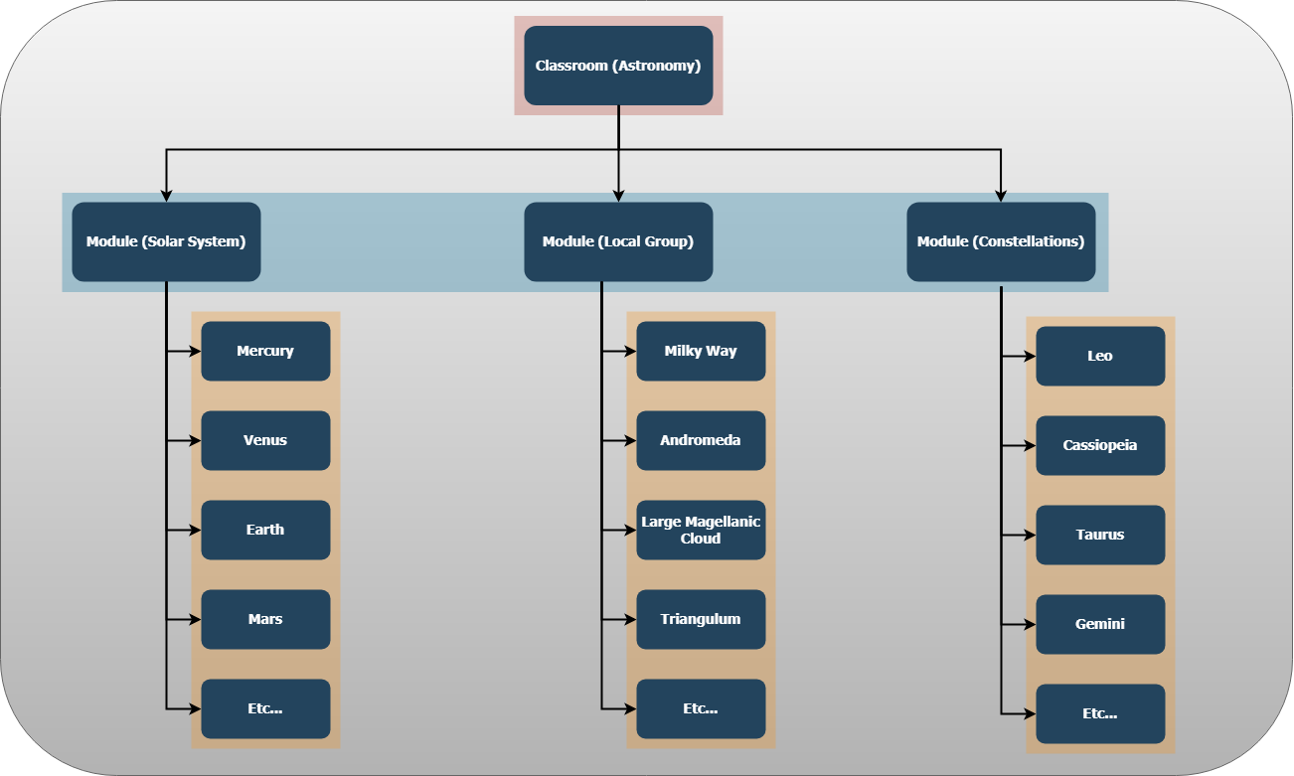
The initial step is, naturally, a user launching the app. Upon launch, a user signs in to their profile. If they have not yet created an account, they must sign up by assigning themselves a username, password, and register to a classroom using a key given to them by the teacher, or admin. Once logged in, the user may load a classroom. Loading a classroom allows a user to view the available modules within that classroom.
Upon loading a Module (see Figure 2 for a representation of the classroom-module hierarchy), a user is brought to Collection Mode. Here, the user must search the environment to locate resources, which are represented as a twinkling star in the distance within an augmented reality environment. Once a user locates a star representation of an item, they transition to the scene that holds the targeted resource. Here they will be afforded the opportunity to watch a short video related to this item. To gather a resource, the user must answer questions derived from the video about the resource. The user will be required to answer a certain percentage of these questions correctly before they can gather the item. From there they are brought back to the Collect Mode scene or can enter Build Mode.
A user may switch between Collection Mode and Build Mode, although once all the items available have been collected collection mode will be useless as it will not show any available items. In Build Mode, the user is prompted what to build into the scene, in this case the Solar System. Once the object has been built, the user may review the structure by moving around the scene. For Build Mode to be completed, all the resources must be collection and placed appropriately in the structure.
As data collection is one of the most important requirements of this project, data will be collected about user activities throughout these steps. Datum include time spent answering questions, the percent of question answered correctly, the answer chosen by the user, whether the answer is correct or incorrect, and time spent building the overall structure.
B. Website – Administrative Portal
On load, the website will show a general information page of the augmented reality game. All other functionality will require the user to have a registered account. Links to log in or register for an account which will be available on the home page. Once logged in, the default home page will be replaced by the user’s home/profile page. On this page, registered teachers will have options to view their classroom and view student statistics. See Figure 3 for the website homepage.
VII. Testing and Evaluation
Our plan for testing our application is relatively standard. Once a feature has been implemented, it should be tested thoroughly. Features should be tested in ways we expect to break or cause errors to make sure everything works as intended and things that aren’t allowed to happen are accounted for.
It is important to document the problems that we face when we are using our program. We should take notice when a problem occurs, attempt to replicate it, take measures to fix the error, and then document the process. This procedure ensures that if we run into a similar issue again or if a user has the same problem, we have the resources to solve the problem without wasting too much time.
FIGURE 3
Website Homepage
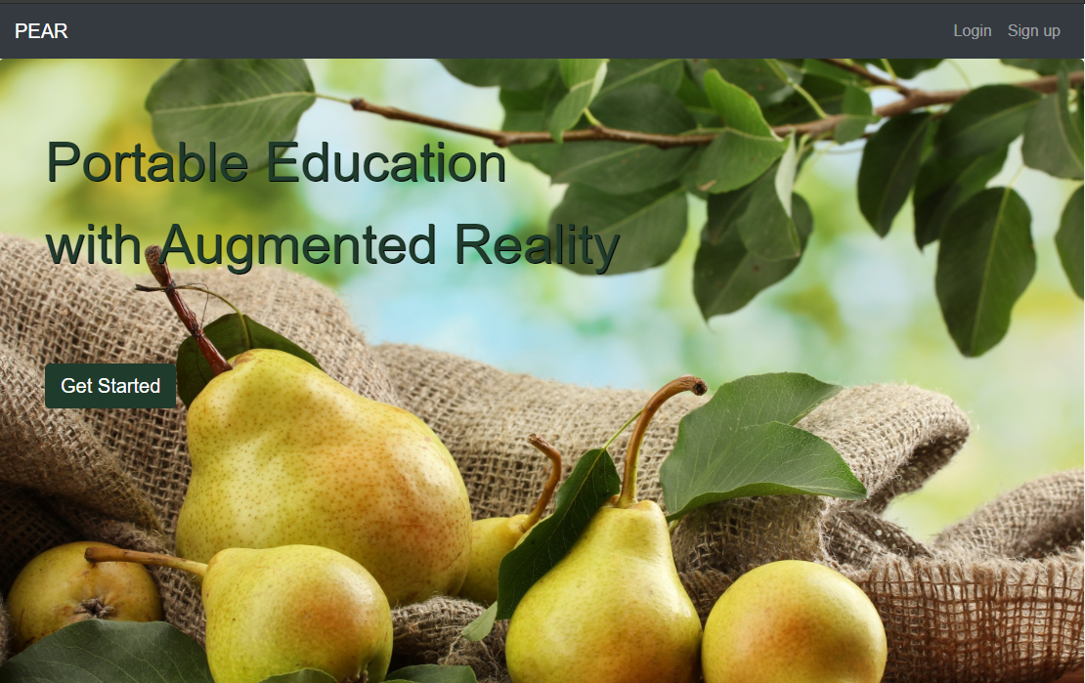
A. Early Stages
Installing the application - Does the application install properly to the intended devices? What are some possible ways that installation could go wrong? How long does it take for the application to install to a phone? Which phones will the application work on?
Login Functionality - Does the login function work properly? Does it correctly match up the username with the password? Database access through the application should be done through code that works with Firebase.
User Interface - Is the user interface clear and easy to understand? Do the options and buttons available in the interface change the visuals? Are there buttons that could be removed, condensed, or made clearer? The early stages user interface testing should be extremely basic and cover the most rudimentary requirements.
B. Development Stage
Communication with Backend - Does the application correctly save and store the data that is submitted? What problems are there with database communication? Are there additional things that we did not foresee that need to be added to the backend for smoother data access?
Augmented Reality Interaction - Does the augmented reality portion of the application perform as expected? Do the interactive portions of the game show up when expected? What problems do we run into while implementing this part of the game? How do we fix those problems?
C. Final Stages
Website question adjustment - How well does the website add, delete, or edit questions? Do these adjustments work?
Exporting data - How well does the data exporting option work? Are there any hang ups or errors? Is the exported data clearly labeled and easy to understand?
D. Checklist
- Students can create an account
- Students can login with their created account
- Students can join a classroom created by a teacher
- Students can view the content posted in the classroom such as modules and levels
- Students can partake in collection of materials which will be added to an inventory containing all the materials they’ve collected
- Students can review their inventory to review the content related to each material
- Students will use materials collected to build an overall scene
- Students will be able to review content related to the materials they are collecting and the larger scenes they build
- Students will answer questions related to the materials they collect and the scenes they build

- Teachers can create an account
- Teachers can login with their created account
- Teachers can create classrooms and allow students to join with a proper access code
- Teachers can assign students modules and levels related to their curriculum
- Teachers can view the progress of individual students throughout each level
- Teachers can view the progress of the overall class throughout each level
- Teachers can view other data analytics related to student achievements and progress throughout the entire class
- Teachers can download or export student data to .csv or .xls formats for their own data analytics
When the mobile application is functional, it should provide an educational learning experience for students and present them with new ways to learn about the solar system. It should be fun and entertaining while keeping the topic of learning about space at the forefront.
Our target demographic are students in middle school (grades 6-8) and we would ideally like to test with this group for possible insights. We would also like to test the mobile application with teachers in these grade levels to get feedback on what features they find useful to use in their classrooms, if they feel they have enough flexibility to create lessons for their students, and what other features they would like to see in future versions.
This application will also be collecting data on how students answer questions or solve puzzles, how often student get the correct answers, and how much information do students retain when presented with the same concepts again in a following session using the augmented reality game.
VIII. Administrative Content
If further down the line, our team realizes we need a specific device or a program to aid us in our efforts, Emily Johnson has mentioned that she would be able to put in a request for her department to receive that piece of equipment or software. As of right now, out team plans on making use of free development software such as Unity, thus making our current expected project total to be zero dollars.
IX. Conclusion
We’ve learned a lot along the way developing this application. We think we chose the correct technology stack to develop this application and have had a great experience working with Vuforia within Unity for our augmented reality development. Vuforia has made working with augmented reality rather straight forward. We’ve also enjoyed working with Google Firebase as our backend provider and using it as our one-stop-shop for all our database and website hosting needs. Utilizing Angular for the website has allowed us to create a clean user interface for the administrative portal, along with access to AngluarFire2 allowing us to communicate with the Google Firebase backend. Also, within the website, using ngx-charts to represent the data collected along the way has allowed us to present this data in an easy to read and digest format for educators.
Augmented reality has great potential as a supplemental, non-traditional, learning method. We suspect that this highly-interactive, multi-sensory learning method can increase retention of material by students to a significant amount. We hope that PEAR can be used to prove this hypothesis.

Acknowledgement
The authors wish to acknowledge our sponsor, Dr. Emily Johnson, for allowing us to participate in this project and work with her during her educational gaming research studies. We would also like to thank Dr. Mark Heinrich for his lessons on working with a large project such as this, and his valuable feedback during the development of this year-long project.

