**01_CCP_9436_Card_Activation_English_Correct_name_Chrome**

**User:** uat****55

**Pass:** Mex*****2

**Step 1:** Launch CCP with valid URL

UAT: https://sit.banamexsoaproxy1.intranet.banamex.com/uat2ps/banamex-cards-es/login

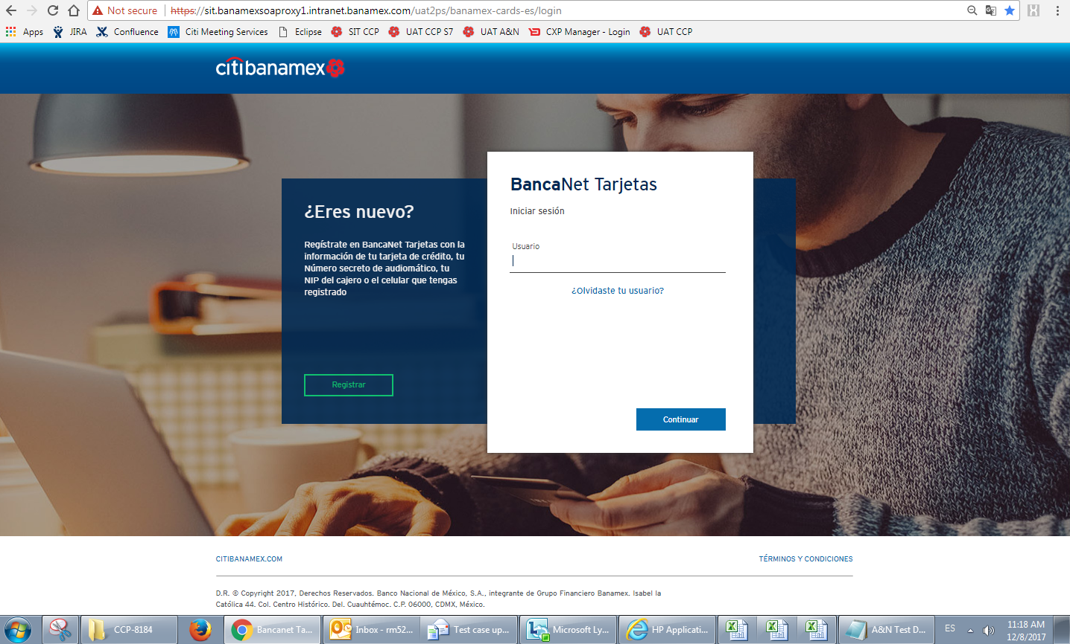

**Step 2:** Click on "Ingresar" button

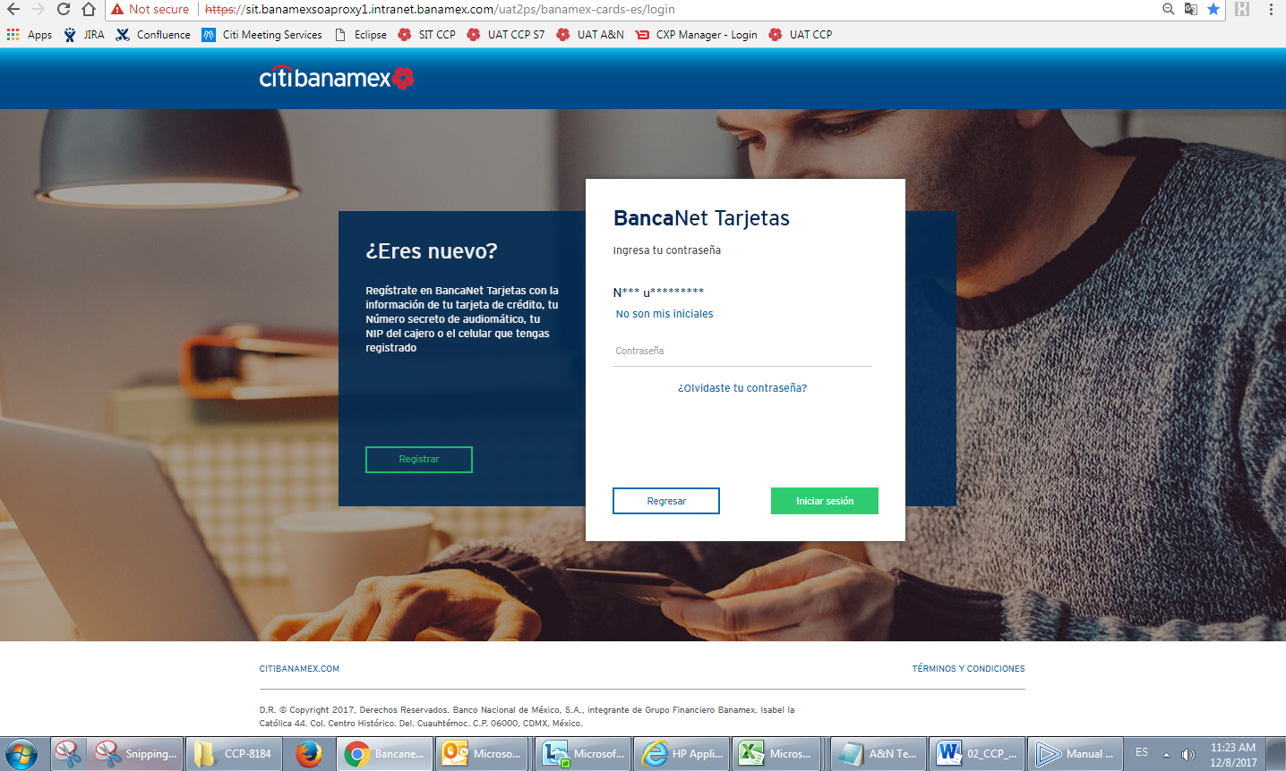

**Step 3:** Enter correct username and password. Click on "Ingresa" button

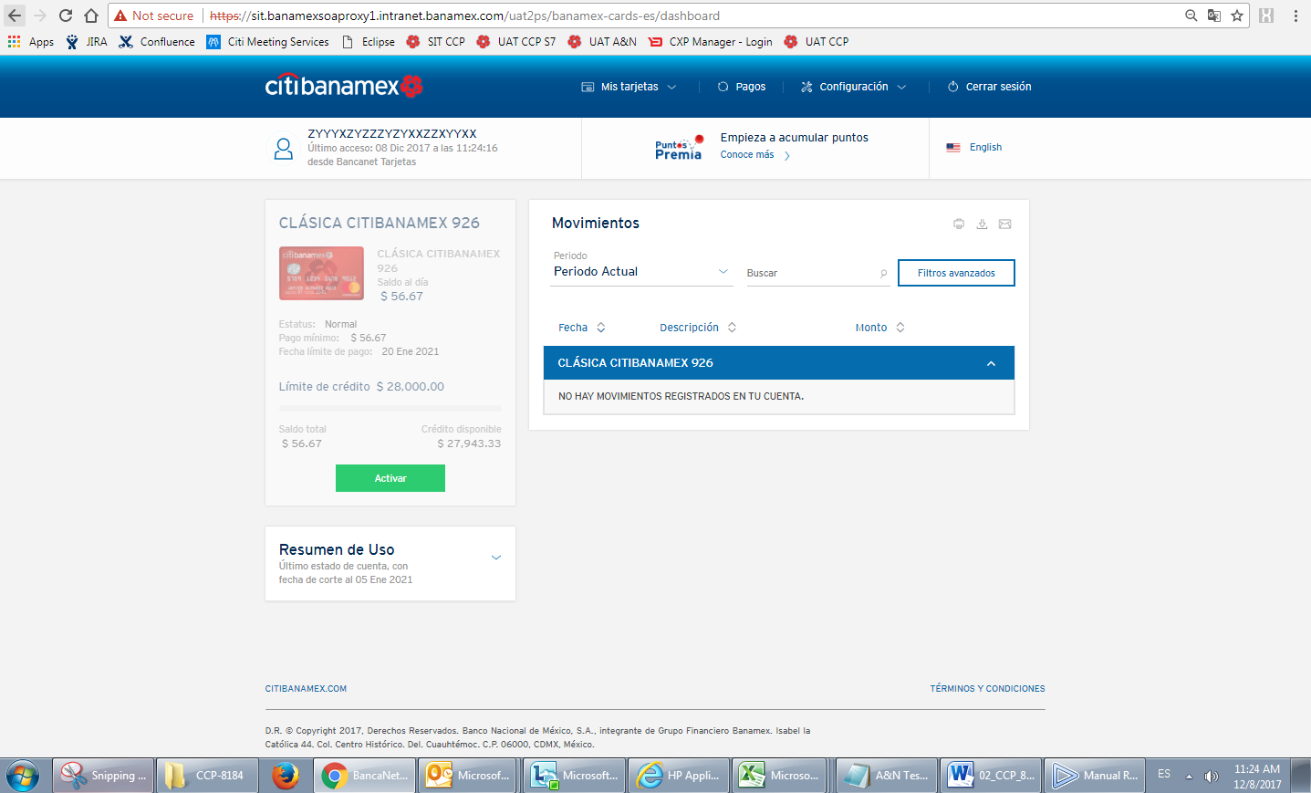

**Step 4:** Check that English is the default language. A Mexican flag must be displayed giving the option to change to Spanish.

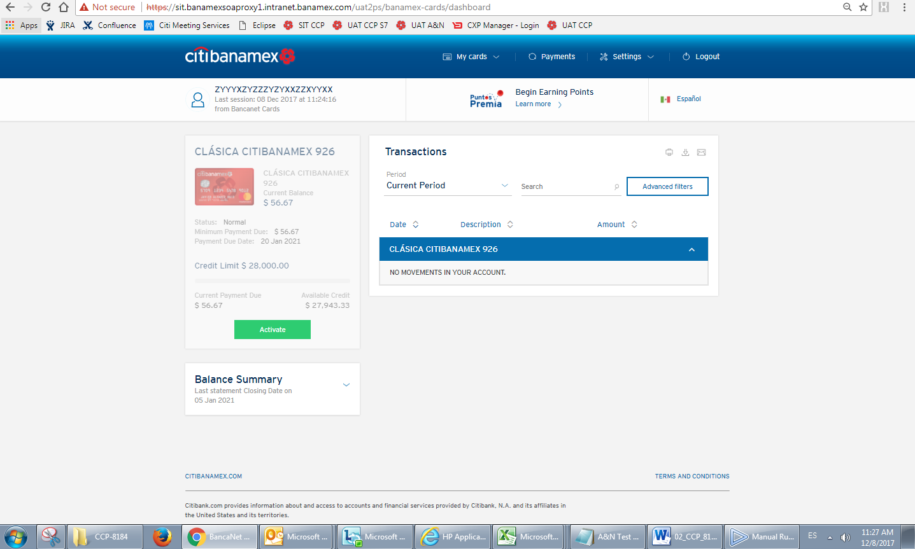

**Step 5:** Select "Settings" on the top menu and click on "Activate Card(s)" option

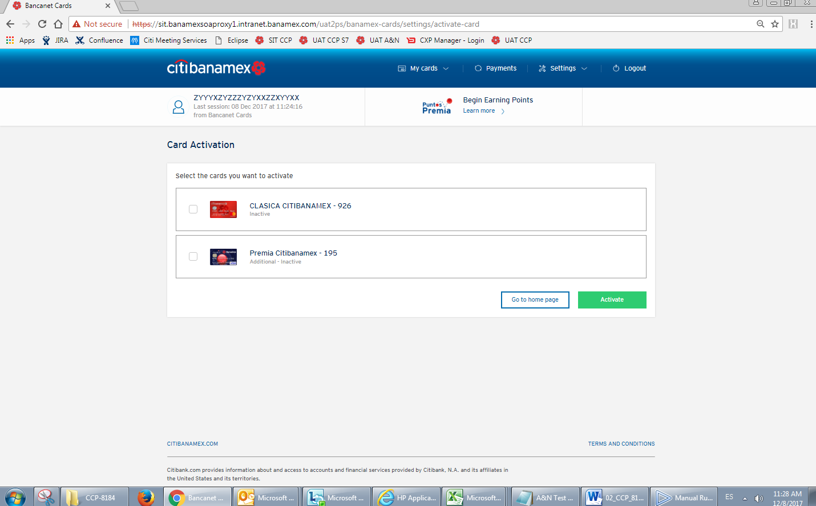

**Step 6:** Check the name of the Page located in the browser tab. The name should be "BancaNet Cards" **(FAILED)**

