|  |  |
| --- | --- |
| **ID** | Login_Err_01 |
| **Server Name** | http://localhost:7777/portalserver/banamex-cards-es/login |
| **UI Error Message** | Verifica que tu usuario y/o contraseña sean correctas |
| **BackBase Error Response Body** | {  "code" : "21",  "status" : 403,  "type" : "invalid",  "message" : null  } |
| **APIm Error Response Body** |  |
| **Root Cause** | Either username or password is invalid |
| **Additional Information (if any)** | The user needs to check whether username and password is correct. |
| **Screenshot** | Below |

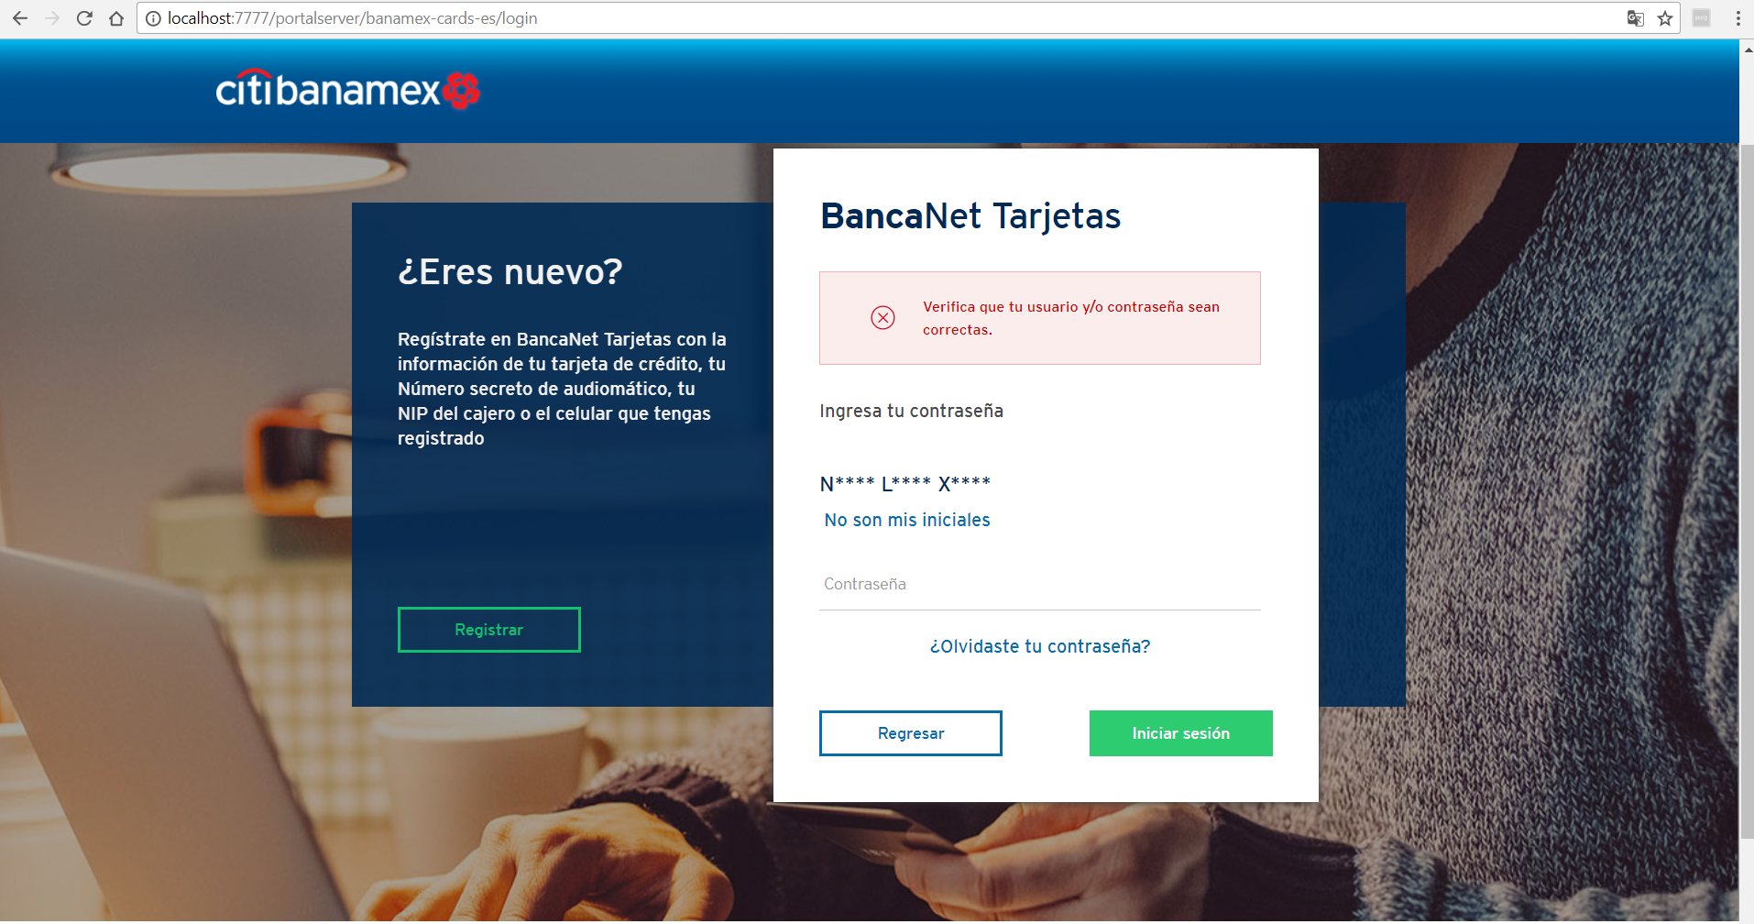

|  |  |
| --- | --- |
| **ID** | Login_Err_02 |
| **Server Name** | http://localhost:7777/portalserver/banamex-cards-es/login |
| **UI Error Message** | En este momento no podemos completar tu solicitud. Inténtalo más tarde |
| **BackBase Error Response Body** | {"errors" :  [{"code" : 500,  "eventId" : "ID-USTX15369L02211-55652-1511213032283-1-778",  "message" : "Unexpected server error occurred"  }  ]} |
| **APIm Error Response Body** |  |
| **Root Cause** | Unexpected server error |
| **Additional Information (if any)** | Unexpected server error happened from APIM |
| **Screenshot** | Below |

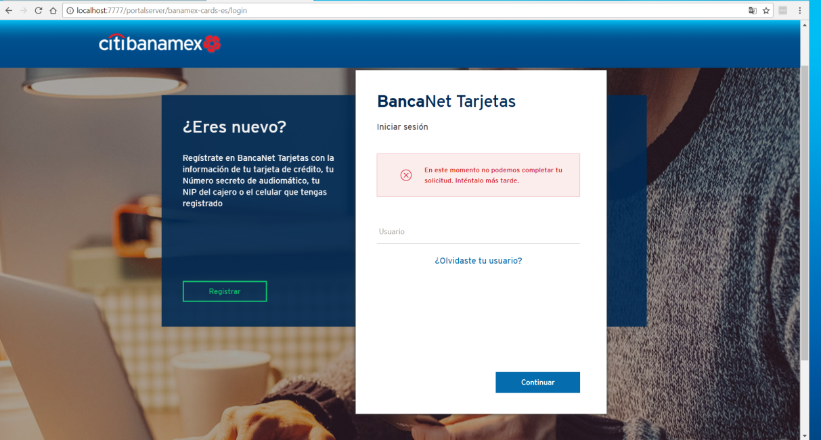

|  |  |
| --- | --- |
| **ID** | Login_Err_03 |
| **Server Name** | http://localhost:7777/portalserver/banamex-cards-es/login |
| **UI Error Message** | Acceso bloqueado |
| **BackBase Error Response Body** | {  "code" : "200011",  "status" : 403,  "type" : "ACCESS_BLOCKED",  "message" : "200011-ClientId is inactive"  } |
| **APIm Error Response Body** | {  "type":"error",  "code":"userAccountLocked",  "details":"200011-account locked"  } |
| **Root Cause** | If the users already access blocked during prelogin scenarios and when the user try to login the below screen shot shown |
| **Additional Information (if any)** |  |
| **Screenshot** | Below |

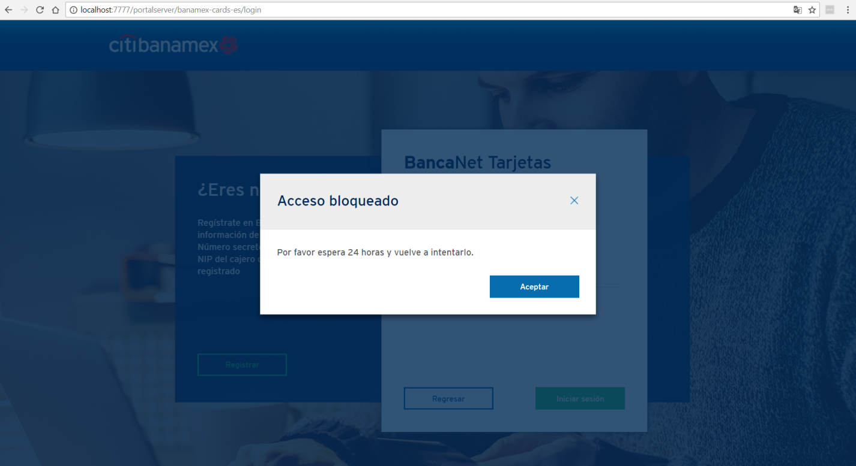

|  |  |
| --- | --- |
| **ID** | Login_Err_04 |
| **Server Name** | http://localhost:7777/portalserver/banamex-cards-es/login |
| **UI Error Message** | Acceso inválido |
| **BackBase Error Response Body** | {   "errorCode": "401",  "errorType": "SOFT_BLOCKED",  } |
| **APIm Error Response Body** | {  "type":"error",  "code":"userAccountLocked",  "details":"15-account locked"  } |
| **Root Cause** | If the user enters invalid details 5 consecutive times. |
| **Additional Information (if any)** |  |
| **Screenshot** | Below |

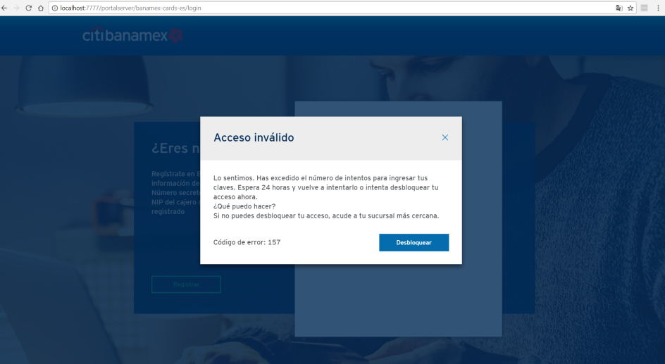

|  |  |
| --- | --- |
| **ID** | Login_Err_05 |
| **Server Name** | http://localhost:7777/portalserver/banamex-cards-es/login |
| **UI Error Message** | Acceso inválido |
| **BackBase Error Response Body** | {   "errorCode": "401",  "errorType": "HARD_BLOCKED",  } |
| **APIm Error Response Body** | {  "type":"error",  "code":"userAccountLocked",  "details":"180-account locked"  } |
| **Root Cause** | If the user enters invalid details 20 or more times, he/she will be hard blocked |
| **Additional Information (if any)** |  |
| **Screenshot** | Below |

