|  |  |
| --- | --- |
| **ID** | Recover_Password_Err_01 |
| **Server Name** | http://localhost:7777/portalserver/banamex-cards-es/recover-password |
| **UI Error Message** | Verifica que la información sea correcta. |
| **BackBase Error Response Body** | {   "errorCode": "401",  "errorType": "INVALID_CARD",  "details" : "Invalid credit card details"  } |
| **APIm Error Response Body** | {  "code": "invalidCard",    "details": "The Card details entered are invalid",    "type": "ERROR"   } |
| **Root Cause** | Invalid credit card details |
| **Additional Information (if any)** |  |
| **Screenshot** | Below |
|  |  |

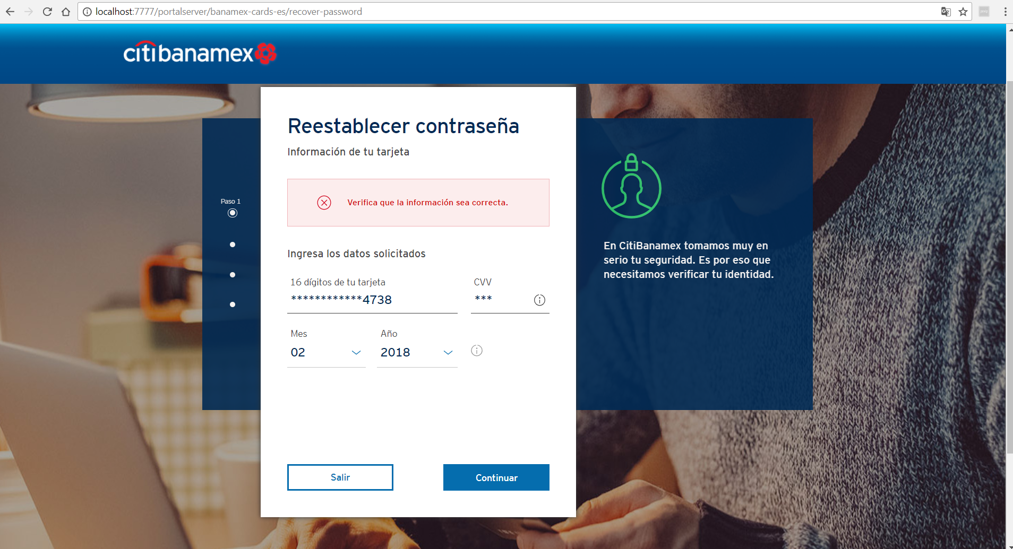

|  |  |
| --- | --- |
| **ID** | Recover_Password_Err_02 |
| **Server Name** | http://localhost:7777/portalserver/banamex-cards-es/recover-password |
| **UI Error Message** | Verifica tu celular. |
| **BackBase Error Response Body** | {  "status":"INCORRECT_VALIDATION_PHONE"  } |
| **APIm Error Response Body** | NA |
| **Root Cause** | Incorrect phone number |
| **Additional Information (if any)** |  |
| **Screenshot** | Below |
|  |  |

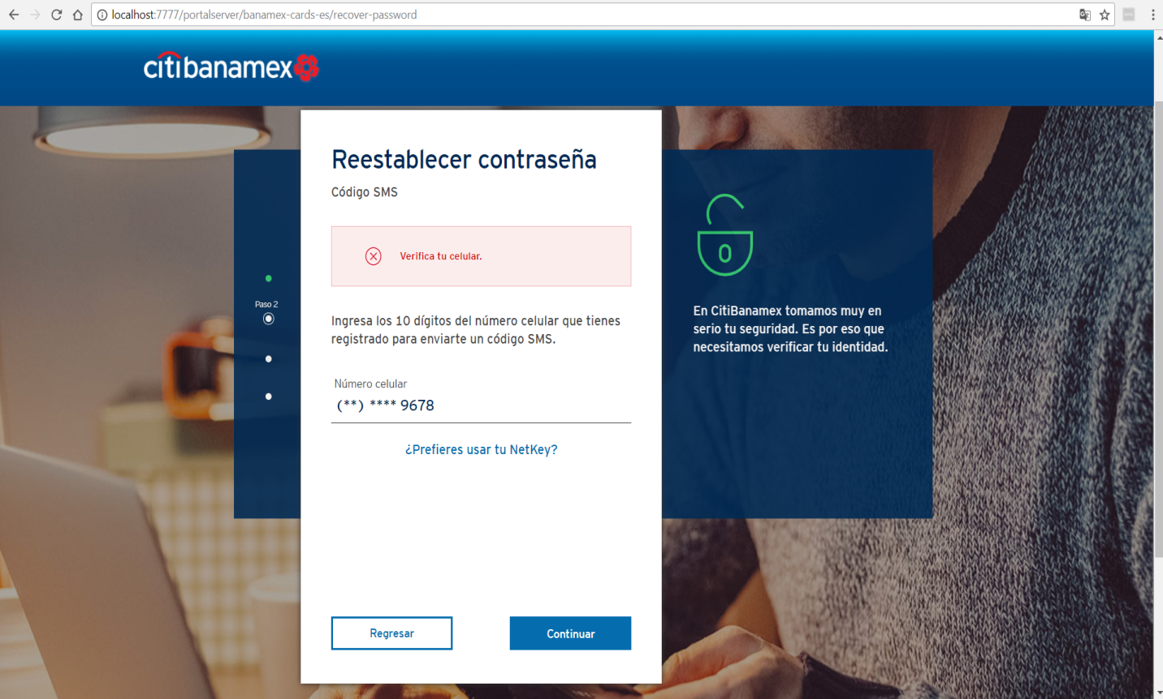

|  |  |
| --- | --- |
| **ID** | Recover_Password_Err_03 |
| **Server Name** | http://localhost:7777/portalserver/banamex-cards-es/recover-password/ |
| **UI Error Message** | Inténtalo de nuevo. |
| **BackBase Error Response Body** | {  "errorCode": "401",  "errorType": "OTP_INVALID_CODE"  } |
| **APIm Error Response Body** |  |
| **Root Cause** | Incorrect OTP |
| **Additional Information (if any)** | The users enters incorrect OTP Code |
| **Screenshot** | Below |

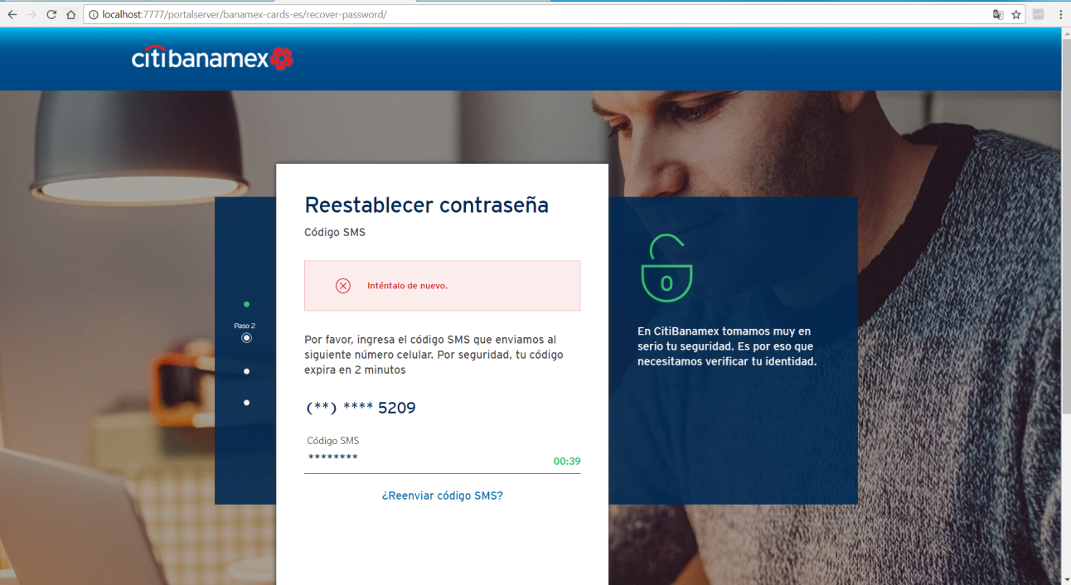

|  |  |
| --- | --- |
| **ID** | Recover_Password_Err_04 |
| **Server Name** | http://localhost:7777/portalserver/banamex-cards-es/recover-Password/ |
| **UI Error Message** | Acceso bloqueado |
| **BackBase Error Response Body** | {"errorCode":"401","errorType":"ACCESS_BLOCKED"} |
| **APIm Error Response Body** | {"type":"error","code":"userAccountLocked","details":" 200011-account locked"} |
| **Root Cause** | Five consecutive attempts tends the access blocked during pre-login |
| **Additional Information (if any)** |  |
| **Screenshot** | Below |
|  |  |
|  |  |

