When Baaron will raise a purchase order instruction, then supplier will get a mail (It is preferable to open this mail in desktop device) like this:

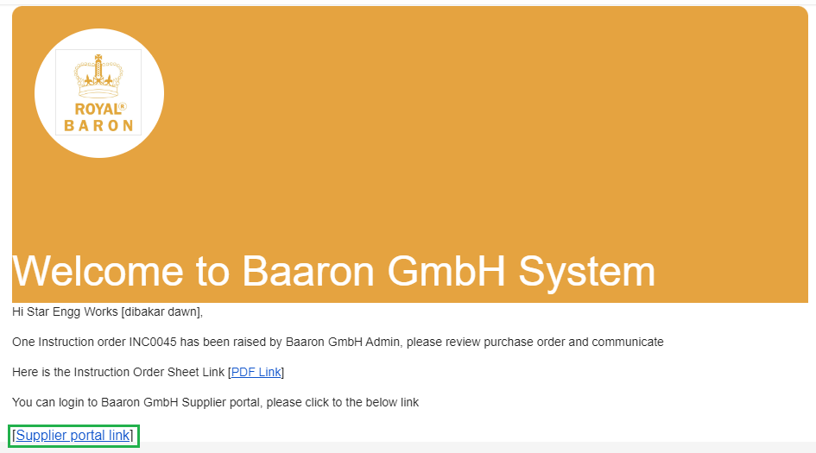

You have click on the link “Supplier portal Link”, highlighted in green border. When you click on the highlighted link, it will open the supplier portal, and it will ask for OTP, the screen will look like this:

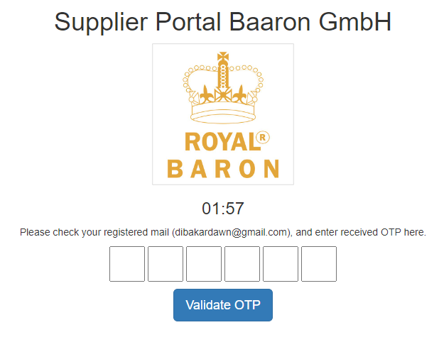

You will receive an OTP in your registered mail id, like this:

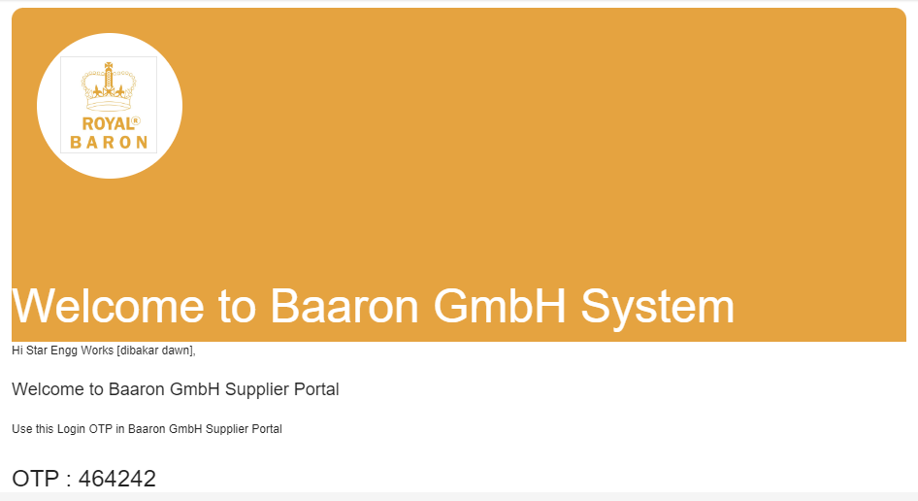

You can see the OTP in the mail. You have to use the OTP in order to login to the supplier portal. You can use this OTP like this.

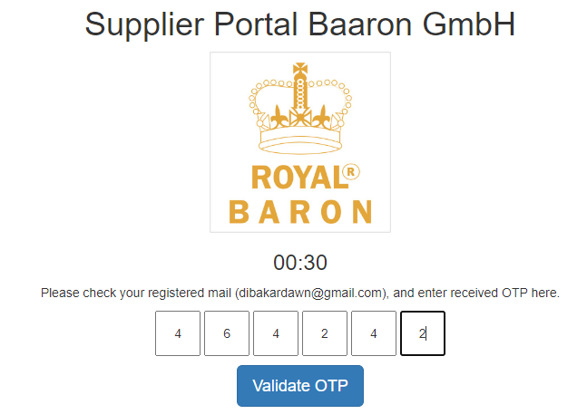

Now click validate OTP button, it will be landed into the supplier portal. As soon as you landed in to the portal, you can see the purchase order pdf. Where you can see the actual purchase order, where you can check what is in the order from Baaron. “Process this order” button will appear (Highlighted in red) beside the purchase order pdf, like this:

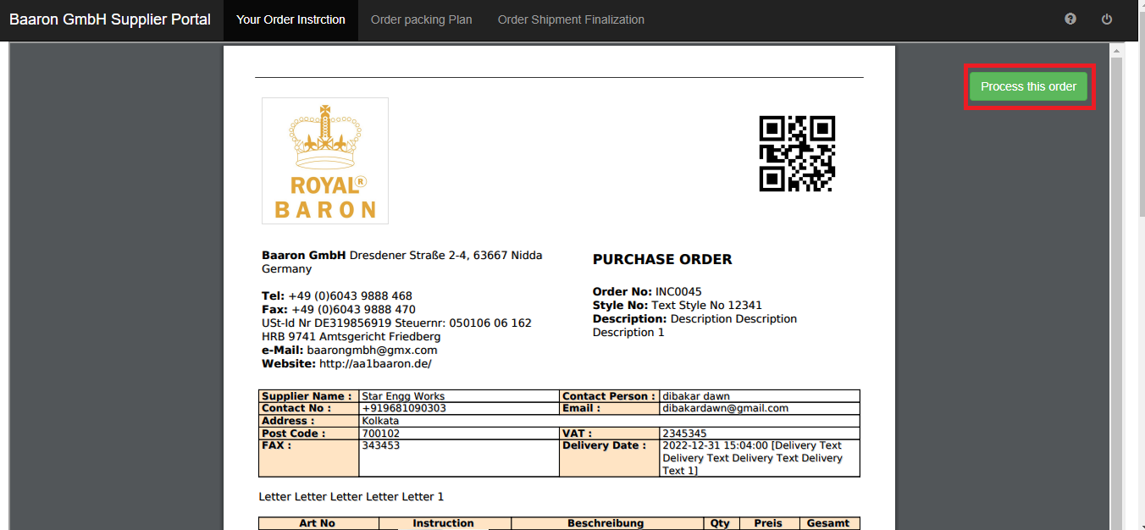

Click the “process this order” button; it will be landed on to the “Order packing plan”, it will be looks like this:

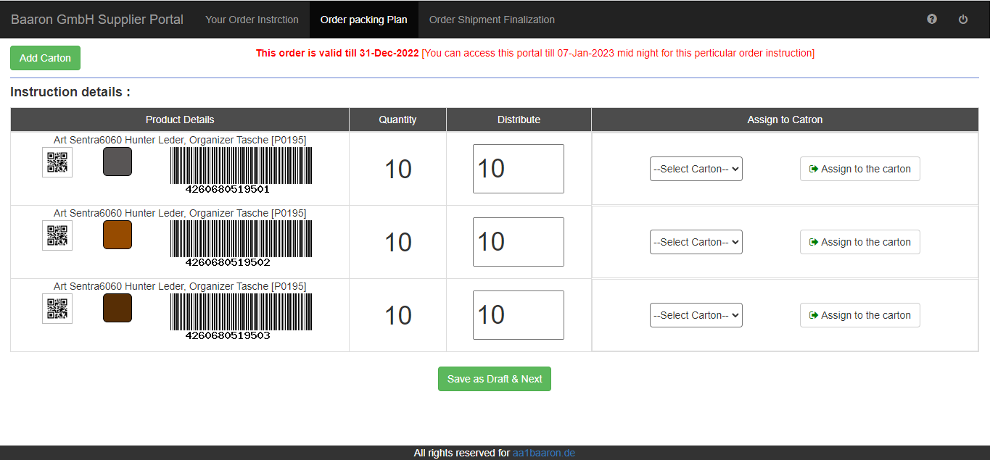

Here 3 points has to be noticed.

1. There is a validity of this order has been highlighted at the top section of the screen, Where you can find delivery date is mentioned in the Red text, and there is another date is mentioned later is the date by which you can access this portal. This portal cannot be accessed beyond the mentioned timeline.
2. You can see the instruction details, the product article names with the barcode and the corresponding color. The quantity has been displayed in the Quantity column. So you have to distribute this quantity in to respective cartons. There is a distribute column, where some pre populated value will be there, in respective rows.
3. Now you have to create some cartons, in order to address these product articles. Click on “Add carton ” button, Like this :

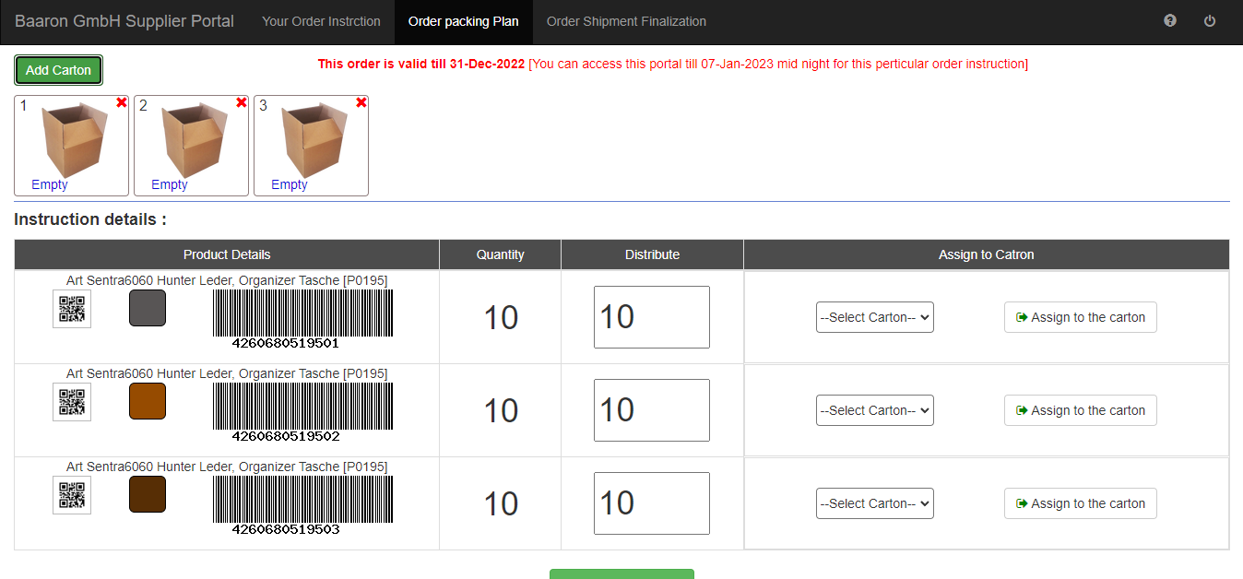

So like this, you have created 3 cartons for these 3 order articles. Initially, these 3 cartons will be Empty. Now we need to assign some order articles in to these cartons. So now you have to choose a carton corresponding to the ordered articles, like this:

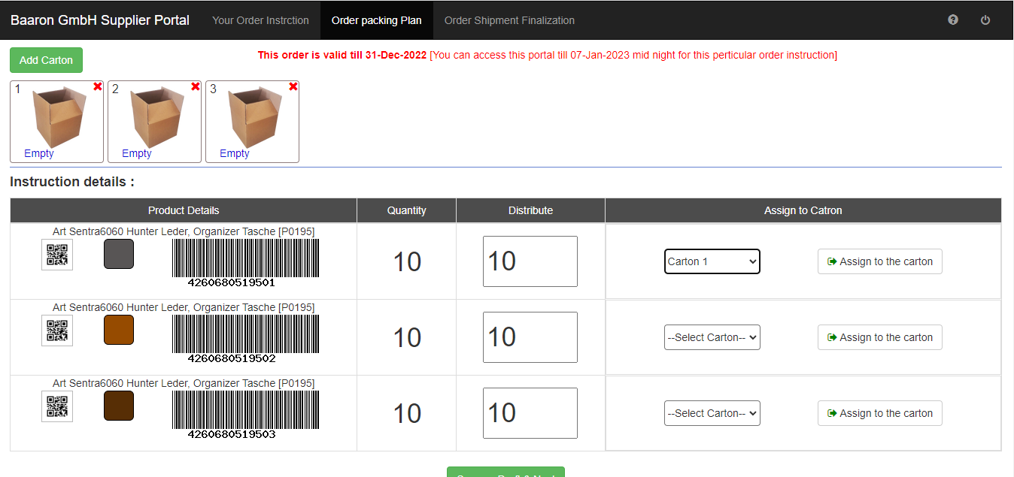

So you can see I have created 3 cartons, and I have assigned carton 1 for the first order articles. So technically I am assigning the first order article to the carton 1, clicking “Assign to the carton” button. When you click on the “Assign to the carton” button, you can notice that carton 1 will not be an empty anymore, “view inside” label will be displayed for the corresponding carton, like this:

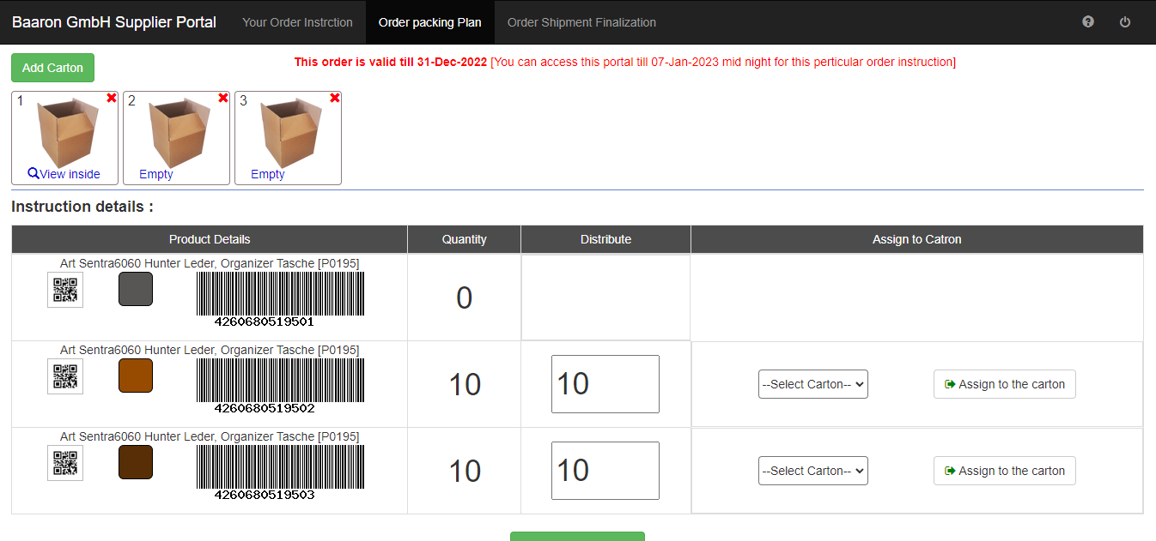

Now you can see the assigned items will be visible, if you click “View inside” label, like this:

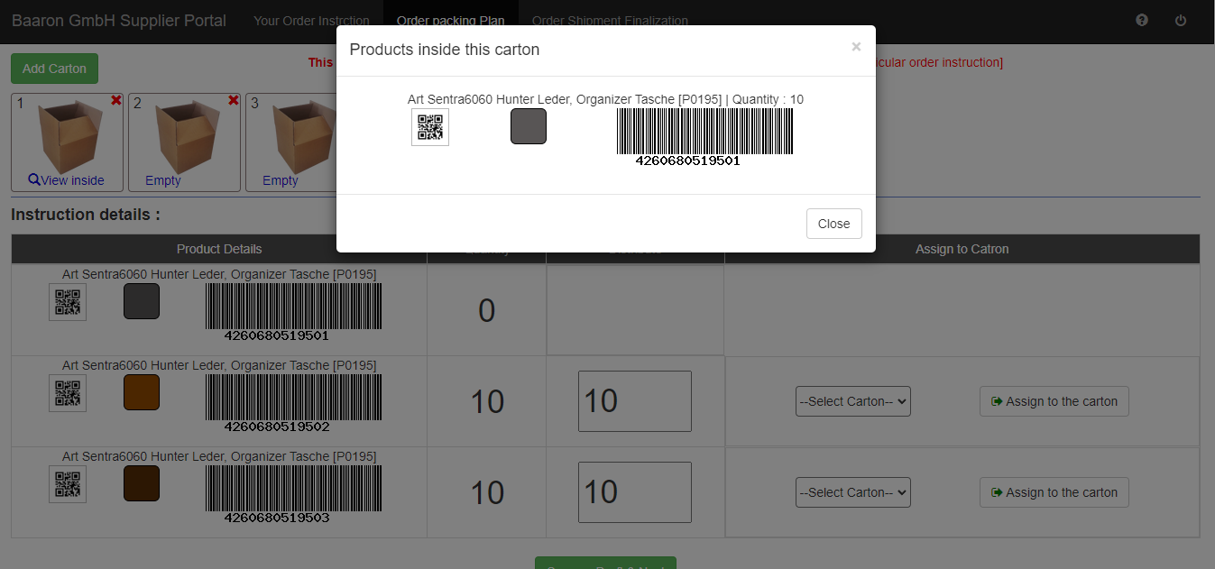

And at the same time you can see the first order item Quantity became ZERO. Which means, it has been assigned successfully? Like this, you can assign the 2nd item to carton 2, and 3rd item to carton 3, like this:

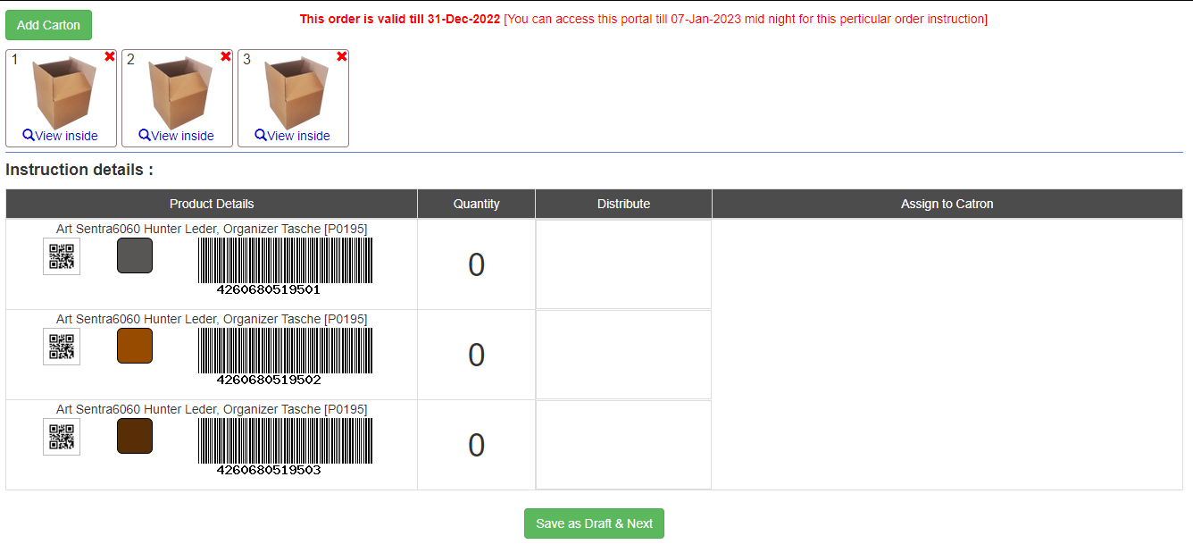

So now you can see all the order items has been assigned. Here I want to mention one condition here; you don’t have to assign all the items in a single day or single time. Don’t worry you have time. You can login to this portal whenever you want to within the delivery date (or access date = delivery date + 7 days) One thing you need to do is to save the changes (Save as Draft & next button), otherwise the changes will gone. After doing this it will be landed to the next screen “Order shipment finalization” like this:

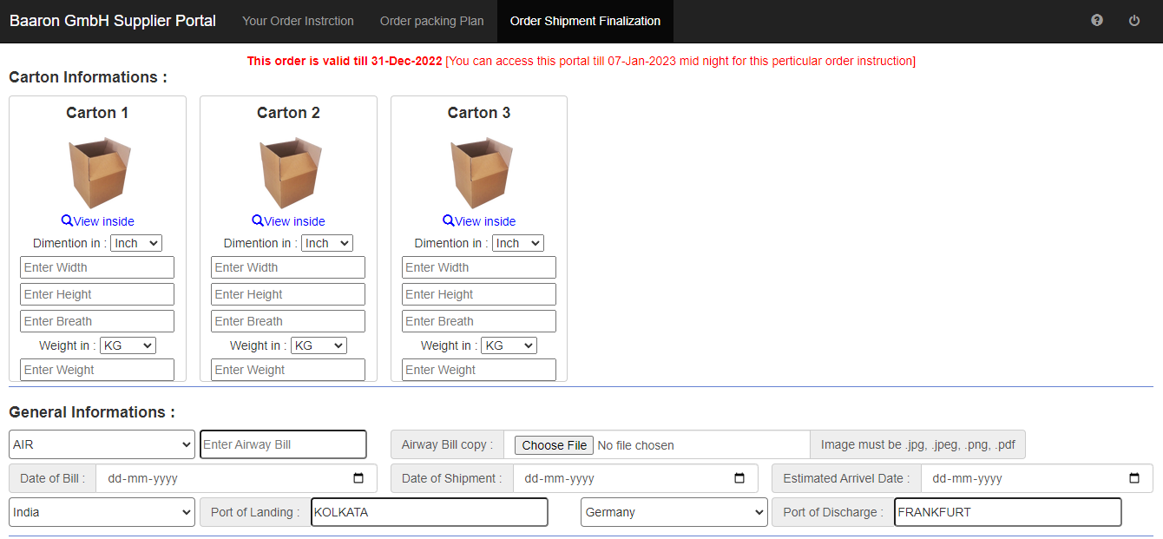

In this screen you have to put all the details about every cartons, width, height, breath, weight. Here we have a “Save as draft” button; which will save you data at any point, it will not finalize anything. Next you have to put Mode of shipment, AW bill, Sea Bill, You need to provide corresponding bill scan copy (That copy should be .png, .jpg, .jpeg or .pdf only). You have to put the dates & places according to the fields.

If you fill that you have filled all the information, you can finalize this data clicking the finalize button. But remember, once you have finalized, you cannot change any data. After finalization, it will be redirected to the “Your order instruction” screen, appearing with “print packing list” button, like this:

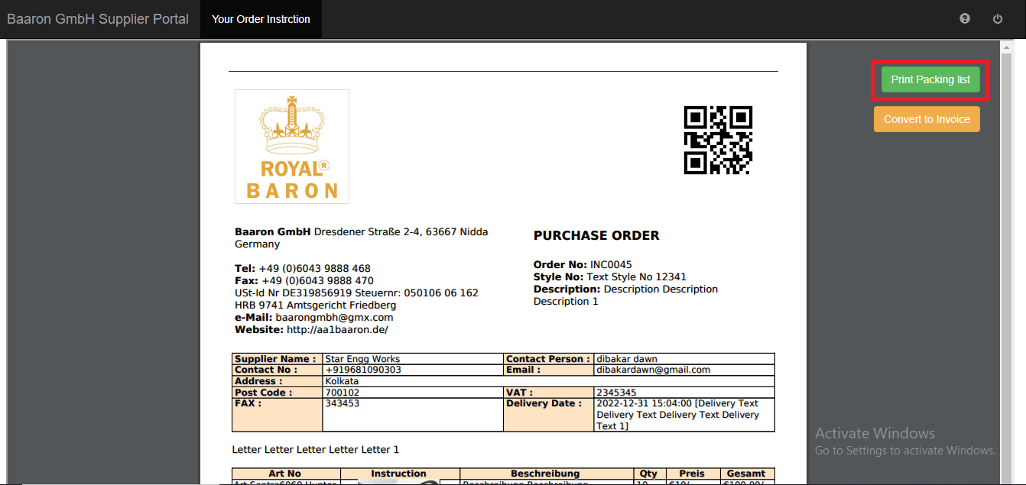

If you click on the print packing list button, then it will open a print friendly packing list for your order. Now you can print your packing list, and attach it with your delivery. Print packing list is looks like this:

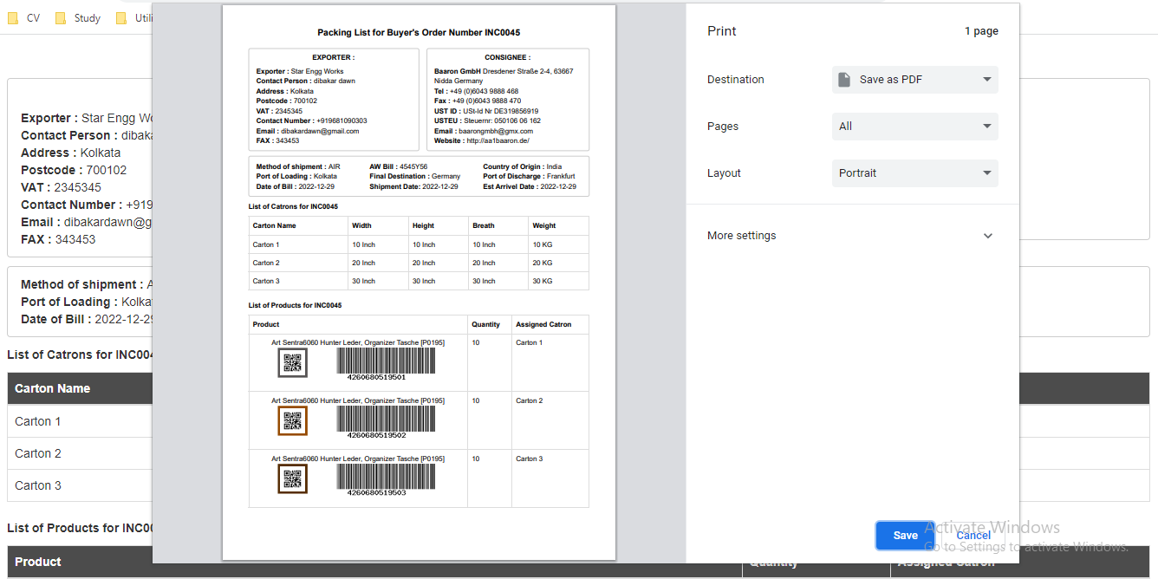

You can generate your invoice also from this system, please follow the steps:

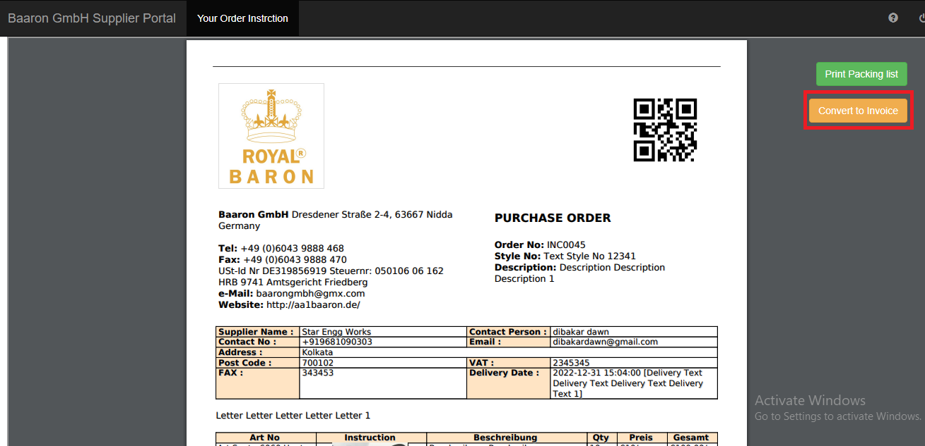

You can see there is a button “Convert to Invoice”, If you click it; It will open an window like this, where you need to put your financial information, like this:

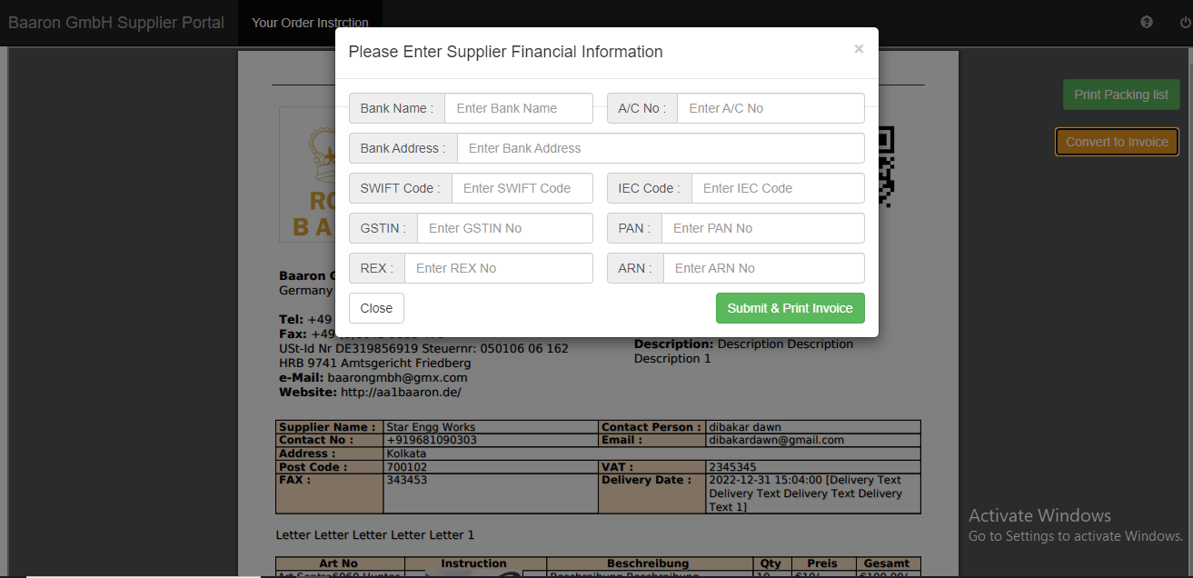

You need to put all the information, as all the information is very important, and all information is mandatory. (Some time these information can be pre-populated, the reason behind is either Baaron has stored your information at the time of your registration, or you have provided your information at the time of previous invoices). After submitting these information it will be landed in the same page, with “Print Invoice” button.

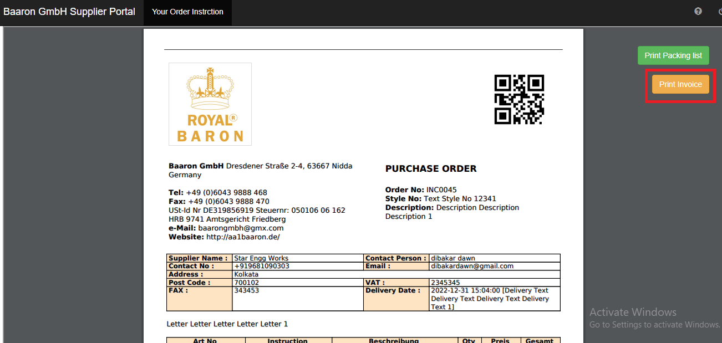

If you click “print invoice” it will print the Invoice for you, like this:

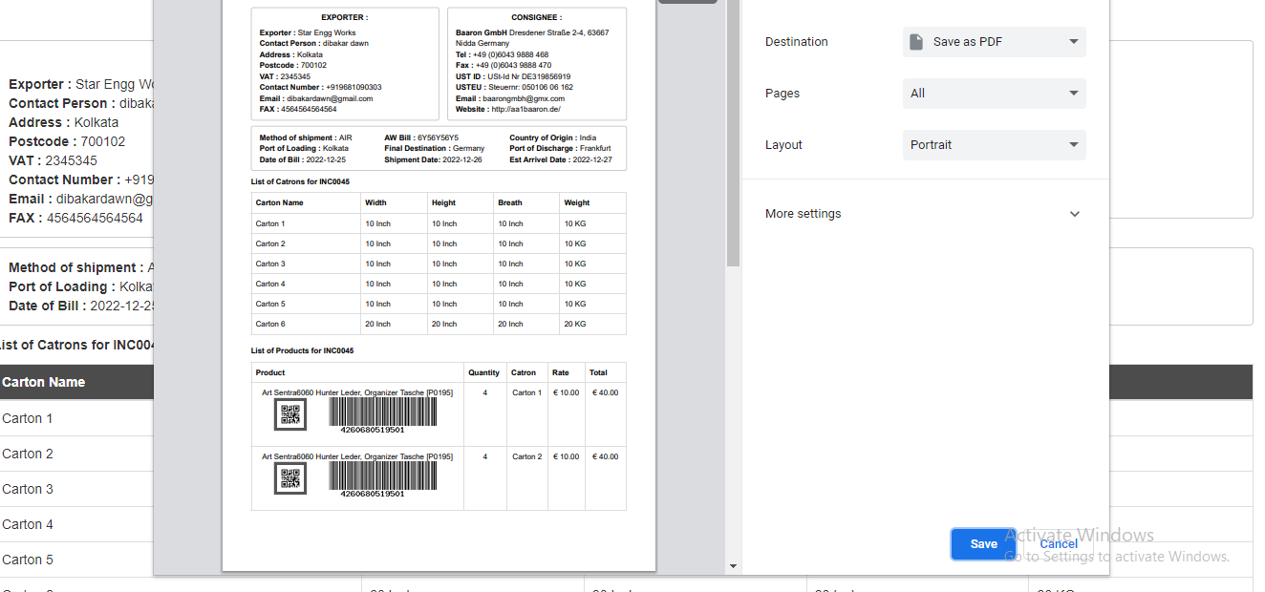

In this way you can print your invoice. Here the journey for Supplier portal ends. For further questions you can call Baaron business communication number.