ID | Recover_Username_Err_01
Server Name | http://localhost:7777/portalserver/banamex-cards-es/recover-username/
UI Error Message | Verifica que la información sea correcta.
BackBase Error Response Body | {  "errorCode": "401",  "errorType": "INVALID_CARD",  "details" : "Invalid credit card details"  }
APIm Error Response Body | {  "code": "invalidCard",  "details": "The Card details entered are invalid",  "type": "ERROR"  }
Root Cause | Invalid credit card details
Additional Information (if any) | The user needs to check all the information entered is correct.
Screenshot | Below

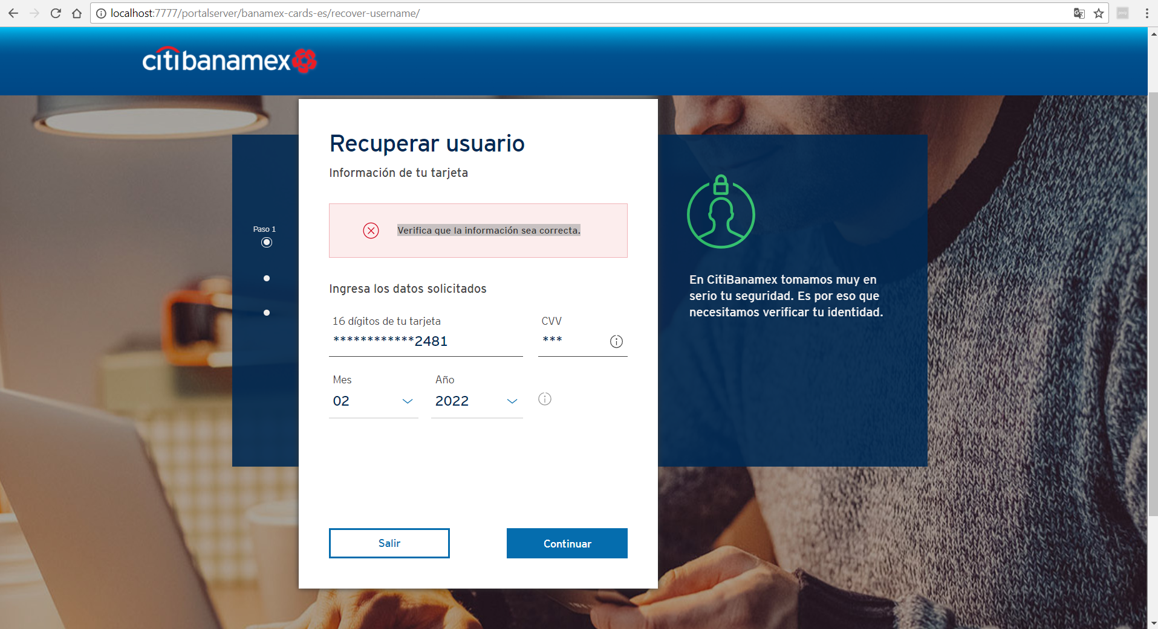

ID | Recover_Username_Err_02
Server Name | http://localhost:7777/portalserver/banamex-cards-es/recover-username/
UI Error Message | Verifica tu celular.
BackBase Error Response Body | {"status":"INCORRECT_VALIDATION_PHONE"}
APIm Error Response Body | NA
Root Cause | Incorrect phone number
Additional Information (if any) | The users enters incorrect phone number
Screenshot | Below

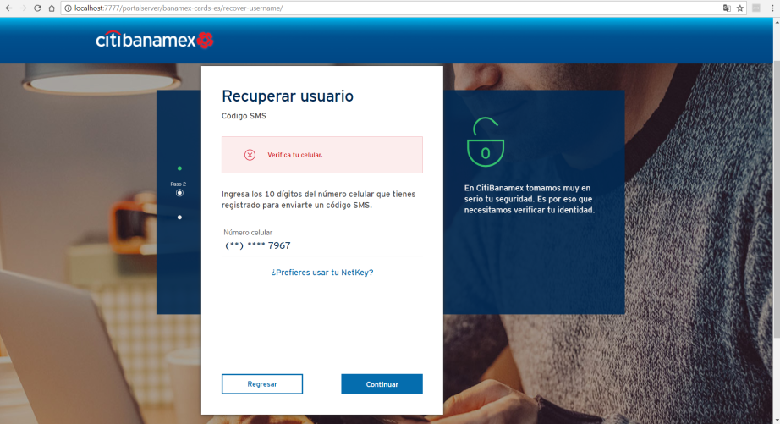

ID | Recover_Username_Err_03
Server Name | http://localhost:7777/portalserver/banamex-cards-es/recover-username/
UI Error Message | Inténtalo de nuevo.
BackBase Error Response Body | {  "errorCode": "401",  "errorType": "OTP_INVALID_CODE"  }
APIm Error Response Body
Root Cause | Invalid OTP code
Additional Information (if any)
Screenshot | Below

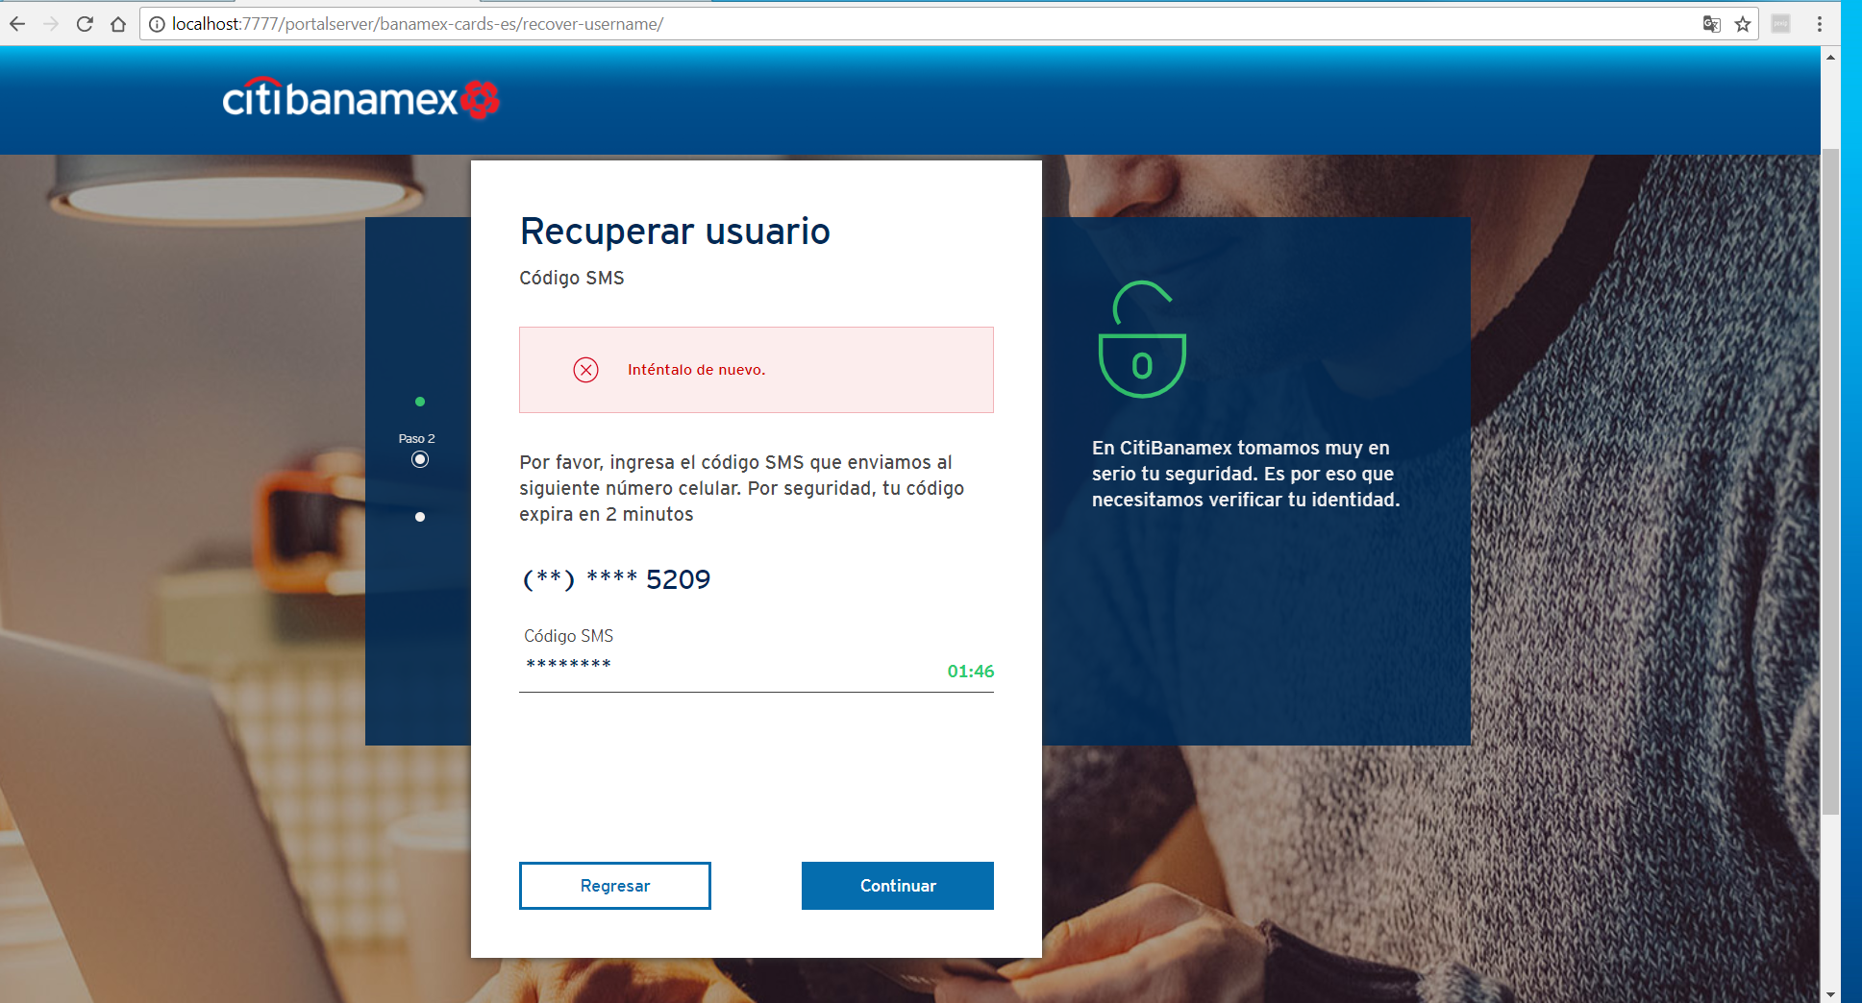

ID | Recover_Username_04
Server Name | http://localhost:7777/portalserver/banamex-cards-es/recover-username/
UI Error Message | Verifica que tu usuario y/o contraseña sean correctas
BackBase Error Response Body | {  "code" : "20",  "status" : 403,  "type" : "invalid",  "message" : null  }
APIm Error Response Body
Root Cause | Password is invalid
Additional Information (if any)
Screenshot | Below

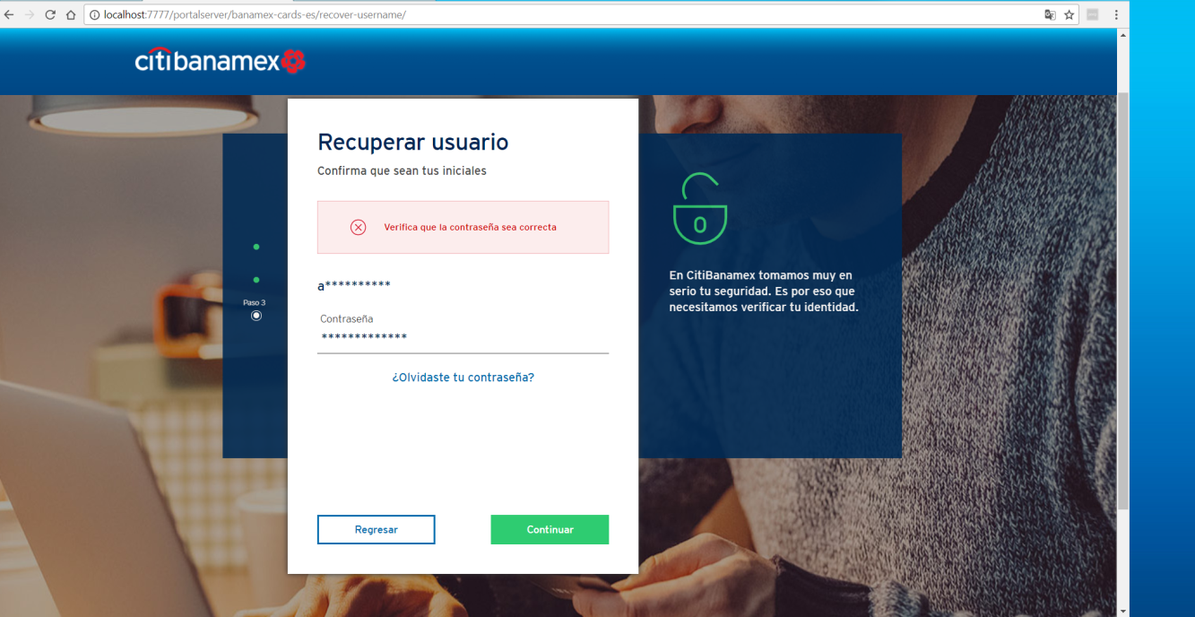

ID | Recover_Username_Err_05
Server Name | http://localhost:7777/portalserver/banamex-cards-es/recover-username/
UI Error Message | Acceso bloqueado - Por favor espera 24 horas y vuelve a intentarlo.
BackBase Error Response Body | {"errorCode":"401","errorType":"ACCESS_BLOCKED"}
APIm Error Response Body | {"type":"error","code":"userAccountLocked","details":" 200011-account locked"}
Root Cause | Five consecutive invalid otp attempt leads access blocked in pre login
Additional Information (if any)
Screenshot | Below

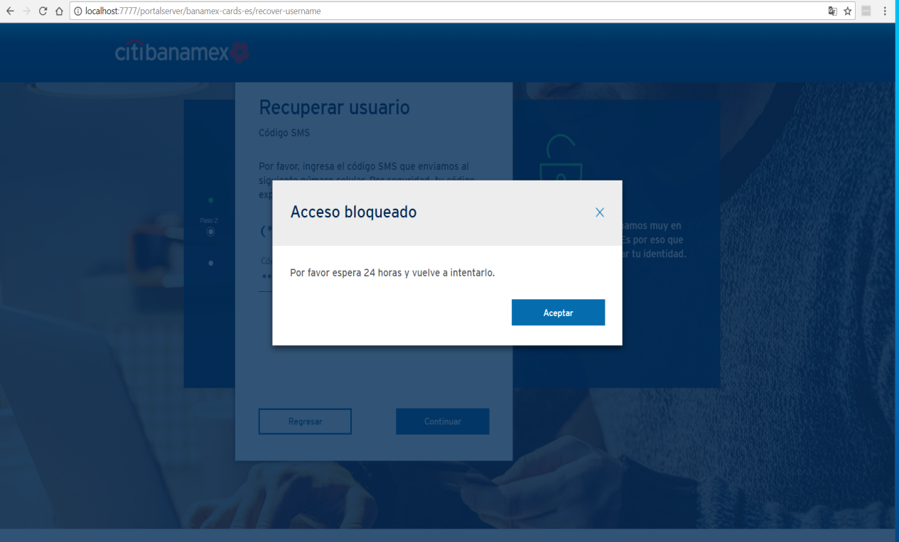

ID | Recover_Username_Err_06
Server Name | http://localhost:7777/portalserver/banamex-cards-es/recover-username/
UI Error Message | Registro inválido  Por motivos de seguridad no se ha podido completar tu operación. Por favor, comunícate al Centro de Atención Telefónica:  *De la Ciudad de México: 1226 2639 / 2262 6301  *Del interior sin costo: 01 800 021 2345.
BackBase Error Response Body | {  "code":"6906",  "details":"Invalid Card Details",  "type":"CARD_BLOCK"  }
APIm Error Response Body | {  "validCard": true,  "ccsCardRegistry": true,  "cardTypeIndicator": "P",  "customerRelationshipID": "0000000000082480155",  "electronicAccess": false,  "cardBlockResponse": {  "tempBlock": false,  "cardBlockStatusCode": true,  "accountBlockStatusCode1": null,  "accountBlockStatusCode2": null  },  "cardErrorMessage": "",  "cardErrorCode": "0"  }
Root Cause | User has enter a card blocked
Additional Information (if any)
Screenshot | Below

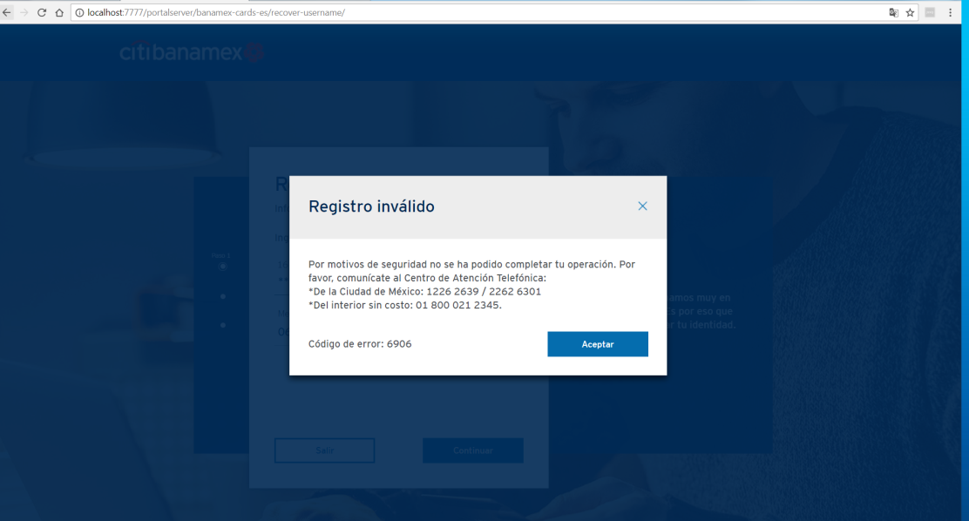

ID | Recover_Username_Err_07
Server Name | http://localhost:7777/portalserver/banamex-cards-es/recover-username/
UI Error Message | En este momento no podemos completar tu solicitud. Inténtalo más tarde.
BackBase Error Response Body | {  "errorCode": "500",  "errorType": "TECHNICAL_DIFFICULTY",  "details" : "Technical Difficulty"  }
APIm Error Response Body | {  "type": "error",  "code": "serverUnavailable",  "details": "The request failed due to an internal error/server unavailability"  }
Root Cause | APIM is down.
Additional Information (if any)
Screenshot | Below

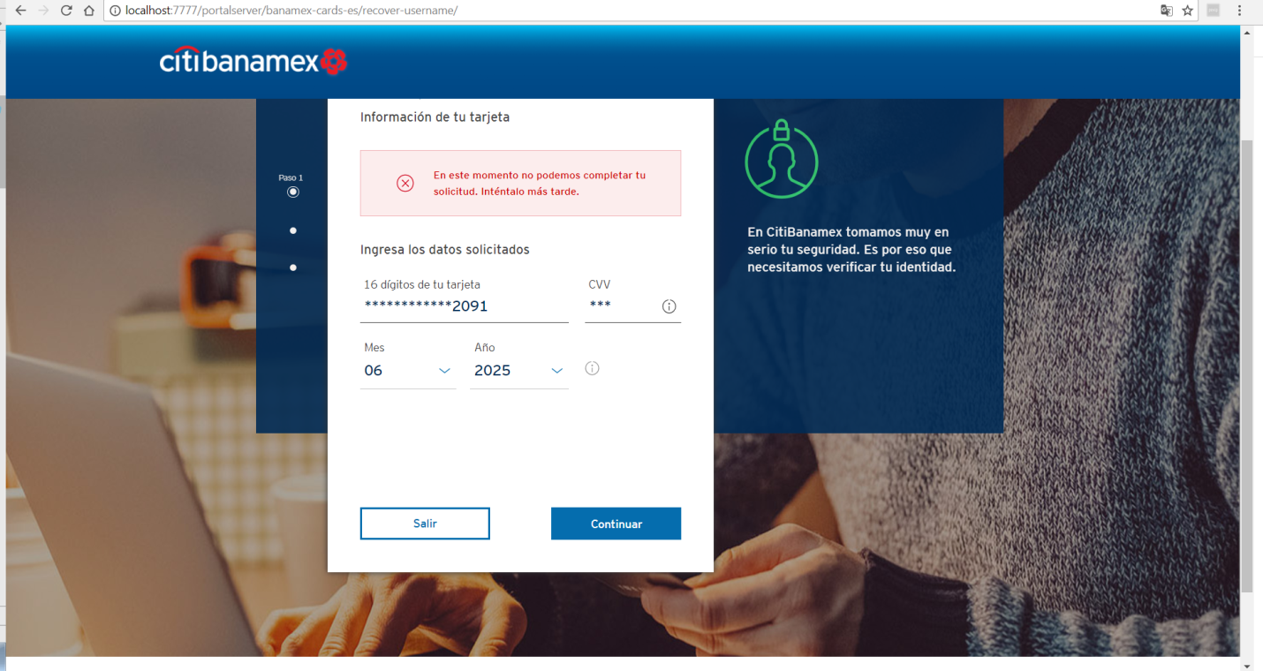
ID | Recover_Username_Err_08
Server Name | http://localhost:7777/portalserver/banamex-cards-es/recover-username/
UI Error Message | Acceso inválido
BackBase Error Response Body | {  "errorCode": "401",  "errorType": "SOFT_BLOCKED",  }
APIm Error Response Body | {"type":"error","code":"userAccountLocked","details":" 15-account locked"}
Root Cause | If the user enters invalid details 5 consecutive times.
Additional Information (if any)
Screenshot | Below

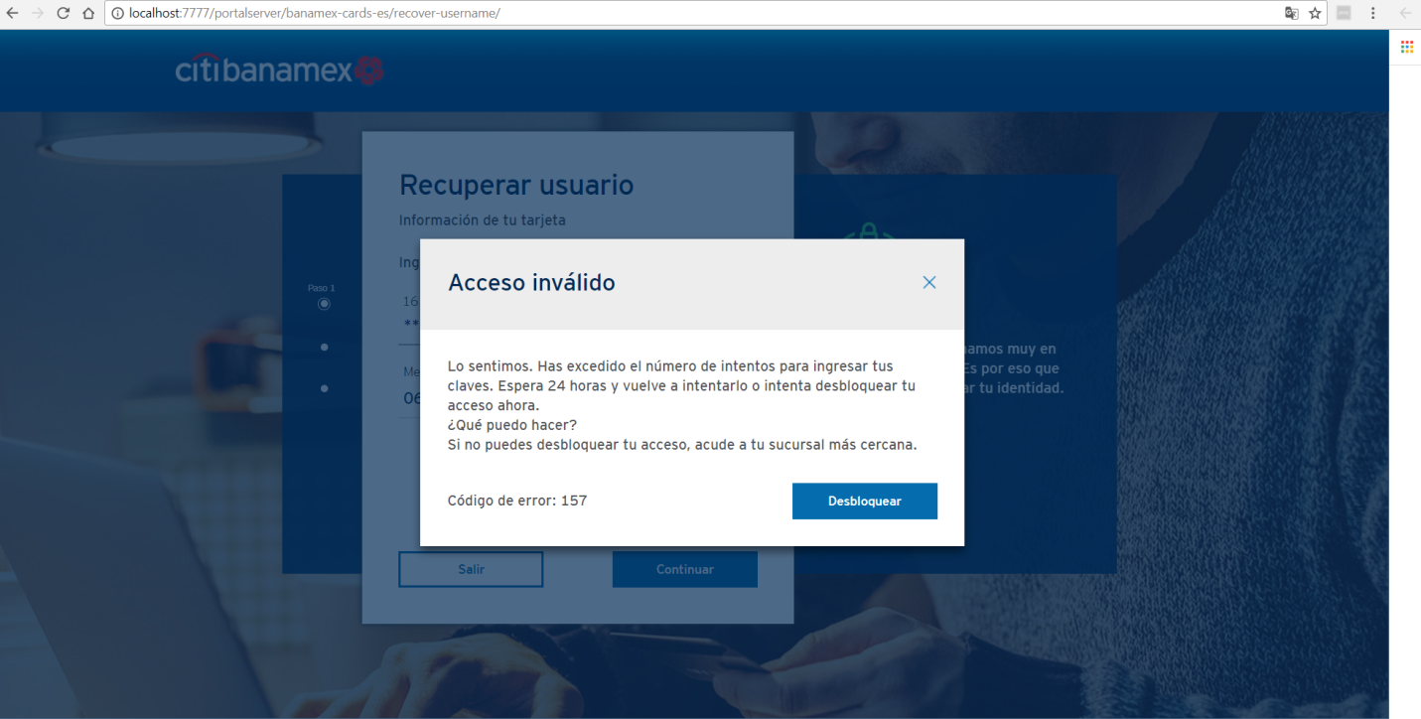

ID | Recover_Username_Err_09
Server Name | http://localhost:7777/portalserver/banamex-cards-es/recover-username/
UI Error Message | Acceso inválido
BackBase Error Response Body | {  "errorCode": "401",  "errorType": "HARD_BLOCKED",  }
APIm Error Response Body | {"type":"error","code":"userAccountLocked","details":" 180-account locked"}
Root Cause | If the user enters invalid details 20 or more times, he/she will be hard blocked
Additional Information (if any)
Screenshot | Below

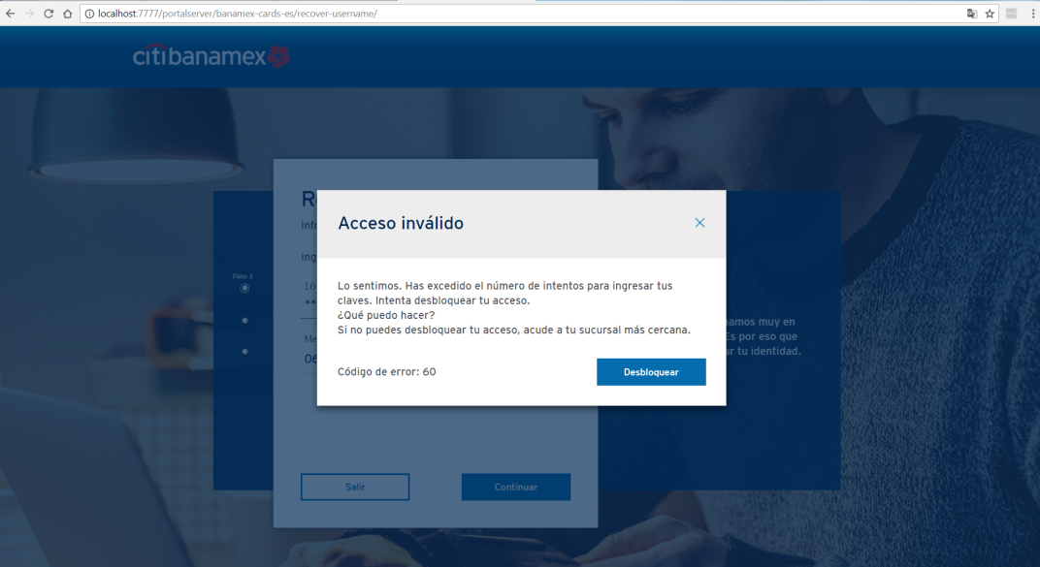
ID | Recover_Username_Err_10
Server Name | http://localhost:7777/portalserver/banamex-cards-es/recover-username/
UI Error Message | Registro inválido
BackBase Error Response Body | {  "errorCode": "401",  "errorType": "CARD_STOLEN",  }
APIm Error Response Body | {  "validCard": true,  "ccsCardRegistry": true,  "cardTypeIndicator": "P",  "customerRelationshipID": "0000000000082480155",  "electronicAccess": false,  "cardBlockResponse": {  "tempBlock": false,  "cardBlockStatusCode": S,  "accountBlockStatusCode1": null,  "accountBlockStatusCode2": null  },  "cardErrorMessage": "",  "cardErrorCode": "0"  }
Root Cause | If the card was stolen and tried to recover username
Additional Information (if any)
Screenshot | Below

