ID | Registration_Err_01
Server Name | http://localhost:7777/portalserver/banamex-cards-es/register-nonbancanet
UI Error Message | Verifica que la informacion sea correcta
BackBase Error Response Body | {"errorCode": "401",  "errorType": "INVALID_CARD",  "details" : "Invalid Card Details"}
APIm Error Response Body | { "code": "invalidCard",  "details": "The Card details entered are invalid",  "type": "ERROR" }
Root Cause | Information received is invalid
Additional Information (if any)
Screenshot | Below

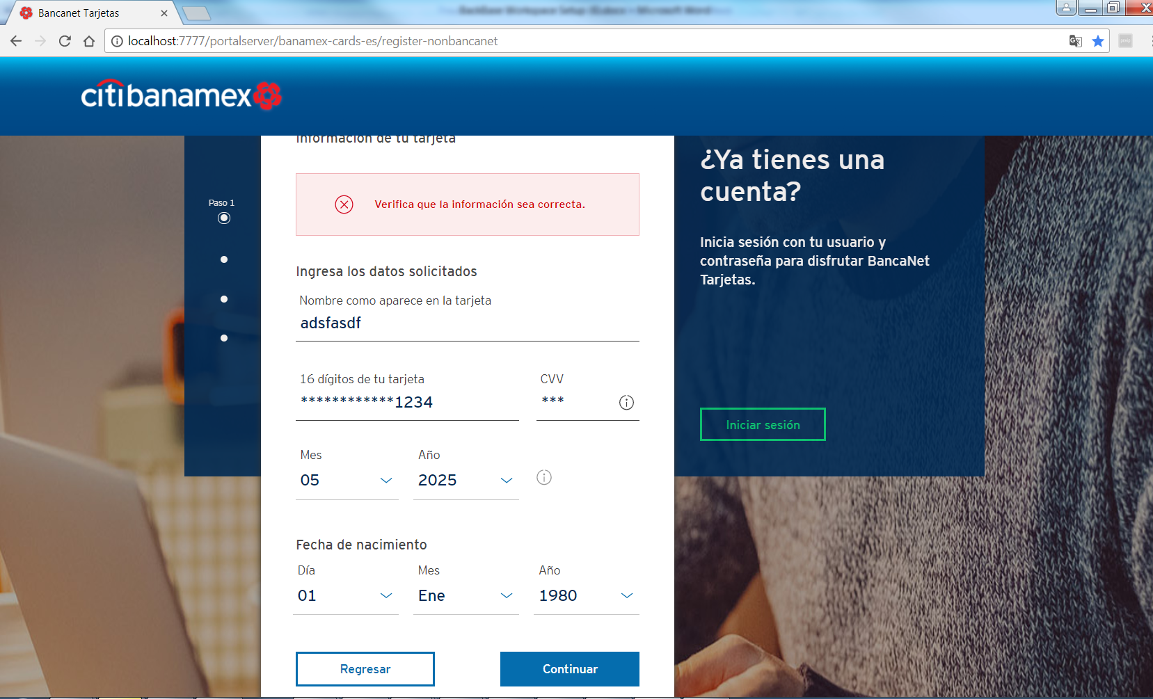

ID | Registration_Err_02
Server Name | http://localhost:7777/portalserver/banamex-cards-es/register-nonbancanet
UI Error Message | En este momento no podemos completar tu solicitud. Inténtalo más tarde.
BackBase Error Response Body | {"errorCode": "500",  "errorType": "TECHNICAL_DIFFICULTY",  "details" : "Technical Difficulty"}
APIm Error Response Body | {  "type": "error",  "code": "serverUnavailable",  "details": "The request failed due to an internal error/server unavailability",  "  }
Root Cause | - APIM server is down  - Status from APIM is not a valid scenario possible error en APIM
Additional Information (if any)
Screenshot | Below

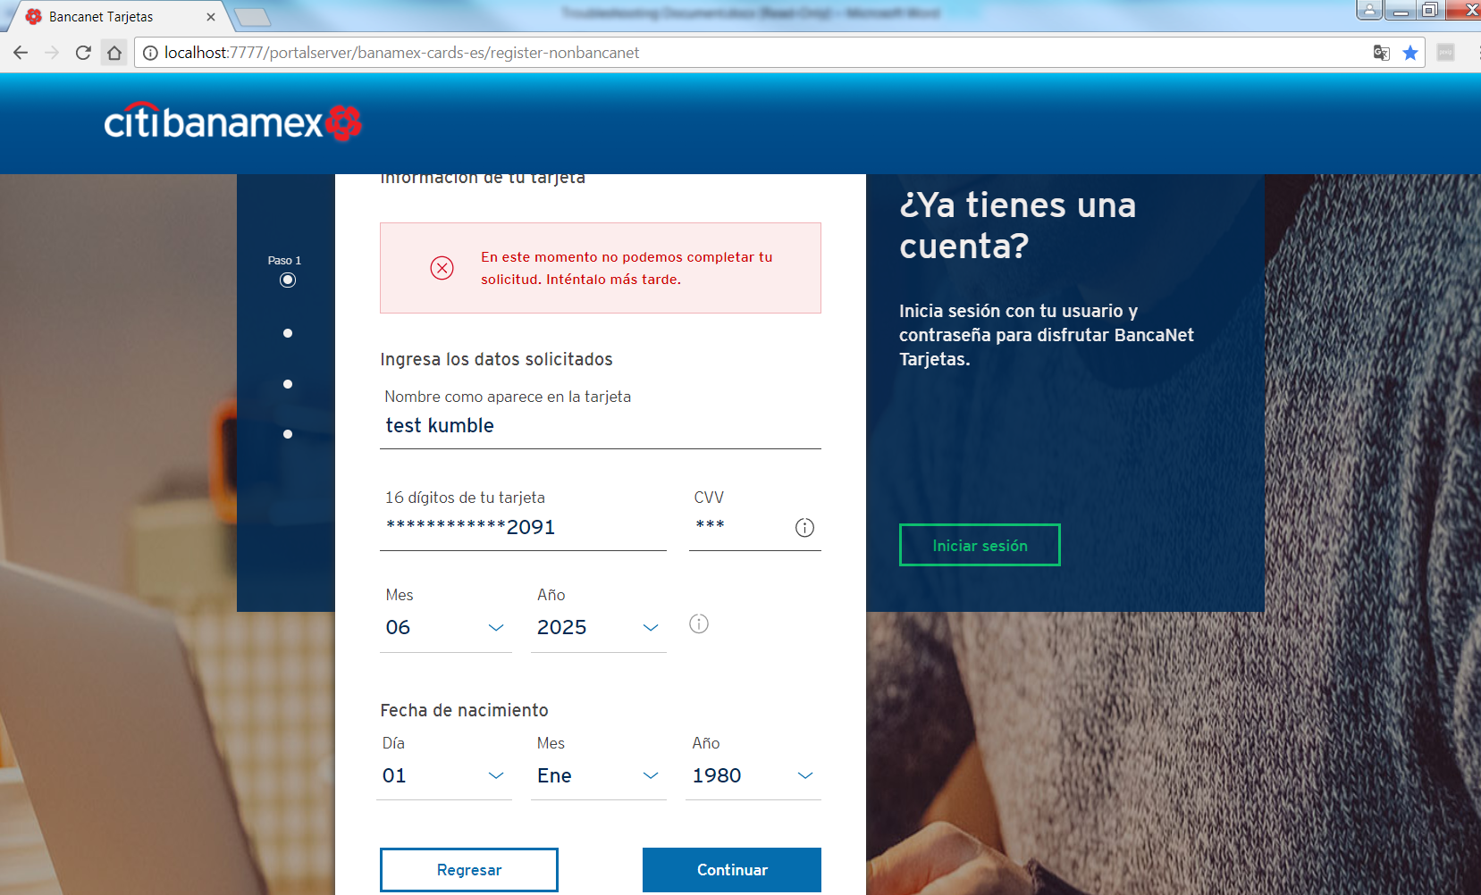

ID | Registration _Err_03
Server Name | http://localhost:7777/portalserver/banamex-cards-es/register-nonbancanet
UI Error Message | Hemos identificado que ya estas registrado en BancaNet Tarjetas, selecciona continuar para iniciar sesión.
BackBase Error Response Body | {"errorCode": "401",  "errorType": "CARD_REGISTERED",  "details" : "Card Alredy registered"}
APIm Error Response Body | {  "validCard": true,  "ccsCardRegistry": true,  "cardTypeIndicator": "P",  "customerRelationshipID": "0000000000082480155",  "electronicAccess": false,  "cardBlockResponse": {  "tempBlock": false,  "cardBlockStatusCode": null,  "accountBlockStatusCode1": null,  "accountBlockStatusCode2": null  },  "cardErrorMessage": "",  "cardErrorCode": "0"  }
Root Cause | User has enter a card already registered
Additional Information (if any)
Screenshot | Below

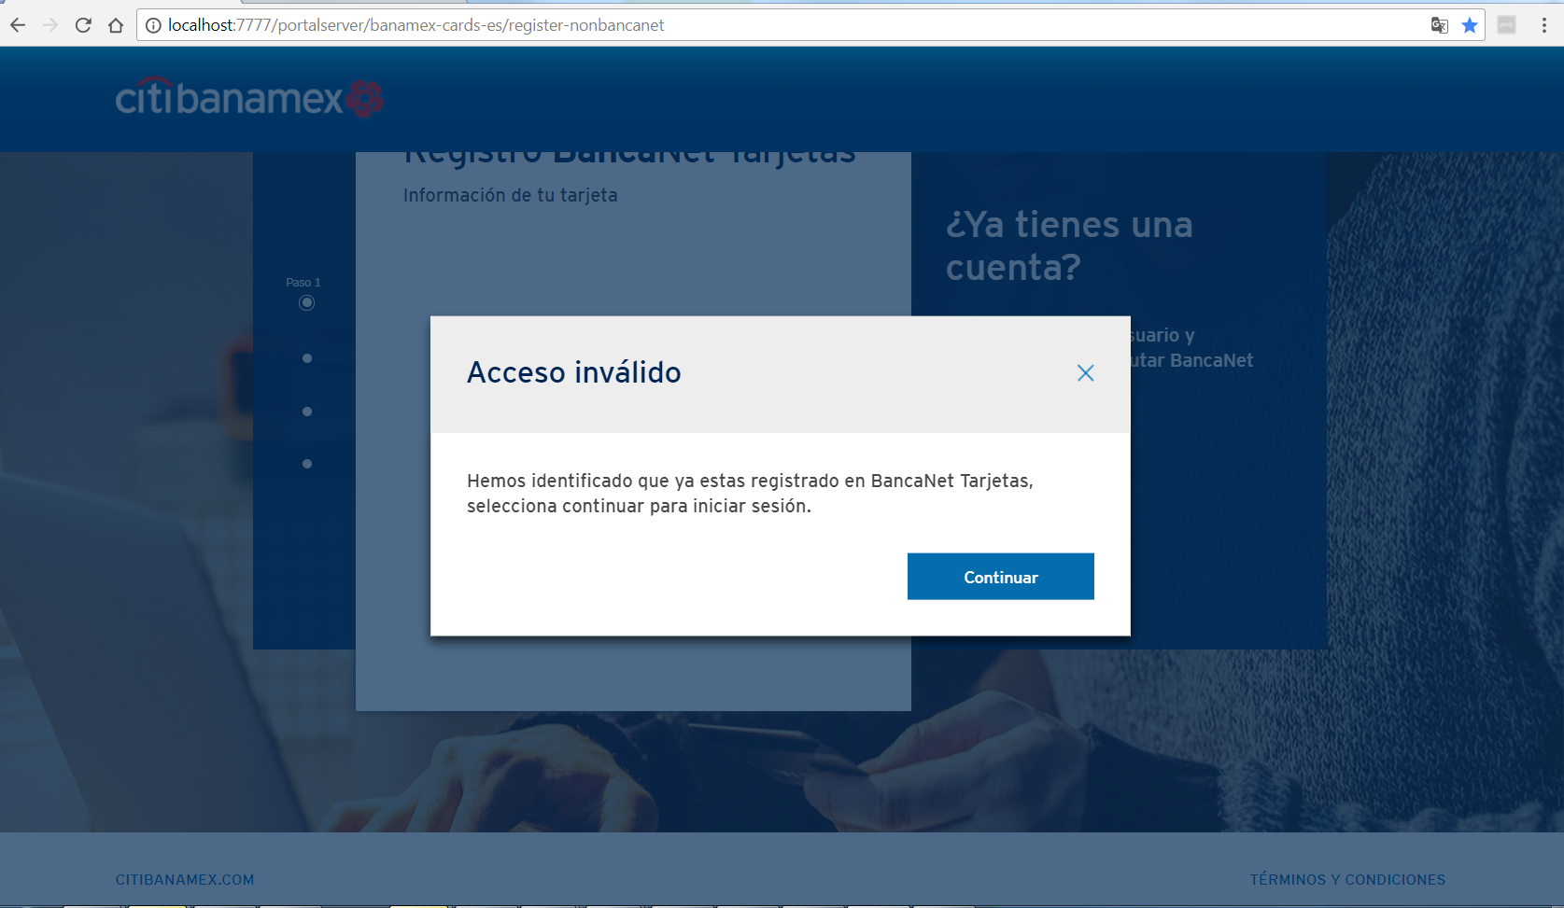

ID | Registration _Err_04
Server Name | http://localhost:7777/portalserver/banamex-cards-es/register-nonbancanet
UI Error Message | Hemos identificado que ya estas registrado en BancaNet Tarjetas, selecciona continuar para iniciar sesión.
BackBase Error Response Body | {"errorCode": "401",  "errorType": "CARD_LOST"}
APIm Error Response Body | {  "validCard": true,  "ccsCardRegistry": true,  "cardTypeIndicator": "P",  "customerRelationshipID": "0000000000082480155",  "electronicAccess": false,  "cardBlockResponse": {  "tempBlock": false,  "cardBlockStatusCode": L,  "accountBlockStatusCode1": null,  "accountBlockStatusCode2": null  },  "cardErrorMessage": "",  "cardErrorCode": "0"  }
Root Cause | User has enter a card with status lost
Additional Information (if any)
Screenshot | Below

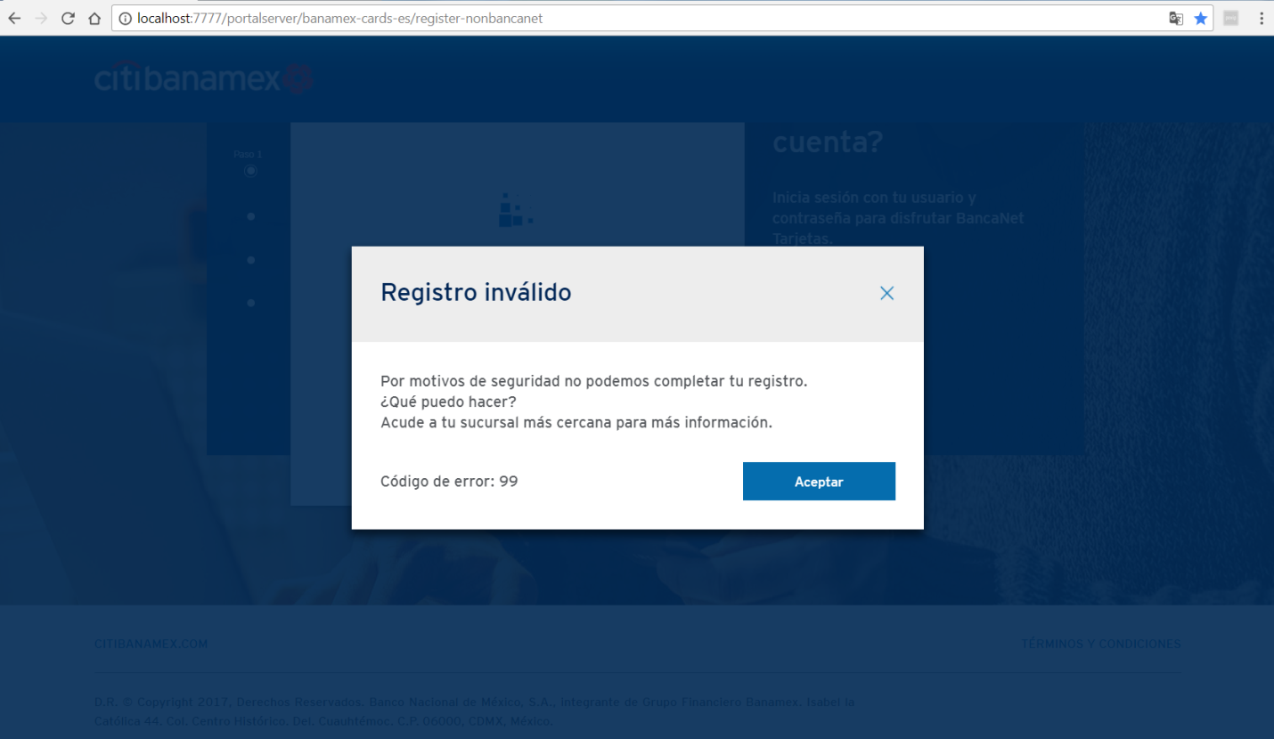

ID | Registration _Err_05
Server Name | http://localhost:7777/portalserver/banamex-cards-es/register-nonbancanet
UI Error Message | Hemos identificado que ya estas registrado en BancaNet Tarjetas, selecciona continuar para iniciar sesión.
BackBase Error Response Body | {"errorCode": "401",  "errorType": "CARD_STOLEN"}
APIm Error Response Body | {  "validCard": true,  "ccsCardRegistry": true,  "cardTypeIndicator": "P",  "customerRelationshipID": "0000000000082480155",  "electronicAccess": false,  "cardBlockResponse": {  "tempBlock": false,  "cardBlockStatusCode": S,  "accountBlockStatusCode1": null,  "accountBlockStatusCode2": null  },  "cardErrorMessage": "",  "cardErrorCode": "0"  }
Root Cause | User has enter a card with status stolen
Additional Information (if any)
Screenshot | Below

ID | Registration _Err_06
Server Name | http://localhost:7777/portalserver/banamex-cards-es/register-nonbancanet
UI Error Message | Hemos identificado que ya estas registrado en BancaNet Tarjetas, selecciona continuar para iniciar sesión.
BackBase Error Response Body | {"errorCode": "401",  "errorType": "CARD_BLOCK"}
APIm Error Response Body | {  "validCard": true,  "ccsCardRegistry": true,  "cardTypeIndicator": "P",  "customerRelationshipID": "0000000000082480155",  "electronicAccess": false,  "cardBlockResponse": {  "tempBlock": false,  "cardBlockStatusCode": true,  "accountBlockStatusCode1": null,  "accountBlockStatusCode2": null  },  "cardErrorMessage": "",  "cardErrorCode": "0"  }
Root Cause | User has enter a card blocked
Additional Information (if any)
Screenshot | Below

ID | Registration_NIP_Err_01
Server Name | http://localhost:7777/portalserver/banamex-cards-es/register-nonbancanet
UI Error Message | Inténtalo de nuevo.
BackBase Error Response Body | {"errorCode":"401",  "errorType":"INVALID_PIN",  "validPin":false}
APIm Error Response Body | {  "OAFL3519OperationResponse": {  "pinValidationResponse": {  "responseHeader": {  "responseMessageId": 3519,  "responseVersionNumber": 10,  "responseTerminalId": "00000000MX",  "responseUserdId": "RASWK"  },  "responseDateTime": {  "responseDate": 170058,  "responseTime": 0  },  "responseCode": 0,  "responseMoreInd": "N",  "responseFlag": "R",  "responseFormat": 1,  "responseReturnCode": "1",  "responseReturnMessage": "INVALID PIN",  "responseInvIcardTries": 0  }  }  }
Root Cause | Invalid pin entered
Additional Information (if any)
Screenshot | Below

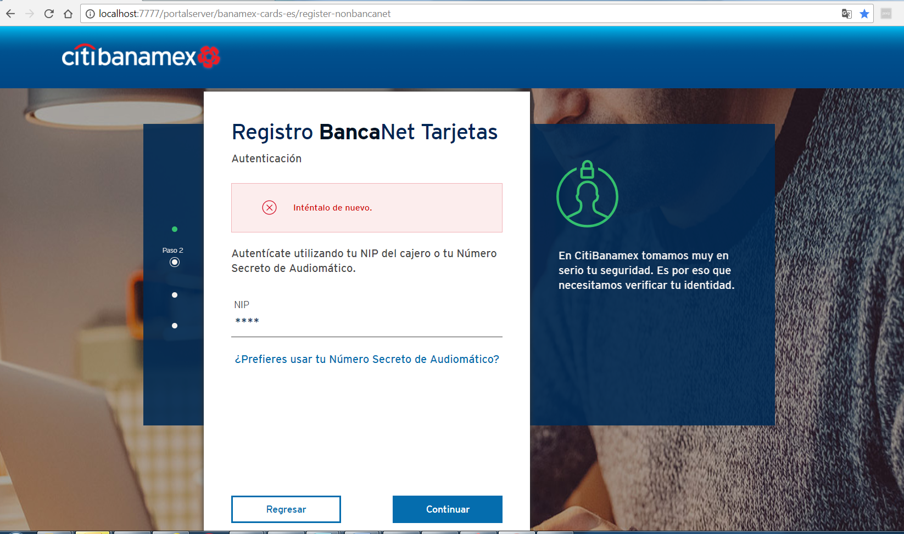

ID | Registration_NIP_Err_02
Server Name | http://localhost:7777/portalserver/banamex-cards-es/register-nonbancanet
UI Error Message | En este momento no podemos completar tu solicitud. Inténtalo más tarde.
BackBase Error Response Body | {"errorCode": "401",  "errorType": "INVALID_APPLICATION_CONTEXT",  "details" : "Invalid Application Context"}
APIm Error Response Body | N/A
Root Cause | User has reach inactivity time limit
Additional Information (if any) | Invalid application context happens reached inactivity time limit
Screenshot | Below

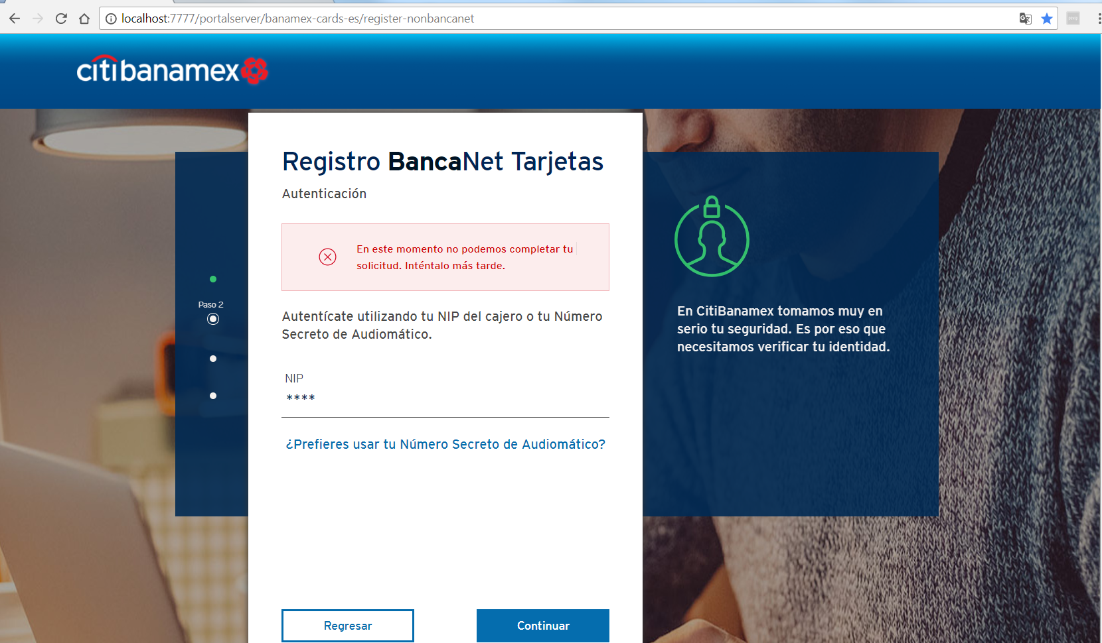

ID | Registration_NIP_Err_03
Server Name | http://localhost:7777/portalserver/banamex-cards-es/register-nonbancanet
UI Error Message | En este momento no podemos completar tu solicitud. Inténtalo más tarde.
BackBase Error Response Body | {"errorCode": "500",  "errorType": "TECHNICAL_DIFFICULTY",  "details" : "Technical Difficulty"}
APIm Error Response Body | { "type": "error",  "code": "serverUnavailable",  "details": "The request failed due to an internal error/server unavailability"}
Root Cause | - APIM server is down  - Status from APIM is not a valid scenario possible error en APIM
Additional Information (if any)
Screenshot | Below

ID | Registration_phone_Err_01
Server Name | http://localhost:7777/portalserver/banamex-cards-es/register-nonbancanet
UI Error Message | Verifica tu celular.
BackBase Error Response Body | {"errorCode": "401",  "errorType": "INVALID_APPLICATION_CONTEXT",  "details" : "Invalid Application Context"}
APIm Error Response Body | N/A
Root Cause | User has reach inactivity time limit
Additional Information (if any) | Invalid application context happens reached inactivity time limit
Screenshot | Below

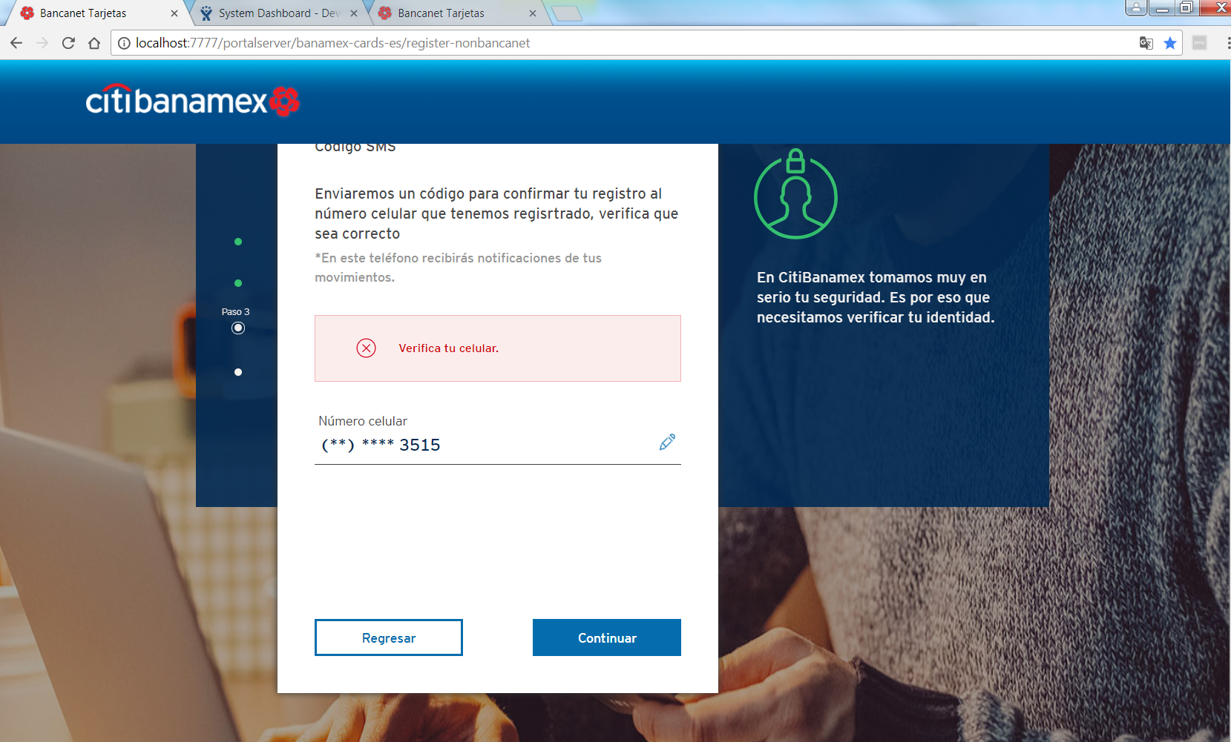
ID | Registration_phone_Err_02
Server Name | http://localhost:7777/portalserver/banamex-cards-es/register-nonbancanet
UI Error Message | En este momento no podemos completar tu solicitud. Inténtalo más tarde.
BackBase Error Response Body | {"errorCode": "500",  "errorType": "INTERNAL_SERVER_ERROR"}
APIm Error Response Body | { "type": "error",  "code": "serverUnavailable",  "details": "The request failed due to an internal error/server unavailability"}
Root Cause | Status from APIM is not a valid scenario possible error en APIM
Additional Information (if any)
Screenshot | Below

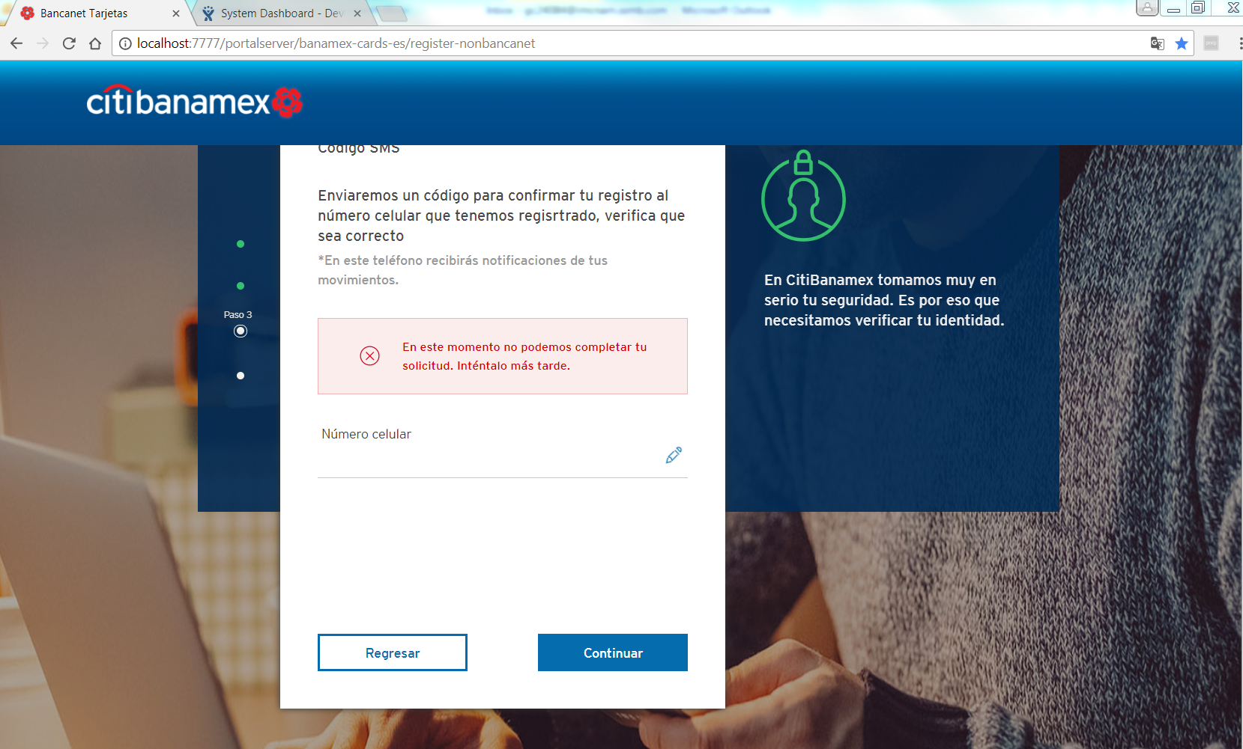

ID | Registration_Cred_Err_01
Server Name | http://localhost:7777/portalserver/banamex-cards-es/register-nonbancanet
UI Error Message | Este usuario ya esta registrado. Por favor, elige otro.
BackBase Error Response Body | {"errorCode": "401",  "errorType": "USERID_EXISTS "}
APIm Error Response Body | {  "code": "userIDRegistered",  "details": "User ID already registered",  "type": "ERROR"  }
Root Cause | User has enter a username already registered
Additional Information (if any)
Screenshot | Below

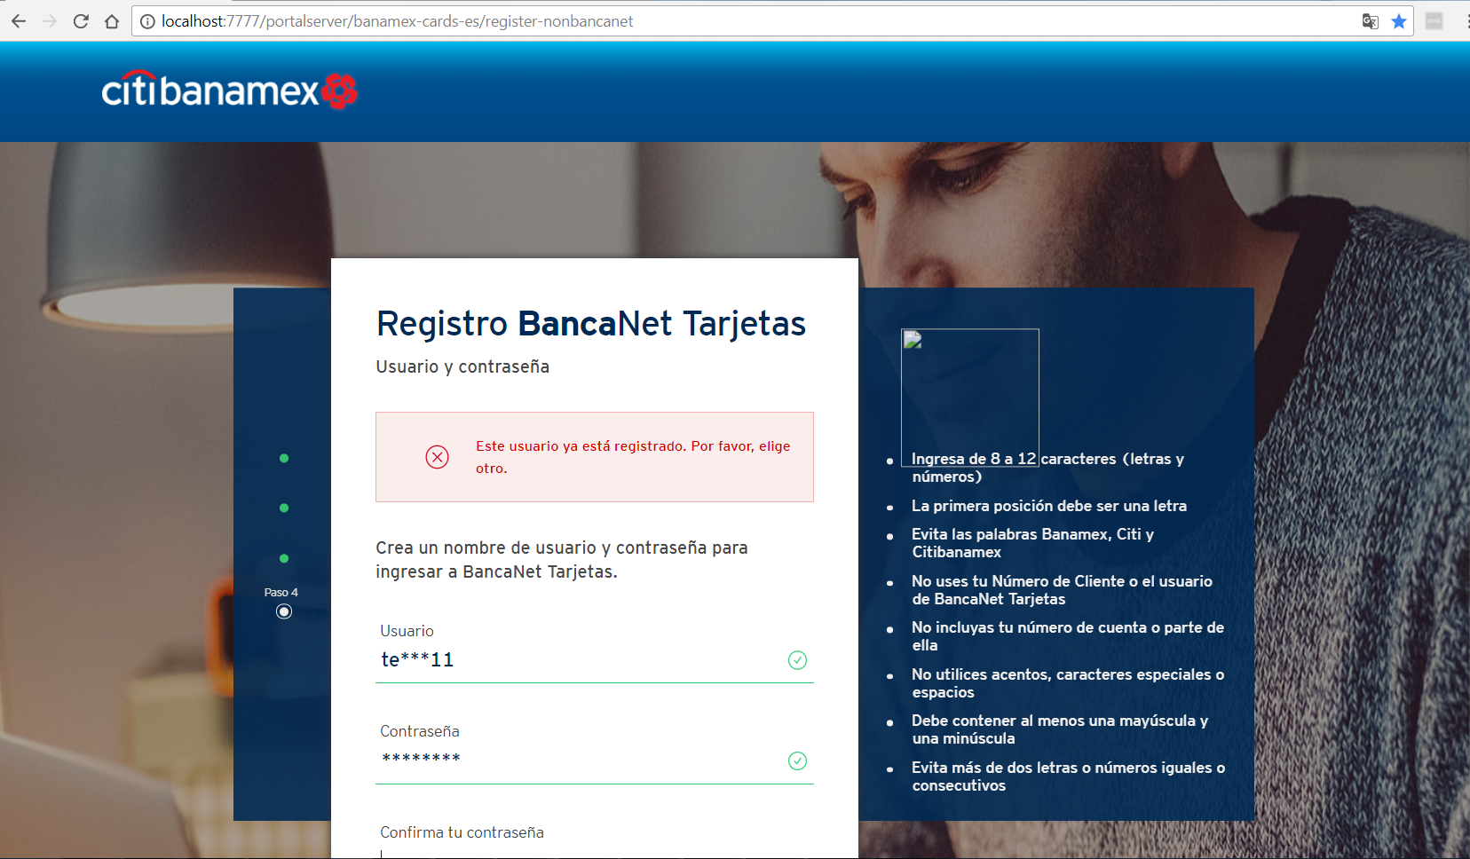

ID | Registration_Cred_Err_02
Server Name | http://localhost:7777/portalserver/banamex-cards-es/register-nonbancanet
UI Error Message | Lo sentimos.  En este momento no podemos completar tu registro. Recarga la página y si el problema persiste inténtalo más tarde
BackBase Error Response Body | {"errorCode": "401",  "errorType": "INVALID_APPLICATION_CONTEXT",  "details" : "Invalid Application Context"  }
APIm Error Response Body | N/A
Root Cause | User has reached inactivity time limit
Additional Information (if any) | Invalid application context happens reached inactivity time limit
Screenshot | Below

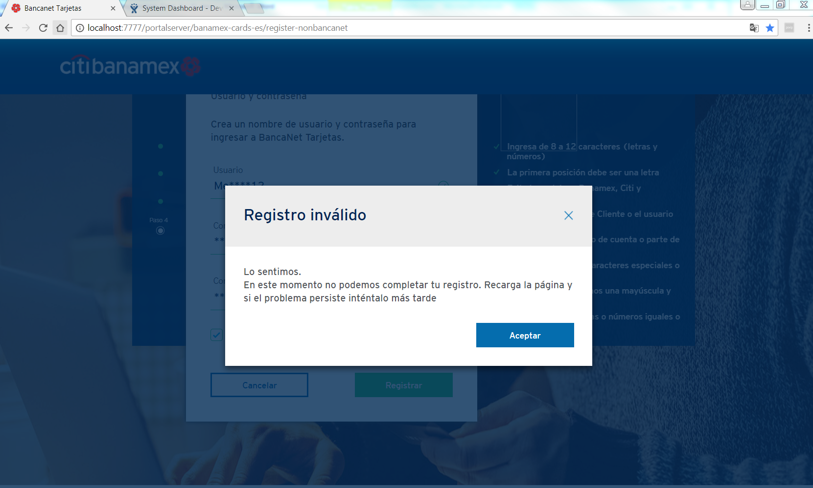

ID | Registration_Cred_Err_03
Server Name | http://localhost:7777/portalserver/banamex-cards-es/register-nonbancanet
UI Error Message | Lo sentimos.  En este momento no podemos completar tu registro. Recarga la página y si el problema persiste inténtalo más tarde
BackBase Error Response Body | {"errorCode": "500",  "errorType": "TECHNICAL_DIFFICULTY",  "details" : "Technical Difficulty"}
APIm Error Response Body | { "type": "error",  "code": "serverUnavailable",  "details": "The request failed due to an internal error/server unavailability"}
Root Cause | - APIM server is down  - Status from APIM is not a valid scenario possible error en APIM
Additional Information (if any)
Screenshot | Below

ID | Registration_Cred_Err_04
Server Name | http://localhost:7777/portalserver/banamex-cards-es/register-nonbancanet
UI Error Message | Lo sentimos.  En este momento no podemos completar tu registro. Recarga la página y si el problema persiste inténtalo más tarde
BackBase Error Response Body | {"errors" : [{"code" : 500, "eventId" : "ID-USTX15369L02211-55652-1511213032283-1-4445", "message" : "Unexpected server error occurred"}]}
APIm Error Response Body | { "type": "error",  "code": " Unexpected server error occurred "
Root Cause | Unexpected server error from APIM check APIM services
Additional Information (if any)
Screenshot | Below

