Diba Makki
144420189
CCP555NSC
Fall 2025
Lab 10 – S3 and DynamoDb

Link to your completed tests/integration/lab-10-dynamodb.hurl in your fragments GitHub repo
https://github.com/dibamackie/CCP555-2025F-NSC-Diba-Makki-144420189/blob/main/tests/integration/lab-10-dynamodb.hurl

Screenshot of your tests/integration/lab-10-dynamodb.hurl test passing, when run against your fragments server, LocalStack, and DynamoDB Local using docker compose (i.e., show the terminal(s) running the necessary commands to make this happen).

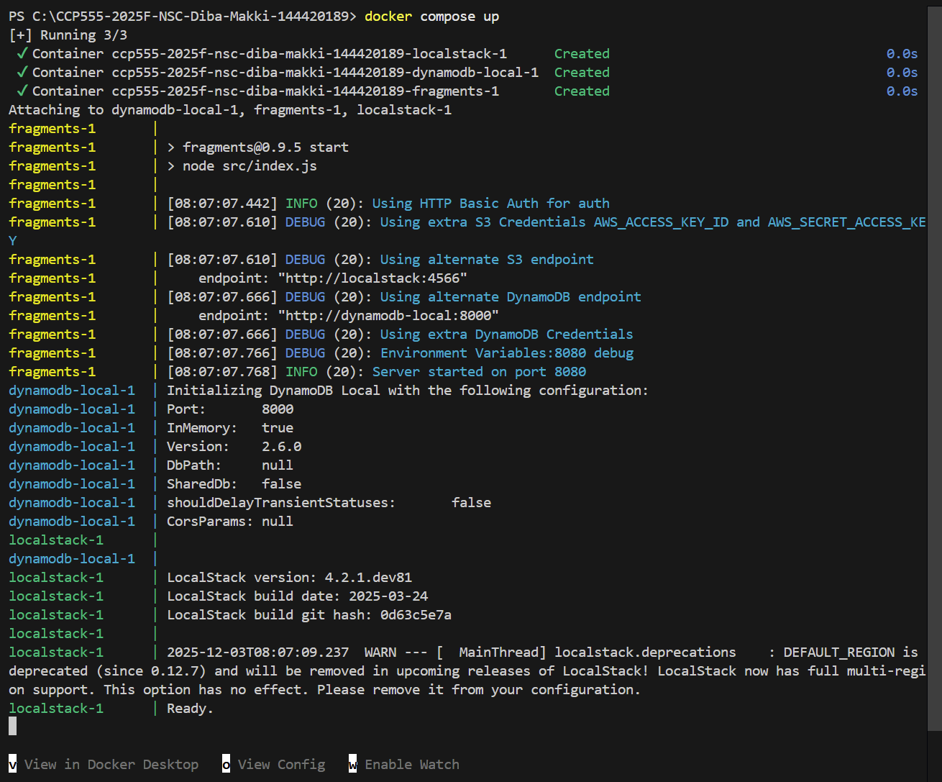

Creating table using local stack with the provided script in bash:
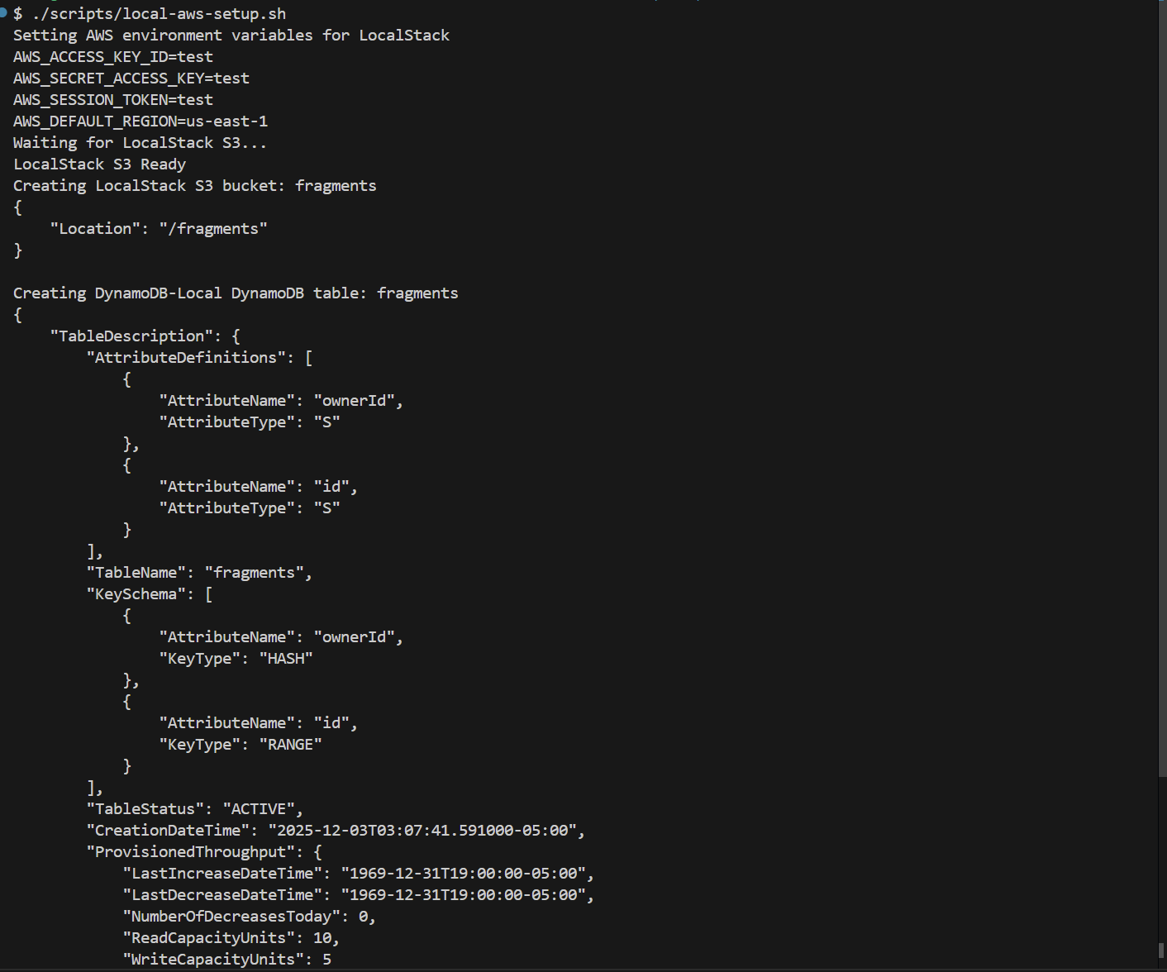
Running integration tests all passing:
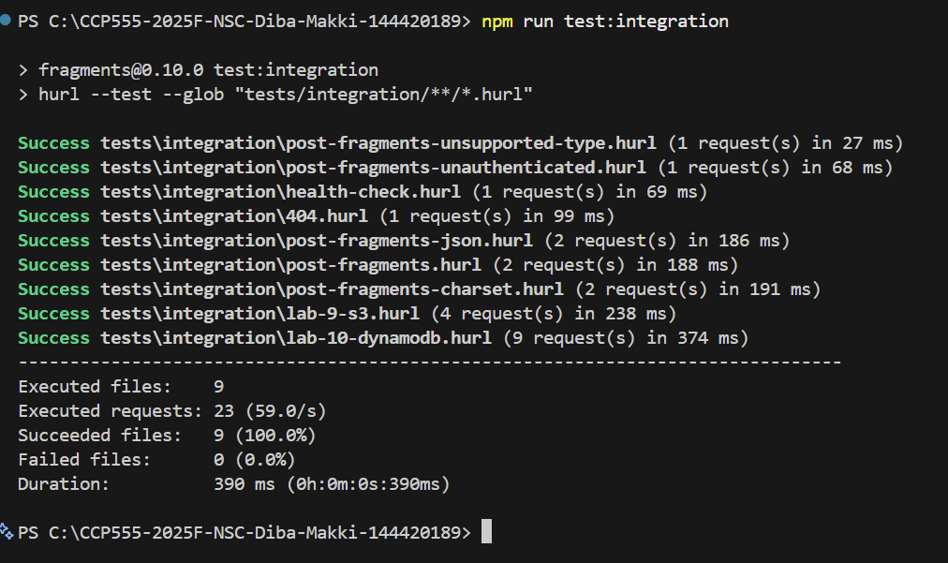
Screenshot of your ci.yml GitHub Actions Workflow passing everything, including your integration tests.

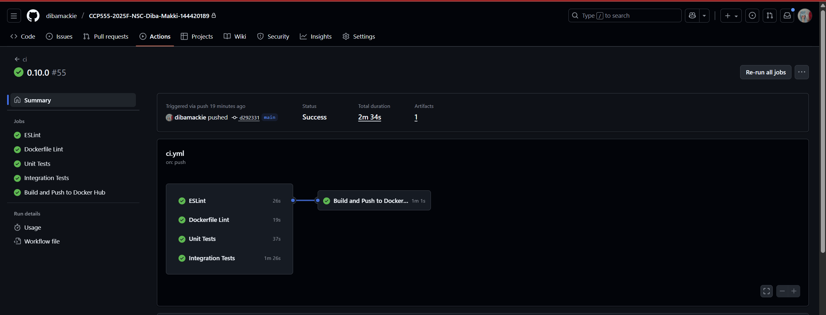

Screenshot of your fragments-ui creating a fragment using your Elastic Container Service deployment (i.e., show the Network tab to prove which back-end service is being used)

Creating fragment: a3ce4b77-7598-4721-8f81-cce6b7bdd42f and owner ID: 431960129da4f8b18e8221a96461e872c26bf7d42715468769c3d4daae2525cf
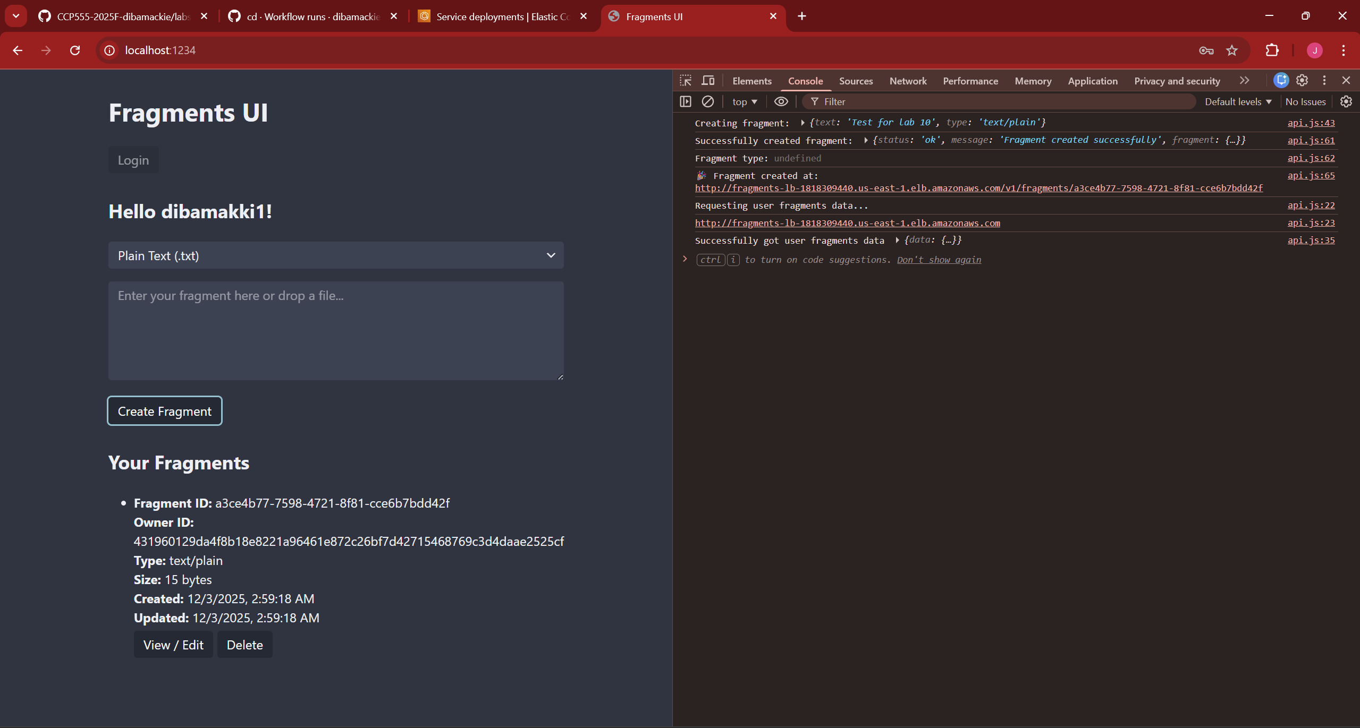
Network tab showing headers and location:

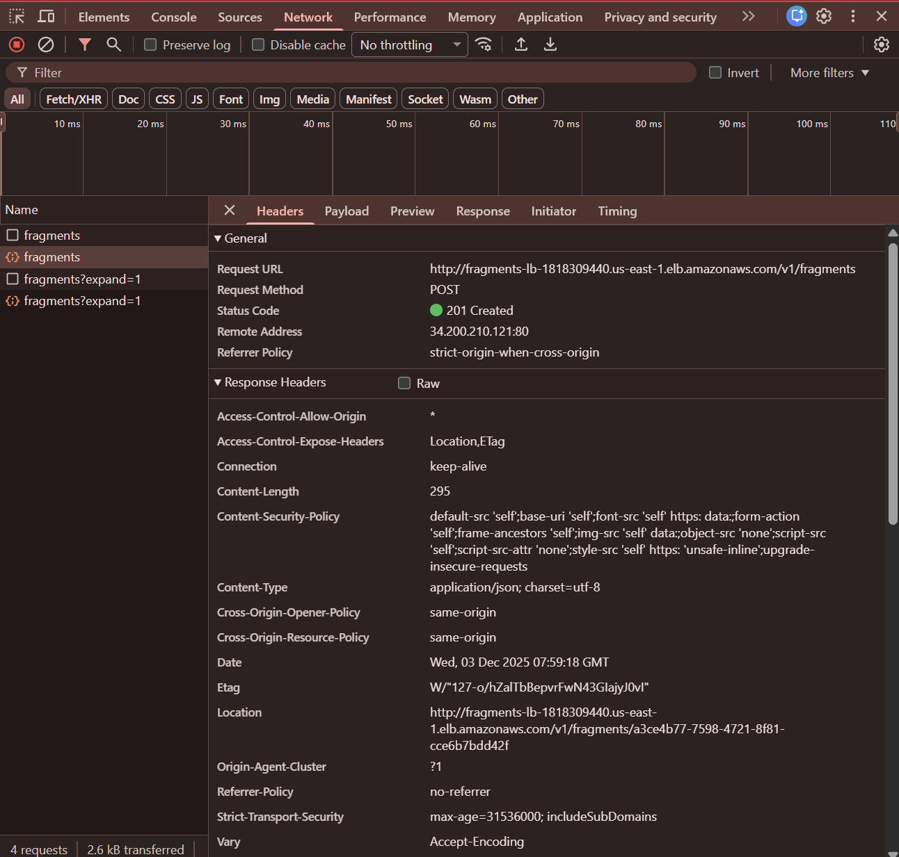

Screenshot of the AWS DynamoDB Console showing the fragment you just created in DynamoDB as an Item in your Table (i.e., prove that you've been able to create the fragment metadata in DynamoDB)

Aws DynamoDB tab showing fragments table and my created fragment:
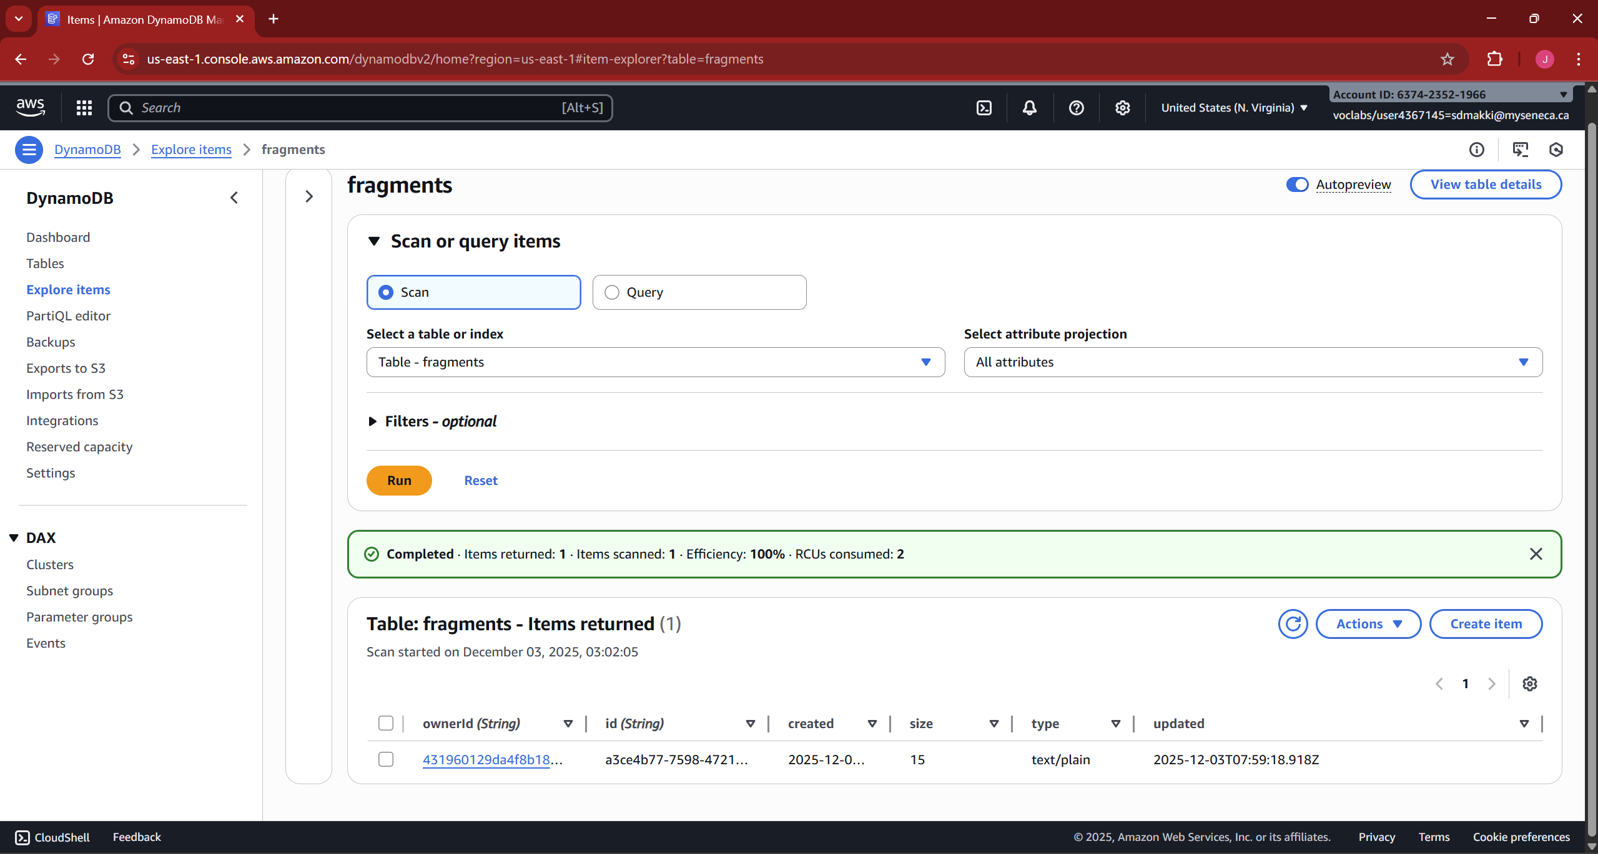
Details of fragment a3ce4b77-7598-4721-8f81-cce6b7bdd42f in DynamoDB explore items tab:
