Diba Makki
144420189
CCP555NSC
Fall 2025
Lab 7 – Docker Hub

- Screenshot of the first time you ran Hadolint on your Dockerfile, showing any warnings or errors you had to correct.

- Screenshot of a successful CI workflow, showing your new Dockerfile Lint and Docker Hub jobs succeeding.
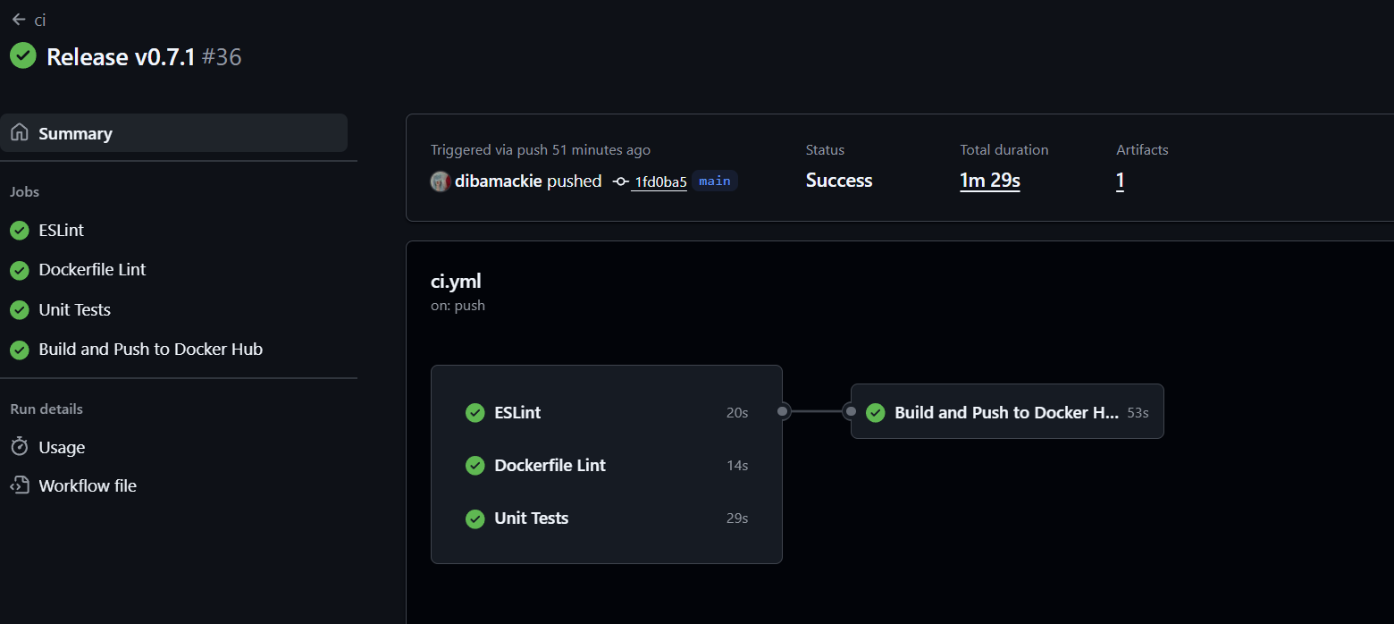

- Screenshot of a successful CI workflow, showing your new Dockerfile Lint and Docker Hub jobs succeeding.
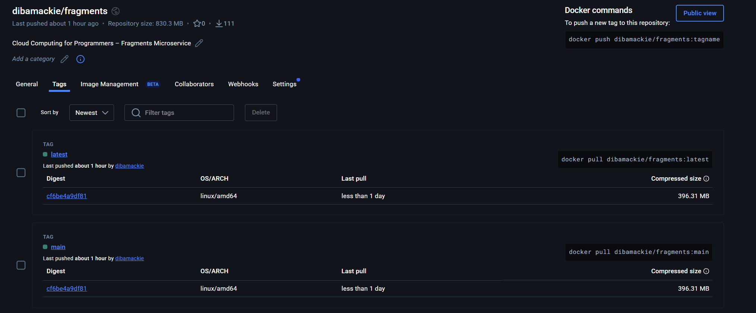

- Screenshot of a successful CI workflow, showing your new Dockerfile Lint and Docker Hub jobs succeeding.
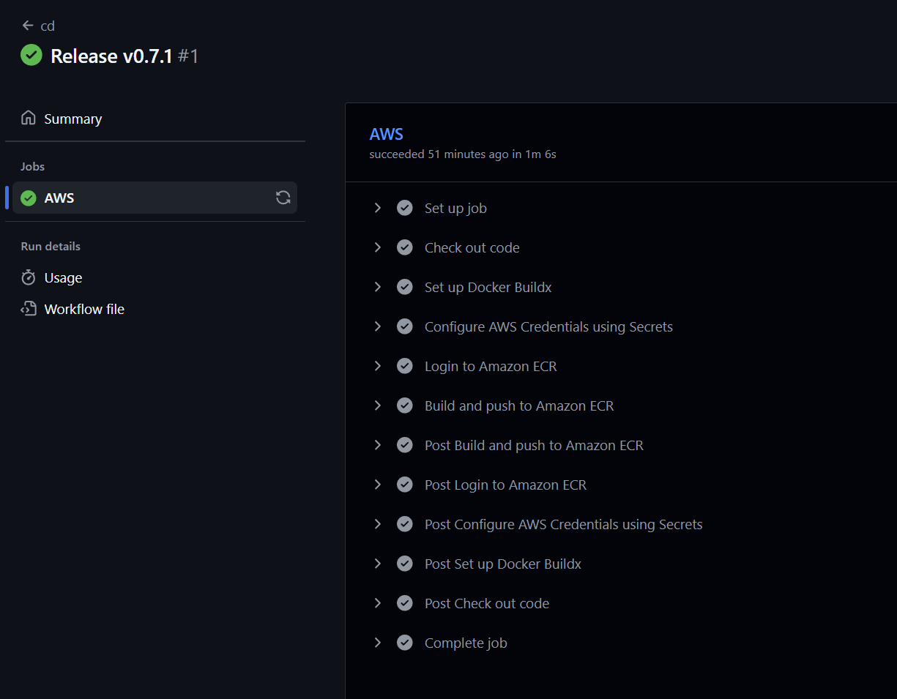
- Screenshot of your Amazon Elastic Container Registry showing your fragments Image and tags, built via GitHub Actions.
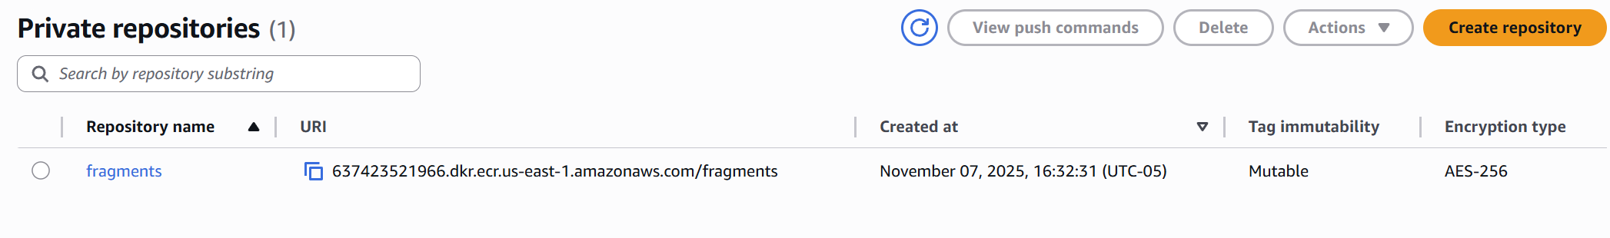
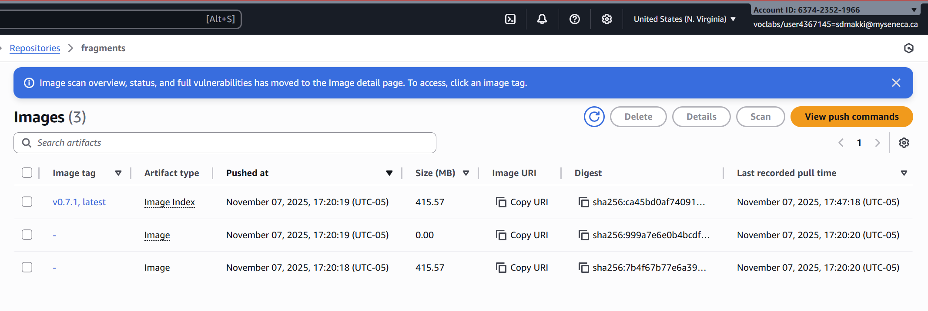
- Screenshot of your Amazon Elastic Container Registry showing your fragments Image and tags, built via GitHub Actions.

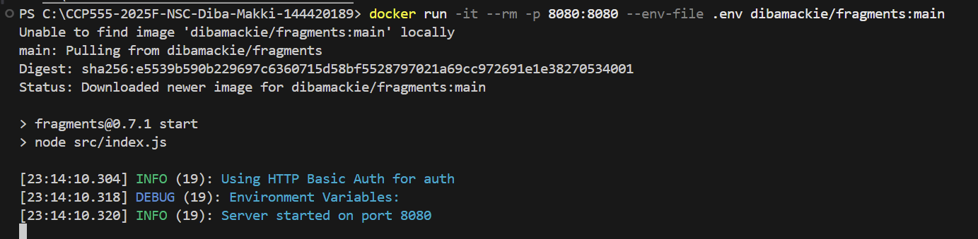
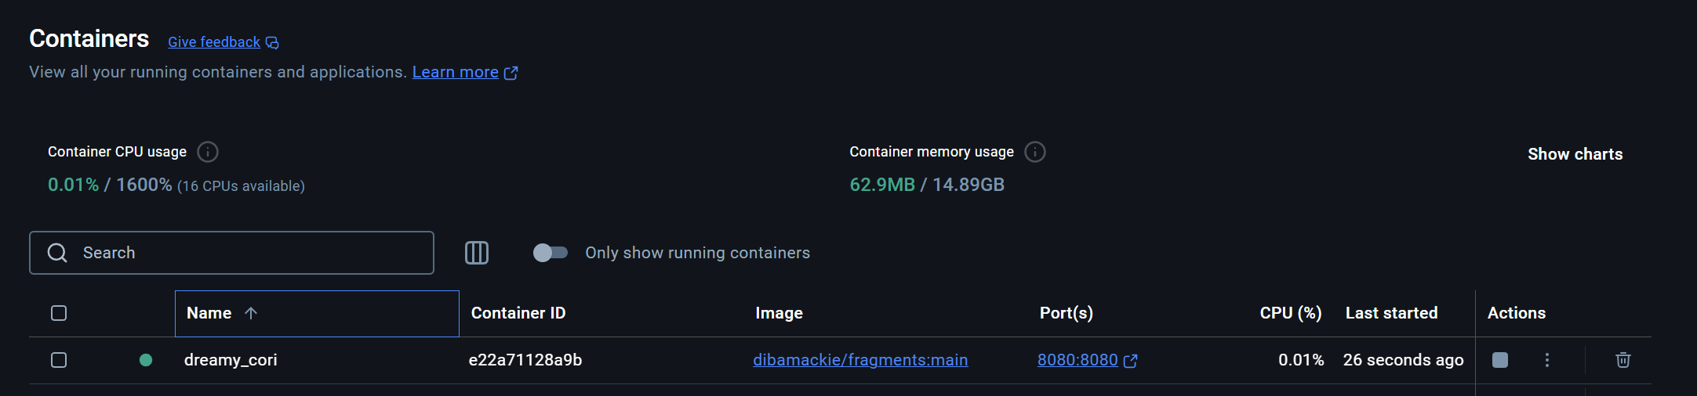

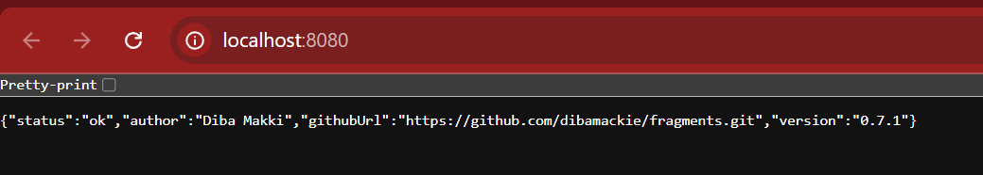
- Screenshot of EC2 instance running the v0.7.0 image (or your latest version tag) your Amazon Elastic Container Registry and fragments repo, built and pushed by your GitHub Actions cd.yml workflow.
