Diba Makki
144420189
CCP555NSC
Fall 2025
Lab 5 – Dockerizing the Fragments Microservice
Repo : https://github.com/dibamackie/CCP555-2025F-NSC-Diba-Makki-144420189/tree/main

Part 1 – Local Machine (Docker Desktop)
1. Build the Docker Image
docker build -t fragments:latest .
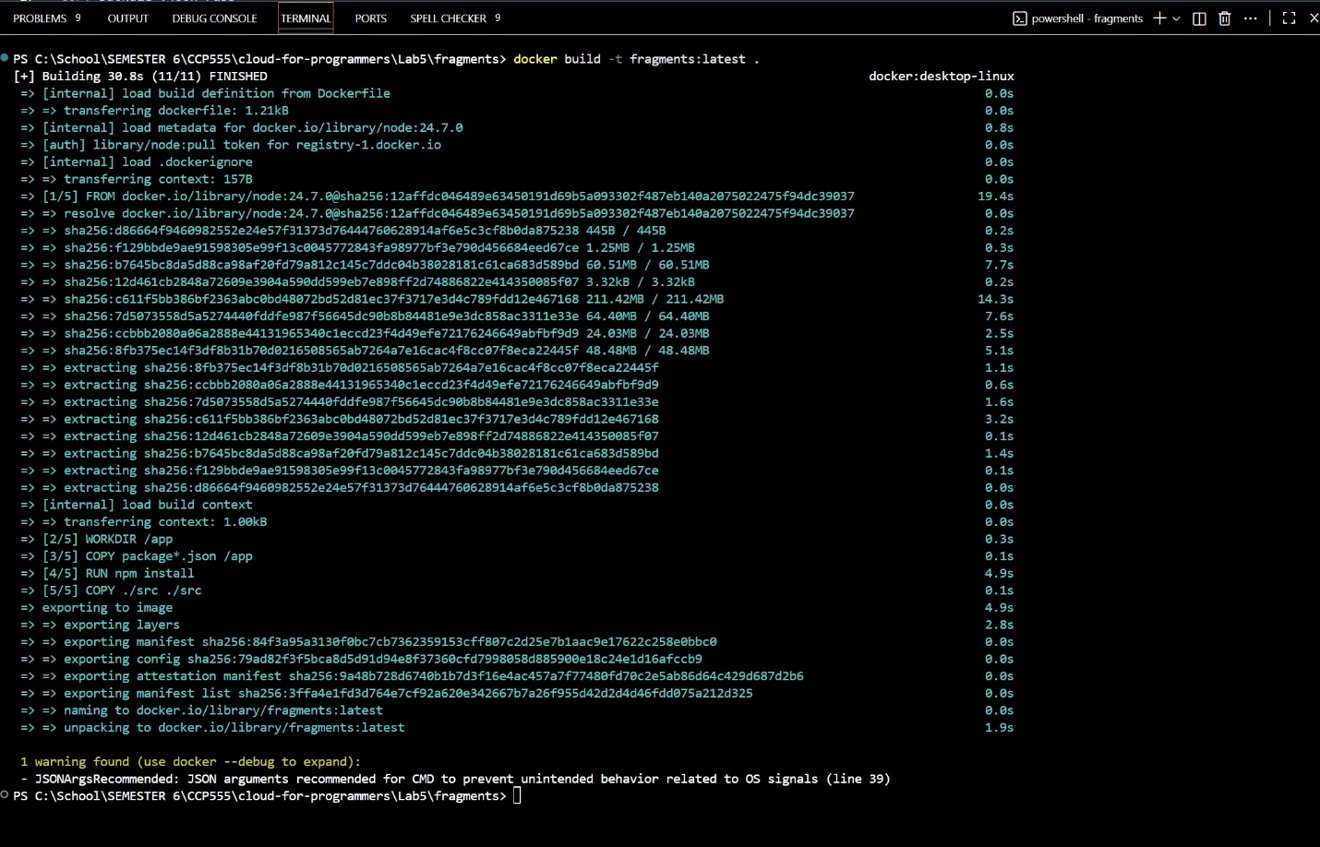
2. Run the Container in Detached Mode (Port 5555 → 8080)
docker run --rm --name fragments --env-file env.jest -e LOG_LEVEL=debug -p 5555:8080 -d fragments:latest
3. Verify the Container is Running
docker ps

4. Test the Server (Health Check)
curl http://localhost:5555/v1/
5. View the Logs
docker logs fragments
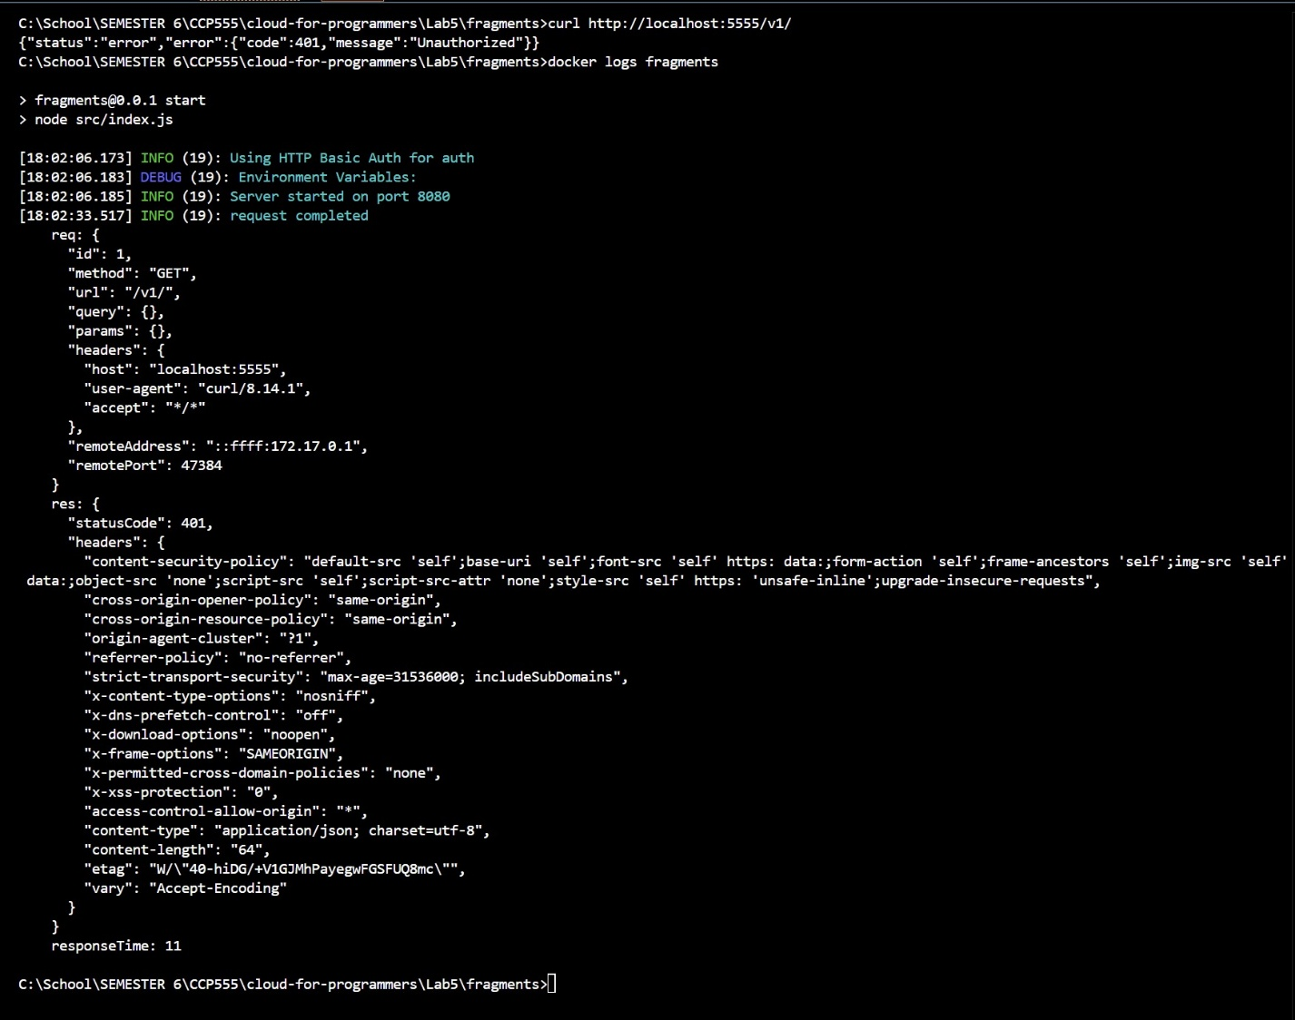

6. View in VS Code Docker Extension
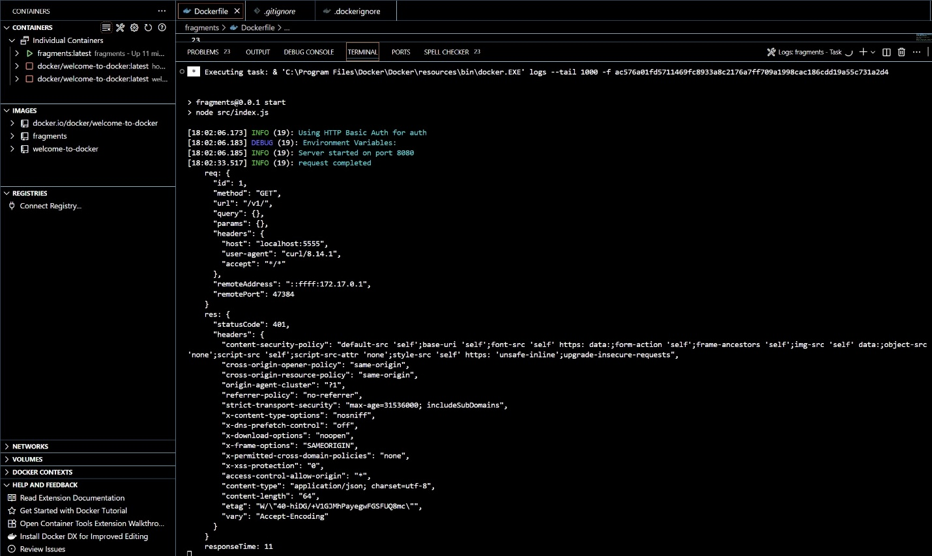
Part 2 – AWS EC2 Instance

7. Build the Docker Image on EC2
cd package
docker build -t fragments:latest .
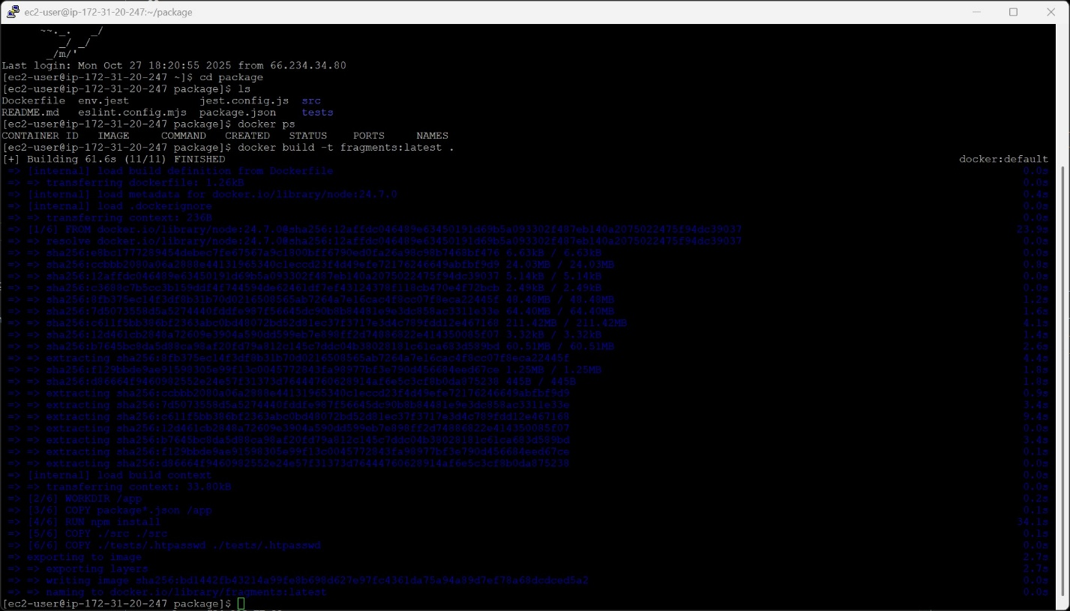

8. Verify the Image Exists
docker image ls fragments

9. Run the Container in Detached Mode (Port 8080 → 8080)
docker run --rm --name fragments --env-file env.jest -e LOG_LEVEL=debug -p 8080:8080 -d fragments:latest
10. Verify Container is Running on EC2
docker ps

11. Test Server from Laptop
curl http://34.228.77.92:8080/v1/
12. View Logs on EC2
docker logs fragments
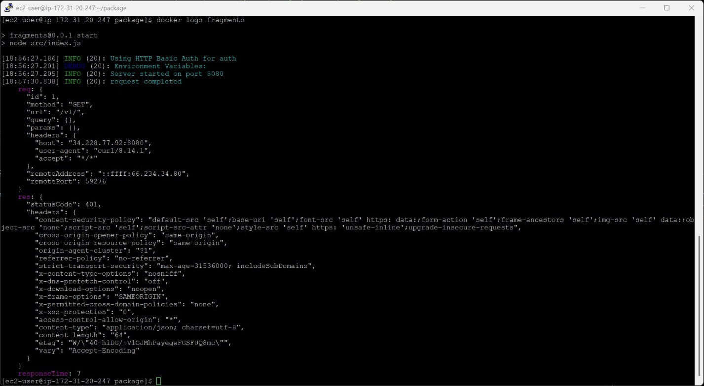
14. Stop and Verify Container Stopped
docker kill fragments
docker ps
