Diba Makki
144420189
CCP555NSC
Fall 2025
Lab 6 – Docker Hub

Part 1 – Warm-up (hello-world)
Command: docker pull hello-world
Successfully pulled the hello-world image from Docker Hub, confirming Docker’s connection to the public registry.
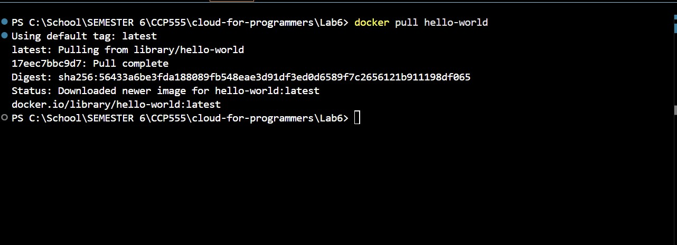
Command: docker images
Shows the hello-world image listed locally, verifying that it was downloaded and stored.
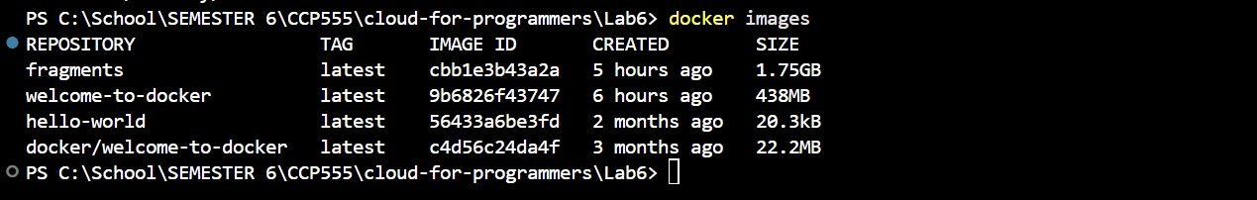
docker run --rm hello-world
Demonstrates that the image runs correctly and Docker is functioning properly by displaying the “Hello from Docker!” message.
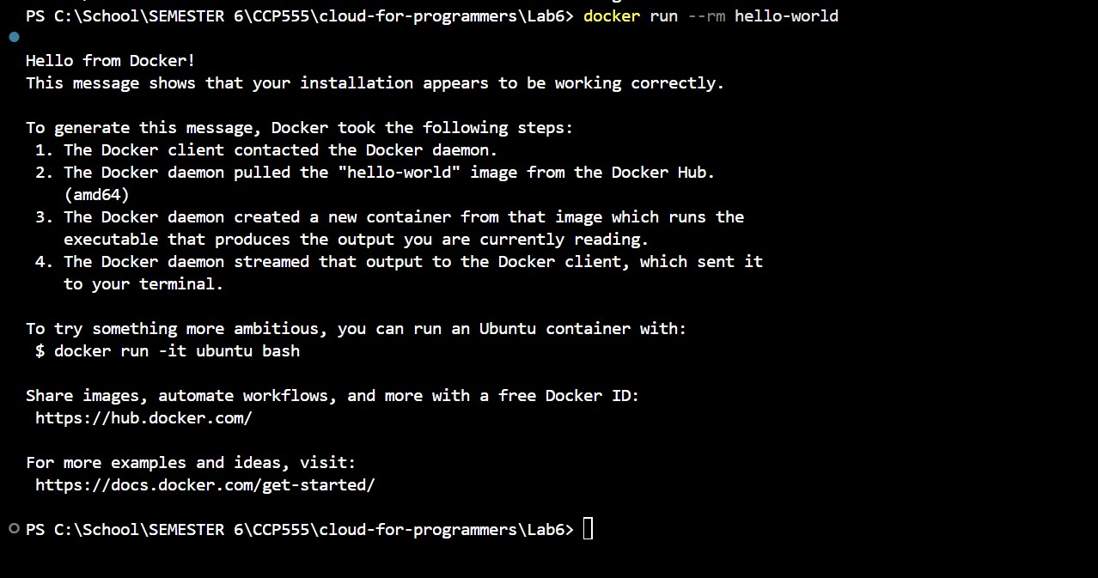
Part 2 – Docker Hub Setup and Tagging
docker tag fragments dibamackie/fragments
and
docker tag fragments dibamackie/fragments:lab-6
Tagged the local fragments image with both latest and lab-6 tags to prepare for pushing to Docker Hub.
docker images
Shows the fragments image listed with both dibamackie/fragments:latest and dibamackie/fragments:lab-6, confirming proper tagging.
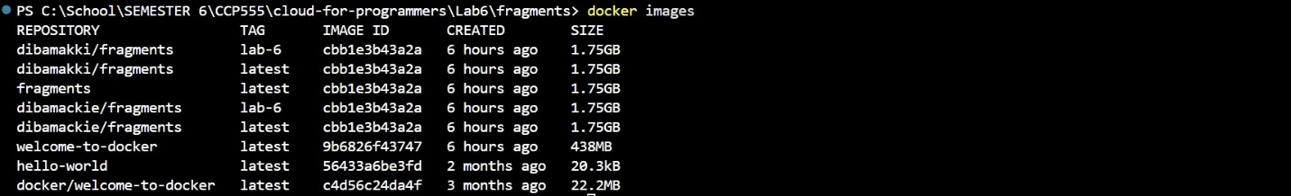
docker push dibamackie/fragments
and
docker push dibamackie/fragments:lab-6
Both tags were successfully pushed to Docker Hub, as shown by the “Pushed” and “Layer already exists” messages.
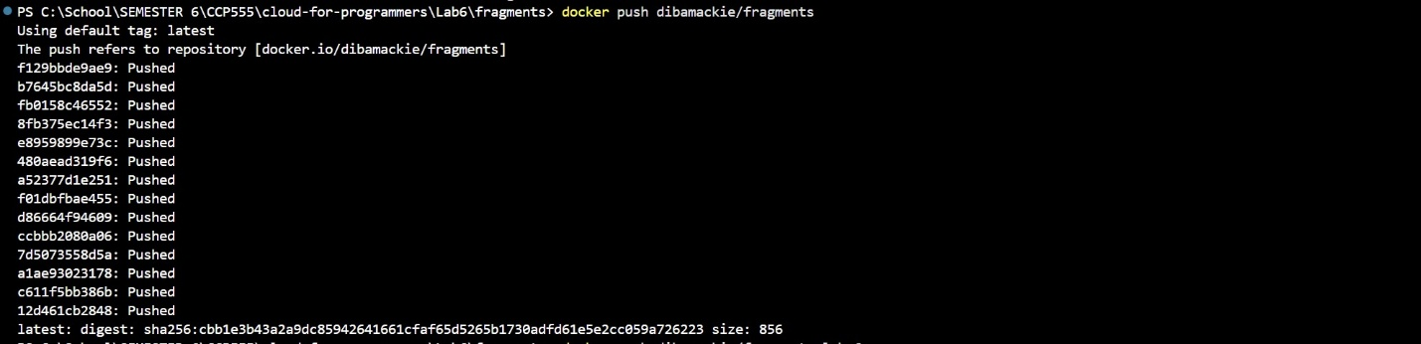
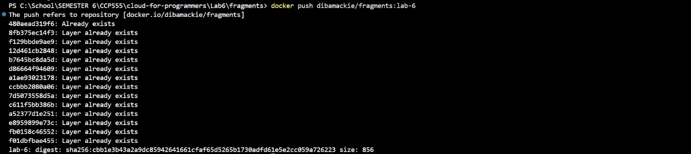
Docker Hub repository page
Displays both the latest and lab-6 tags published under the dibamackie/fragments repository.
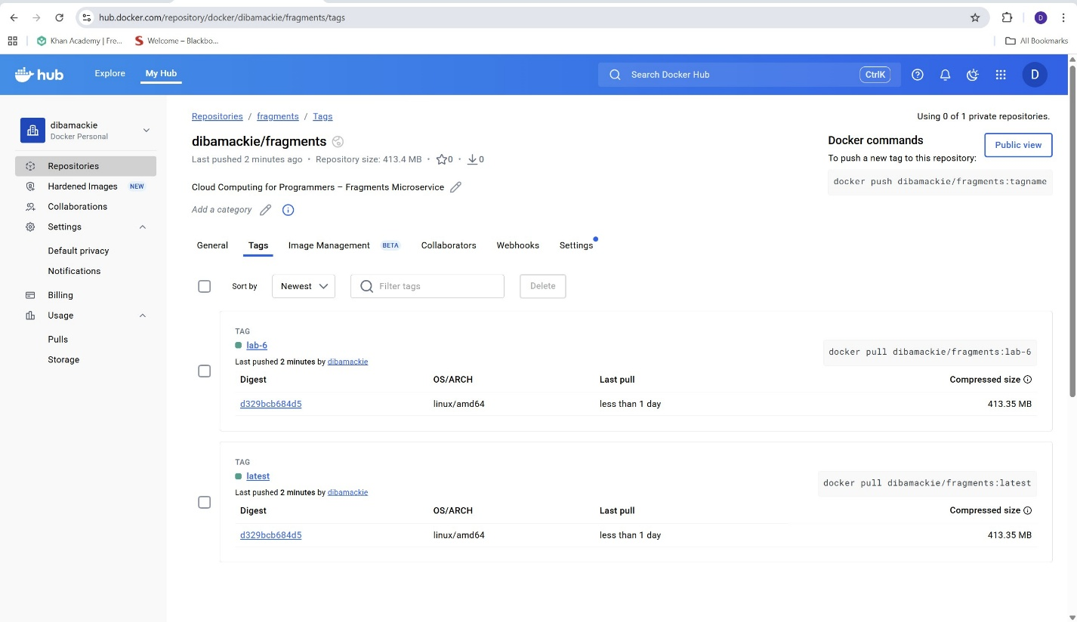

Part 3 – Running on EC2 Using Docker Hub Image
docker pull dibamackie/fragments:lab-6
Pulled the fragments image from Docker Hub to the EC2 instance, confirming the repository is publicly accessible.
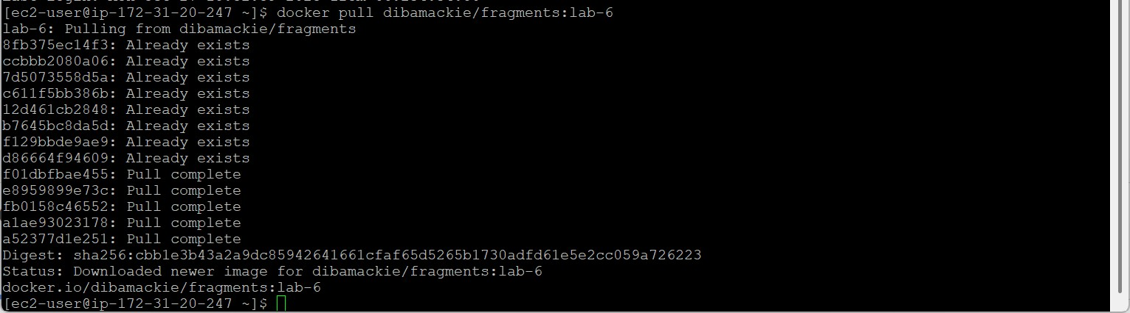
docker run --rm --name fragments -p 8080:8080 -d dibamackie/fragments:lab-6
Started a new container on EC2 from the Docker Hub image, showing the container ID was created successfully.
docker ps
Verifies the container is actively running on EC2 with port 8080 exposed for external access.
docker logs fragments
Displays server startup logs confirming “Using HTTP Basic Auth for auth” and “Server started on port 8080.”
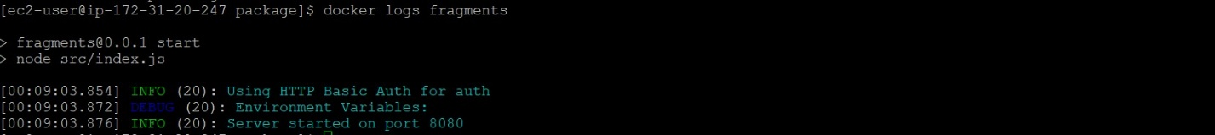
curl http://18.208.189.216:8080/v1/
Shows the response {"status":"error","error":{"code":401,"message":"Unauthorized"}}, proving the server is running and reachable from the public Internet.
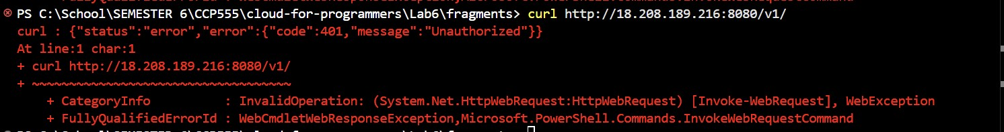
docker kill fragments
and
docker ps
Demonstrates that the container was stopped and no containers remain running afterward.
Location: AWS EC2 → Security → Inbound Rules
Shows that port 8080 (TCP) is open to 0.0.0.0/0, allowing external traffic to reach the fragments microservice running in Docker.
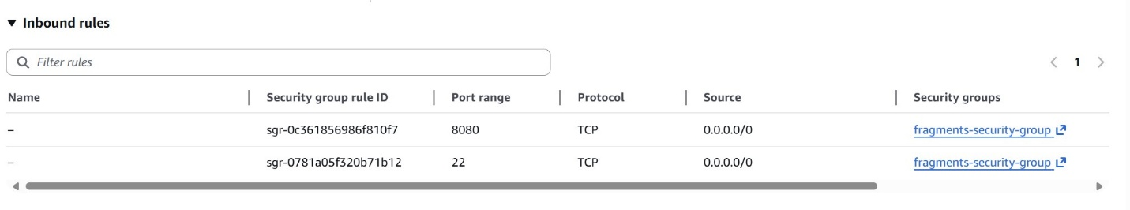

Part 4 – Step 20 and Step 21 (Optimizations + New Tags)
docker build -t dibamackie/fragments:latest -t dibamackie/fragments:lab-6 -t dibamackie/fragments:lab-6-step-20 .
Built an optimized, multi-stage Docker image for the fragments microservice.
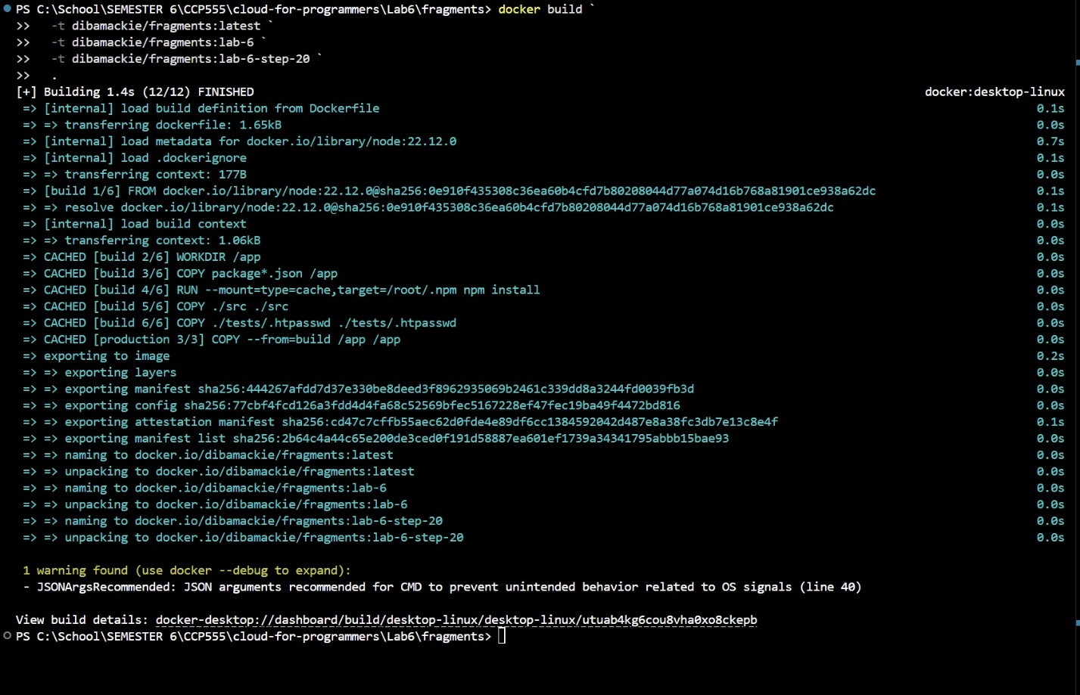
docker push dibamackie/fragments:lab-6-step-20
Successfully pushed the optimized image to Docker Hub.
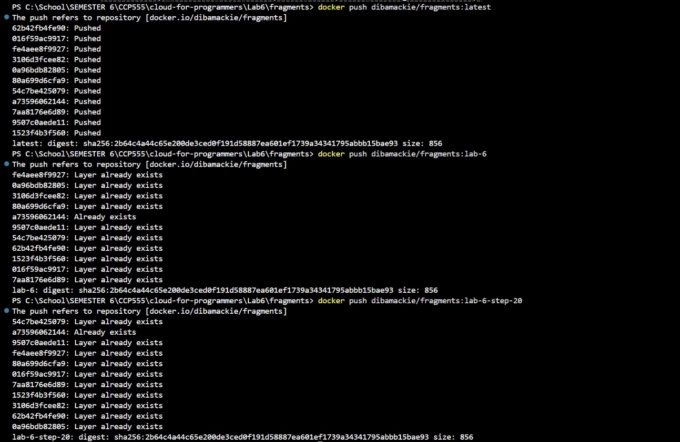
Docker Hub “Tags” page
Shows latest, lab-6, and lab-6-step-20 tags.
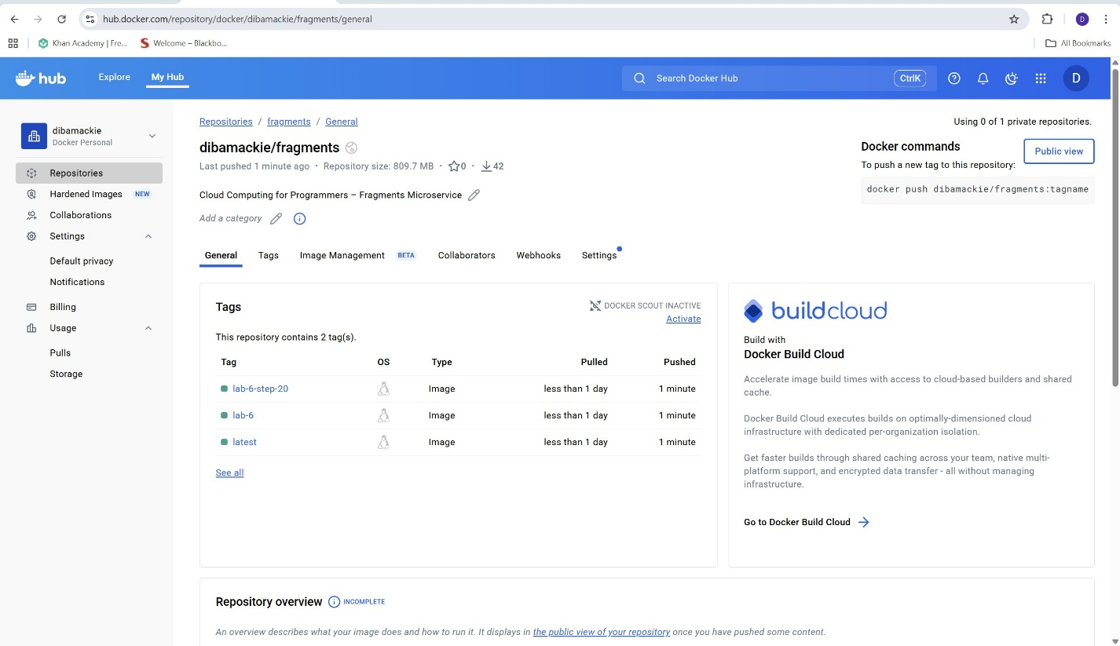
docker build -t dibamackie/fragments:latest -t dibamackie/fragments:lab-6 -t dibamackie/fragments:lab-6-step-21 .
Rebuilt and tagged the image after implementing a functional requirement (authentication).
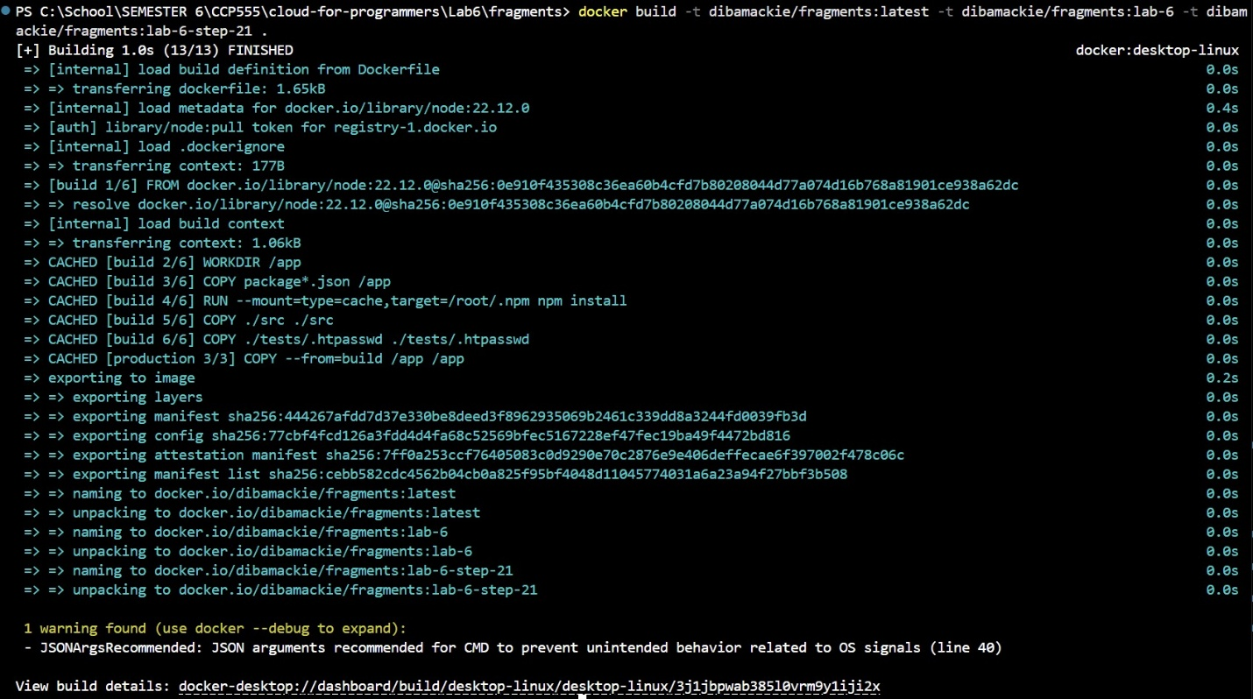
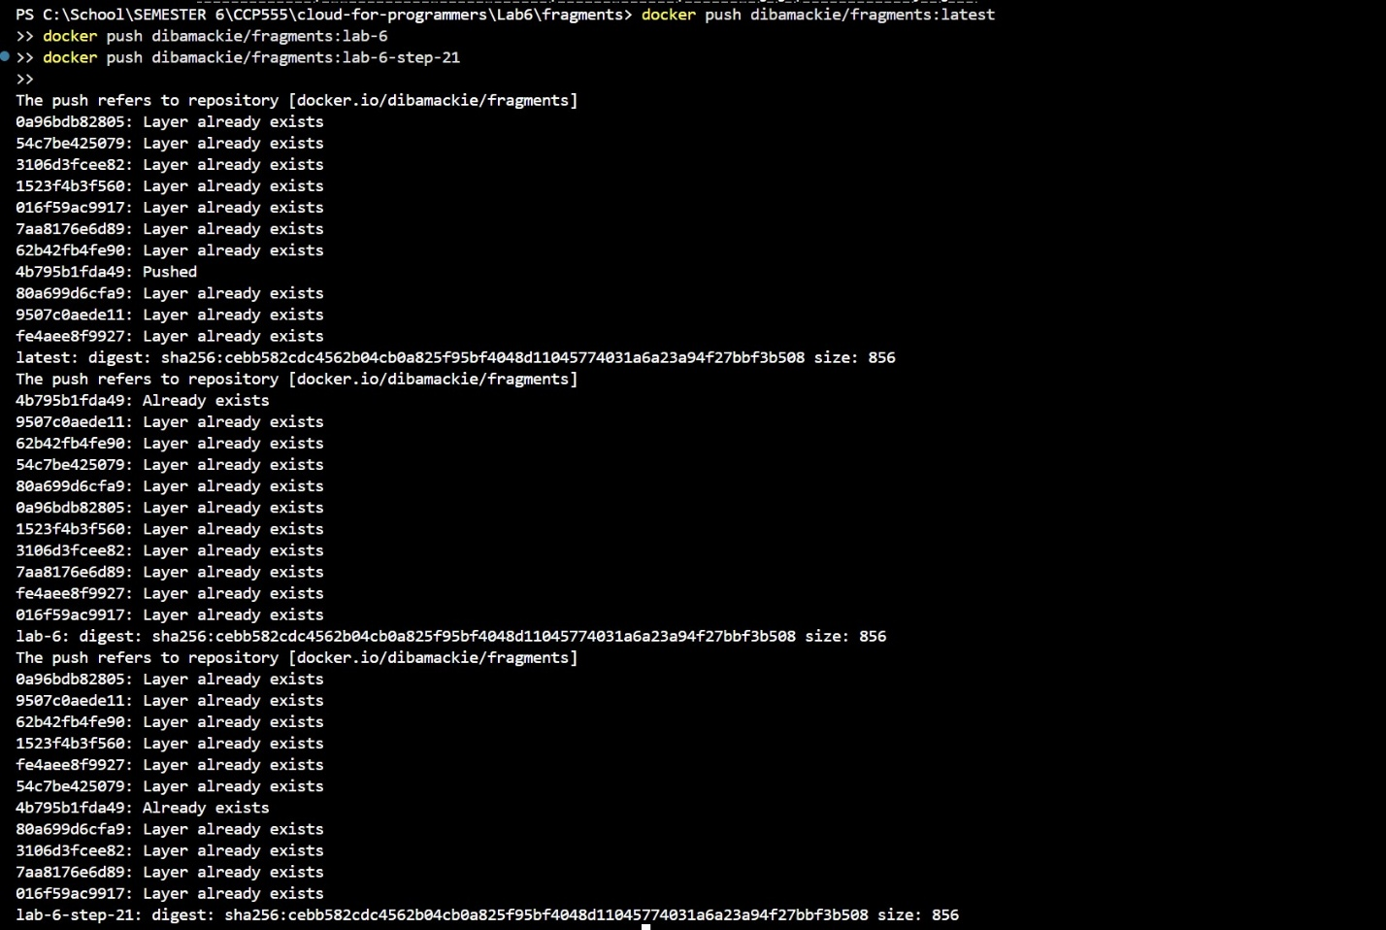
Docker Hub “Tags” page again
Shows all tags including lab-6-step-21, confirming successful pushes.
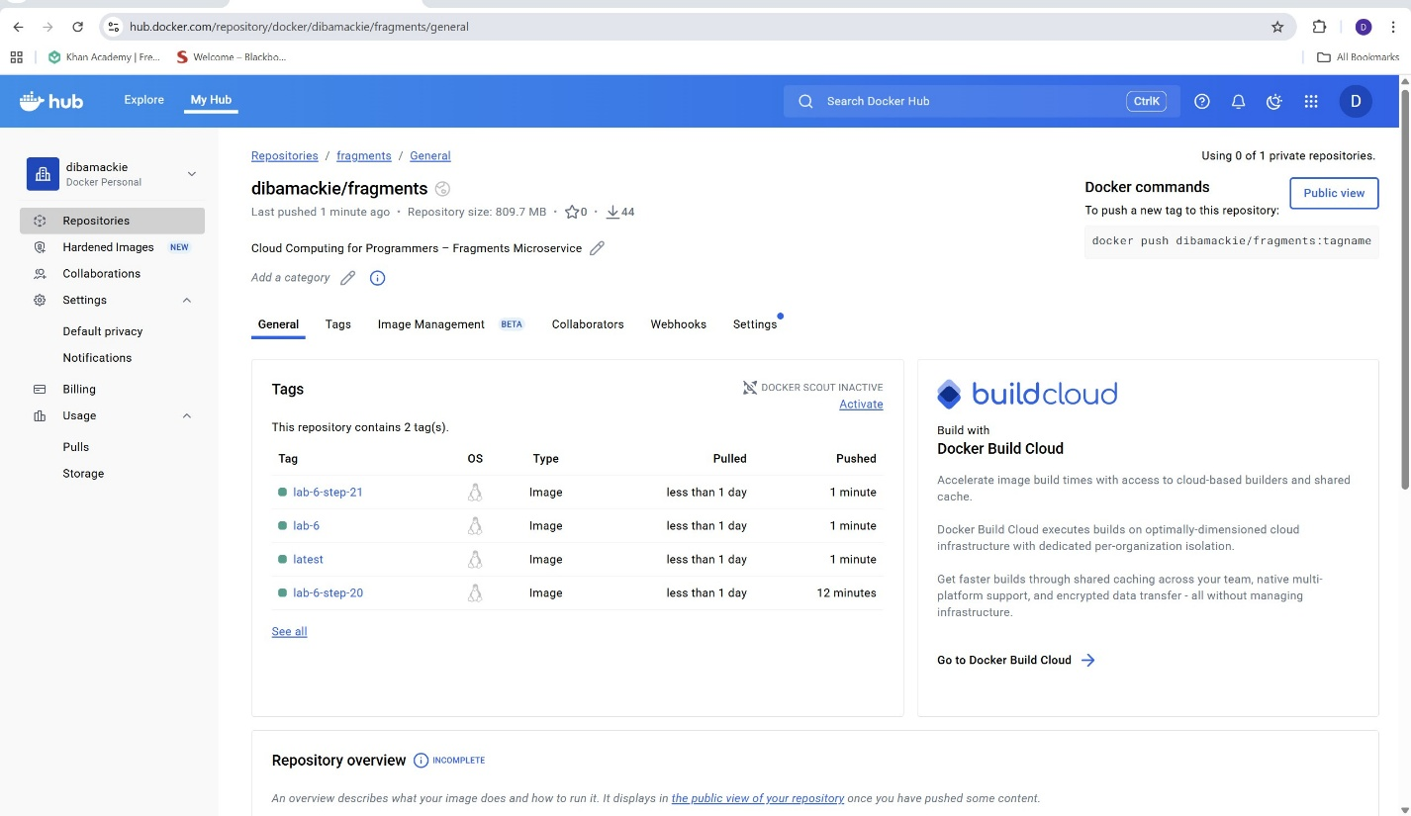
Step 20 and Step 21 Explanation
Step 20 – Dockerfile Optimization
In this step, I optimized the Dockerfile for the fragments microservice using a multi-stage build to separate dependency installation from the final runtime image.
Key improvements:
- Reduced image size by using node:22.12.0 and only copying required files.
- Added labels, environment variables (PORT, NPM_CONFIG_LOGLEVEL, NPM_CONFIG_COLOR).
- Copied .htpasswd for HTTP Basic Auth support.
- Exposed port 8080 for web access.
These optimizations improve build efficiency and security, and result in a smaller, cleaner image.
Step 21 – Assignment 2 Requirement Implementation
For Step 21, I implemented authentication as an initial Assignment 2 requirement.
- The container uses HTTP Basic Auth configured through env.jest and .htpasswd.
- Unauthenticated requests to /v1/ return a 401 Unauthorized response.
- Logs confirm the service starts with Basic Auth enabled.
This ensures protected access to API routes.
I built and pushed a new image with tags: latest, lab-6, and lab-6-step-21.

