Diba Makki
144420189
CCP555NSC
Fall 2025
Lab 8 – Docker Compose (S3,DynamoDB, LocalStack)

- Add all of the changes you've made to your code to git and push to GitHub. Link to the tests/integration folder on GitHub for your fragments repo, showing all of the .hurl files you wrote for the test cases above.
https://github.com/dibamackie/CCP555-2025F-NSC-Diba-Makki-144420189/tree/main/tests/integration
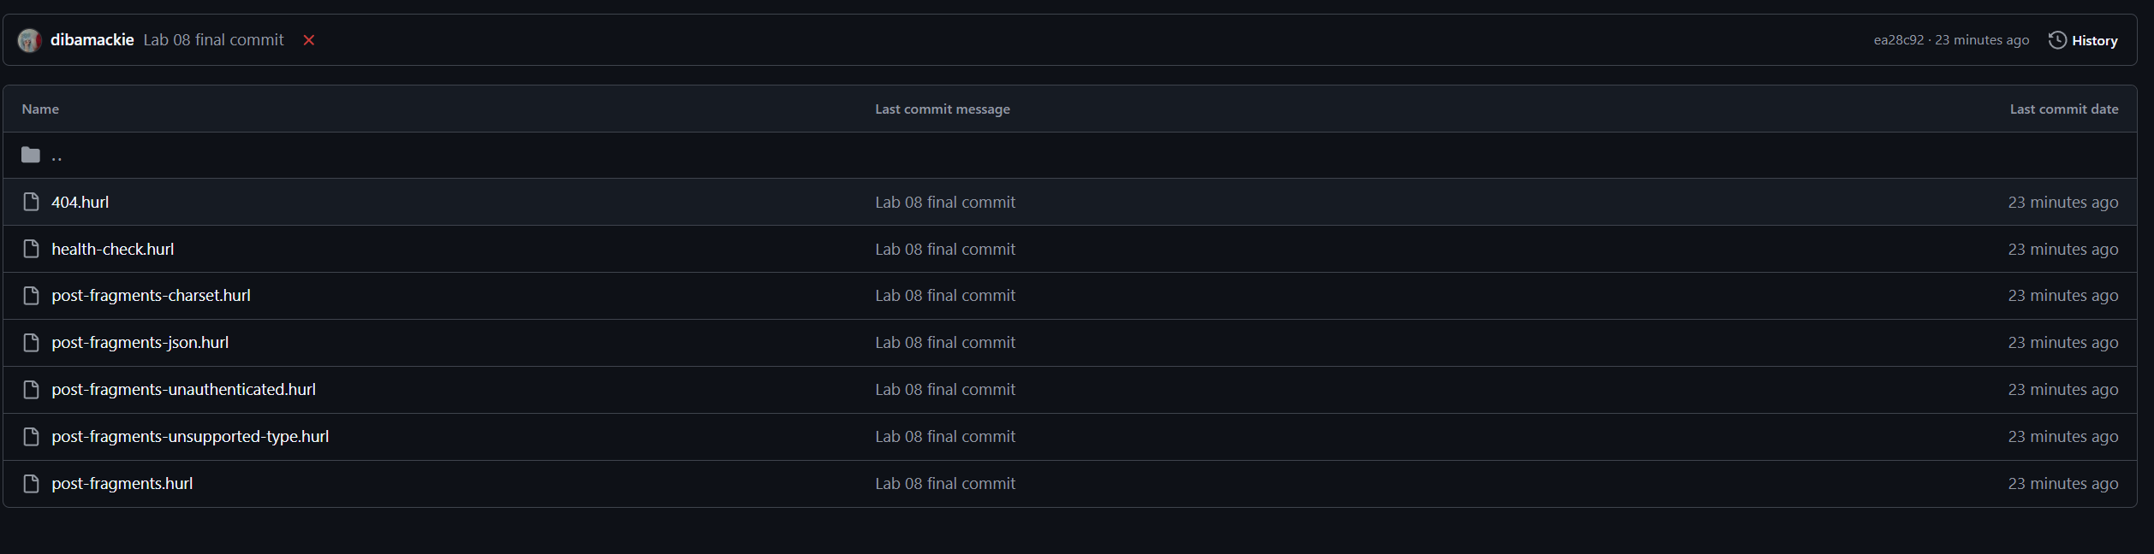

- Screenshot of all three containers successfully being started using docker compose.
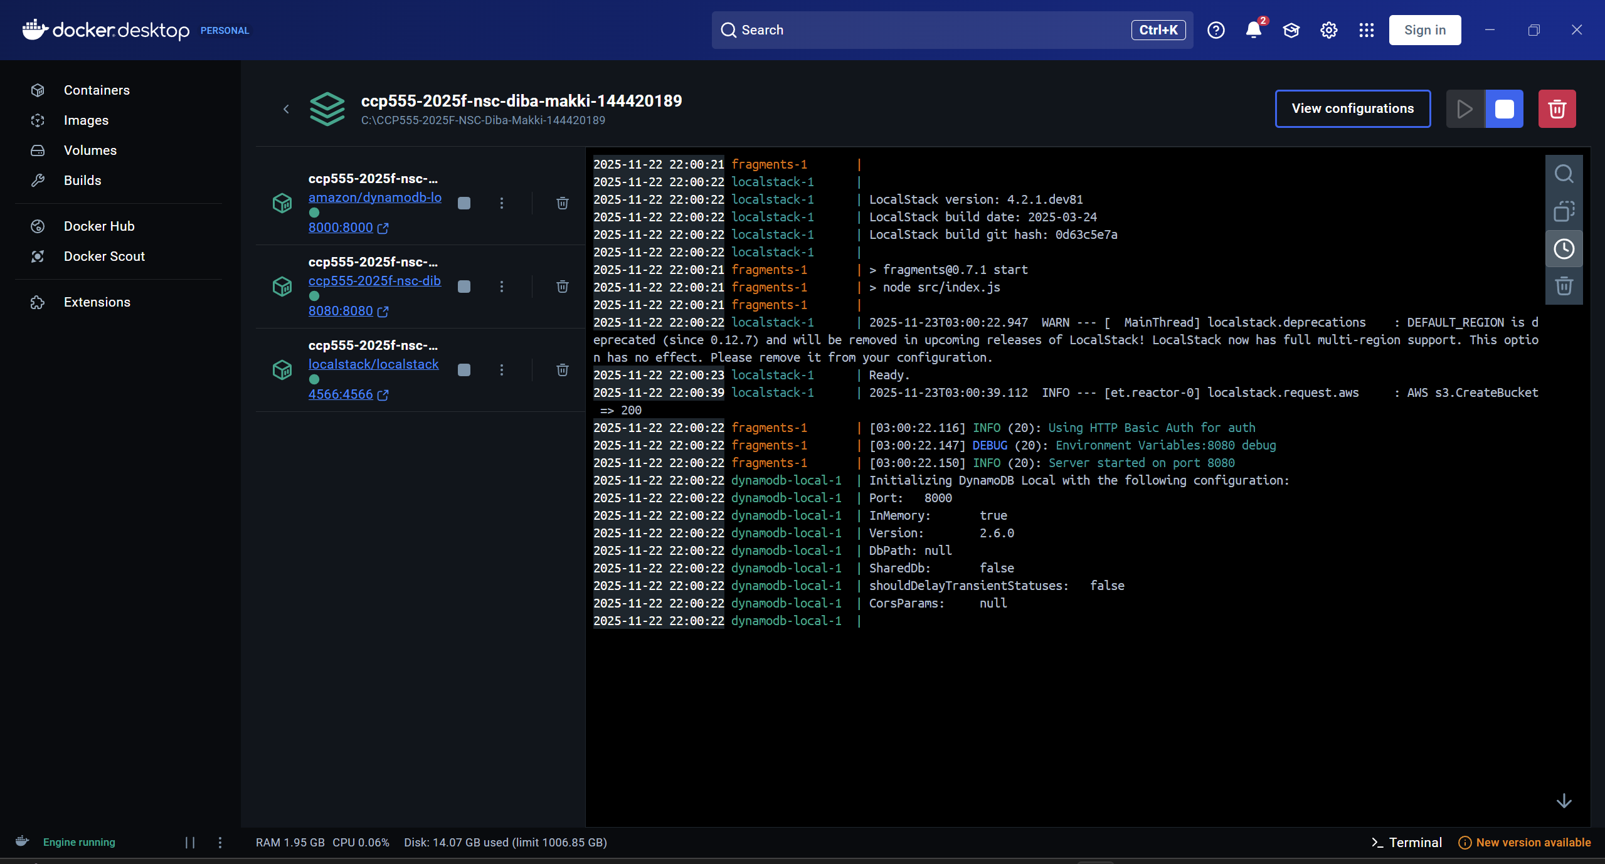

Curl command checking each of the 3 containers:
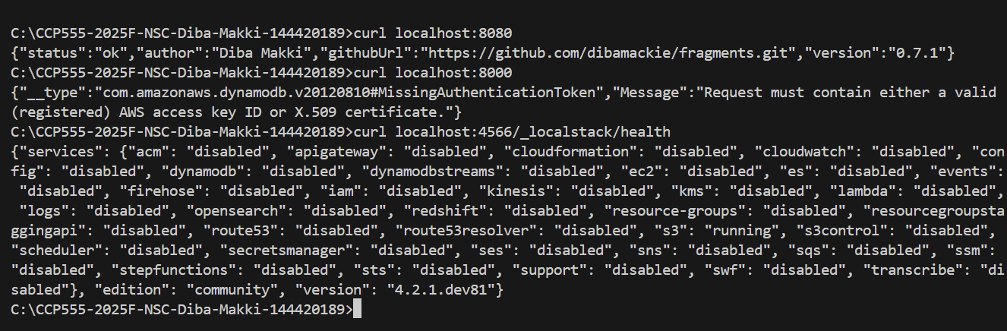

- Screenshot of the local-aws-setup.sh running successfully against the running containers
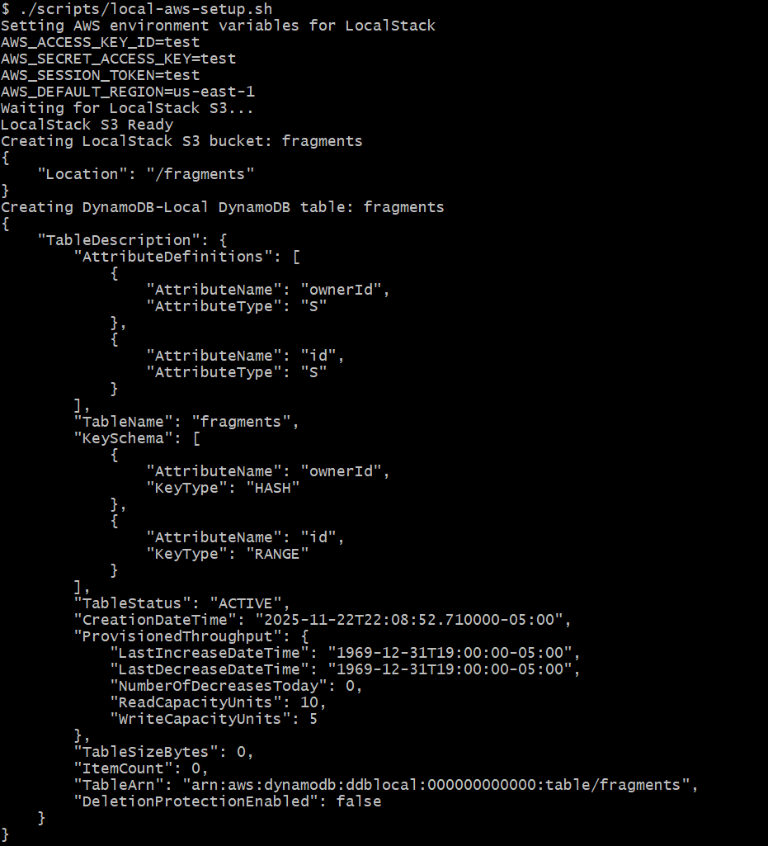

- Screenshot of hurl successfully running all of the integration tests described above.
