Diba Makki
144420189
CCP555NSC
Fall 2025
Lab 9 – S3 and ECS

Link to your completed tests/integration/lab-9-s3.hurl in your fragments GitHub repo
https://github.com/dibamackie/CCP555-2025F-NSC-Diba-Makki-144420189/blob/main/tests/integration/lab-9-s3.hurl

Screenshot of your tests/integration/lab-9-s3.hurl test passing, when run against your fragments server and LocalStack using docker compose (i.e., show the terminal(s) running the necessary commands to make this happen)
Docker compose up
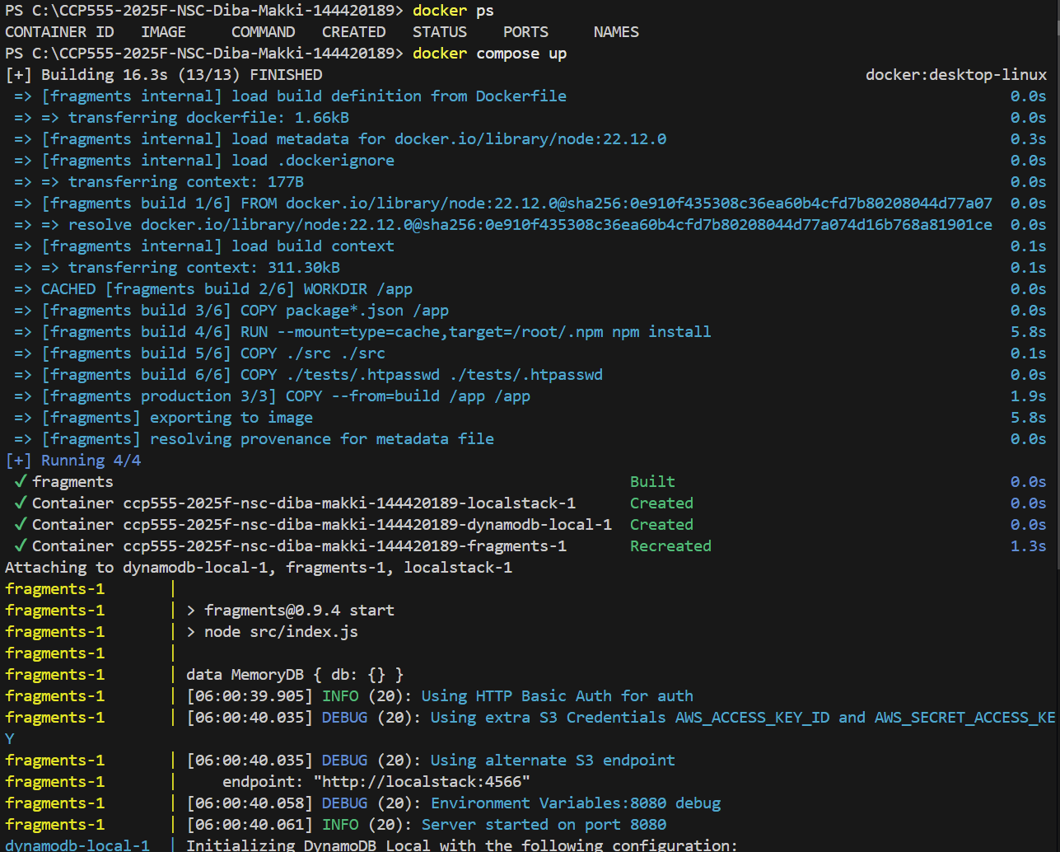

Running the script
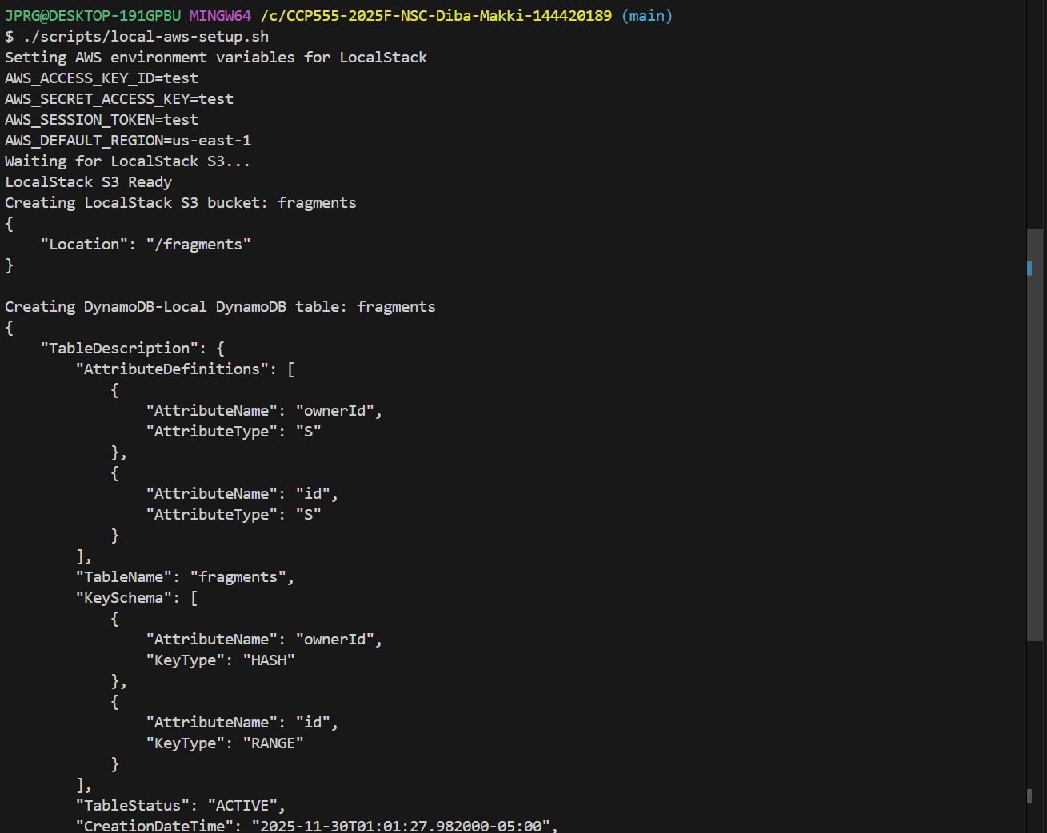

Running the integration tests
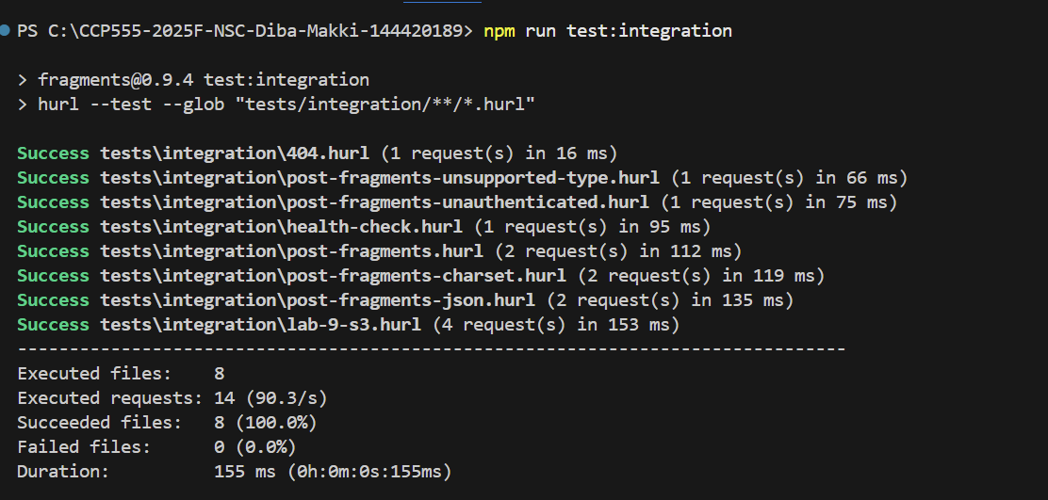
Screenshot of your fragments-ui creating a fragment using your Elastic Container Service deployment (i.e., show the Network tab to prove which back-end service is being used)
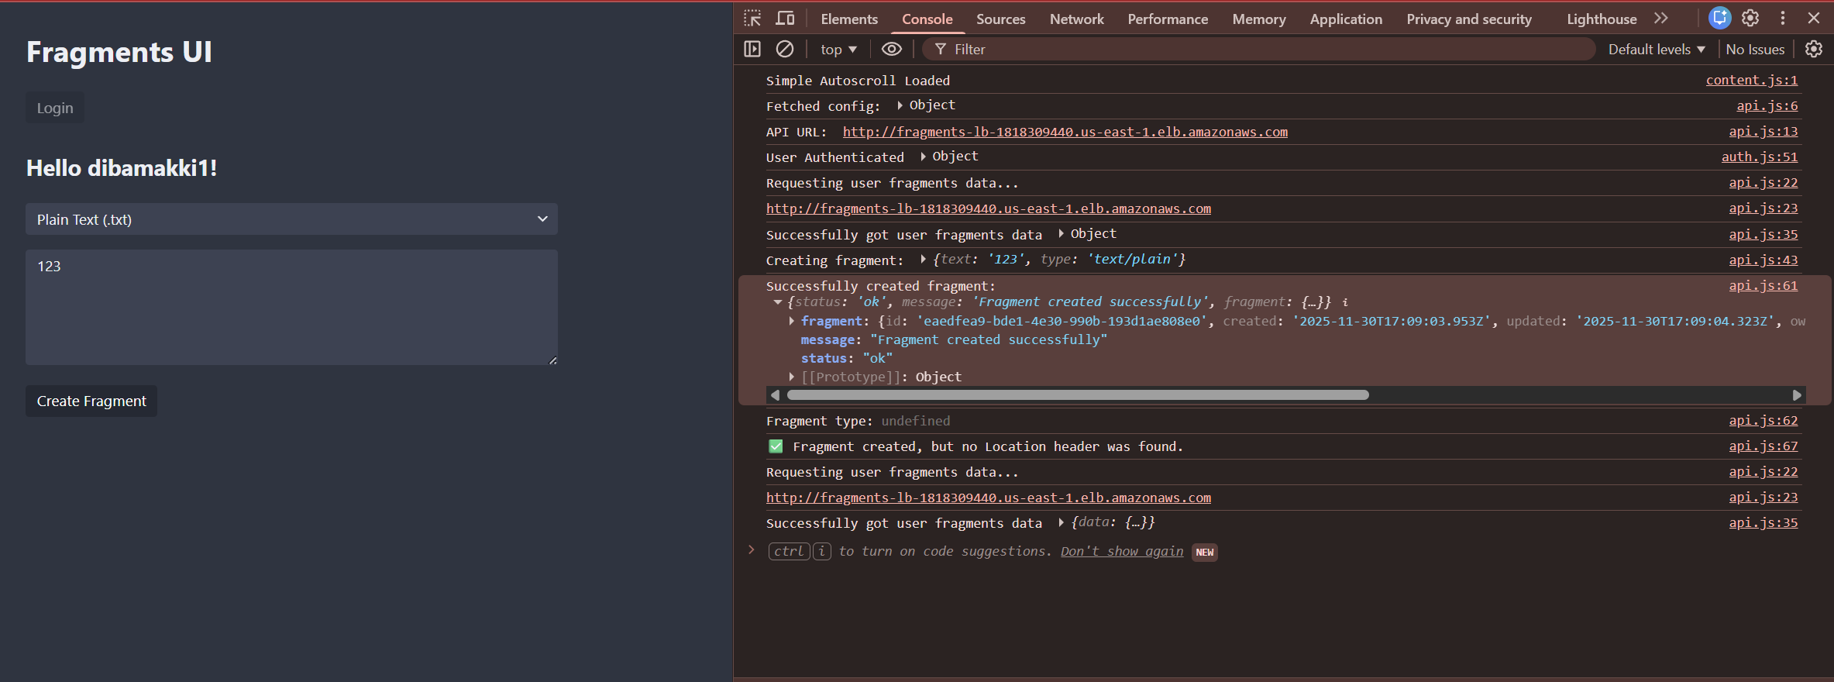
Header location is targeted at the load balancer in AWS in the network tab
Fragment id is: eaedfea9-bde1-4e30-990b-193d1ae808e0
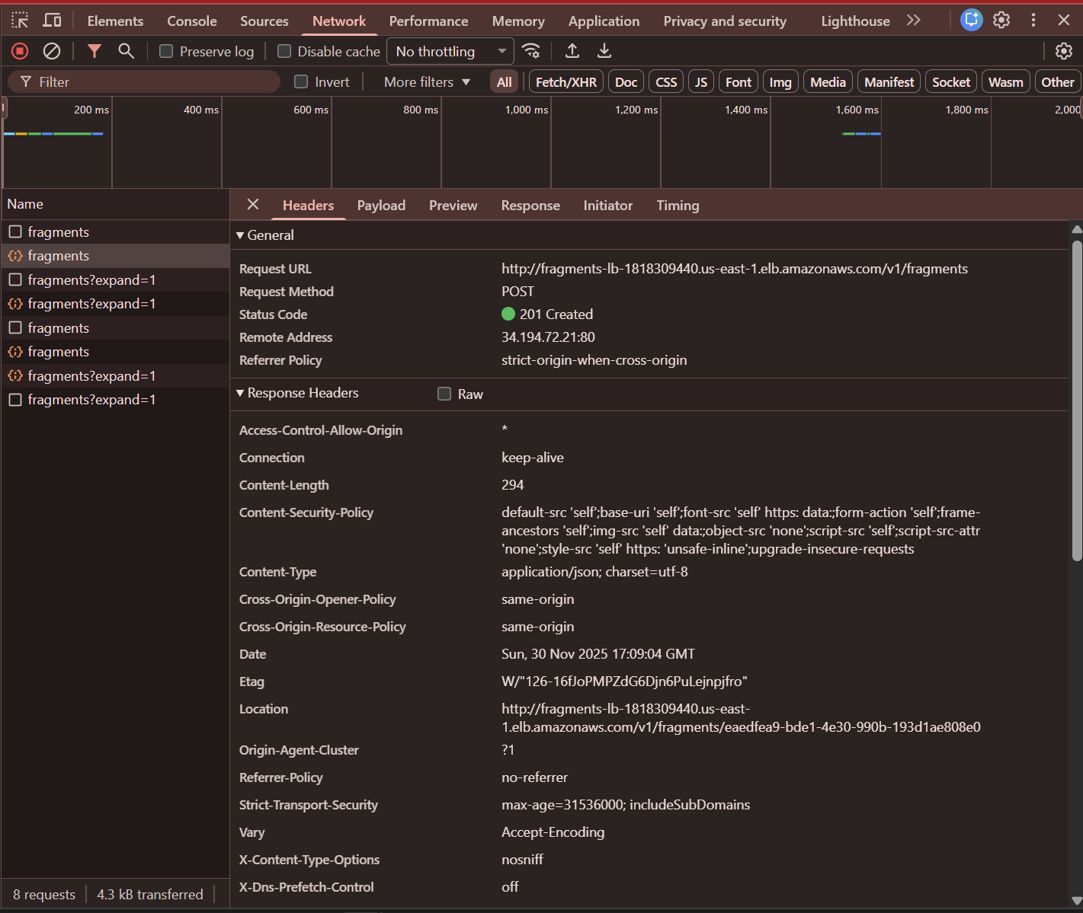

Screenshot of the AWS S3 Console showing the fragment you just created in S3 as an object in your bucket (i.e., prove that you've been able to create the fragment data in S3)
Fragment located in S3 with id eaedfea9-bde1-4e30-990b-193d1ae808e0

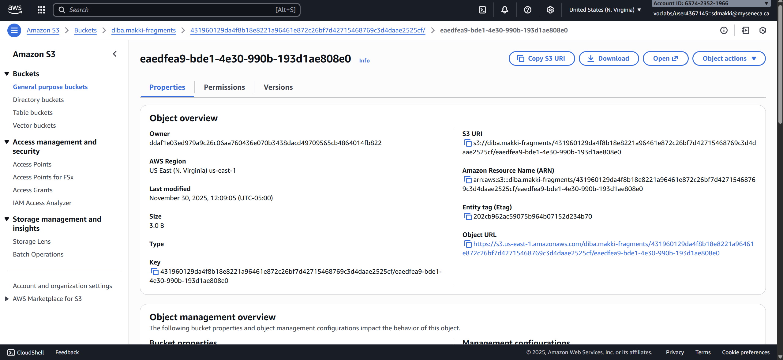
S3 bucket with my fragment located there
