**Supporting Information for**

**All the Earth will not remember: how geographic gaps structure the record of diversity and extinction**

Isaac W. Krone1,2*, Katherine M. Magoulick1,3, Ryan M. Yohler1,3

1 Department of Integrative Biology, University of California, Berkeley; Berkeley, CA 94720

2 University of California Museum of Vertebrate Zoology; Berkeley, CA 94720

3 University of California Museum of Paleontology; Berkeley, CA 94720

Isaac W. Krone

Email: [ikrone@berkeley.edu](mailto:ikrone@berkeley.edu)

Contents:

Table S1: “Missing” Taxa

Figure S1: Extant and fossil Geographic range distributions of modern tetrapods.

Figure S2: Species-level completeness of amphibians according to FGR cutoff values and IUCN status.

Figures S3-S6: Species-level phylogenies of tetrapods with branches colored according to maximum FGR area of their descendant nodes.

**Table S1**.

“Missing” (PBDB FGR of 0) Taxa according to PBDB.

|  |  |  |  |  |
| --- | --- | --- | --- | --- |
| taxon_no | taxon_rank | PBDB Name | Why Missing? | IUCN Name |
| 390213 | species | *Alouatta palliatus* | gender trouble | *Alouatta palliata* |
| 420378 | species | *Alsophis cantherigerus* | generic change | *Cubophis caymanus* |
| 133744 | species | *Amblystoma*  *maculatum* | misspelled | *Ambystoma maculatum* |
| 368705 | species | *Ammodramus*  *henslowii* | generic change | *Passerculus henslowii* |
| 428663 | species | *Aphelocoma insularis* | IUCN lumped | *Aphelocoma californica* |
| 432137 | species | *Artibeus (Artibeus)*  *jamaicensis* | parenthetical  genus | *Artibeus jamaicensis* |
| 432672 | species | *Balaenoptera ricei* | recently split (not in IUCN  Data pre-2021) | *Balaenoptera ricei* |
| 104264 | species | *Bos taurus* | Least Concern  possible | *Bos taurus* |
| 133747 | species | *Bufo americanus* | generic change | *Anaxyrus americanus* |
| 387477 | species | *Bufo calamita* | generic change | *Anaxyrus clamitans* |

|  |  |  |  |  |
| --- | --- | --- | --- | --- |
| 353836 | species | *Bufo marinus* | generic change | *Rhinella marina* |
| 110843 | species | *Bufo terrestris* | generic change | *Anaxyrus terrestris* |
| 110871 | species | *Bufo woodhousei* | generic change | *Anaxyrus woodhousii* |
| 368315 | species | *Butorides virescens* | IUCN lumped | *Butorides striata* |
| 104153 | species | *Canis familiaris* | Least Concern  possible | *Canis familiaris* |
| 173404 | species | *Caretta caretta* | no Cheloniids  in GARD |  |
| 173399 | species | *Chelonia mydas* | no Cheloniids  in GARD |  |
| 368532 | species | *Chroicocephalus*  *philadelphia* | generic change | *Larus philadelphia* |
| 45177 | species | *Clethrionomys gapperi* | generic change | *Myodes gapperi* |
| 110875 | species | *Cnemidophorus*  *sexlineatus* | generic change | *Aspidoscelis sexlineatus* |
| 368388 | species | *Coccothraustes*  *vespertinus* | generic change | *Hesperiphona vespertina* |
| 161184 | species | *Dasypus (Dasypus)*  *novemcinctus* | parenthetical  genus | *Dasypus novemcinctus* |
| 369210 | species | *Dryocopus pileatus* | generic change | *Hylatomus pileatus* |
| 155172 | species | *Elaphe guttata* | generic change | *Pantherophis guttatus* |
| 155170 | species | *Elaphe obsoleta* | generic change | *Pantherophis obsoletus* |
| 53100 | species | *Elaphe vulpina* | generic change | *Pantherophis vulpinus* |
| 105179 | species | *Emys marmorata* | generic change | *Actinemys marmorata* |
| 162072 | species | *Equus (Asinus) kiang* | parenthetical  genus | *Equus kiang* |
| 291374 | species | *Eumeces fasciatus* | generic change | *Plestiodon fasciatus* |
| 408764 | species | *Eumeces laticeps* | generic change | *Plestiodon laticeps* |
| 408765 | species | *Eumeces obsoletus* | generic change | *Plestiodon obsoletus* |
| 72201 | species | *Eumetopias jubata* | gender trouble | *Eumetopias jubatus* |
| 46459 | species | *Eutamias minimus* | generic change | *Neotamias minimus* |
| 231413 | species | *Felis domesticus* | Least Concern  possible | *Felis domesticus* |
| 132797 | species | *Geochelone carbonaria* | uncertain  taxon change | *Chelonoidis carbonaria* |
| 160881 | species | *Geomys lutescens* | IUCN lumped | *Geomys bursarius* |
| 371950 | species | *Hapalocrex flaviventer* | generic change | *Laterallus flaviventer* |
| 46934 | species | *Hesperomys taylori* | generic change | *Baiomys taylori* |
| 155176 | species | *Heterodon platyrhinos* | misspelled | *Heterodon platirhinos* |
| 369230 | species | *Himantopus*  *mexicanus* | IUCN lumped | *Himantopus himantopus* |
| 83088 | species | *Homo sapiens* | Least Concern  possible |  |
| 104849 | species | *Hyla cinerea* | generic change | *Dryophytes cinerea* |

|  |  |  |  |  |
| --- | --- | --- | --- | --- |
| 104847 | species | *Hyla gratiosa* | generic change | *Dryophytes gratiosus* |
| 104848 | species | *Hyla squirella* | generic change | *Dryophytes squirellus* |
| 110939 | species | *Hyla versicolor* | generic change | *Dryophytes versicolor* |
| 428640 | species | *Icterus bullockii* | specific  correction | *Icterus bullockiorum* |
| 203520 | species | *Insulacebus*  *toussaintiana* | not extant |  |
| 385259 | species | *Jacchus oedipus* | invalid name |  |
| 110828 | species | *Lampropeltis getulus* | gender trouble | *Lampropeltis getula* |
| 47712 | species | *Liomys irroratus* | generic change | *Heteromys irroratus* |
| 372078 | species | *Loxigilla violacea* | generic change | *Melopyrrha violacea* |
| 241953 | species | *Lytoloma jeanesii* | not extant |  |
| 420388 | species | *Melopyrrha nigra* | generic change | *Pyrrhulagra nigra* |
| 82030 | species | *Mesoplodon*  *carlhubbsi* | no IUCN Range | *Mesoplodon carlhubbsi* |
| 82031 | species | *Mesoplodon*  *ginkgodens* | no IUCN Range | *Mesoplodon ginkgodens* |
| 48584 | species | *Microtus guildayi* | not extant |  |
| 420397 | species | *Natalus micropus* | generic change | *Chilonatalus micropus* |
| 432177 | species | *Nesophontes edithae* | not extant | *Nesophontes edithae* |
| 368273 | species | *Oceanodroma*  *homochroa* | generic change | *Hydrobates homochroa* |
| 428655 | species | *Oceanodroma melania* | generic change | *Hydrobates melania* |
| 428659 | species | *Oceanodroma*  *microsoma* | generic change | *Hydrobates microsoma* |
| 368104 | species | *Oreothlypis celata* | generic change | *Leiothlypis celata* |
| 160975 | species | *Oryzomys fulvescens* | generic change | *Oligoryzomys fulvescens* |
| 80726 | species | *Pagophilus*  *groenlandica* | gender trouble | *Pagophilus groenlandicus* |
| 308912 | species | *Pekania pennanti* | generic change | *Martes pennanti* |
| 414896 | species | *Petrochelidon albifrons* | uncertain  taxon change | *Petrochelidon pyrrhonota* |
| 134730 | species | *Phalacrocorax auritus* | generic change | *Nannopterum auritus* |
| 368290 | species | *Phalacrocorax*  *brasilianus* | generic change | *Nannopterum brasilianus* |
| 335295 | species | *Phalacrocorax*  *pelagicus* | generic change | *Nannopterum pelagicus* |
| 134732 | species | *Phalacrocorax*  *penicillatus* | generic change | *Nannopterum pencillatus* |
| 369113 | species | *Phalaropus tricolor* | generic change | *Steganopus tricolor* |
| 284762 | species | *Philander opposum* | misspelled | *Philander opossum* |
| 105014 | species | *Phoca hispida* | generic change | *Pusa hispida* |
| 369557 | species | *Pica nuttalli* | misspelled | *Pica nutalli* |
| 368752 | species | *Picoides borealis* | generic change | *Dryobates borealis* |

|  |  |  |  |  |
| --- | --- | --- | --- | --- |
| 368082 | species | *Picoides pubescens* | generic change | *Dryobates pubescens* |
| 133787 | species | *Picoides villosus* | generic change | *Dryobates villosus* |
| 50359 | species | *Pipistrellus hesperus* | generic change | *Parastrellus hesperus* |
| 50360 | species | *Pipistrellus subflavus* | generic change | *Perimyotis subflavus* |
| 243545 | species | *Platypeltis ferox* | generic change | *Apalone ferox* |
| 50428 | species | *Plecotus townsendii* | generic change | *Corynorhinus townsendii* |
| 368061 | species | *Polyborus plancus* | generic change | *Caracara plancus* |
| 368527 | species | *Porphyrio martinica* | gender trouble | *Porphyrio martinicus* |
| 372024 | species | *Priotelus roseigaster* | generic change | *Temnotrogon roseigaster* |
| 50757 | species | *Prodipodomys*  *griggsorum* | not extant |  |
| 354369 | species | *Proischyromys perditus* | not extant |  |
| 104845 | species | *Pseudacris clarki* | misspelled | *Pseudacris clarkii* |
| 368562 | species | *Psittacus*  *leucocephalus* | generic change | *Amazona leucocephala* |
| 224063 | species | *Puma yagouaroundi* | generic change | *Herpailurus yagouaroundi* |
| 110841 | species | *Rana catesbeiana* | generic change | *Lithobates catesbeiana* |
| 53090 | species | *Rana pipiens* | generic change | *Lithobates pipiens* |
| 395216 | species | *Rangifer caribou* | specific  correction | *Rangifer tarandus* |
| 155189 | species | *Regina alleni* | generic change | *Liodytes alleni* |
| 63816 | species | *Sagmatias obliquidens* | generic change | *Lagenorhynchus obliquidens* |
| 408308 | species | *Sauromalus obesus* | specific  change | *Sauromalus ater* |
| 372344 | species | *Saurothera merlini* | generic change | *Coccyzus merlini* |
| 99689 | species | *Scaphiopus*  *(Scaphiopus) couchi* | parenthetical  genus | *Scaphiopus couchi* |
| 99685 | species | *Scaphiopus*  *(Scaphiopus) holbrooki* | parenthetical  genus | *Scaphiopus holbrooki* |
| 432088 | species | *Solenodon cubanus* | generic change | *Atopogale cubana* |
| 51654 | species | *Sorex monticolus* | gender trouble | *Sorex monticola* |
| 51682 | species | *Spermophilus armatus* | generic change | *Urocitellus armatus* |
| 51688 | species | *Spermophilus*  *columbianus* | generic change | *Urocitellus columbianus* |
| 51719 | species | *Spermophilus*  *spilosoma* | generic change | *Xerospermophilus spilosoma* |
| 51723 | species | *Spermophilus*  *tridecemlineatus* | generic change | *Ictidomys tridecemlineatus* |
| 51915 | species | *Sylvilagus leonensis* | not extant |  |
| 96485 | species | *Synaptomys*  *(Mictomys) borealis* | parenthetical  genus | *Synaptomys borealis* |
| 111091 | species | *Syrrhophus marnocki* | generic change | *Eleutherodactylus marnockii* |
| 160966 | species | *Tadarida aurispinosa* | generic change | *Nyctinomops aurispinosus* |
| 160960 | species | *Tadarida laticaudata* | generic change | *Nyctinomops laticaudatus* |

|  |  |  |  |  |
| --- | --- | --- | --- | --- |
| 363763 | species | *Testudo costarricensis* | not extant | *Geochelone costaricensis* |
| 368572 | species | *Tiaris bicolor* | generic change | *Melanospiza bicolor* |
| 344622 | species | *Tinosaurus pristinus* | not extant |  |
|  | genus | Amblystoma | Misspelled | Ambystoma |
|  | genus | Syrrhophus | generic change | Eleutherodactylus |
|  | genus | Oceanodroma | generic change | Hydrobates |
|  | genus | Hapalocrex | generic change | Laterallus |
|  | genus | Melopyrrha | generic change | Pyrrhulagra |
|  | genus | Chroicocephalus | generic change | Larus |
|  | genus | Homo | very least  concern |  |
|  | genus | Insulacebus | not extant |  |
|  | genus | Jacchus | invalid name |  |
|  | genus | Liomys | generic change | Heteromys |
|  | genus | Prodipodomys | not extant |  |
|  | genus | Mictomys | generic change | Synaptomys |
|  | genus | Hesperomys | generic change | Baiomys |
|  | genus | Proischyromys | not extant |  |
|  | genus | Nesophontes | not extant |  |
|  | genus | Sagmatias | generic change | Lagenorhynchus |
|  | genus | Pekania | generic change | Martes |
|  | genus | Caretta | no Cheloniids  in GARD |  |
|  | genus | Chelonia | no Cheloniids  in GARD |  |
|  | genus | Lytoloma | not extant |  |
|  | genus | Tinosaurus | not extant |  |
|  | family | Dicamptodontidae | IUCN lumped | Ambystomatidae |
|  | family | Chamaeidae | IUCN lumped | Paradoxornithidae |
|  | family | Trichechinae | misspelled | Trichechidae |
|  | family | NO_FAMILY_SPECIFIED | Not valid  family |  |
|  | family | Zapodidae | IUCN lumped | Dipodidae |
|  | family | Aplodontidae | misspelled | Aplodontiidae |
|  | family | Hesperomyidae | unclear |  |
|  | family | Ischyromyidae | not an extant  taxon |  |
|  | family | Nesophontidae | not an extant  taxon |  |
|  | family | Cheloniidae | no Cheloniids  in GARD |  |
|  | family | Crotalidae | IUCN lumped | Viperidae |
|  | family | Dipsadidae | IUCN lumped | Colubridae |

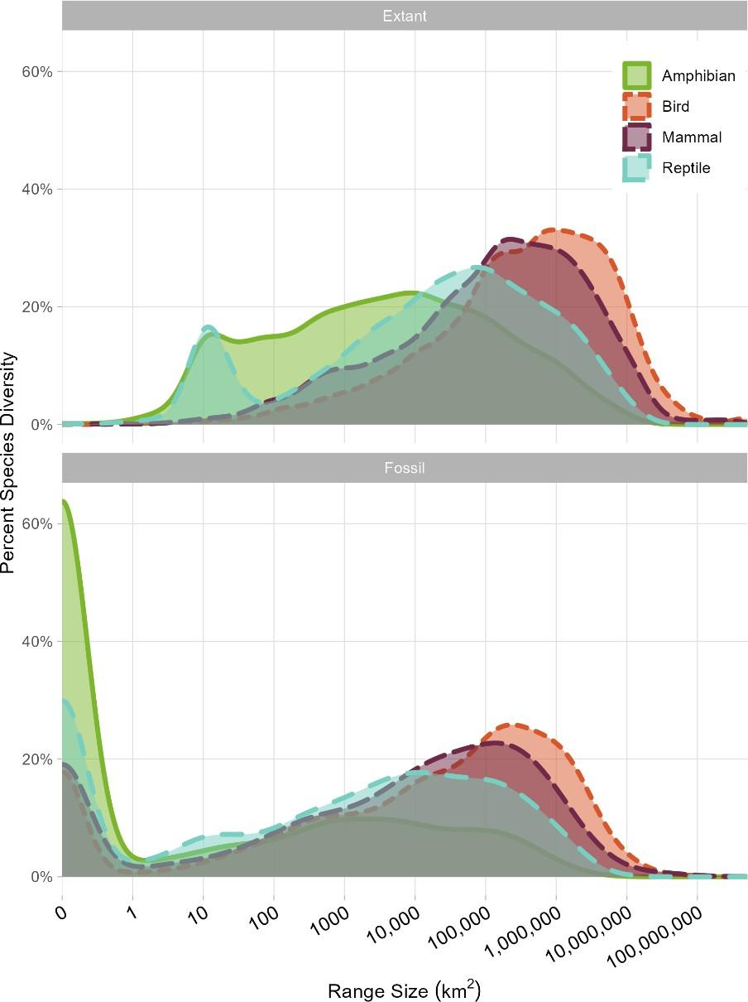

Fig. S1. Distribution of Extant and Fossil Geographic Range sizes (km2) for modern tetrapods.

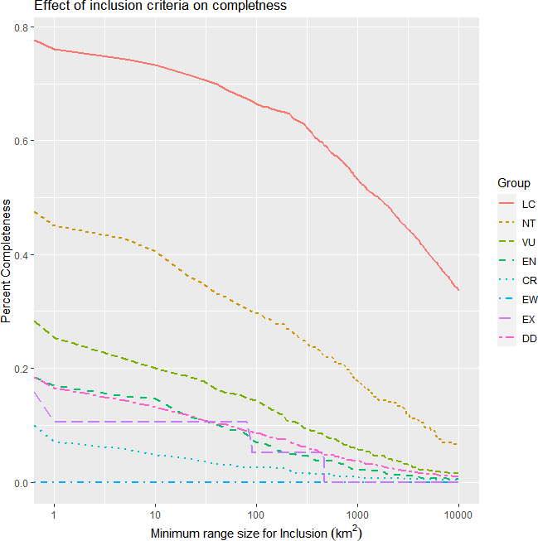

Fig. S2. Species-level completeness of a geographically structured amphibian fossil record by IUCN category.