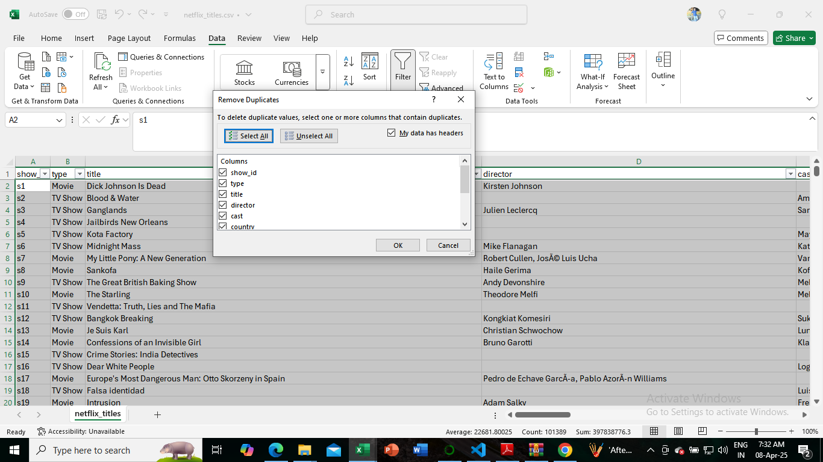

Steps to remove duplicate

There was no duplicate row found in the dataset

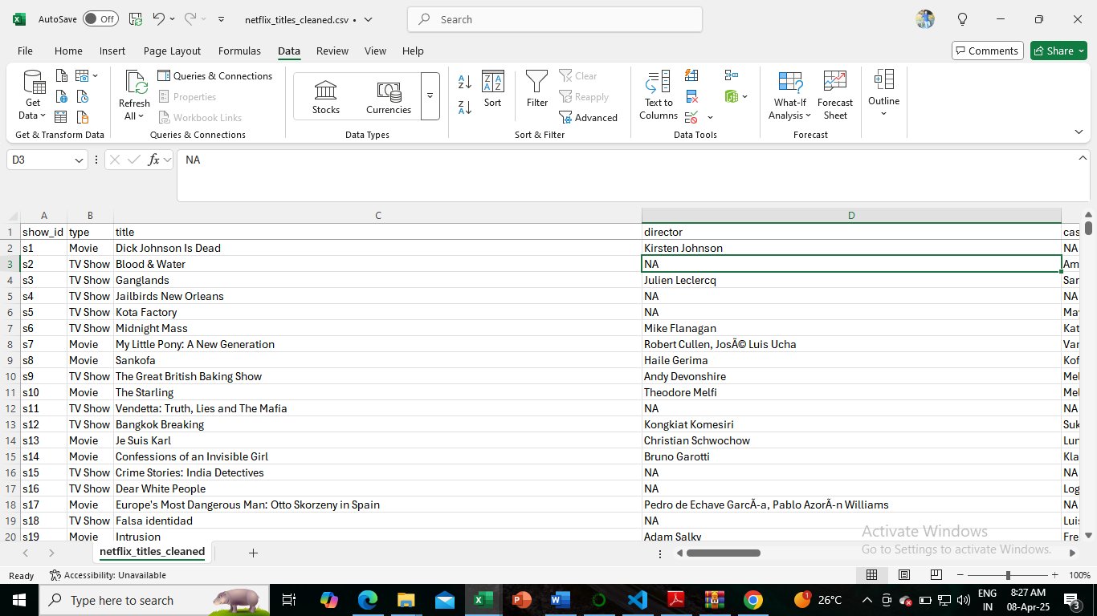

Replaced all the blank cells with “NA”