### 

**TRADICTION**

**CSC648 SOFTWARE ENGINEERING**

**SPRING 2020**

**TEAM 01**

|  |  |
| --- | --- |
| **Milestone** | **Date** |
| M1 Version V1 | 3/5/2020 |

### 

|  |  |
| --- | --- |
| **Team members:** | **SFSU email** |
| **Brian Lim – Team lead** | **blim6@mail.sfsu.edu** |
| **May Naing – Frong-end Lead** | **mnaing1@mail.sfsu.edu** |
| **Sanjay Mirani – Back-end Lead** | **smirani1@mail.sfsu.edu** |
| **Dibs Bharati – GitHub Master** | **dbharati@mail.sfsu.edu** |
| **Zike Xian – Database master 1** | **zxian@mail.sfsu.edu** |
| **Benjamin Fletes – Database Master 2** | **bfletes1@mail.sfsu.edu** |

## Table of Contents

Executive Summary: 3

Use Cases: 4

List of main data items and entities: 8

Functional Requirements: 9

List of Non-functional Requirements: 11

Competitive Analysis: 15

High-level System Architecture: 18

Team: 19

Checklist: 20

### 

## Executive Summary:

A **stock market**, **equity market** or **share market** is the aggregation of buyers and sellers of stocks (also called shares), which represent ownership claims on businesses. Stock price forecasting is a popular and important topic in financial and academic studies. Share Market is an untidy place for predicting since there are no significant rules to estimate or predict the price of the share in the share market. Many methods like technical analysis, fundamental analysis, time series analysis, and statistical analysis, etc. are all used to attempt to predict the price in the share market but none of these methods are proved as a consistently acceptable prediction tool.

With our application, users or more precisely traders will be able to open a trading account and upload necessary documents related to it like bank statements, valid ID, SSN, etc. The main feature of this project is to generate an approximate forecasting output and create a general idea of future values based on the previous data by generating a pattern. The scope of this project does not exceed more than a generalized suggestion tool. To make it more user-friendly, a simple GUI for the basic understanding of first-time users will also be implemented. Traders can also view the stocks and choose to look at its details and decide whether to buy using an integrated payment gateway or not. Also, they can view the stocks they invested in viewing their own portfolio page. Users can add their interesting stocks in Wishlist and get notified when the prices go up or down through mobile messages and mail. News Feeds for the latest news related to the stock market will be displayed. Twitter analysis for a particular stock will be displayed on the stock page which will help the user decide to buy the stock or not.

To generate traction for the site, we will market our site by buying ads on social media sites and other sites that we deem to have similar interest. Tradiction plans on collecting interest from customer’s cash and stocks as well as rebates from market makers and trading venues. In addition, a premium account option will be implemented where the user will be able to access additional features such as investment advice from professionals, or the AI Stock Price Predictor.

## Use Cases:

**User Profiles:**

**Joanna** is a junior-standing business student at SFSU. While she is a great business student, her use and understanding of technology is not so great. Joanna often runs into issues when using her computer and requires frequent assistance. She is enrolled in an investment class where as an individual project, her instructor has tasked her to create a fake portfolio. Given a certain amount of money, she needs to create a portfolio that will net her the largest return on investment. With no experience in stock-trading applications, she runs across an advertisement for Tradiction on Facebook and decides to use the web application for her project.

**John** is a stay-at-home dad that makes his money investing. He is very literate on many different trading platforms. Over the years, he has made several hundred-of-thousands in profit, lives comfortably, and supports his family. His portfolio is diverse and uses several trading-applications to diversify. He uses Etrade for mutual funds, Fidelity for bonds, and Robinhood for individual stocks. After learning about Tradiction from his friends who are also day-traders, he decided to give it a shot and realized how easy, informative, and responsive Tradiction was. John decides to buy and sell individual stocks on Tradiction instead of Robinhood.

**Karen** is a software engineer and is a hobbyist investor. She works at a large tech company in the Bay Area and is very busy. She has two kids, a 5-year-old and a 14-year-old, and a husband. She takes care of most of the housework and works from home 2 days a week. While doing housework, she watches the news and keeps an eye out for reports on the stock market. She has been working on building up her investment profile for about a year and is looking to invest in some new stocks. As she is somewhat new to investing, she constantly consults her friends and coworkers on what to do next.

**Kevin** is a young engineer who recently earned a high position in his company in Texas. He lives alone and doesn’t have to support anyone else for the time being. With his position, he now makes a stable income and is interested in investing some of his money. He has no experience in investing nor has he been taught how the stock market works. Because of this, he tries to do his research and learn from what others have written online. He is constantly browsing sites like Reddit and Investopedia for tips and tricks. Upon doing this, he comes across a forum post about a site called Tradiction that is easy to use and is good for beginners.

**Sanjay** is new to investing and is scared to lose his money. To minimize his loss, he puts all his extra money into the bank. Over a few years, Sanjay experiences little returns from the bank. In conversation, he brings this up with one of his friends, who suggests he try Tradiction. After hearing the amount of return his friend made, Sanjay is inspired to give Tradiction a go.

**Specific Use Cases**

1. Joanna is relieved that she does not need to create an account to monitor stocks. By searching for stocks and adding them to her dashboard, she monitors the status of each of her stocks independently and looks at the past performance of the company before deciding on which stocks to purchase.
2. John looks to see how the market is moving. He checks out which companies earned the most and which earned the least last week and the weeks prior.
3. Karen wants to monitor the status of the stocks in her portfolio. After looking at her stock portfolio breakdown from her trading account, she adds each stock individually so that she can monitor the status of each of her stocks independently.
4. Karen’s friend recommends investing in a couple of small companies, but Karen wants to check how they’re performing first. She searches each of them up and compares how they all did. Upon deciding which ones were most optimal, she creates an account to purchase stocks in each one.
5. Kevin closely monitors several companies in Big Tech over the last two weeks and is unsure how to invest his money. He creates a Tradiction account and uses the support functionality to chat with a stock expert to get her advice.
6. Sanjay is new to investing but he wants to learn and start investing. He registers as a new user and creates a trading account in Tradiction. He selects a stock and then goes to the expert category. He selects an expert. The expert starts discussing his choice of stocks. The expert tells him various aspects associated with his choice.
7. Sanjay scrolls through some stocks on Tradiction. He wants to buy some stocks but they are above his budget. So, he keeps the stocks in the wishlist category of his trading account. After a week, Matt returns to Tradiction. He sees the stock in the wishlist and then buys it.
8. Sanjay uses Tradiction’s accurate price prediction functionality to invest in the right stock and finds his way to regular investors in the field.

**Use Case Diagram:**

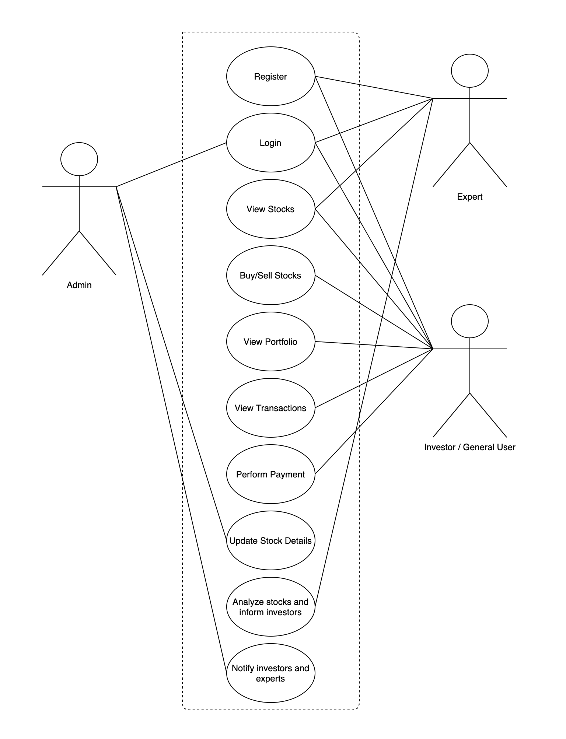

## List of main data items and entities:

* **User:** New user visiting site for the very first time. They can create an account, view stock lists, know details of a particular stock, but cannot buy/sell stocks.
* **Traders:** Registered Users with an account, who can view stocks, buy/sell stocks, update personal details, view transaction history, update portfolio, chat with an expert.
* **Experts:** Registered Stock experts. Can view, analyze and chat with users to provide them best advice and guidance for buying/selling stock.
* **Admin:** Person having full access to the site. Also, the one reviewing and approving accounts of the traders and experts.
* **Customer Support:** Dedicated 24/7 service available for the customers to answer and resolve their queries.
* **Prediction Tab:** A dedicated tab for accurate prediction of prices of a stock just by entering a stock symbol.
* **Newsfeeds:** Displaying top news related to the stock market.

### 

## Functional Requirements:

**NEW USERS: -**

* Shall be able to create a new account, whether be an expert or trader.
* Shall be able to view news feeds.
* Shall be able to view Stock lists.
* Shall be able to view a particular stock detail.
* Shall be able to contact customer support for any query.
* Shall not be able to chat with an expert (Unregistered Trader).
* Shall not be able to buy/sell stocks.
* Shall not have a transaction history and a portfolio page.

**REGISTERED USERS/TRADERS: -**

* Shall be able to login.
* Shall be able to edit personal information provided.
* Shall be able to logout.
* Shall be able to view news feeds.
* Shall be able to view Stock lists.
* Shall be able to view a particular stock detail.
* Shall be able to chat with an expert.
* Shall be able to buy stocks.
* Shall be able to sell stocks.
* Shall be able to view his transaction history.
* Shall be able to add his interested stock in his wishlist.
* Shall be able access prediction tab to know the estimated price for a stock.

**REGISTERED EXPERTS: -**

* Shall be able to login.
* Shall be able to logout.
* Shall be able to view news feeds.
* Shall be able to view Stock lists.
* Shall be able to view a particular stock detail.
* Shall be able to buy stocks.
* Shall be able to sell stocks.
* Shall be able to chat with users.
* Shall be able to view his transaction history.
* Shall be able to add his interested stock in his wishlist.
* Shall be able access prediction tab to know the estimated price for a stock.

**ADMIN: -**

* Shall be able to login.
* Shall be able to logout.
* Shall be able to view details entered by traders.
* Shall be able to view details entered by experts.
* Shall be able to accept/reject traders' accounts.
* Shall be able to accept/reject experts' accounts.

## List of Non-functional Requirements:

1. **Security**
   1. Login shall be required to make purchases
   2. User’s shall verify their emails when registering an account
   3. User’s shall be able to set a display name different than their email
   4. User’s emails shall not be displayed by default
   5. Passwords shall be encrypted before storing in the database
   6. User’s session timeout limit shall be decided by the administrator
   7. User’s session shall only be ended by code design
   8. Content uploaded by users shall be audited by the administrator
   9. User’s payment information shall be encrypted
   10. This site shall not accept any third-party cookies
2. **Audit**
   1. New registrations shall be audited by the administrator
   2. New registrations shall be approved by the administrator
   3. Users shall not be able to login to administrator accounts
3. **Performance**
   1. The site loading time shall be less than 2 seconds for all screens
   2. Application shall be able to retrieve information from the database and react in a timely manner.
   3. The site shall handle requests asynchronously following a REST format
4. **Capacity**
   1. The total data storage for the site shall not exceed 80% of the server’s capacity for this site
   2. The website shall be capable of handling at least 50 users
   3. The website shall be scalable, so that new features can be added easily
5. **Reliability**
   1. Downtime for maintenance shall be less than 3 hours per month
   2. Downtime for maintenance shall not affect the site’s main functionality
   3. In all cases, users shall be informed of downtime for maintenance, either via an announcement on the main page, or e-mail
6. **Recovery**
   1. In case of a total site failure, the whole site shall be shut down for revision.
   2. If the site is broken, the mean time to recovery shall not exceed one day.
   3. User data is the most valuable aspect and priority will be placed on recovering such data in case of total failure.
7. **Data Integrity**
   1. Database tables shall be backed up weekly
   2. Administrator shall be able to execute a recovery if needed
   3. Image sizes shall be restricted to at most 1 megabyte
   4. Images shall be uploaded in jpg, jpeg, or png formats
   5. Images will be saved on Amazon’s s3 storage server
   6. URLs to image will be stored on the database
8. **Compatibility**
   1. The site shall be compatible with the last version of the Safari browser version 11.1.2
   2. The site shall be compatible with the last version of the Firefox browser version 70
   3. The site shall be compatible with the last version of the Chrome browser version 80
   4. Third party applications shall not be able to modify any content that may affect the site compatibility
   5. Content should be able to be ignored by most popular ad-block services.
   6. The site shall be able to account for any other compatibility issues created as a result of browser updates in the future
   7. The site should be compatible to escalate to new databases
9. **Conformance with Coding Standards**
   1. Architecture and design standards shall meet all the requirements listed under the High-level system architecture and technologies used section of this document
   2. Design pattern is to be strictly enforced with all aspects of the site.
   3. Appropriate documentation must be created for all code that is individually written for future maintenance.
   4. Production code shall not have any log or output to the console.
   5. All errors must not halt the web application without appropriate error handling.
   6. Only working code that meets all code standards shall be submitted to the main branch of the project repository
   7. Code shall be thoroughly tested and debugged before being considered working code
   8. All internal errors and exceptions encountered when writing or modifying code shall be stored in a log
   9. Any error that can affect the site’s functionality shall be reported to the user
   10. Errors shall be handled in a way that does not affect site functionality
   11. The whole production cycle of the site shall be finished at least one week before the delivery date
   12. The site shall be tested and debugged as a whole product at least one week before the delivery date
   13. The site shall not be launched without all priority one features finished and working
   14. All major changes to the application shall be discussed by the team and communicated to the class CTO.
10. **Look and Feel Standards**
    1. The application and its layouts shall look professional
    2. The site shall be simple, so that it is usable to a wide range of users, and all previously mentioned parties
    3. Targeted users will be the main priority for ensuring usability and readability.
    4. Elements on screen shall meet the compatibility standards of all supported browsers
    5. Elements on screen shall meet the compatibility standards of all supported browsers on mobile devices
    6. Elements on screen shall be aesthetically pleasing
    7. The site shall be able to work correctly without mouse interaction
    8. The site shall be able to work correctly without keyboard interaction
    9. Elements in screen shall be resized automatically without user interaction when being loaded in all the different platforms supported by the site
    10. Application’s user interface shall make it easy for users to find what they are looking for.
11. **Scalability**
    1. The CPU instance and storage capacity shall be updated to be able to handle a large number of users if needed
12. **Web Site Policies**
    1. A link to the policies of this site shall be always visible in all its pages to be accessible by all the parties
    2. The site will not store any payment information.
    3. Users payment information shall be kept confidential and secure
    4. The website shall allow users to register an account.
    5. Email verification shall be implemented upon registration.
    6. User’s shall agree to the application's privacy policy before using the product.

## Competitive Analysis:

|  |  |  |  |
| --- | --- | --- | --- |
| **Features/Company** | **Yahoo Finance** | **ETrade** | **Robinhood** |
| **Strengths** | Provides lots of information and news about the market | Large variety of features, 24/7 live support | Very sleek and clean design, low cost |
| **Weaknesses** | Dashboard feature hidden behind paywall, cluttered design | So many options which makes it difficult to navigate. | Limited number of features. The color for a white background makes it a little hard for the eyes. |
| **Pricing** | Free for standard use, $34.99/month or $349.99/year for premium features | Free for standard use, but prices range from $0.65-$1.50 by contract | Free for standard use, $5/month for premium features |
| **Social Media** | Facebook, Twitter, Instagram, Tumblr | Facebook, Twitter, Instagram, LinkedIn, YouTube | Blog posts, Facebook, Twitter, Instagram, LinkedIn |
| **Onboarding Experience and Usability** | Account not required to read articles or view stocks. | Straightforward to open account, difficult to navigate | Clutter free UI and easy to sign up/log in for an account. |

### 

|  |  |  |  |  |
| --- | --- | --- | --- | --- |
| **Features/Company** | **Yahoo Finance** | **ETrade** | **Robinhood** | **Tradiction** |
| **View Performance of individual stocks** | + | + | + | + |
| **Purchase stocks** | - | + | + | + |
| **AI Stock Price Predictor** | - | - | - | + |
| **Sentimental Analysis on Twitter comments** | - | - | - | ++ |
| **Chatting with stock market experts** | - | - | - | + |

**Performance of Individual Stocks:**

Compared to our competitors, Tradiction’s monitoring of individual stocks will display both a simplified dashboard, showing all the stocks that the user adds, with the addition of a detailed analysis page where the user can see high-level information such as opening and closing prices, open and close 52, other important statistics, as well as a large graph portraying the price performance over a long period.

**Purchasing Stocks:**

Like other stock trading applications, Tradiction will allow the user to purchase stocks. Stocks that are purchased will be added to a dashboard, where they can easily be monitored. These features are similar to two rival stock-trading applications, ETrade and Robinhood.

**AI Stock Price Predictor:**

The most important feature of Tradiction is to display our users the most accurate price of the stock for the next day which can allow traders to rethink their trade for the stock.

**Sentimental Analysis on Twitter Comments:**

Sentiment analysis or formally twitter analysis is used in the project where comments related to the particular stock are fetched from twitter and sentiment analysis is done on every single one and are averaged and results maps to one of the three outputs: - Positive, Negative and Neutral and this result is displayed on the stock page and will also be used in AI Stock Price Predictor.

**Chatting with Stock Market Experts:**

Our users will have an option to chat with a stock expert where they can get best advice from the experts and invest in the best stock.

### 

## High-level System Architecture:

* Server Host: AWS 1 vCPU 1 GiB RAM
* Operating System: Ubuntu Server 18.04 LTS (HVM), SSD Volume Type
* Database: MySQL 8.0.18
* Web server: None
* Server-Side Language: Python 3.8.1
* Front-End Language: HTML5, CSS, JavaScript
* Additional Technologies:
  + Web framework: Django 3.0.2
  + IDE: PyCharm 2019.3.3

## Team:

|  |  |
| --- | --- |
| **Engineer** | **Role** |
| Brian Lim | Team Lead |
| May Naing | Front-end Lead |
| Sanjay Mirani | Back-end Lead |
| Dibs Bharati | Github Master |
| Zike Xian | Database Master 1 |
| Benjamin Fletes | Database Master 2 |

### 

### 

### 

### 

### 

### 

### 

### 

### 

### 

## Checklist:

* **Team found a time slot to meet outside of class**
  + DONE
* **GitHub master chosen**
  + DONE
* **Team decided and agreed together on using the listed SW tools and deployment server**
  + DONE
* **Team ready and able to use the chosen back and front-end frameworks and those who need to learn are working on learning and practicing**
  + ON TRACK
* **Team lead insured that all team members read the final M1 and agree/understand it before submission**
  + DONE
* **GitHub organized as discussed in class (e.g. master branch, development branch, folder for milestone documents, etc.)**
  + DONE