WebApi_Handson

- First Web Api using .Net core
Create a .Net core web application with API template. Use the option to create controller with Read Write permissions. Notice the ValuesController creation with Action methods corresponding to the Action verbs.
On creation of the Web API, execute the application and check if the GET action method result is returned as expected.

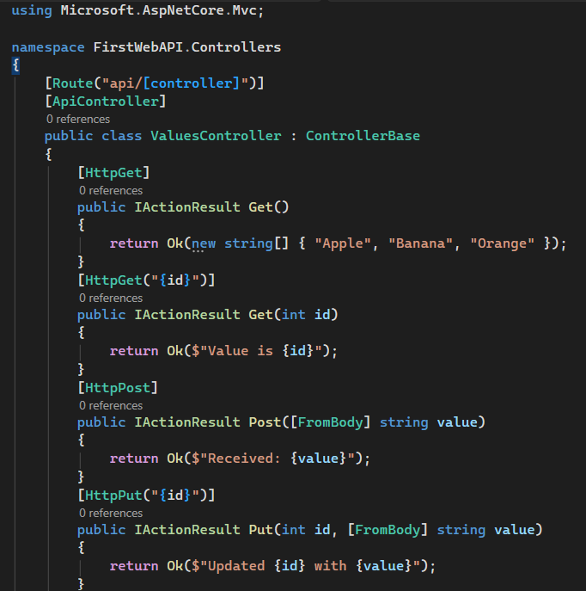
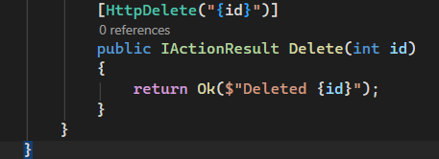
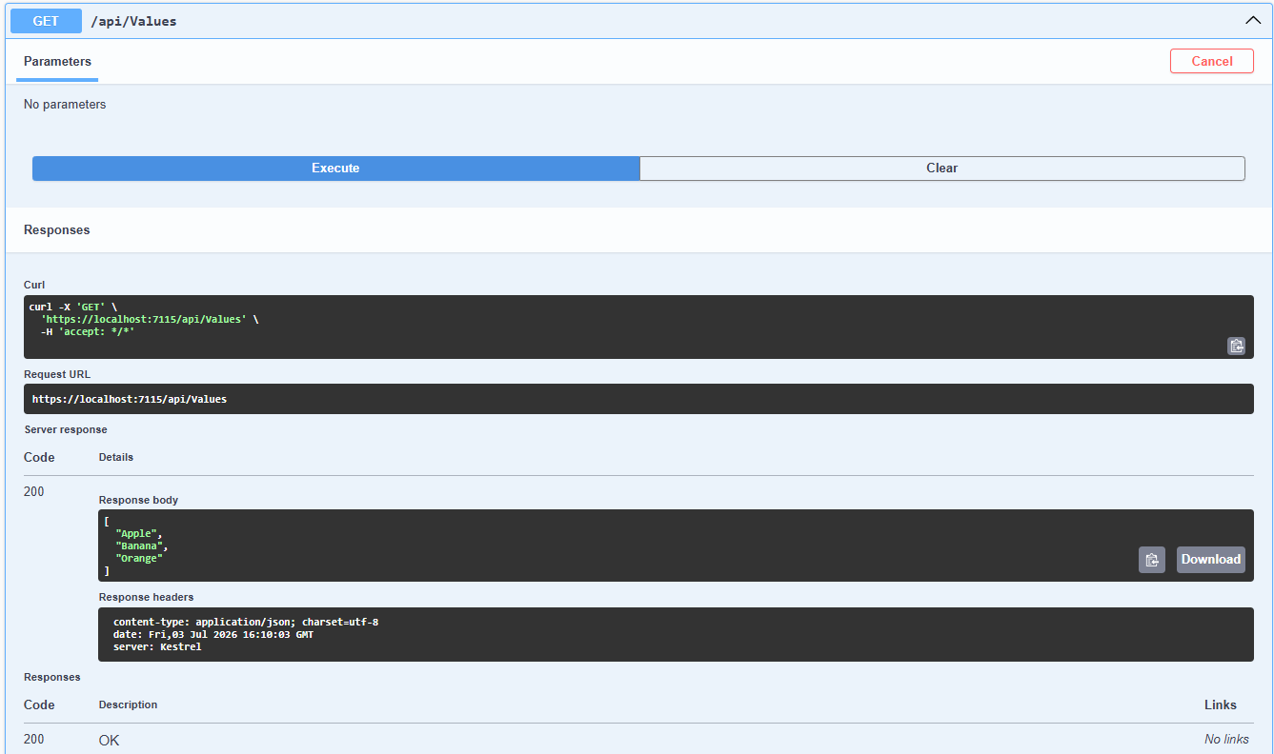

- Web Api using .Net core with Swagger
Create a .Net core web application with API template. (Use existing application if created). Install Swashbuckle.AspNetCore Nuget package. Post this do the following steps in Startup.cs
- In ConfigureServices method, add the code provided below.
services.AddSwaggerGen(c =>
{
c.SwaggerDoc("v1", new Info
{
Title = "Swagger Demo",
Version = "v1",
Description = "TBD",
TermsOfService = "None",
Contact = new Contact() { Name = "John Doe", Email = "john@xyzmail.com", Url = "www.example.com" },
License = new License() { Name = "License Terms", Url = "www.example.com" }
});
});
- In Configure method, add the code provided below.
app.UseSwagger();
app.UseSwaggerUI(c =>
{
// specifying the Swagger JSON endpoint.
c.SwaggerEndpoint("/swagger/v1/swagger.json", "Swagger Demo");
});

Execute the application which will load the default ‘Values’ controller(Settings as per launchSettings.json) GET action method. Change the url to https://localhost:[port number]/swagger

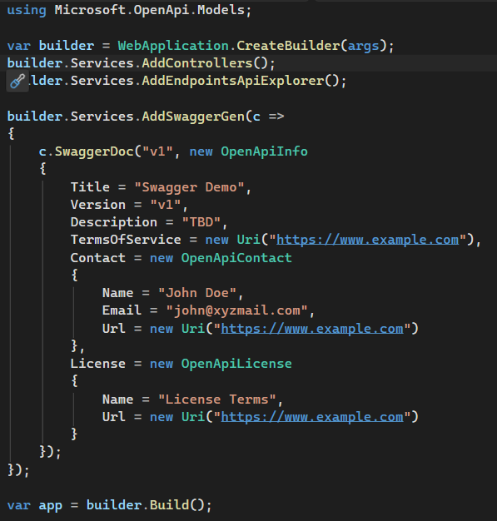

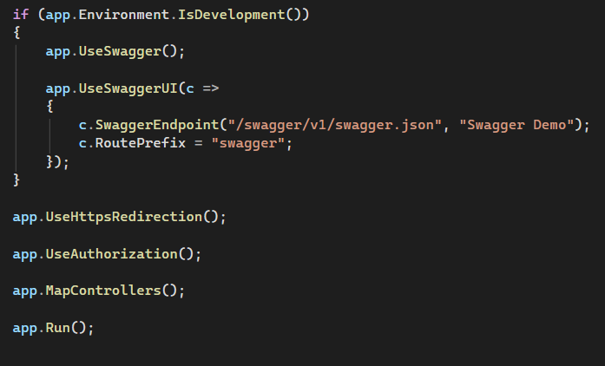

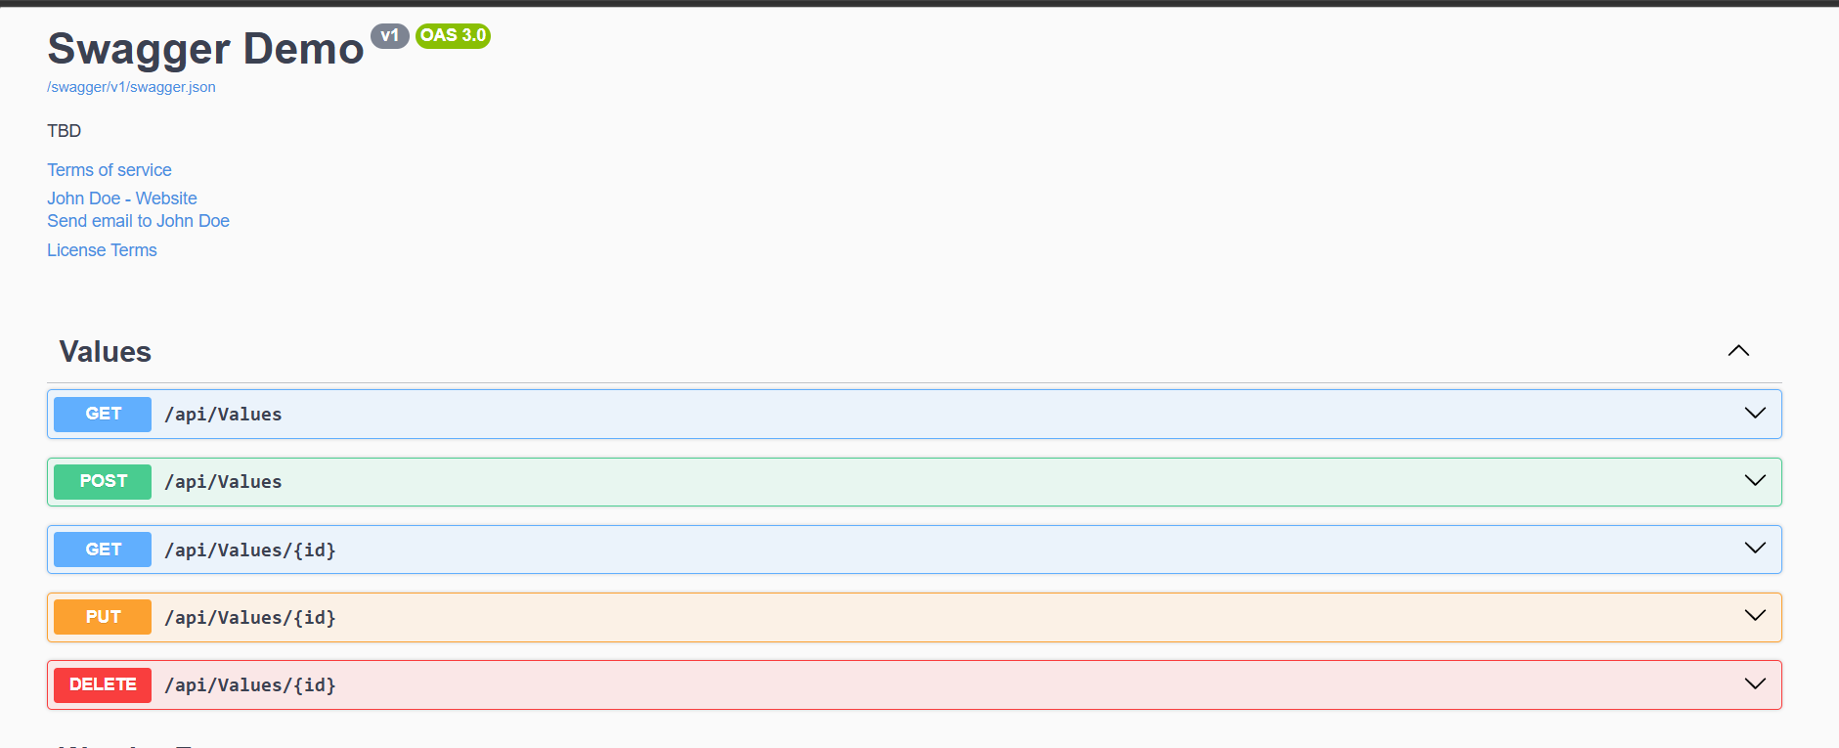

- Web Api using custom model class
Create a Custom class ‘Employee’ of the below defined structure
public class Employee
{
public int Id { get; set; }
public string Name { get; set; }
public int Salary { get; set; }
public bool Permanent { get; set; }
public Department Department { get; set; }
public List<Skill> Skills { get; set; }
public DateTime DateOfBirth { get; set; }
}

Create a new controller - EmployeeController with Read Write actions
Constructor: Create few records, HTTPGet, HTTPPost/HTTPPut
Create a Private method GetStandardEmployeeList that returns a List of Employee class. Invoke this method in the Get action method of the EmployeeController that was created in the previous step.
Public ActionResult<Employee> GetStandrad()
Modify the return type of the Get action method(without parameter) to return List of Employee class object
Add ProducesResponseType to the GET action method for Status code 200
Check the Swagger description for the GET method for success status code

- Create a Custom action filter for Authorization.
The requirement is to intercept incoming requests and check if there is a key ‘Authorization’ in the request header or not. If it is there, then to check if it contains a value ‘Bearer’ or not.

Create a folder ‘Filters’ in the application solution. Create a class ‘CustomAuthFilter’ to filter requests. Inherit ActionFilterAttribute. Override OnActionExecuting method to check if the request object has Header ‘Authorization’ or not. If not, throw BadRequestResult with the message
Invalid request - No Auth token
If the header is present, then check if the value contains the word ‘Bearer’. If not, throw BadRequestResult with the message
Invalid request - Token present but Bearer unavailable

Add an attribute CustomAuthFilter to the Employee controller to filter any request to check for the Authorization token in the request header.

- Custom Exception filter
Create a class ‘CustomExceptionFilter’ to catch the exceptions occuring the application. Implement IExceptionFilter thru the OnException method
Use the exception context to fetch the exception detail. Capture that and write it to a File in the system.
Set the Result property of the exception context to ExceptionResult.
Throw an exception in GET action method.
Ensure that the GET action method has ProducesResponseType for 500 - Internal server error
Use Swagger to test the exception and message being thrown.
Note: This needs WebApiCompatShim NuGet package installation
1)
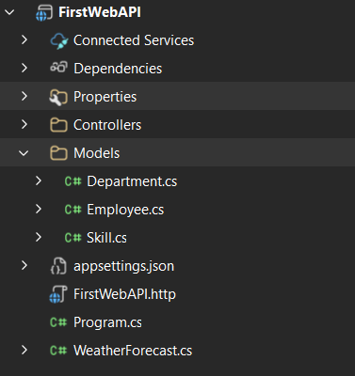
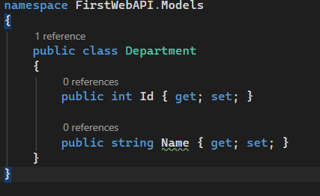

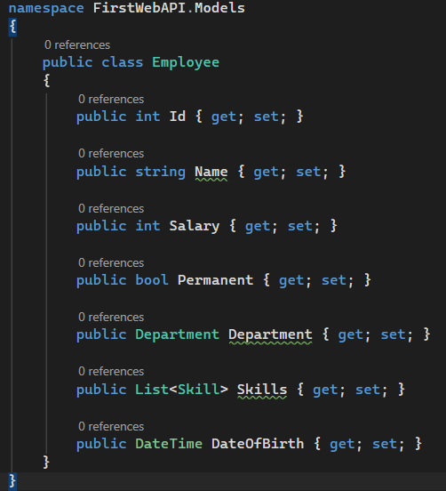
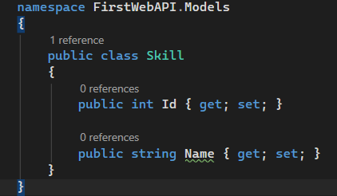

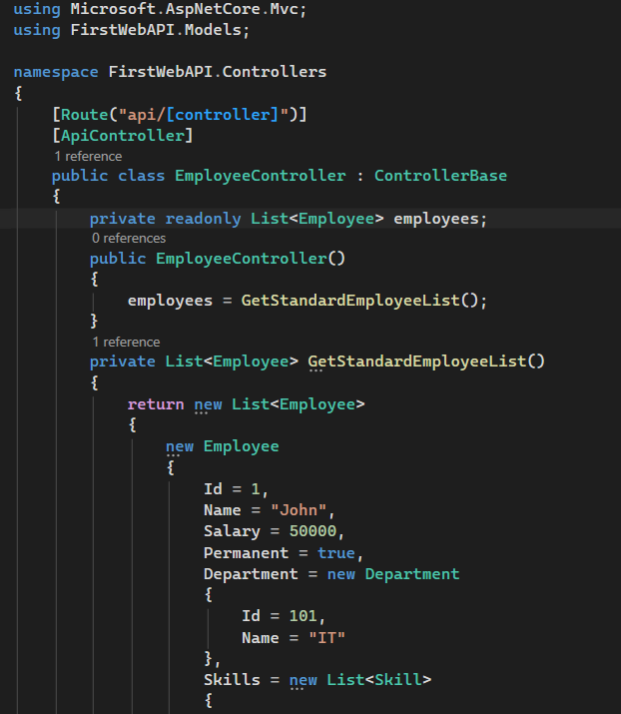
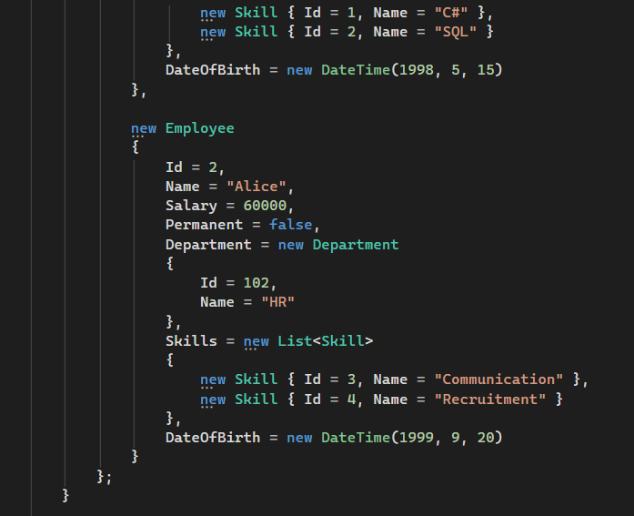

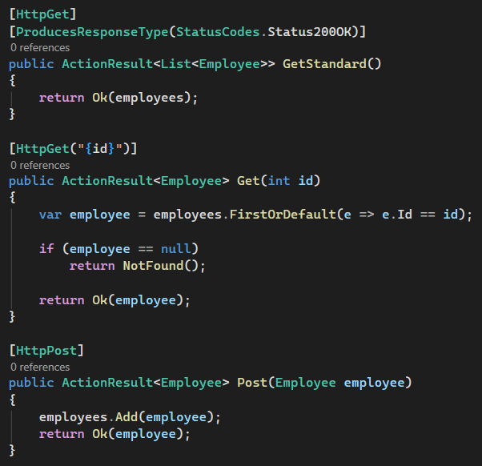
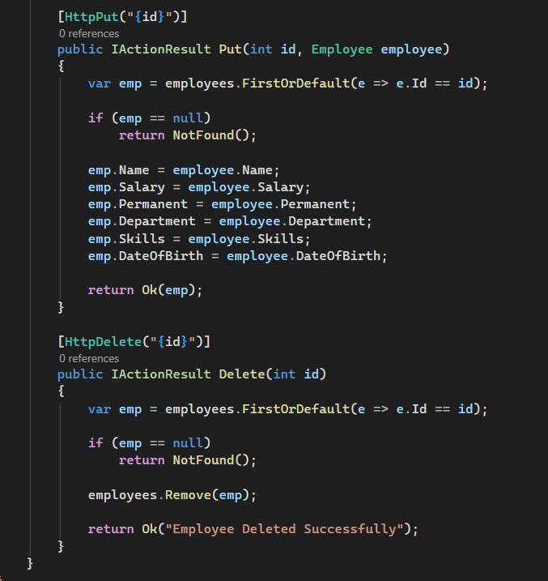
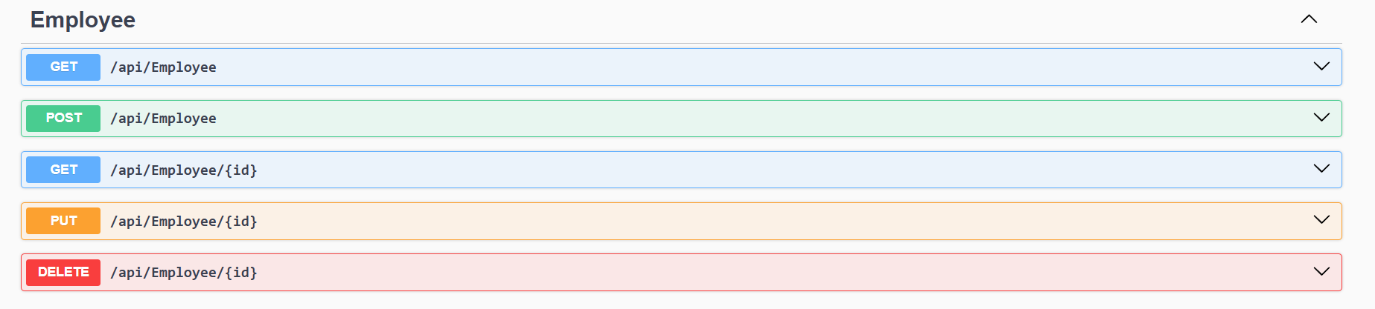

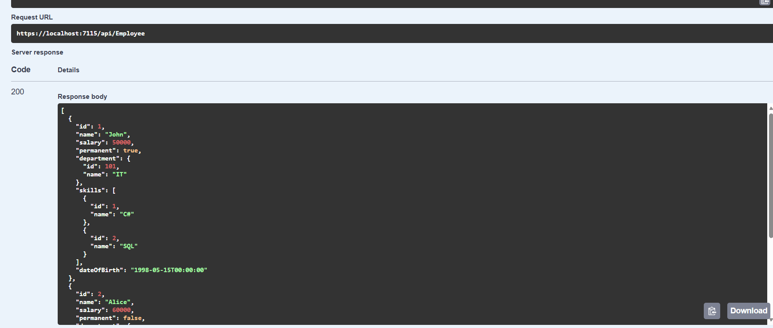

2)
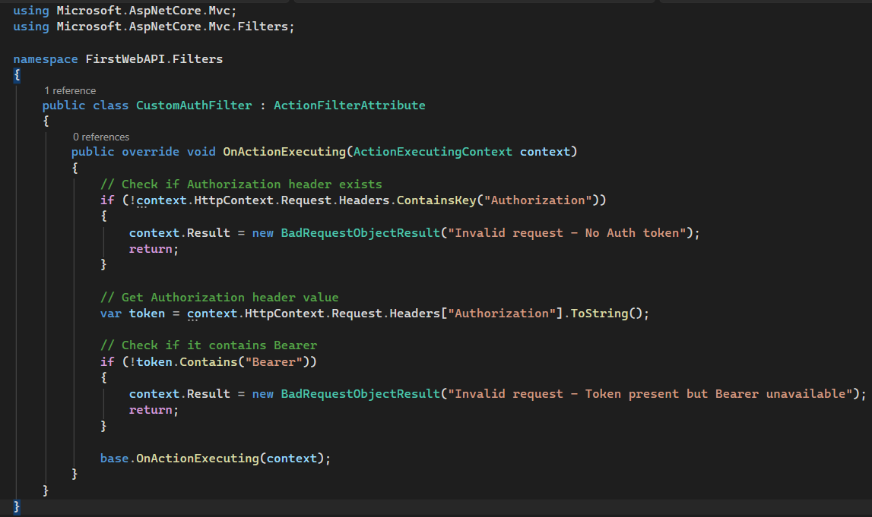

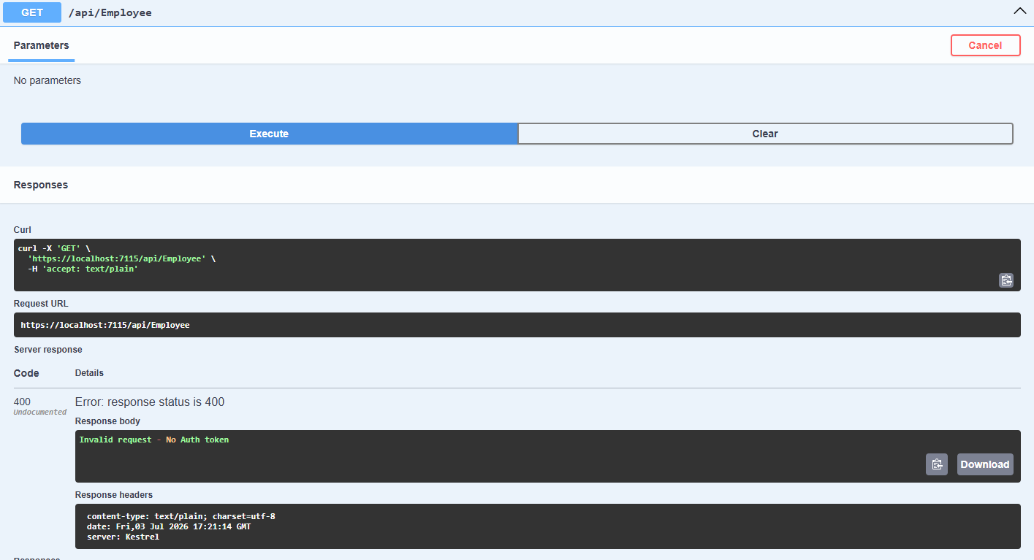
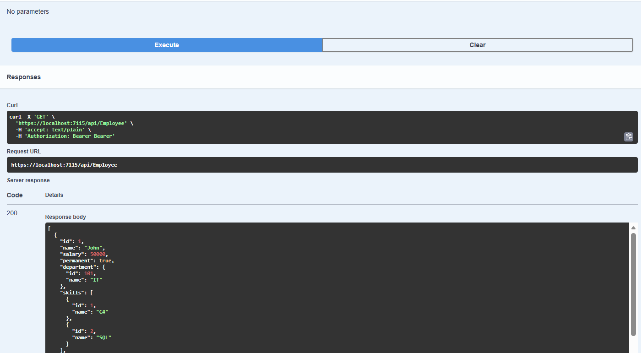

3)
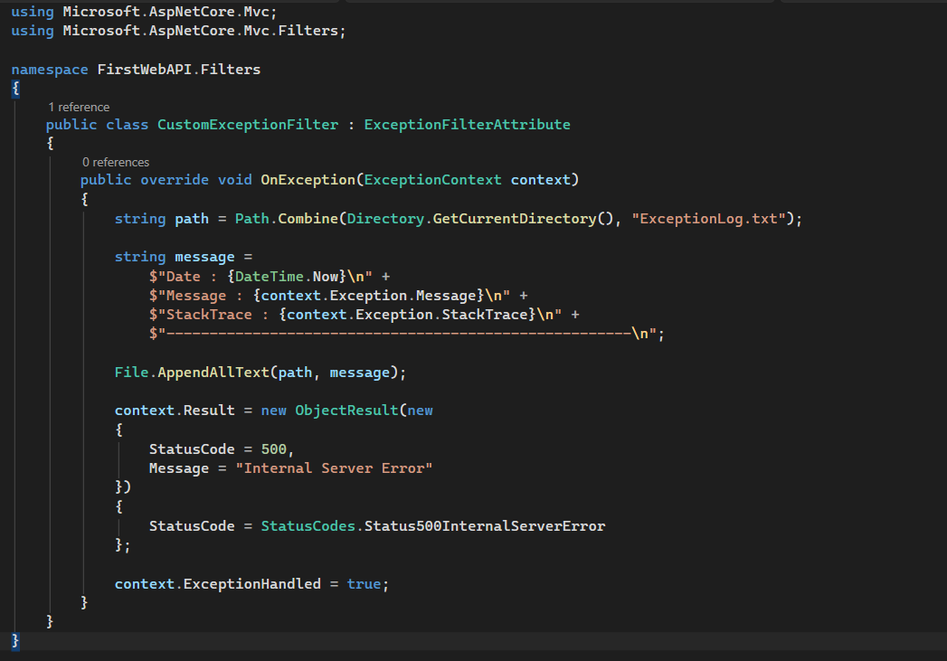
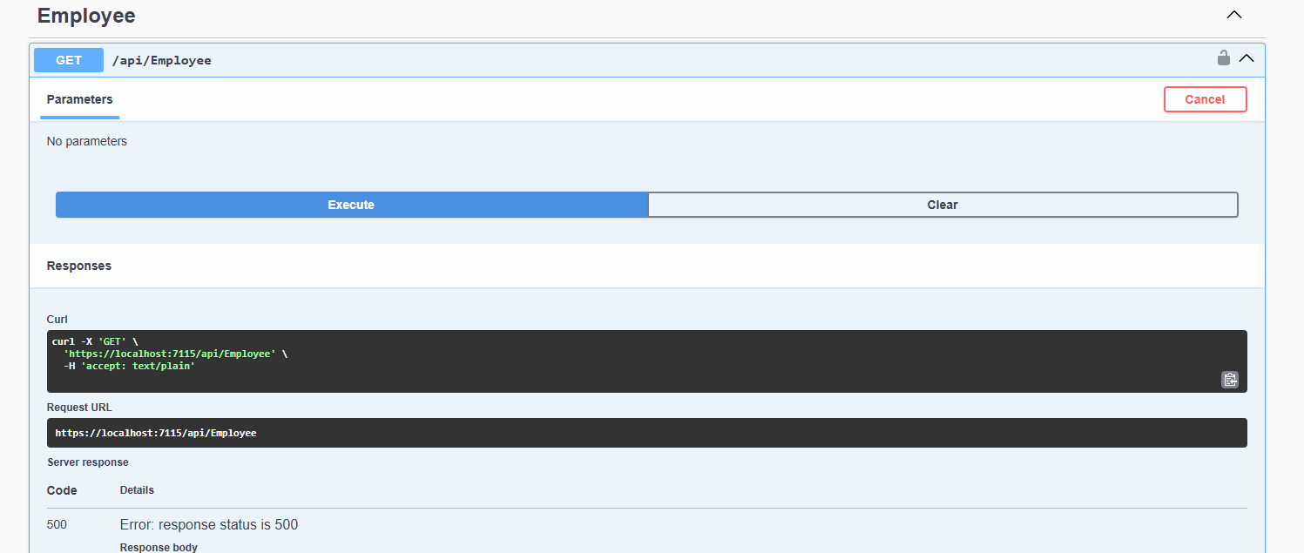

4)
- Web Api CRUD operation
Update Employee data as per the input thru Web API PUT action method call

Employee information has to be updated based on the user input. Use Swagger tool to invoke the action method mapped with Http PUT action verb to update an employee data.
Modify the action method to return Employee data thru ActionResult.
Check if the id value is lesser than or equal to 0. If true, throw BadRequest action result with the message ‘Invalid employee id’

If the value is greater than 0 but not available in the list of employee ids that is there in the hardcoded list of employees, throw BadRequest action result with the same message as stated above.

If the id value is valid, use the JSON data from the input body and update the hardcoded list. Filter the employee list data for the input id and return that as the output.

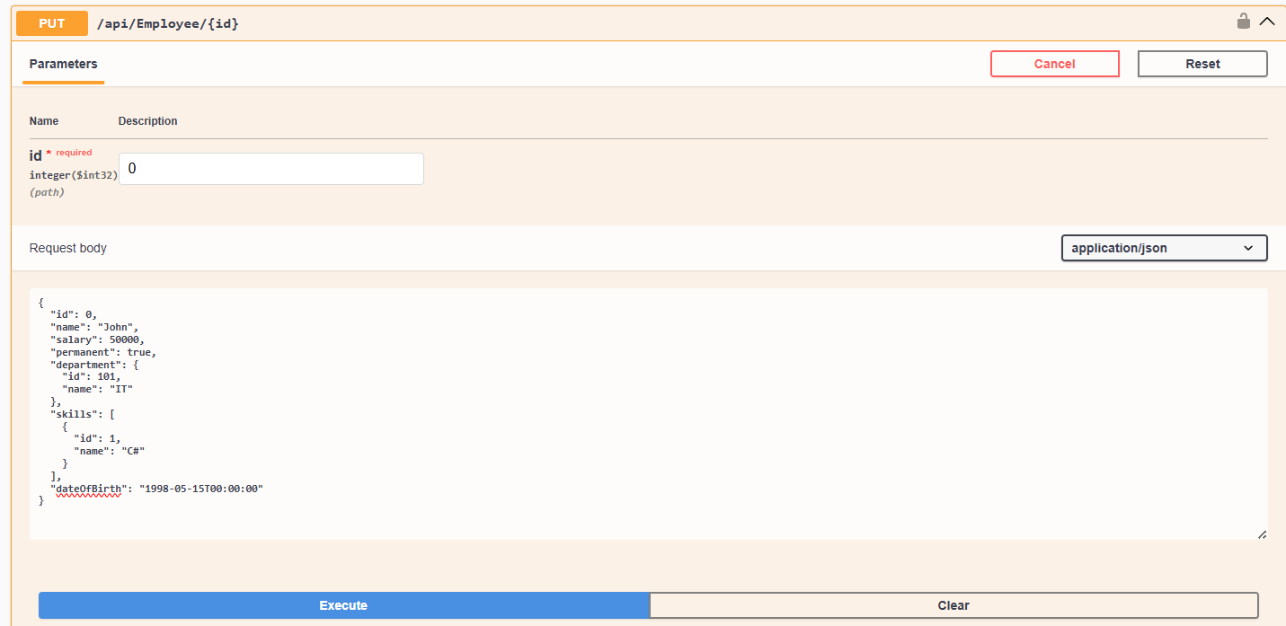

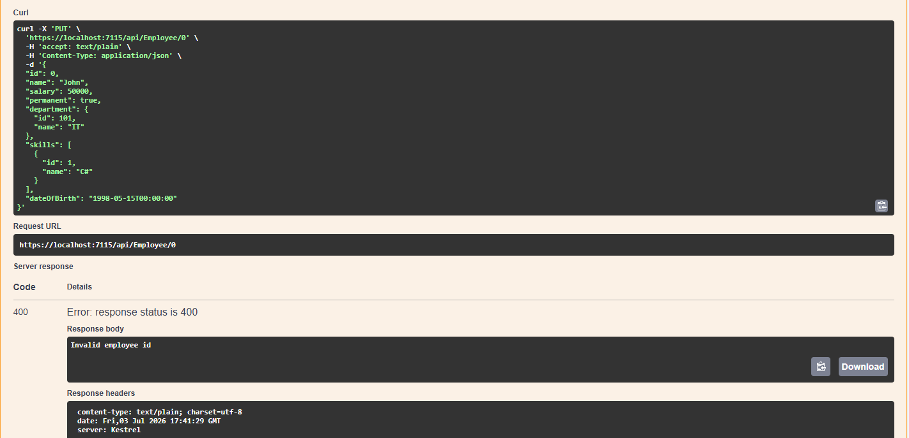
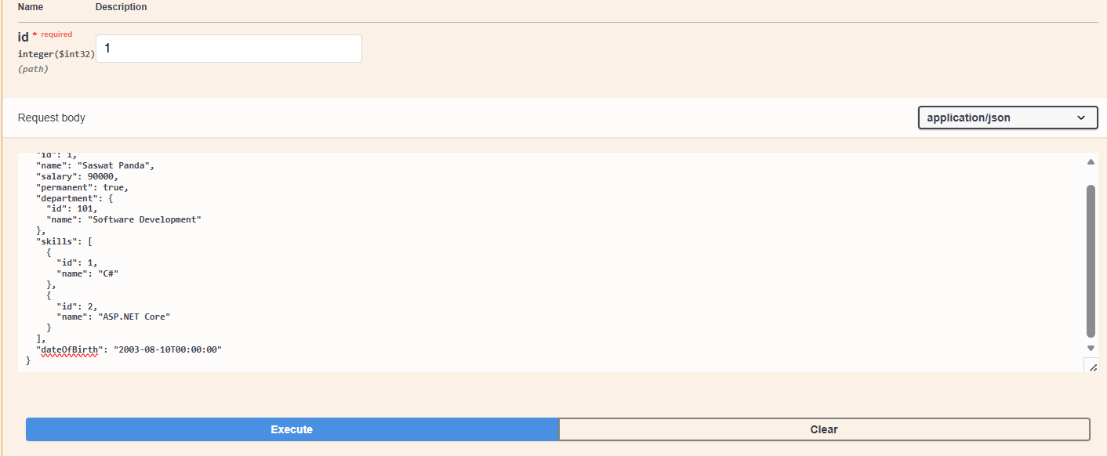
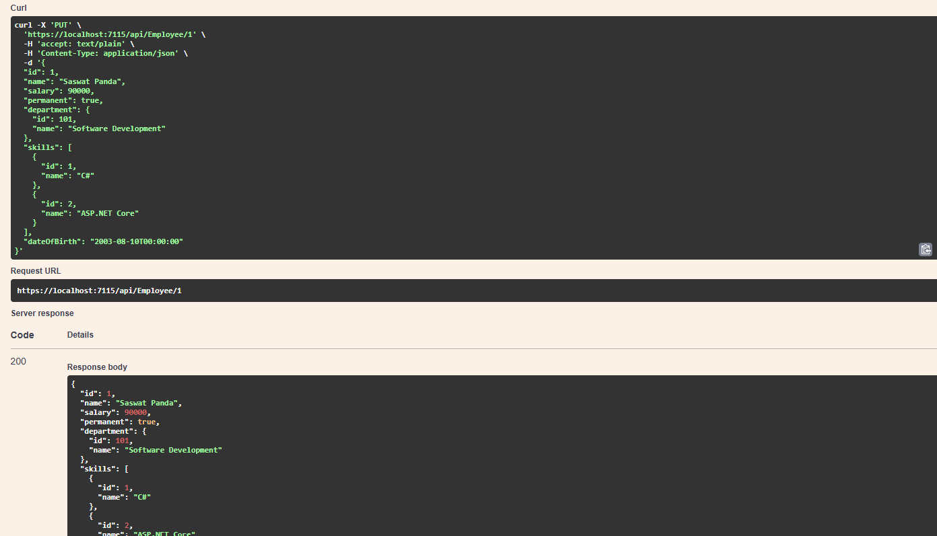
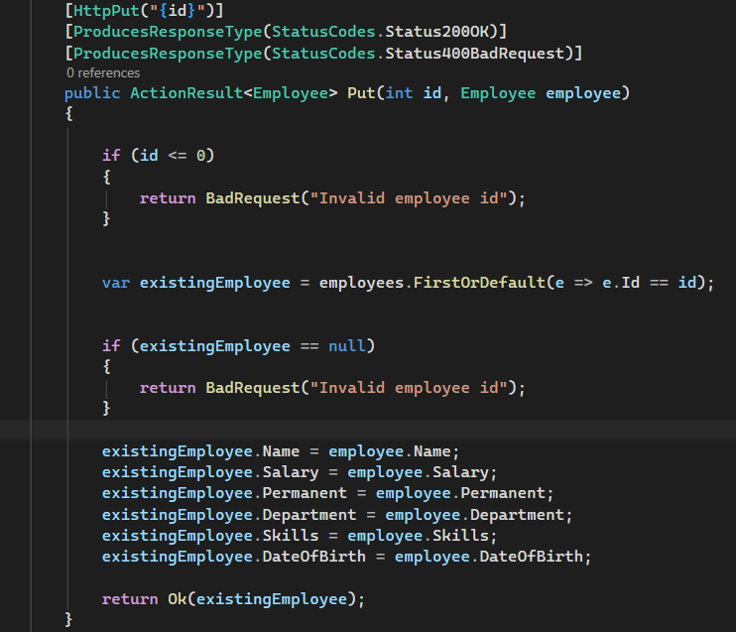

5)
- JsonWebToken
There are various modes of authenticating a request. Json Web Token(JWT) authentication is one among them. It is a methodology of passing a token in the Authorization header value in the request so that it can be checked at the WebAPI and validated. If not there, then ‘Unauthorized’ status message with status code 401 should be thrown.
Use the below code in Startup.cs
- In ConfigureServices method
string securityKey = "mysuperdupersecret";
var symmetricSecurityKey = new SymmetricSecurityKey(Encoding.UTF8.GetBytes(securityKey));
services.AddAuthentication(x =>
{
x.DefaultAuthenticateScheme = JwtBearerDefaults.AuthenticationScheme;
x.DefaultChallengeScheme = JwtBearerDefaults.AuthenticationScheme;
x.DefaultSignInScheme = JwtBearerDefaults.AuthenticationScheme;
})
.AddJwtBearer(JwtBearerDefaults.AuthenticationScheme, x =>
{
x.TokenValidationParameters = new TokenValidationParameters
{
//what to validate
ValidateIssuer = true,
ValidateAudience = true,
ValidateLifetime = true,
ValidateIssuerSigningKey = true,
//setup validate data
ValidIssuer = "mySystem",
ValidAudience = "myUsers",
IssuerSigningKey = symmetricSecurityKey
};
});
- In Configure method
app.UseAuthentication();

This is to enable the JWT authentication in .Net core

Create a new controller ‘AuthController’ in the Web API application. Add AllowAnonymous attribute to the controller. Create a private method GenerateJSONWebToken as shown thru the code below.

private string GenerateJSONWebToken(int userId, string userRole)
{
var securityKey = new SymmetricSecurityKey(Encoding.UTF8.GetBytes("mysuperdupersecret"));
var credentials = new SigningCredentials(securityKey, SecurityAlgorithms.HmacSha256);

var claims = new List<Claim>
{
new Claim(ClaimTypes.Role, userRole),
new Claim("UserId", userId.ToString())
};

var token = new JwtSecurityToken(
issuer: "mySystem",
audience: "myUsers",
claims: claims,
expires: DateTime.Now.AddMinutes(10),
signingCredentials: credentials);

return new JwtSecurityTokenHandler().WriteToken(token);
}

Note that the issuer, audience and the securitykey defined in the Startup.cs code and method code shown above is the same and should match.

Invoke the GenerateJSONWebToken in the GET action method by sending some value for user id and ‘Admin’ for the user role. This is to set Claims information to check the user role

- Use the JWT generated thru the AuthController to be used in POSTMAN request.

Remove the ‘CustomAuthFilter’ that is currently mapped to the Employee controller(if already done)

Use Authorize attribute in the Employee controller to check if the request header contains ‘Authorization’ key with ‘Bearer’ token or not. If the token is unavailable, then ‘Unauthorized’ status message whose code 401 will be thrown. Use POSTMAN to hit a GET action method call. Note the ‘Status’ attribute in the ‘Headers’ section in the output window.

Use the AuthController to generate the JWT. Use that in the GET action method call thru POSTMAN if the request is authenticated or not.

Modify the token value in the POSTMAN tool and check if ‘Unauthorized’ status message is thrown. Note the ‘Status’ attribute in the ‘Headers’ section in the output window.

- Check for JWT expiration

A JWT token has an attribute which can be set to determine how long the token is valid to be used.
In the GenerateJSONWebToken method in AuthController, the ‘expires’ attribute of the JwtSecurityToken object denotes the time in minutes for which the token would be valid.

Modify the duration for ‘expires’ attribute to 2 minutes. Check the POSTMAN request for GET call AFTER 2 minutes of generation of the JWT, which should yield ‘Unauthorized’ message with Http status code 401.

- Add the roles to be authorized in the Authorize attribute.
The Authorize attribute supports the roles to be used to filter the controller action method access.
The GenerateJSONWebToken method of AuthController uses the role ‘Admin’ set in the claims.

Include the role ‘POC’ in the Authorize attribute in the Employee controller. Hit the GET action method of the Employee controller thru POSTMAN. Verify if the response status is ‘Unauthorized’ with status code 401

Include the role ‘Admin’ along with ‘POC’ in the Authorize attribute in the Employee controller. Hit the GET action method of the Employee controller thru POSTMAN. Verify if the response status is OK with status code 200

Solution:-
1)
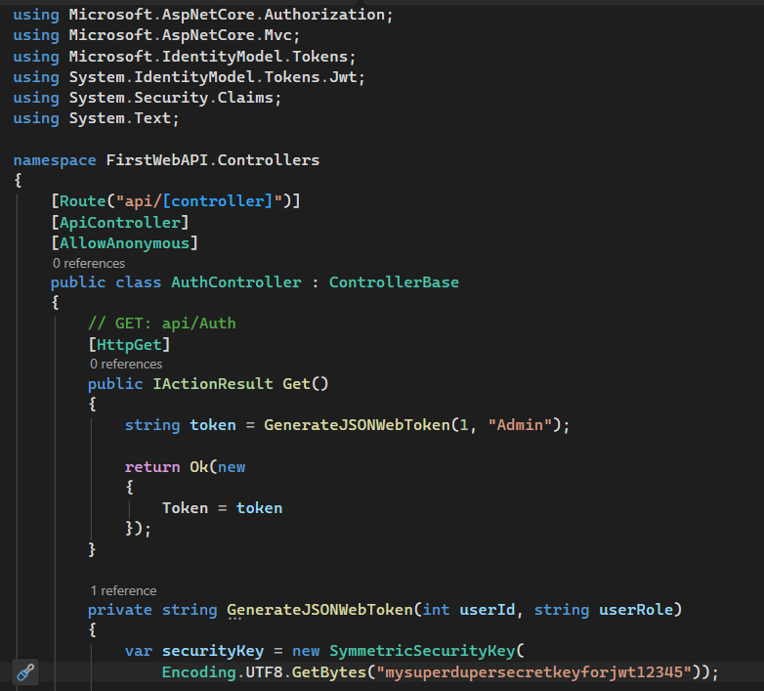
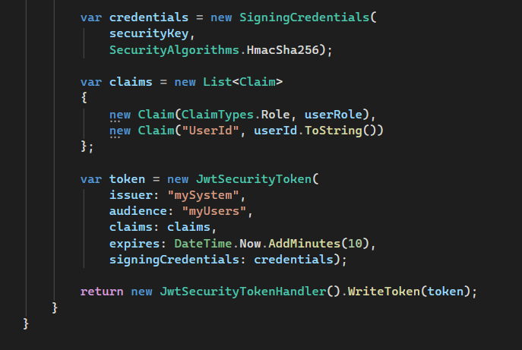
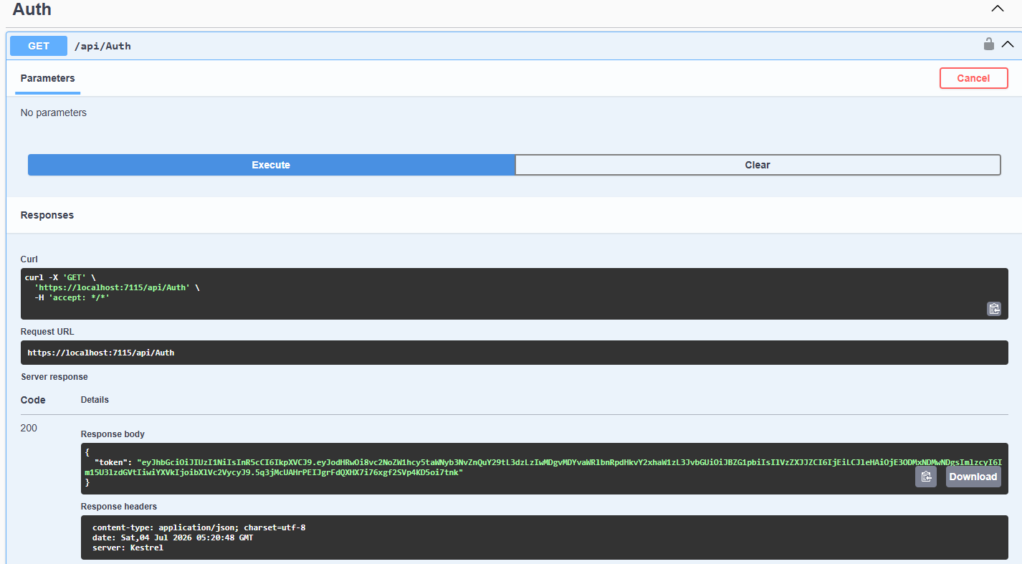

After Bearer Token
