**BIRGUNJ INSTITUTE OF TECHNOLOGY**

**Birgunj, Parsa, Nepal**

**DEPARTMENT OF COMPUTER ENGINEERING**

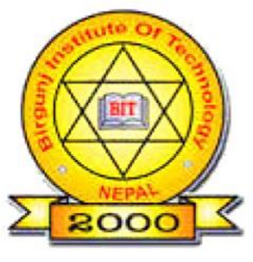**Certificate**

This is to certified that a benefits record of the project work titled **“Pollution Control System”** is being submitted by

**Dibyanshu kumar jaiswal (DCOM- 00255-018)**

**Mohan sharma (DCOM- 002..-018)**

**Aabid Ansari (DCOM- 002..-018)**

**Kushum patel (DCOM- 002..-018)**

**Muskan yadav (DCOM-002..-018)**

of 6th semester Diploma In Computer Engineering in the year 2078 in the partial fulfillment of the requirements for the award of Degree of Diploma in Computer Engineering of **BIRGUNG INSTUTE OF TECHNOLOGY (BIT).**

……………………..…. ……..…...………………….

Er. Raghib Hussain Er. Anish Ansari

**(Acting Principal)**  **(Internal Guide)**

………………….….

Er. Sarita Jayswal

**(HOD of DCOM)**